ZENITH introduces its new ambassador in Tianjin
Attended by an audience of journalists, VIPs and friends of the brand, the roadshow event held in Tianjin on August 23rd 2018 marked the first appearance of Eason Chan as the new ZENITH ambassador, along with the unveiling of the video campaign. The evening also witnesssed the introduction in China of the Zenith Defy El Primero 21 Full Diamonds.

Zenith created a futuristic atmosphere for this occasion, set against an understated black backdrop to usher guests into the next era of watchmaking, while offering an immersive experience of the new “Into the Second” video campaign. The latter stars Eason Chan as the face of the brand in Asia and offers a stunning interpretation of the artist’s musical focus on rhythm, tempo, passion and dedication, all attributes that are equally shared by Zenith with regard to watchmaking. The “Into The Second” theme innovatively combines the image of a sundial, believed to be the prototype of timepieces in human history, the beat of a metronome, as well as a monologue by Eason Chan, into a well-curated story. Jointly orchestrated by the new ZENITH ambassador and CEO Julien Tornare, the fast-paced and lively high-tech presentation also featured the launch of the Defy El Primero 21 Full Diamonds.

Melody meets movement
When it comes to the creation of music, which requires polishing by time and attention to detail, no sacrifice is too great for Chan, who says: “Alongside my lifelong passion for music, I am committed to helping people appreciate the value of making every second count.” Zenith shares a similar philosophy. From the legendary high-frequency El Primero movement to the miraculous Defy, which boasts 1/100th of a second chronograph, Zenith has been constantly pushing the boundaries of horology for over 150 years with the release of creations that have revolutionized Swiss watchmaking.

Powered by the the new 1/100th of a second chronograph movement, the groundbreaking El Primero 21 Full Diamonds takes extravagant style to the next level, complementing its rich inner workings with a diamond-set bezel featuring a dazzling five carats.

Speaking at the press conference, Julien Tornare said: “Our thanks go to Eason Chan, as well as everyone present, for joining us on this special occasion. Over the past century, Zenith has demonstrated that it takes consistent devotion and passion to stand out as a pioneer in one’s field.”

In keeping with Zenith’s vocation for interpreting "time” through its own languages, the launch event was also marked by the start of an exhibition tour chronicling the evolution of time. Providing an exceptional wideangle viewpoint of Zenith and its 150-year journey, the exhibition ends on August 26th, before moving on to Wuhan, Chengdu, Beijing and Hong Kong.

ZENITH: The Future of Swiss Watchmaking
Since 1865, Zenith has been guided by authenticity, daring and passion in pushing the boundaries of excellence, precision and innovation. Soon after its founding in Le Locle by visionary watchmaker Georges Favre-Jacot, Zenith gained recognition for the precision of its chronometers, with which it has won 2,333 chronometry prizes in just over a century and a half of existence: an absolute record. Famed for its legendary 1969 El Primero calibre enabling short-time measurements accurate to the nearest 1/10th of a second, the Manufacture has since developed over 600 movement variations. Today, Zenith offers new and fascinating vistas in time measurement, including 1/100th of a second timing with the Defy El Primero 21; and a whole new dimension in mechanical precision with the world’s most accurate watch, the 21st century Defy Lab. Energised by newly reinforced ties with a proud tradition of dynamic, avant-garde thinking, Zenith is writing its future… and the future of Swiss watchmaking.

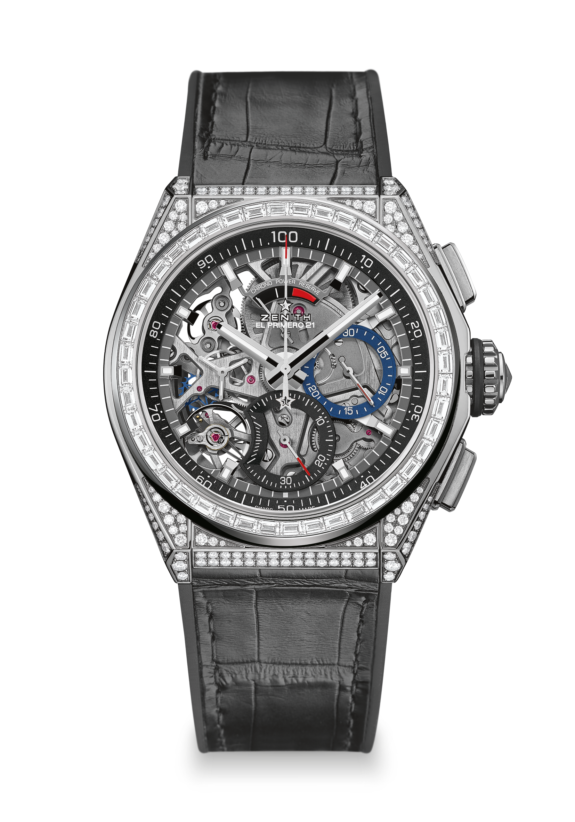
DEFY EL PRIMERO 21 FULL DIAMOND
TECHNICAL DETAILS

Reference: 32.9000.9004/78.R582

New 1/100th of a second chronograph movement
Exclusive dynamic signature of one rotation per second
One escapement for the Watch (36,000 VpH - 5 Hz)
One escapement for the Chronograph (360,000 VpH - 50Hz)
Chronometer-certified

MOVEMENT
El Primero 9004 automatic
Calibre: 14 ½ ``` (Diameter: 32 mm)
Thickness: 7.9 mm
Components: 293
Jewels: 53
Frequency 36,000 VpH (5 Hz)
Power reserve approx. 50 hours
Special oscillating weight with “circular satin-brushed” motif

FUNCTIONS
1/100th of a second chronograph functions
Chronograph power-reserve indication at 12 o'clock
Hours and minutes in the centre
Small seconds at 9 o'clock
- Central chronograph hand
- 30-minute counter at 3 o'clock
- 60-second counter at 6 o'clock

CASE, DIAL & HANDS
Titanium case with diamonds
Titanium bezel set with baguette-cut diamonds
Diameter: 44 mm
Opening diameter: 35.5 mm
Thickness: 14.50 mm
Crystal: Domed sapphire crystal with anti-reflective treatment on both sides
Case back: Transparent sapphire crystal
Water resistance: 10 ATM
Dial: Openworked
Hour markers: Rhodium-plated, faceted and coated with Super-LumiNova®
Hands: Rhodium-plated, faceted and coated with Super-LumiNova®

STRAP AND BUCKLE
Black rubber coated with black alligator leather
Titanium double folding clasp

GEMSETTING
Case: 288 VVS brilliant-cut diamonds
Bezel: 44 VVS baguette-cut diamonds
Carats : approx.. 5.00 cts

