ZENITH UNVEILS THREE THEMED EDITIONS AT THE SIAR 2018

Zenith explores new sources of inspiration and flamboyant baroque imagery – skulls, pirates and the Virgen de Guadalupe – through a set of exclusive special-edition Defy Zero G timepieces destined for Latin America and presented at the 2018 Salón Internacional Alta Relojería (SIAR).

Autumn’s number one luxury annual appointment with time in Latin America, the Salón Internacional Alta Relojería (SIAR) is the key reference for the promotion and sale of fine watches. At the 2018 edition of this unique showcase, which will run from October 16th to 18th, the brand with a guiding star will take the opportunity to launch some unprecedented special editions of its DEFY ZERO G. Featuring a cleverly scaled-down and fine-tuned version of its gyroscopic “Gravity Control” module, these standout timepieces thus belong to the DEFY collection with which Zenith is writing the future of watchmaking.

Spirit of adventure
Zenith offers visitors to the SIAR 2018 models featuring three distinctive aesthetic inspirations that are bound to capture attention. The highly unusual DEFY ZERO G VIRGEN DE GUADELUPE evokes a venerated Catholic image enshrined within the Minor Basilica of Our Lady of Guadalupe in Mexico City. Depicting a reported apparition of the Virgin Mary to an Aztec convert to Christianity, it holds a special place in the religious life of Mexico and represents a symbol of devotion that has come to embody national pride. While skulls have become a trendy fashion motif, Zenith offers a specifically Mexican take on this theme with the DEFY ZERO G SKULL – Dias de los Muertos, celebrating the Mexican Day of the Dead which is an extremely popular national holiday that includes festivals, parades and family gatherings. And speaking of skulls and crossbones, the DEFY ZERO G PIRATES offers watch lovers a chance to set sail on an imaginary maritime adventure filled with exotic islands, buried treasure and swashbuckling sailors.

Each of the three DEFY ZERO G limited editions is available in a choice of titanium, yellow or rose gold, slightly aged to better display its engraved theme. Framing the DEFY ZERO G’s distinctive skeleton dial with its colourful Mexican-themed accents, a 44 mm case features a decorated caseback with a matching metal bracelet and folding clasp. And because every treasure deserves a special treasure chest, each DEFY ZERO G comes nestled in a customised box representing the individual themes. Providing more than adequate power for the fastest getaway, the heart of the Defy Zero G beats to the fierce pace of the manual-winding El Primero 8812S calibre, oscillating at 5 Hz, while a 50-hour power reserve ensures there’s plenty of time in store before reaching the next high seas hold-up.

ZENITH: The Future of Swiss Watchmaking
Since 1865, Zenith has been guided by authenticity, daring and passion in pushing the boundaries of excellence, precision and innovation. Soon after its founding in Le Locle by visionary watchmaker Georges Favre-Jacot, Zenith gained recognition for the precision of its chronometers, with which it has won 2,333 chronometry prizes in just over a century and a half of existence: an absolute record. Famed for its legendary 1969 El Primero calibre enabling short-time measurements accurate to the nearest 1/10th of a second, the Manufacture has since developed over 600 movement variations. Today, Zenith offers new and fascinating vistas in time measurement, including 1/100th of a second timing with the Defy El Primero 21; and a whole new dimension in mechanical precision with the world’s most accurate watch, the 21st century Defy Lab. Energised by newly reinforced ties with a proud tradition of dynamic, avant-garde thinking, Zenith is writing its future… and the future of Swiss watchmaking.

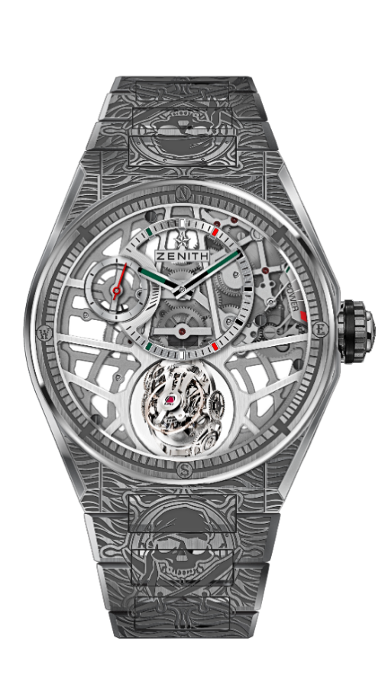
DEFY ZERO G – 44MM
PIRATES EDITION - UNIQUE PIECE
TECHNICAL DETAILS

Reference : 95.9005.8812/80.M9004

KEY POINTS
“Gravity Control” gyroscopic module
that ensures horizontal positioning of the regulating organ
Inspired by the legendary marine chronometers.
Skeletonised movement : El Primero 8812 S
Entirely engraved case and bracelet
Openworked dial with mexican touches colors

MOVEMENT
El Primero 8812 S, Manual
Calibre: 16 ¾``` (Diameter: 38.5mm)
Movement thickness: 7.85mm
Components: 324
Gyroscopic carriage made of 139 components
Jewels: 41
Frequency: 36,000 VpH (5Hz)
Power-reserve: min. 50 hours
Finishes: Platinum counterweight of the gyroscopic system

FUNCTIONS
Hours and minutes offset at 12 o’clock
Small seconds at 9 o’clock
Self-regulating Gravity Control module at 6 o’clock
Power-reserve indication at 2 o’clock

CASE, DIAL & HANDS
Diameter: 44mm
Diameter opening: 35.5mm
Thickness: 14.85mm
Crystal: Domed sapphire crystal with anti-reflective treatment on both sides
Case-back: Decorated transparent sapphire crystal
Material: Brushed Titanium
Water-resistance: 10 ATM
Dial: Openworked with mexican touches colors
Hour-markers: Rhodium-plated, faceted and coated with Super-LumiNova®
Hands: Rhodium-plated, faceted and coated with Super-LumiNova®

STRAP & BUCKLE
Titanium bracelet
Titanium folding buckle
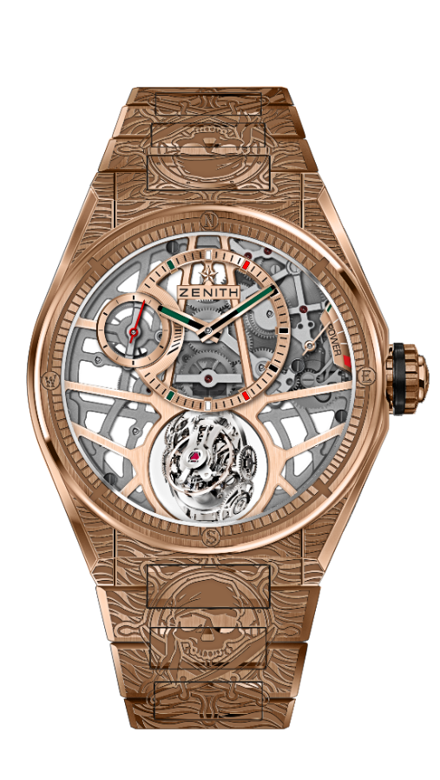
DEFY ZERO G – 44MM
PIRATES EDITION - UNIQUE PIECE
TECHNICAL DETAILS

Reference : 18.9003.8812/76.M9003

KEY POINTS
“Gravity Control” gyroscopic module
that ensures horizontal positioning of the regulating organ
Inspired by the legendary marine chronometers.
Skeletonised movement : El Primero 8812 S
Entirely engraved case and bracelet
Openworked dial with mexican touches colors

MOVEMENT
El Primero 8812 S, Manual
Calibre: 16 ¾``` (Diameter: 38.5mm)
Movement thickness: 7.85mm
Components: 324
Gyroscopic carriage made of 139 components
Jewels: 41
Frequency: 36,000 VpH (5Hz)
Power-reserve: min. 50 hours
Finishes: Platinum counterweight of the gyroscopic system

FUNCTIONS
Hours and minutes offset at 12 o’clock
Small seconds at 9 o’clock
Self-regulating Gravity Control module at 6 o’clock
Power-reserve indication at 2 o’clock

CASE, DIAL & HANDS
Diameter: 44mm
Diameter opening: 35.5mm
Thickness: 14.85mm
Crystal: Domed sapphire crystal with anti-reflective treatment on both sides
Case-back: Decorated transparent sapphire crystal
Material: 18-ct Rose Gold
Water-resistance: 10 ATM
Dial: Openworked with mexican touches colors
Hour-markers: Gold-plated, faceted and coated with black Super-LumiNova®
Hands: Gold-plated, faceted and coated with Super-LumiNova®

STRAP & BUCKLE
Rose Gold bracelet
Rose gold folding buckle
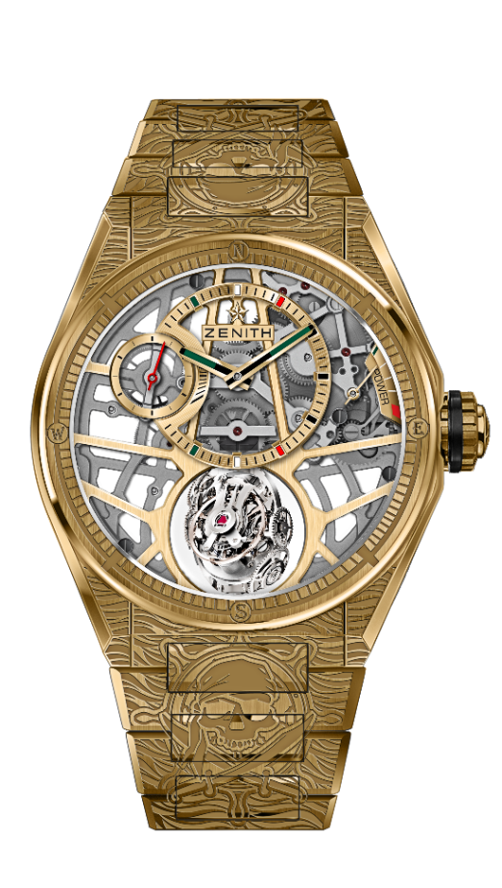
DEFY ZERO G – 44MM
PIRATES EDITION - UNIQUE PIECE
TECHNICAL DETAILS

Reference : 30.9002.8812/75.M9002

KEY POINTS
“Gravity Control” gyroscopic module
that ensures horizontal positioning of the regulating organ
Inspired by the legendary marine chronometers.
Skeletonised movement : El Primero 8812 S
Entirely engraved case and bracelet
Openworked dial with mexican touches colors

MOVEMENT
El Primero 8812 S, Manual
Calibre: 16 ¾``` (Diameter: 38.5mm)
Movement thickness: 7.85mm
Components: 324
Gyroscopic carriage made of 139 components
Jewels: 41
Frequency: 36,000 VpH (5Hz)
Power-reserve: min. 50 hours
Finishes: Platinum counterweight of the gyroscopic system

FUNCTIONS
Hours and minutes offset at 12 o’clock
Small seconds at 9 o’clock
Self-regulating Gravity Control module at 6 o’clock
Power-reserve indication at 2 o’clock

CASE, DIAL & HANDS
Diameter: 44mm
Diameter opening: 35.5mm
Thickness: 14.85mm
Crystal: Domed sapphire crystal with anti-reflective treatment on both sides
Case-back: Decorated transparent sapphire crystal
Material: 18-ct Yellow Gold
Water-resistance: 10 ATM
Dial: Openworked with mexican touches colors
Hour-markers: Gold-plated, faceted and coated with black Super-LumiNova®
Hands: Gold-plated, faceted and coated with Super-LumiNova®

STRAP & BUCKLE
Yellow Gold bracelet
Yellow gold folding buckle
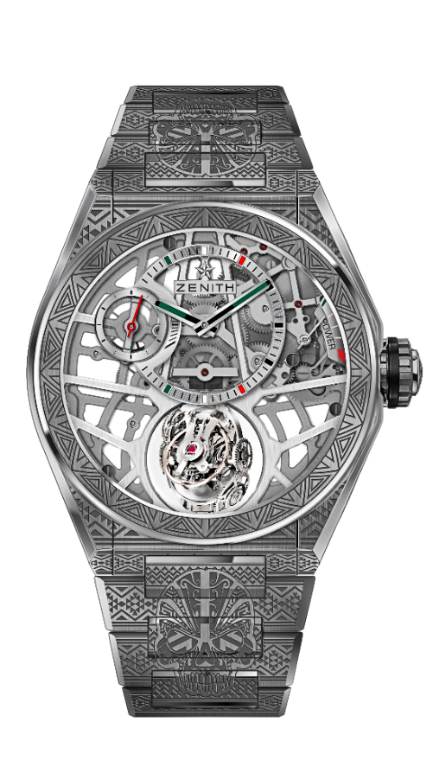
DEFY ZERO G – 44MM
SKULL EDITION - UNIQUE PIECE
TECHNICAL DETAILS

Reference : 95.9003.8812/80.M9002

KEY POINTS
“Gravity Control” gyroscopic module that
ensures horizontal positioning of the regulating organ
Inspired by the legendary marine chronometers.
Skeletonised movement : El Primero 8812 S
Entirely engraved case and bracelet
Openworked dial with mexican touches colors

MOVEMENT
El Primero 8812 S, Manual
Calibre: 16 ¾``` (Diameter: 38.5mm)
Movement thickness: 7.85mm
Components: 324
Gyroscopic carriage made of 139 components
Jewels: 41
Frequency: 36,000 VpH (5Hz)
Power-reserve: min. 50 hours
Finishes: Platinum counterweight of the gyroscopic system

FUNCTIONS
Hours and minutes offset at 12 o’clock
Small seconds at 9 o’clock
Self-regulating Gravity Control module at 6 o’clock
Power-reserve indication at 2 o’clock

CASE, DIAL & HANDS
Diameter: 44mm
Diameter opening: 35.5mm
Thickness: 14.85mm
Crystal: Domed sapphire crystal with anti-reflective treatment on both sides
Case-back: Decorated transparent sapphire crystal
Material: Brushed Titanium
Water-resistance: 10 ATM
Dial: Openworked with mexian touches colors
Hour-markers: Rhodium-plated, faceted and coated with Super-LumiNova®
Hands: Rhodium-plated, faceted and coated with Super-LumiNova®

STRAP & BUCKLE
Titanium bracelet
Titanium folding buckle
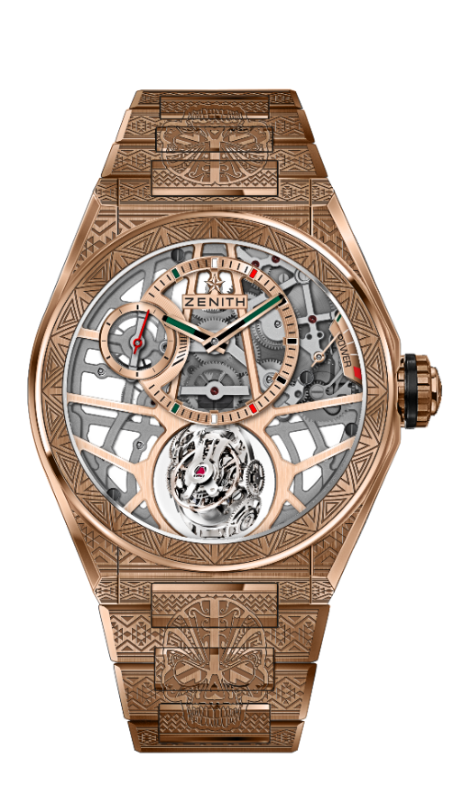
DEFY ZERO G – 44MM
SKULL EDITION - UNIQUE PIECE
TECHNICAL DETAILS

Référence : 18.9001.8812/76.M9001

KEY POINTS
“Gravity Control” gyroscopic module
that ensures horizontal positioning of the regulating organ
Inspired by the legendary marine chronometers.
Skeletonised movement : El Primero 8812 S
Entirely engraved case and bracelet
Openworked dial with mexican touches colors

MOVEMENT
El Primero 8812 S, Manual
Calibre: 16 ¾``` (Diameter: 38.5mm)
Movement thickness: 7.85mm
Components: 324
Gyroscopic carriage made of 139 components
Jewels: 41
Frequency: 36,000 VpH (5Hz)
Power-reserve: min. 50 hours
Finishes: Platinum counterweight of the gyroscopic system

FUNCTIONS
Hours and minutes offset at 12 o’clock
Small seconds at 9 o’clock
Self-regulating Gravity Control module at 6 o’clock
Power-reserve indication at 2 o’clock

CASE, DIAL & HANDS
Diameter: 44mm
Diameter opening: 35.5mm
Thickness: 14.85mm
Crystal: Domed sapphire crystal with anti-reflective treatment on both sides
Case-back: Decorated transparent sapphire crystal
Material: 18-ct Rose Gold
Water-resistance: 10 ATM
Dial: Openworked with mexican touches colors
Hour-markers: Gold-plated, faceted and coated with black Super-LumiNova®
Hands: Gold-plated, faceted and coated with Super-LumiNova®

STRAP & BUCKLE
Rose Gold bracelet
Rose gold folding buckle

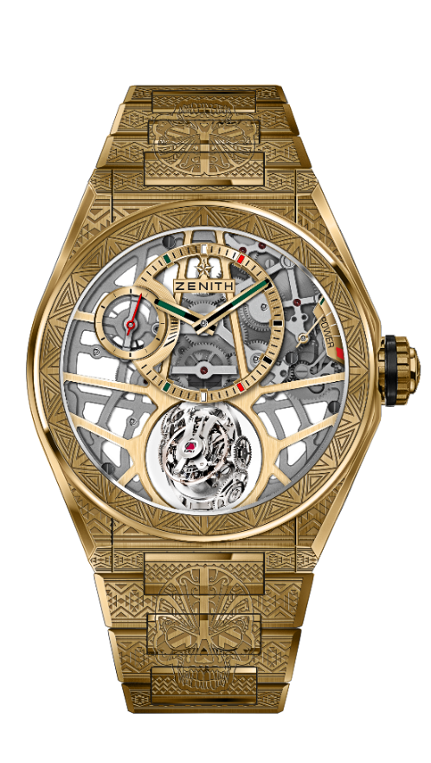
DEFY ZERO G – 44MM
SKULL EDITION - UNIQUE PIECE
TECHNICAL DETAILS

Référence : 30.9002.8812/75.M9002

KEY POINTS
“Gravity Control” gyroscopic module
that ensures horizontal positioning of the regulating organ
Inspired by the legendary marine chronometers.
Skeletonised movement : El Primero 8812 S
Entirely engraved case and bracelet
Openworked dial with mexican touches colors

MOVEMENT
El Primero 8812 S, Manual
Calibre: 16 ¾``` (Diameter: 38.5mm)
Movement thickness: 7.85mm
Components: 324
Gyroscopic carriage made of 139 components
Jewels: 41
Frequency: 36,000 VpH (5Hz)
Power-reserve: min. 50 hours
Finishes: Platinum counterweight of the gyroscopic system

FUNCTIONS
Hours and minutes offset at 12 o’clock
Small seconds at 9 o’clock
Self-regulating Gravity Control module at 6 o’clock
Power-reserve indication at 2 o’clock

CASE, DIAL & HANDS
Diameter: 44mm
Diameter opening: 35.5mm
Thickness: 14.85mm
Crystal: Domed sapphire crystal with anti-reflective treatment on both sides
Case-back: Decorated transparent sapphire crystal
Material: 18-ct Yellow Gold
Water-resistance: 10 ATM
Dial: Openworked with mexican touches colors
Hour-markers: Gold-plated, faceted and coated with black Super-LumiNova®
Hands: Gold-plated, faceted and coated with Super-LumiNova®

STRAP & BUCKLE
Yellow Gold bracelet
Yellow gold folding buckle

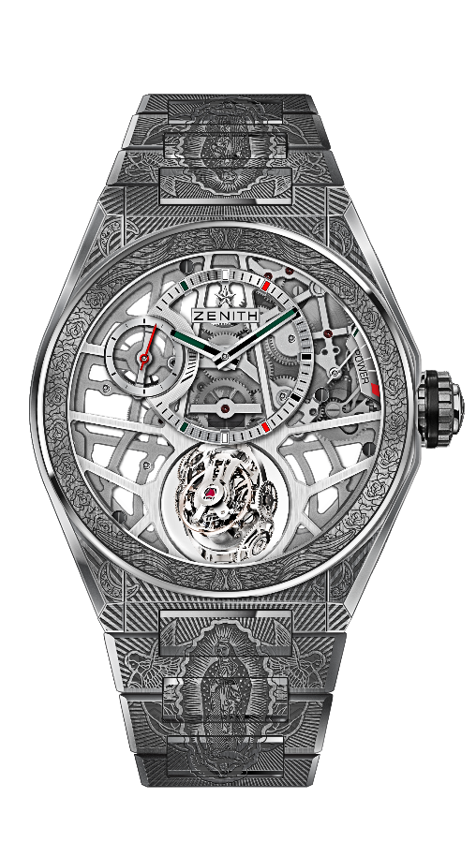
DEFY ZERO G – 44MM
VIRGEN DE GUADALUPE EDITION - UNIQUE PIECE
TECHNICAL DETAILS

Reference : 95.9004.8812/80.M9003

KEY POINTS
“Gravity Control” gyroscopic module that
ensures horizontal positioning of the regulating organ
Inspired by the legendary marine chronometers.
Skeletonised movement : El Primero 8812 S
Entirely engraved case and bracelet
Openworked dial with mexican touches colors

MOVEMENT
El Primero 8812 S, Manual
Calibre: 16 ¾``` (Diameter: 38.5mm)
Movement thickness: 7.85mm
Components: 324
Gyroscopic carriage made of 139 components
Jewels: 41
Frequency: 36,000 VpH (5Hz)
Power-reserve: min. 50 hours
Finishes: Platinum counterweight of the gyroscopic system

FUNCTIONS
Hours and minutes offset at 12 o’clock
Small seconds at 9 o’clock
Self-regulating Gravity Control module at 6 o’clock
Power-reserve indication at 2 o’clock

CASE, DIAL & HANDS
Diameter: 44mm
Diameter opening: 35.5mm
Thickness: 14.85mm
Crystal: Domed sapphire crystal with anti-reflective treatment on both sides
Case-back: Decorated transparent sapphire crystal
Material: Brushed Titanium
Water-resistance: 10 ATM
Dial: Openworked with mexican touches colors
Hour-markers: Rhodium-plated, faceted and coated with Super-LumiNova®
Hands: Rhodium-plated, faceted and coated with Super-LumiNova®

STRAP & BUCKLE
Titanium bracelet
Titanium folding buckle
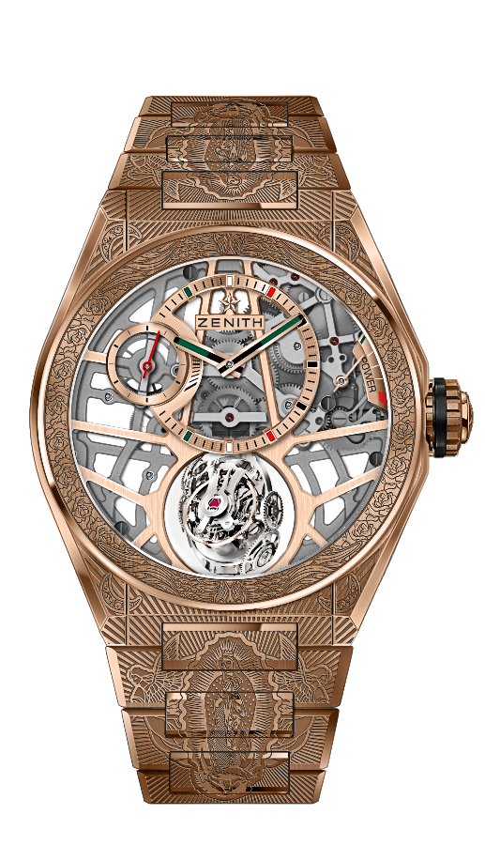
DEFY ZERO G – 44MM
VIRGEN DE GUADALUPE EDITION - UNIQUE PIECE
TECHNICAL DETAILS

Reference : 18.9002.8812/76.M9002

KEY POINTS
“Gravity Control” gyroscopic module
that ensures horizontal positioning of the regulating organ
Inspired by the legendary marine chronometers.
Skeletonised movement : El Primero 8812 S
Entirely engraved case and bracelet
Openworked dial with mexican touches colors

MOVEMENT
El Primero 8812 S, Manual
Calibre: 16 ¾``` (Diameter: 38.5mm)
Movement thickness: 7.85mm
Components: 324
Gyroscopic carriage made of 139 components
Jewels: 41
Frequency: 36,000 VpH (5Hz)
Power-reserve: min. 50 hours
Finishes: Platinum counterweight of the gyroscopic system

FUNCTIONS
Hours and minutes offset at 12 o’clock
Small seconds at 9 o’clock
Self-regulating Gravity Control module at 6 o’clock
Power-reserve indication at 2 o’clock

CASE, DIAL & HANDS
Diameter: 44mm
Diameter opening: 35.5mm
Thickness: 14.85mm
Crystal: Domed sapphire crystal with anti-reflective treatment on both sides
Case-back: Decorated transparent sapphire crystal
Material: 18-ct Rose Gold
Water-resistance: 10 ATM
Dial: Openworked with mexican touches colors
Hour-markers: Gold-plated, faceted and coated with black Super-LumiNova®
Hands: Gold-plated, faceted and coated with Super-LumiNova®

STRAP & BUCKLE
Rose Gold bracelet
Rose gold folding buckle
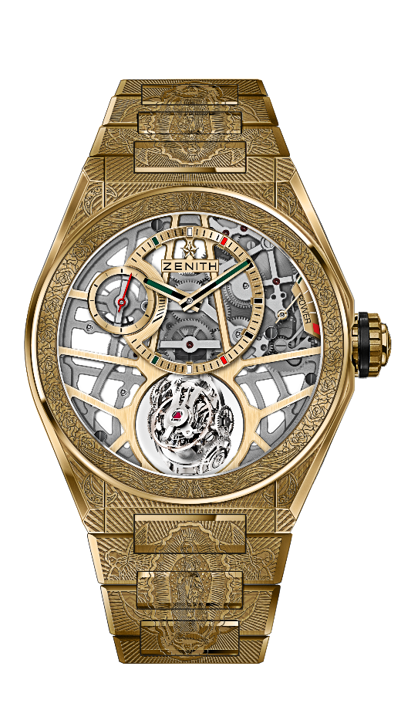
DEFY ZERO G – 44MM
VIRGEN DE GUADALUPE EDITION - UNIQUE PIECE
TECHNICAL DETAILS

Reference : 30.9001.8812/75.M9001

KEY POINTS
“Gravity Control” gyroscopic module
that ensures horizontal positioning of the regulating organ
Inspired by the legendary marine chronometers.
Skeletonised movement : El Primero 8812 S
Entirely engraved case and bracelet
Openworked dial with mexican touches colors

MOVEMENT
El Primero 8812 S, Manual
Calibre: 16 ¾``` (Diameter: 38.5mm)
Movement thickness: 7.85mm
Components: 324
Gyroscopic carriage made of 139 components
Jewels: 41
Frequency: 36,000 VpH (5Hz)
Power-reserve: min. 50 hours
Finishes: Platinum counterweight of the gyroscopic system

FUNCTIONS
Hours and minutes offset at 12 o’clock
Small seconds at 9 o’clock
Self-regulating Gravity Control module at 6 o’clock
Power-reserve indication at 2 o’clock

CASE, DIAL & HANDS
Diameter: 44mm
Diameter opening: 35.5mm
Thickness: 14.85mm
Crystal: Domed sapphire crystal with anti-reflective treatment on both sides
Case-back: Decorated transparent sapphire crystal
Material: 18-ct Yellow Gold
Water-resistance: 10 ATM
Dial: Openworked with mexican touches colors
Hour-markers: Gold-plated, faceted and coated with black Super-LumiNova®
Hands: Gold-plated, faceted and coated with Super-LumiNova®

STRAP & BUCKLE
Yellow Gold bracelet
Yellow gold folding buckle

