ZENITH PLACES WOMEN IN THE SPOTLIGHT IN DUBAI AT THE INAUGURAL EDITION OF LVMH WATCH WEEK – DUBAI 2020

Zenith embarks on the debut edition of LVMH Watch Week with a new kind of innovation in its DEFY collection with DEFY Midnight, a uniquely conceived line of women’s watches with a dreamy, cosmic touch. In addition, the new Elite collection redefines the codes of 21st century watchmaking for the ultimate in contemporary elegance.

“I’m very grateful that Zenith is in Dubai for the first edition of LVMH Watch Week – DUBAI 2020, which I believe is the new international destination for the world of watchmaking. Glamorous and forward-thinking at the same time, Dubai is the perfect place to present an innovative collection of feminine watches. We are placing women’s watches at the forefront of the brand’s creative endeavors. But we weren’t content with making yet another ladies’ watch. With our newest models, it is the first time that Zenith has conceived women’s watches from the ground up”, revealed Zenith CEO Julien Tornare.

EXPLORING TWO SIDES OF FEMININITY

With its new creations dedicated entirely to women, Zenith is elevating both ends of the spectrum of women’s watches. On one side, the resolutely contemporary DEFY Midnight and on the other, the timelessly elegant Elite collection.

There is dreamer in each of us, gazing at the starry night sky and taking in the infinite potential that lies ahead. For its first purely feminine watch, Zenith sought inspiration from the cosmos when creating the DEFY Midnight, a versatile sporty-chic timepiece with a uniquely celestial dial, conceived with free-spirited women in mind. As much a jewel as it is a watch, the DEFY Midnight is the perfect companion for the independent women of today: confident, expressive and with a style of their own. Living by their own rules and assertive in their choices, DEFY Midnight women are never afraid to stand out and project their dreams.

Housed in a 36mm stainless steel case embellished with brilliant-cut diamonds, the dial of the DEFY Midnight gives Zenith’s “time to reach your star” philosophy a literal, visual manifestation. Available in deep blue or grey colors, the dial features a glossy finish with a vertical gradient effect for an unprecedented depth. Portraying the night sky above the endless horizon, where the dark vastness of space gives way to the glimmer of starlight, the dial at once enchants and enlightens the wearer. Evoking the Zenith starry sky, the brand’s faceted star emblem is the highest, brightest point in the depicted night sky. Completing the celestial landscape are stars of different sizes – some of which glow in the dark. A third dial made of white mother-pearl with a vertical gradient effect evokes moonlight on a cloudy night. White diamonds are applied on every hour marker, except at 3 o’clock where the date window is placed. Equipped with the automatic Elite in-house movement, the DEFY Midnight provides dependable precision and autonomy of 50 hours. A star-shaped oscillating weight brings a galactic element to the case-back view.

The DEFY Midnight features an assortment of bracelets and straps that can easily be swapped by the wearer, allowing the DEFY Midnight to adapt itself to different looks and situations. The integrated stainless steel bracelet as well as a selection of colored satin and leather straps with rubber backing can be swapped by means of a quick strap-change mechanism integrated directly onto the back of the straps, and requiring no tools or special skills for the owner to do on her own, be it for a change of seasons or just a change of outfit. Each DEFY Midnight will come in a special box that includes 3 additional colored straps and an interchangeable folding clasp.

**************

Zenith revisits its own past from the vantage point of today, with the newly revamped Elite collection of unisex watches. Sleeker, more minimalistic, yet strong in its graphic identity and confident in its timeless lines and proportions, the Elite collection doesn’t repeat the past, but rather rejuvenates the codes of mid-20th century watchmaking. Through two models available in two sizes and a number of case and dial combinations, the Elite Classic and Moonphase models set the tone for Zenith’s vision of contemporary elegance. The line caters to the desires of those who value the aesthetics and enduring appeal of watches from bygone eras, with just enough modern accents to ensure it never feels antiquated.

Like rays of light darting out from the sun, the radiant sunburst pattern of the Elite Classic dial creates a spectacle of highlights and shadows. To enhance the visual depth, the dial is set with tapered hour markers that are faceted and polished. The minutes and seconds track lend the dial a scientific touch, while slightly larger applied hour markers break up the track and highlight the four cardinal points of the dial. Floating above the lively dial are sharp and slim “Dauphine” shaped hands, a nostalgic nod to Zenith timepieces from mid-20th century.

The Elite Moonphase, majestic in its tones and whimsical in its harmonious asymmetry, uncovers the veil of night to bring out the enchanting beauty of the moon. A midnight blue circle on the lower half of the sunburst pattern dial takes on the same tone as the moonphase disk, giving the impression of an oversized display of the golden moon and stars. In juxtaposition, a small running seconds hand at 9 o’clock recalls the fleeting nature of time.

Carefully reapplying the same elegant proportions across the collection, the Elite Classic and Elite Moonphase models are available in 40.5mm and 36mm case diameters, in stainless steel or rose gold. Besides the choice of dial colors, the wearer can give his or her Elite a more personal touch with a wide choice of straps in numerous materials and colors, available from Zenith boutiques and authorized retailers.

**************

NEW CREATIONS FOR LVMH WATCH WEEK – DUBAI 2020

When two partners who are pioneers in their respective fields come together, the results can be unexpected and exciting. Coinciding with the release of the next-generation Land Rover Defender, a total redesign of the emblematic, all-terrain vehicle with its most significant evolution to date, Zenith and the famed British carmaker are reinforcing their partnership with their most original collaborative watch to date: the DEFY 21 Land Rover Edition. This edition is a rugged and stealthy reinterpretation of the 21st century El Primero high-frequency chronograph, embodying the resilient spirit of the new Land Rover Defender that combines the ultimate in ruggedness and comfort. A limited edition of 250 pieces, it represents a complete makeover of the 1/100th of a second chronograph with a raw and minimalistic look. Crafted in microblasted titanium, the case absorbs light from all angles to better accentuate its faceted surfaces. Paired with a matching closed grey dial, the redesigned display features for the first time in a DEFY 21 a linear power reserve window, with the slightest touches of color for legibility. Gerry McGovern, Land Rover Chief Creative Officer, said: “For the next chapter in our partnership with Zenith we wanted a timepiece that captured the essence of the new Land Rover Defender: modern, durable and highly desirable. With subtle details that capture the character of the new Defender, this for me is the best timepiece we have created with Zenith”.

With respect to exceptional collaborations, Zenith is proud to introduce its newest Friend of the Brand, world-renowned DJ and producer Carl Cox. An undisputed living legend in electronic music and specifically “techno”, Carl Cox is credited with bringing his craft to new heights and his unique sound to a global audience. From underground rave parties in the 80s to main stage performances at festivals and his own stage at Burning Man as well as his pioneering record label, Carl Cox lives the “time to reach your star” philosophy to the fullest. His perseverance and undeniable talent have propelled him from his humble beginnings to becoming one of the most revered and influential personalities in the world of electronic music. For his first eponymous special edition watch, the DEFY 21 Carl Cox, limited to 200 pieces, Zenith turned up the tempo with a special execution of its futuristic 1/100th of a second chronograph, with a carbon fiber bezel and strap stitching that glow in the dark. For a very personal touch by Carl Cox, the open dial keeps the beat pumping with a rotating disk shaped like a vinyl record at 9 o’clock, serving as a running seconds indicator. “I am very lucky that I am able to share my love of music all over the world. All of us have the power within us to feel the beat and dance – my job is to bring that energy out and to unite everyone on the dancefloor. In a similar way, Zenith is about elevating the art of watchmaking and sharing its innovations with the world, so collaborating with them on a watch with a high-frequency beat felt very natural”, said Carl Cox.

There are not many movements that can claim the kind of pedigree enjoyed by the El Primero, which celebrated its 50th anniversary last year. For the first model to be equipped with the groundbreaking movement in 1969, the A384, the brand worked on a new and daring case design. For the bracelet, they sought the expertise of the famed Gay Frères specialist company to create an original and exclusive bracelet that would match the watch’s avant-garde design. The result was the so-called “ladder” bracelet, which featured an unusual open design that boasted superior comfort and a dressier look compared to other sporty steel bracelets of the time. Now, the coveted Ladder bracelet makes its grand return in the A384 Revival, completing the retro look and feel of the revived chronograph icon.

On the subject of icons, Zenith’s line of Pilot watches – specifically the Type 20 collection – is an airborne legend in its own right. Based on the earliest Zenith dashboard instruments that accompanied pioneers like Louis Blériot during the dawn of aviation, the Pilot Type 20 revisits the archetypical Pilot’s Watch design, with a strong vintage accent. Yet until now, the collection has been heavily influenced by the aesthetic of such historical instruments, using a combination of aged case materials and textured colored dials to emulate an early 20th century look. Today, Zenith has revisited its iconic Pilot’s Watch to offer the utility of a modern instrument with all the analog charm of the past. The Pilot Type 20 Rescue and Pilot Type 20 Chronograph Rescue are offered in a stainless steel case with a slate-grey sunray dial, with the signature oversized Arabic numerals entirely made out of Super-LumiNova®.

From the tarmac to the cockpit, yellow is a recurring color in the world of aircrafts that grabs the attention for vital controls and information. Securing this rugged model firmly to the wrist is an aged black calfskin leather strap recalling the classic shearling leather flight jacket, with rivets and a titanium pin buckle as well as a distinctive tab recalling those seen on vintage pilot helmets.

ZENITH: TIME TO REACH YOUR STAR.

Zenith exists to inspire individuals to pursue their dreams and make them come true – against all odds. Since its establishment in 1865, Zenith became the first watch manufacture in the modern sense of the term, and its watches have accompanied extraordinary figures that dreamt big and strived to achieve the impossible – from Louis Blériot’s history-making flight across the English Channel to Felix Baumgartner’s record-setting stratospheric free-fall jump.

With innovation as its guiding star, Zenith features exceptional in-house developed and manufactured movements in all its watches. From the first automatic chronograph, the El Primero, to the fastest chronograph with a 1/100th of a second precision, the El Primero 21, as well as the Inventor that reinvents the regulating organ by replacing the 30+ components with a single monolithic element, the manufacture is always pushing the boundaries of what's possible. Zenith has been shaping the future of Swiss watchmaking since 1865, accompanying those who dare to challenge themselves and break barriers. The time to reach your star is now.

DEFY 21 LAND ROVER EDITION Reference: 97.9000.9004/01.R787

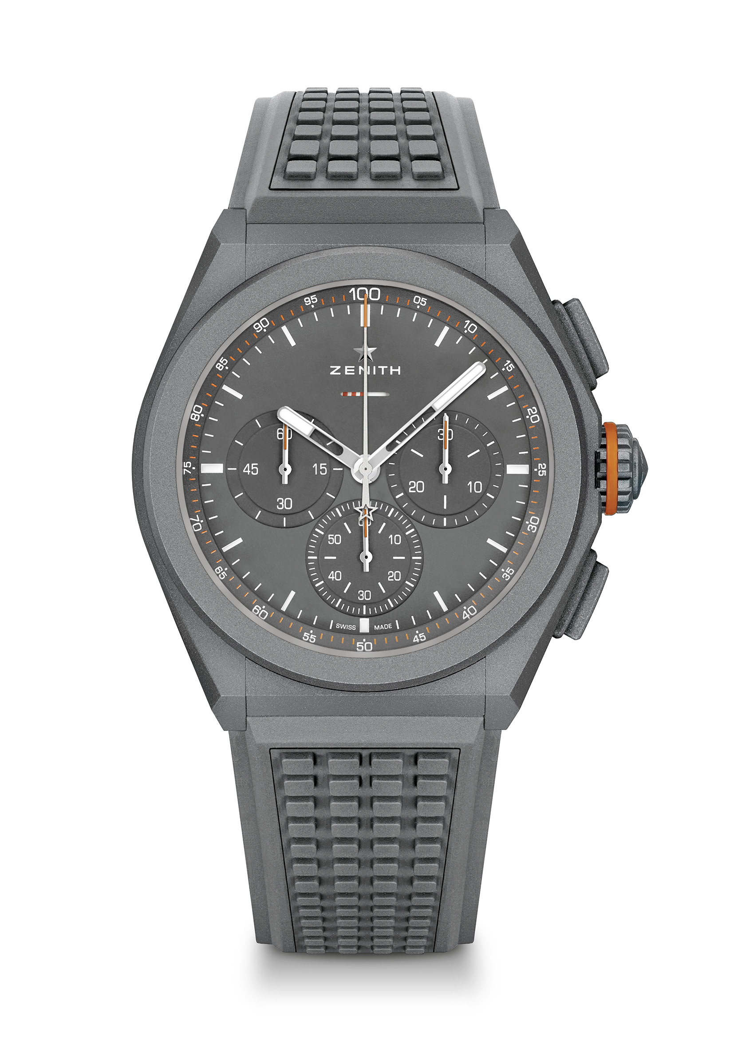
Key points: Tribute to the legendary Defender. 1/100th of a second chronograph movement. Exclusive dynamic signature of one rotation per second. 1 escapement for the Watch (36,000 VpH - 5 Hz); 1 escapement for the Chronograph (360,000 VpH - 50 Hz). Special linear power reserve indicator. TIME LAB Chronometer certified. Limited edition of 250 units
Movement: El Primero 9004 automatic
Frequency 36,000 VpH (5 Hz)
Power reserve approx. 50 hours
Functions : 1/100th of a second chronograph functions. Chronograph power-reserve indication at 12 o'clock. Hours and minutes in the centre. Small seconds at 9 o'clock, Central chronograph hand, 30-minute counter at 3 o'clock, 60-second counter at 6 o'clock
Price 13900 CHF
Material: Grey ceramic
Water resistance: 10 ATM
Dial: Special matt grey dial with special power reserve indicator
Hour markers: transferred and coated with Super-LumiNova®SLN C3
Hands Special anthracite hands, faceted and coated with Super-LumiNova®SLN C3
Bracelet & Buckle: Grey Rubber “Adventure”. Comes with an additional “Country” fabric effect strap. Microblasted titanium double folding buckle

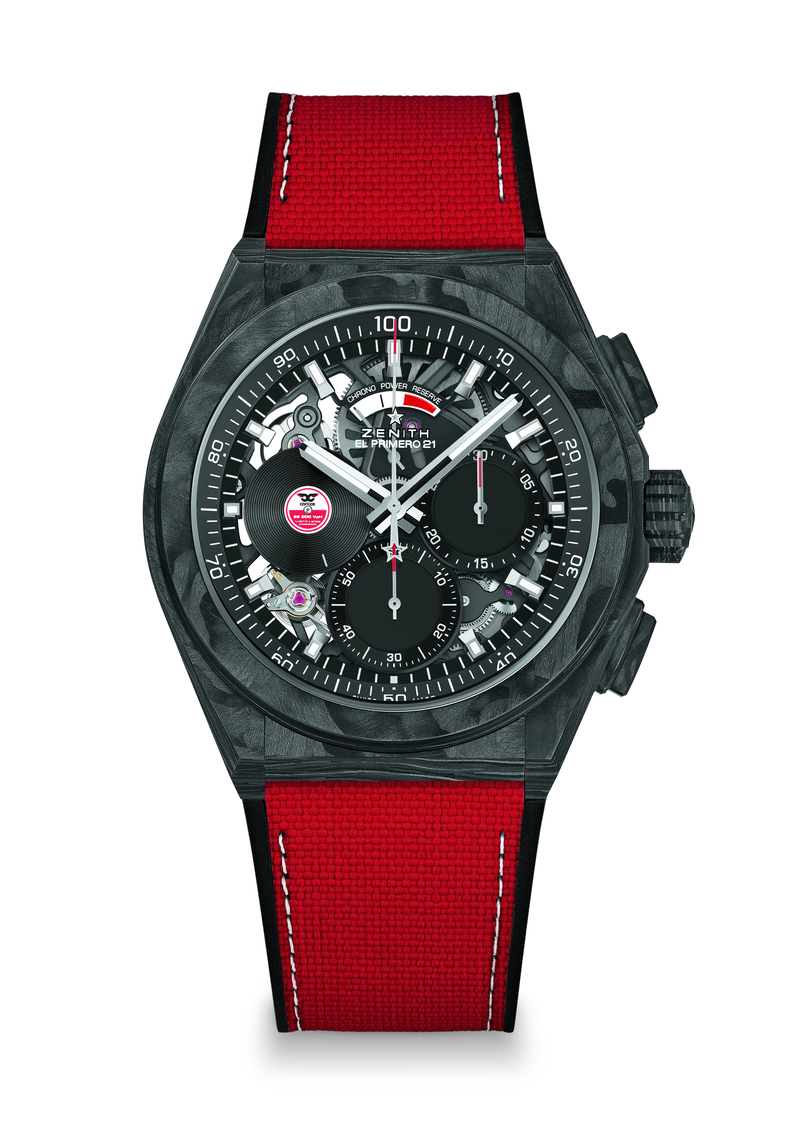
DEFY 21 CARL COX EDITION Reference: 10.9001.9004/99.R941

Key points: Full carbon model: case, pushers, crown and buckle head
Carbon bezel with SuperLuminova. 1/100th of a second chronograph movement. Exclusive dynamic signature of one rotation per second for the Chrono hand. 1 escapement for the Watch (36,000 VpH - 5 Hz);1 escapement for the Chronograph (360,000 VpH - 50 Hz). TIME LAB Chronometer certified. Limited edition of 200 units
Movement : El Primero 9004 automatic
Frequency 36,000 VpH (5 Hz)
Power reserve approx. 50 hours
Black colored main plate on movement
Functions: Hours and minutes in the centre. Special rotating small second disc at 9 o'clock. 1/100th of a second chronograph : Central chronograph hand – one turn per second, 30-minute counter at 3 o'clock, 60-second counter at 6 o'clock, Chronograph power-reserve indication at 12 o'clock
Price 19500 CHF
Material: Black carbon
Water resistance: 10 ATM
Dial: Matt black
Hour markers: Black ruthenium-plated, faceted and coated with Super-LumiNova Black SLN
Hands: Rhodium-plated, faceted and coated with Super-LumiNova Black SLN
Bracelet & Buckle: Black Rubber with red “Cordura effect” & Super-LumiNova stitchings. Titanium double folding buckle with black carbon head.
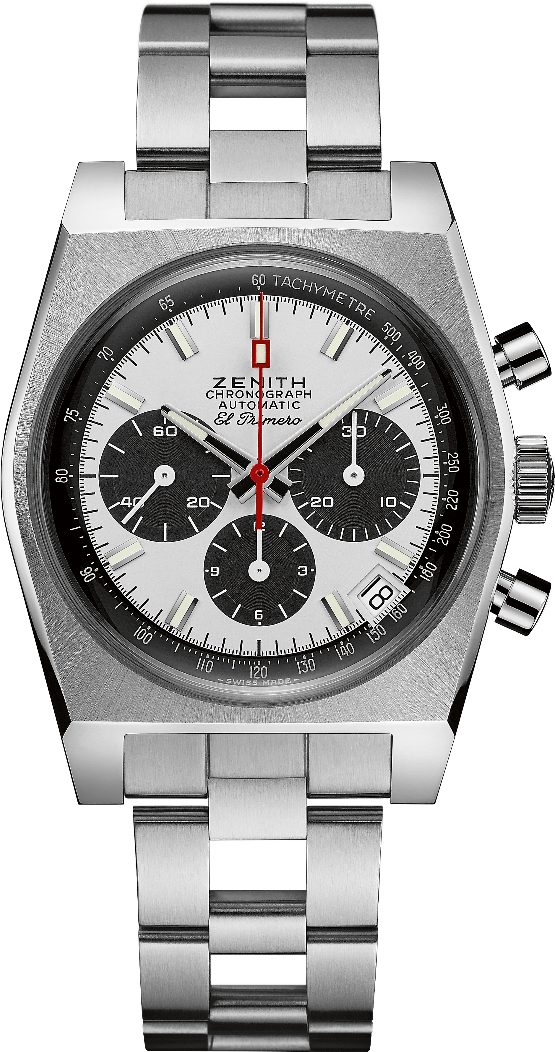
EL PRIMERO A384 REVIVAL Reference: 03.A384.400/21.M384

Key points: Revival of the 1969 Reference A384. Original case with 37 mm diameter
Automatic El Primero column-wheel chronograph. Original Revival of the “Gay Frères” ladder bracelet
Movement: El Primero 400 Automatic
Frequency: 36,000 VpH (5 Hz)
Power-reserve.: min. 50 hours
Functions: Hours and minutes in the centre. Small seconds at 9 o'clock
Chronograph: Central chronograph hand, 12-hour counter at 6 o'clock, 30-minute counter at 3 o'clock. Tachymetric scale. Date indication at 4:30
Price 8400 CHF
Material: Stainless steel
Water-resistance: 5 ATM
Dial: White-lacquered dial with black-coloured counters
Hour-markers: Rhodium-plated, faceted and coated with Super-LumiNova®SLN C3
Hands: Rhodium-plated, faceted and coated with Super-LumiNova®SLN C3
Bracelet & Buckle: “Ladder” bracelet with double folding clasp

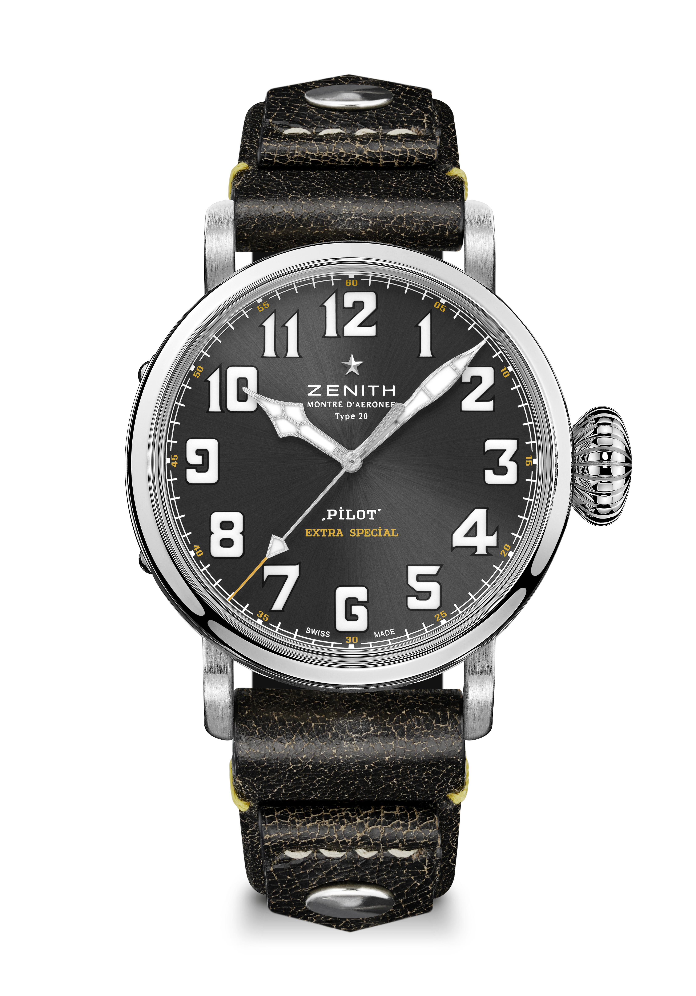
PILOT TYPE 20 RESCUE Reference: 03.2434.679/20.I010

Key points: New 45-MM Brushed steel case. Case-back engraved with Zenith flying instruments logo. Inspired by the legendary Zenith aviation watches. Arabic numerals entirely made of SuperLuminova
Movement: Elite 679 automatic
Frequency: 28,800 VpH (4Hz)
Power-reserve: min. 50 hours
Functions Hours and minutes in the centre. Central second hand
Price 7400 CHF
Case-back: Stainless steel case-back engraved with the Zenith flying instruments logo
Material: Stainless steel
Water-resistance: 10 ATM
Dial: Slate-grey-toned sunray-patterned
Hour-markers: Arabic numerals in Super-LumiNova SLN C1
Hands: Rhodium-plated, faceted and coated with Super-LumiNova SLN C1
Bracelet & Buckle: Black vintage calfskin leather strap with rivets. Titanium pin buckle.

PILOT TYPE 20 RESCUE CHRONOGRAPH Reference: 03.2434.4069/20.I010

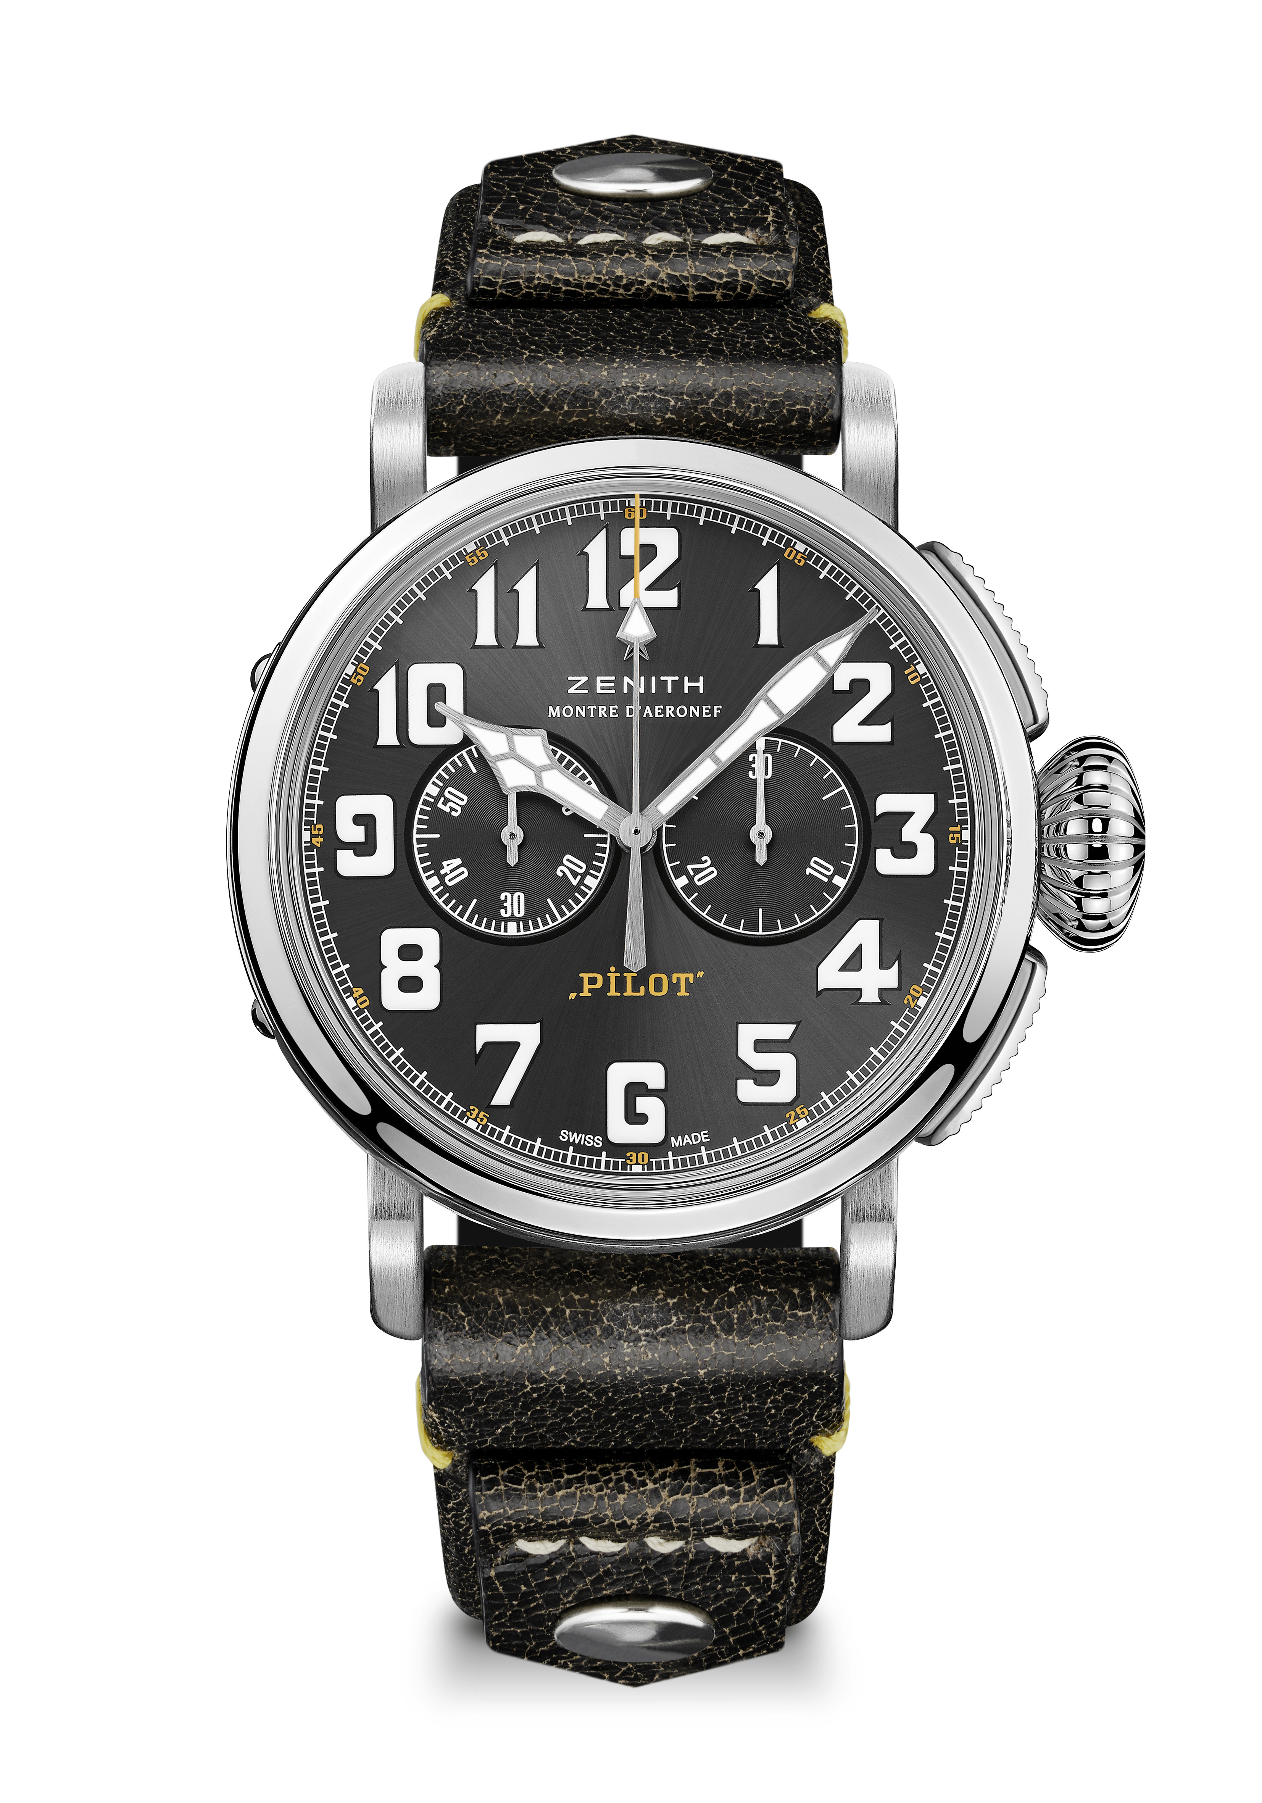
Key points: New 45-MM Brushed steel case, Automatic El Primero column-wheel chronograph, Case-back engraved with Zenith flying instruments logo, Inspired by the legendary Zenith aviation watches, Arabic numerals entirely made of Super-LumiNova
Movement: Movement El Primero 4069, Automatic
Frequency: 36,000 VpH (5Hz)
Power-reserve: min. 50 hours
Functions: Hours and minutes in the centre. Small seconds at 9 o'clock.: Chronograph: Central chronograph hand, 30-minute counter at 3 o'clock
Price 7900 CHF
Case-back: Stainless steel case-back engraved with the Zenith flying instruments logo
Material: Stainless steel
Water-resistance: 10 ATM
Dial: Slate-grey-toned sunray-patterned
Hour-markers: Arabic numerals in Super-LumiNova SLN®C1
Hands: Rhodium-plated, faceted and coated with SuperLuminova SLN®C1
Bracelet & Buckle: Black vintage calfskin leather strap with rivets. Titanium pin buckle.
DEFY MIDNIGHT Reference: 03.9200.67/02.MI001
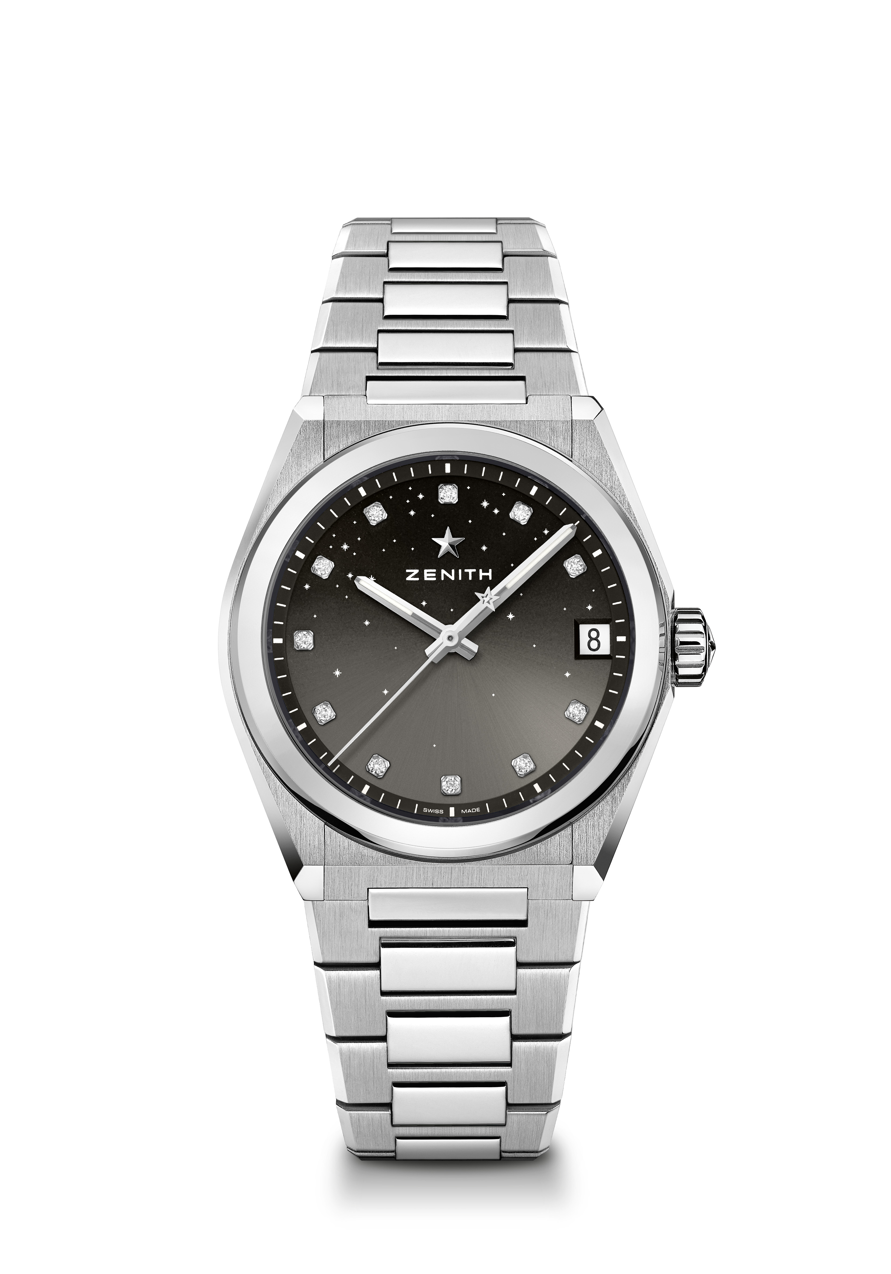
Key points: New 36-MM case dedicated for Women. Gradient dial with starry sky pattern. New Interchangeable strap system. Strap box included : 3 different colors straps + a interchangeable folding buckle
Movement: Elite 670 SK, Automatic
Frequency: 28,800 VpH (4Hz)
Power-reserve: min. 48 hours
Finishing: New star-shaped oscillating weight with satined finishings
Functions: Hours and minutes in the centre. Central seconds hand. Date indication at 3 o’clock
Price 8900 CHF
Material: Stainless steel
Water-resistance: 10 ATM
Dial: Gradient grey
Gemsetting: Carats 0.1 cts, Dial 11 VS brilliant-cut diamonds
Hour-markers: Diamond hour-markers
Hands: Rhodium-plated and faceted, coated with Super-Luminova SLN
Bracelet & Buckle: Stainless steel with interchangeable strap system. Comes with 3 different colored straps.

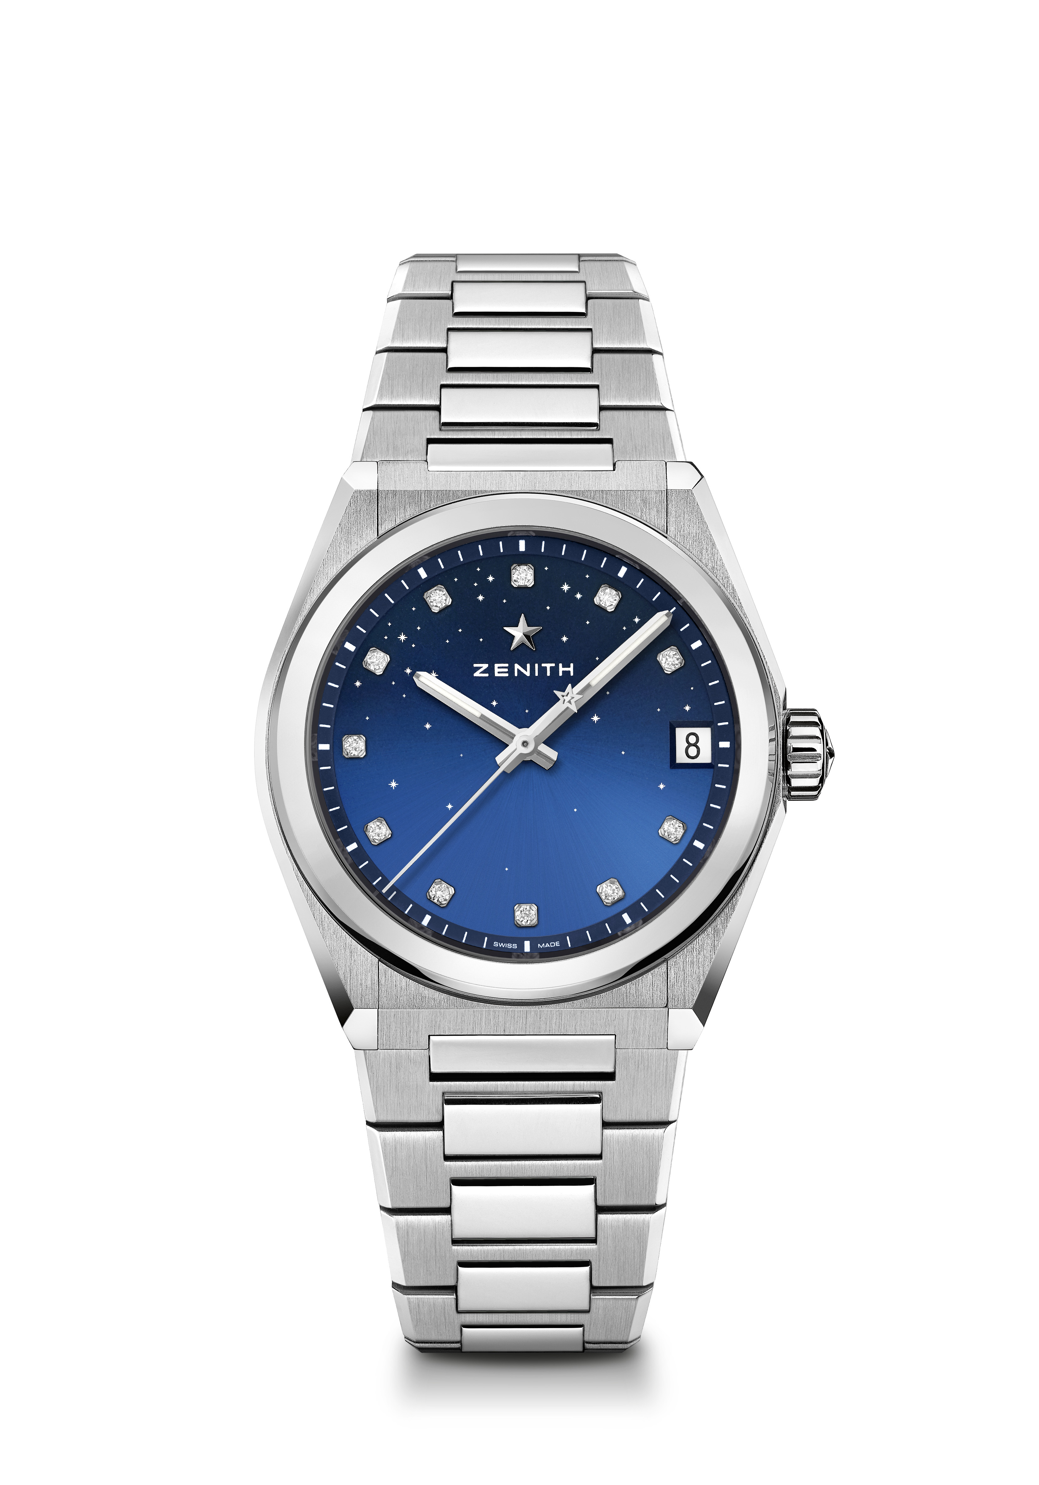
DEFY MIDNIGHT Reference: 03.9200.670/01.MI001
Key points: New 36-MM case dedicated for Women. Gradient dial with starry sky pattern. New Interchangeable strap system. Strap box included : 3 different colors straps + an interchangeable folding buckle
Movement: Elite 670 SK, Automatic
Frequency: 28,800 VpH (4Hz)
Power-reserve: min. 48 hours
Functions: Hours and minutes in the centre. Central seconds hand. Date indication at 3 o’clock
Price 8900 CHF
Gemsetting: Carats 0.1 cts, Dial 11 VS brilliant-cut diamonds
Material: Stainless steel
Water-resistance: 10 ATM
Dial: Gradient blue
Gemsetting: Carats 0.1 cts, Dial 11 VS brilliant-cut diamonds
Hour-markers: Diamond hour-markers
Hands: Rhodium-plated and faceted, coated with Super-Luminova SLN
Bracelet & Buckle: Stainless steel with interchangeable strap system. Comes with 3 different colored straps.
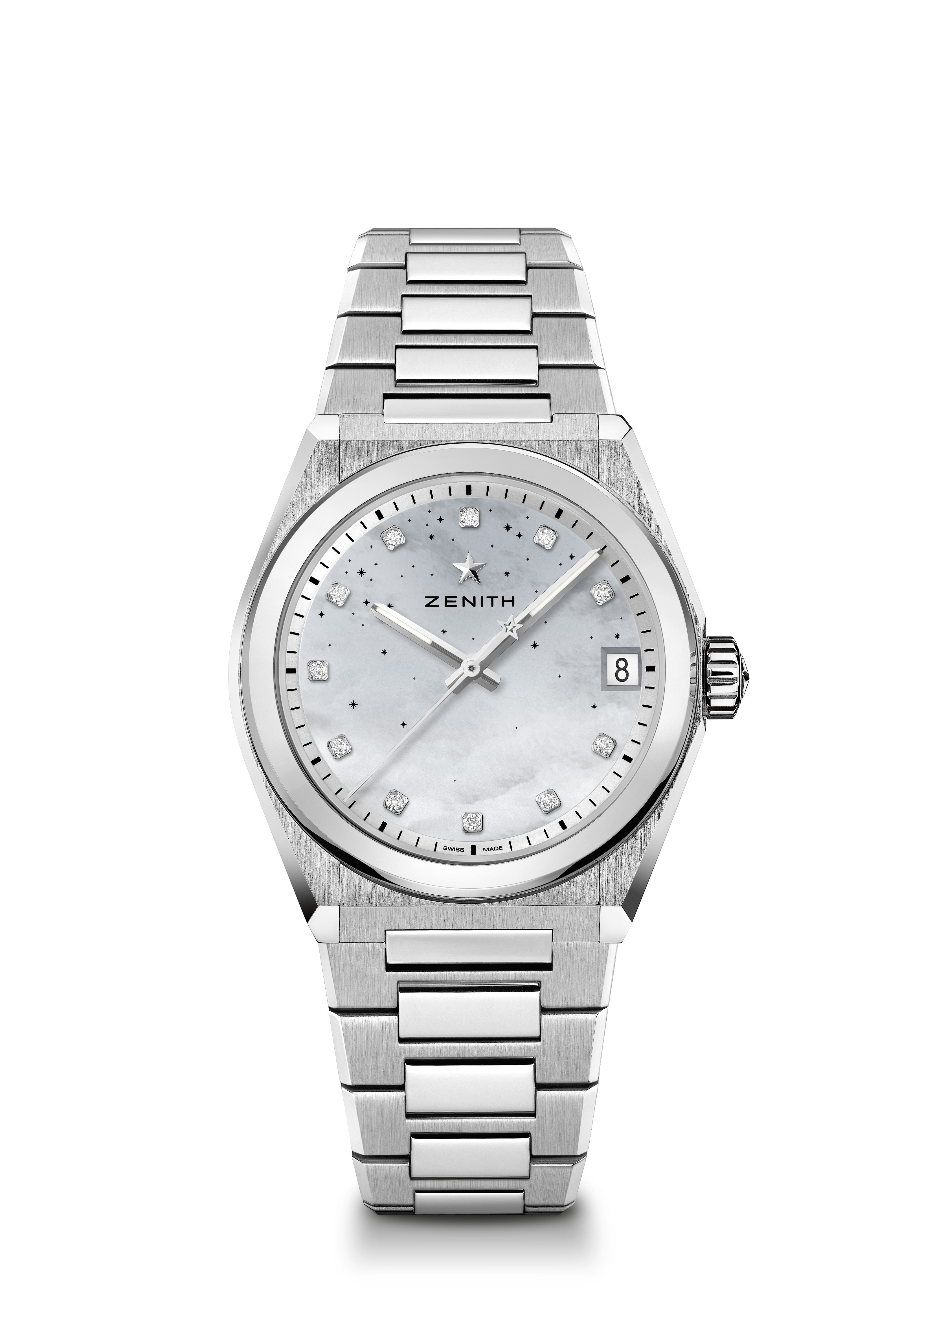
DEFY MIDNIGHT Reference: 03.9200.670/03.MI001

Key points: New 36-MM case dedicated for Women. Gradient dial with starry sky pattern. New Interchangeable strap system. Strap box included : 3 different colors straps + an interchangeable folding buckle
Movement: Elite 670 SK, Automatic
Frequency: 28,800 VpH (4Hz)
Power-reserve: min. 48 hours
Functions: Hours and minutes in the centre. Central seconds hand. Date indication at 3 o’clock
Price 8900 CHF
Material: Stainless steel
Water-resistance: 10 ATM
Dial: Gradient mother of pearl
Gemsetting: Carats 0.1 cts, Dial 11 VS brilliant-cut diamonds
Hour-markers: Diamond hour-markers
Hands: Rhodium-plated and faceted gold, coated with Super-Luminova SLN
Bracelet & Buckle: Stainless steel with interchangeable strap system. Comes with 3 different colored straps.

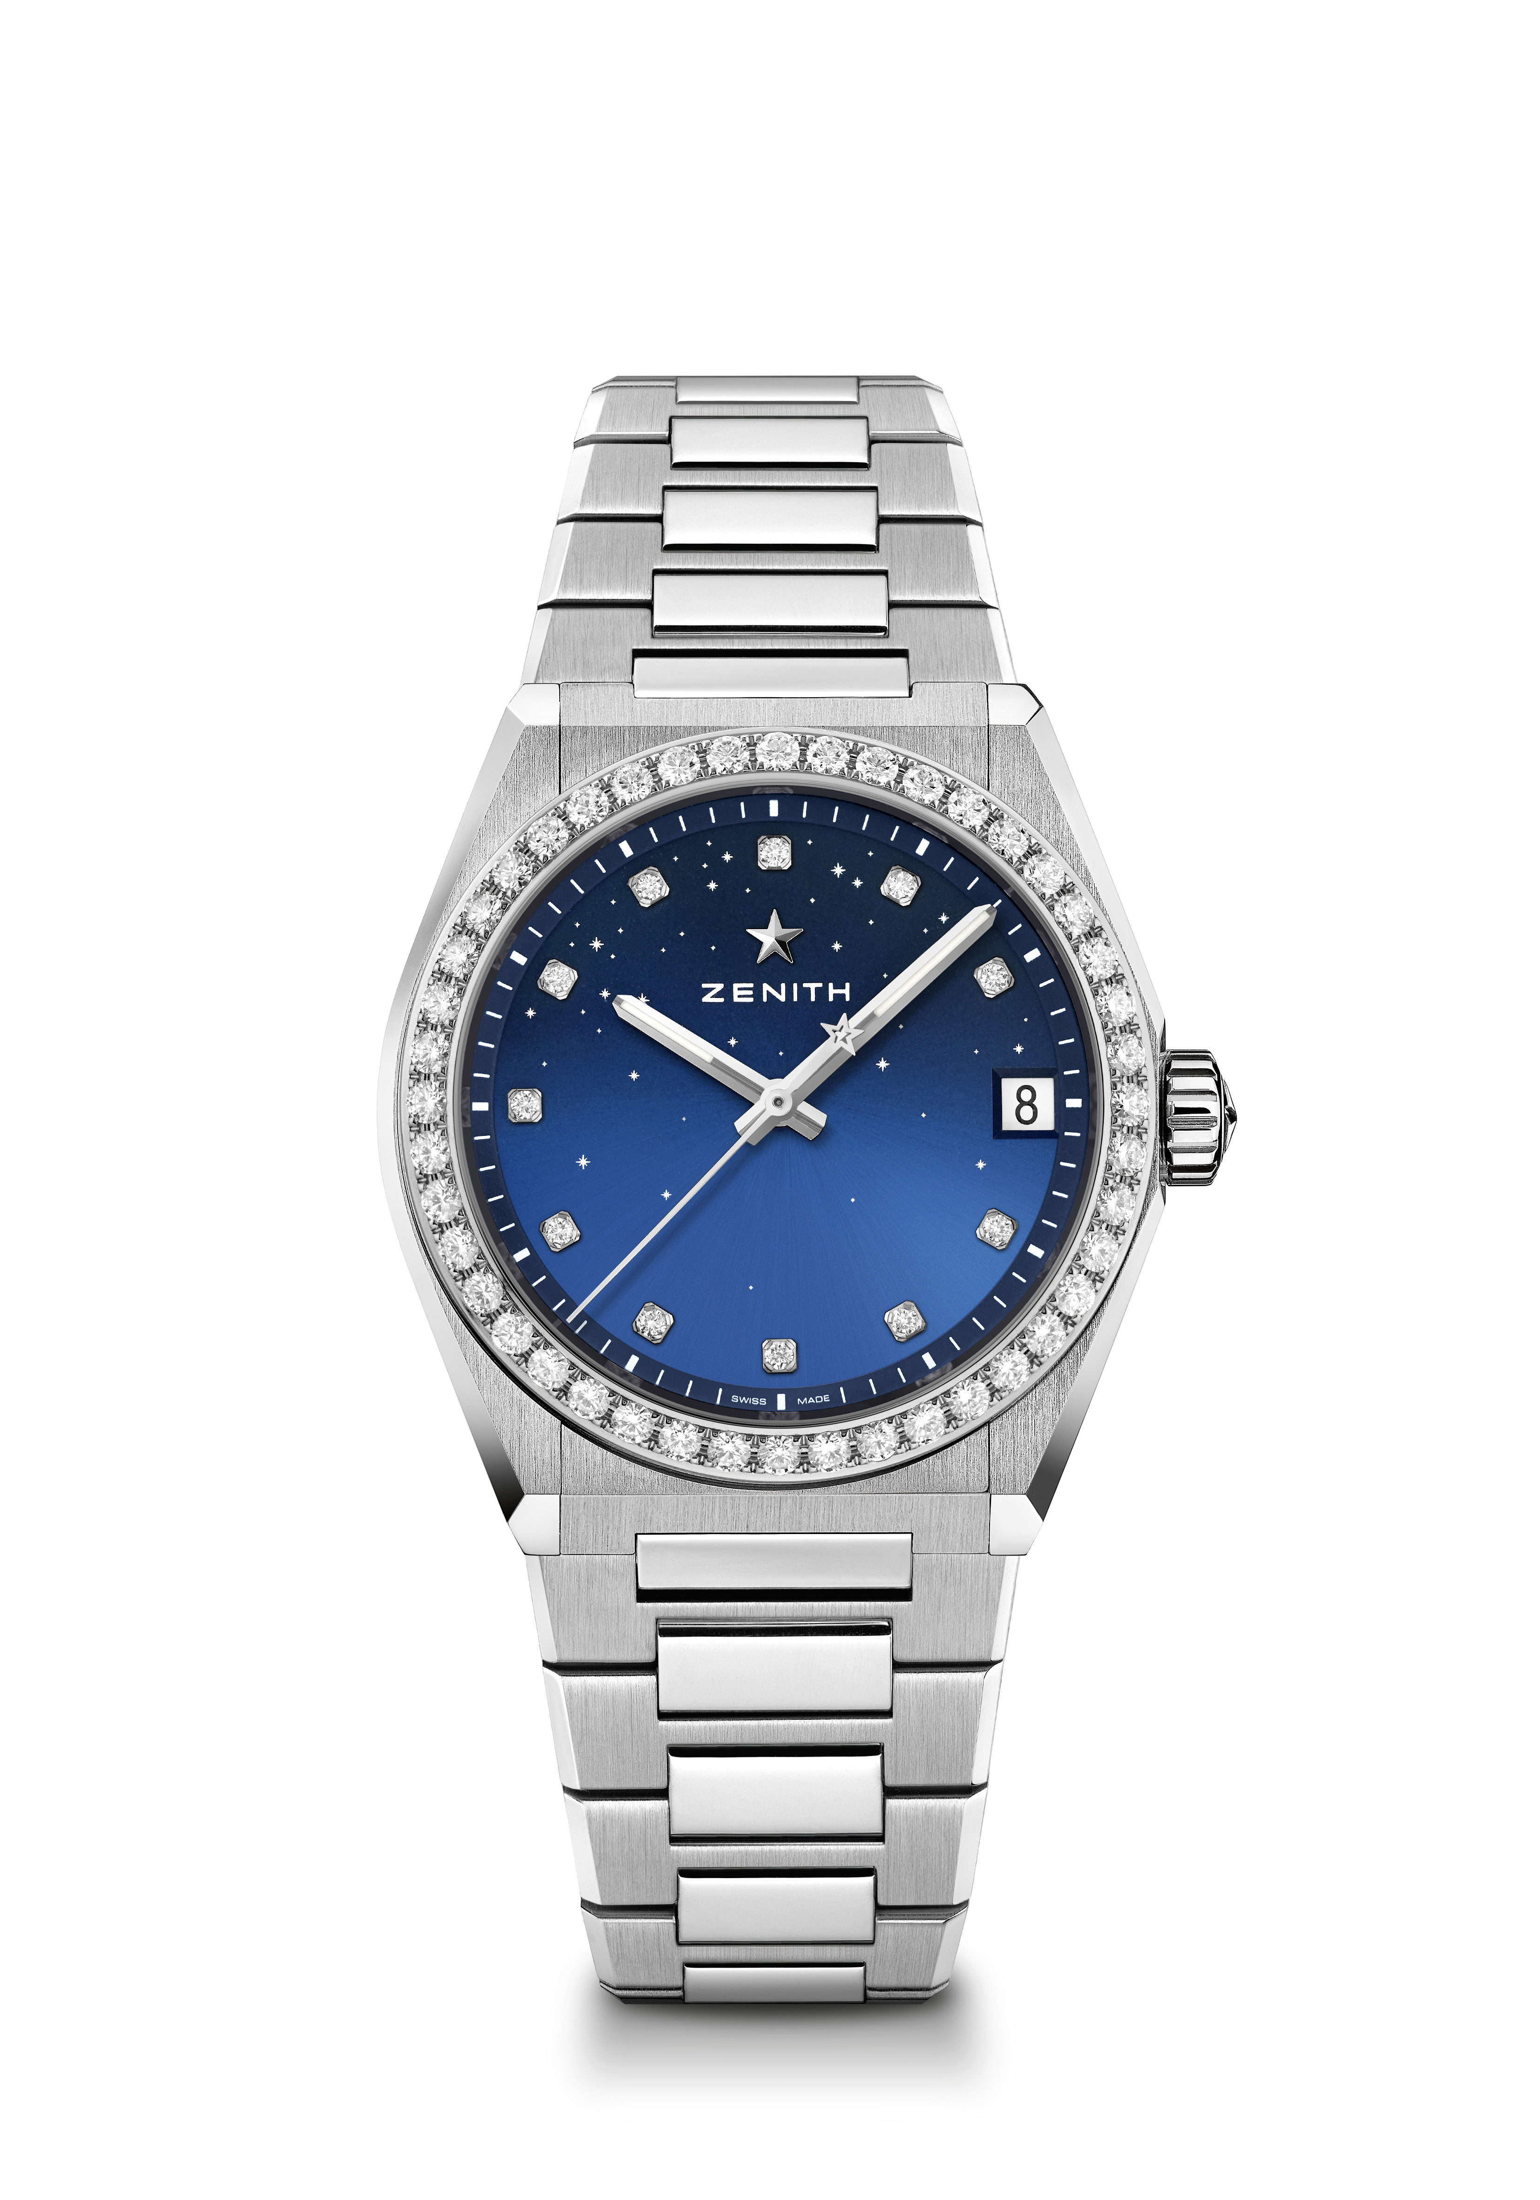
DEFY MIDNIGHT Reference: 16.9200.670/01.MI001
Key points: New 36-MM case dedicated for Women. Gradient dial with starry sky pattern. New. Interchangeable strap system. Strap box included : 3 different colors straps + an interchangeable folding buckle
Movement: Elite 670 SK, Automatic
Frequency: 28,800 VpH (4Hz)
Power-reserve: min. 48 hours
Functions: Hours and minutes in the centre. Central seconds hand. Date indication at 3 o’clock
Price 10900 CHF
Gemsetting: Carats 1.48 cts, Bezel 44 VS brilliant-cut diamonds, Dial 11 VS brilliant-cut diamonds

Material: Stainless steel with diamond-set bezel
Water-resistance: 10 ATM
Dial: Gradient blue
Hour-markers: Diamond hour-markers
Hands: Rhodium-plated and faceted, coated with Super-Luminova SLN
Bracelet & Buckle: Stainless steel with interchangeable strap system. Comes with 3 different colored straps.
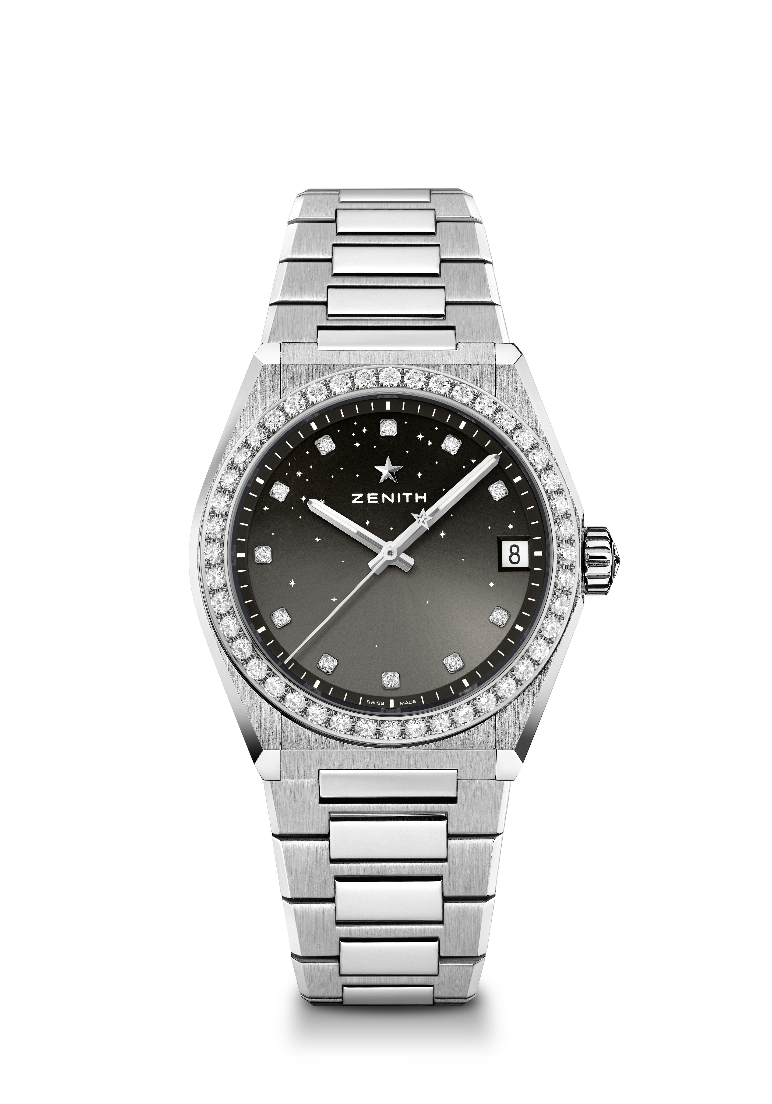
DEFY MIDNIGHT Reference: 16.9200.670/02.MI001
Key points: New 36-MM case dedicated for Women. Gradient dial with starry sky pattern. New Interchangeable strap system. Strap box included : 3 different colors straps + an interchangeable folding buckle
Movement: Elite 670 SK, Automatic
Frequency: 28,800 VpH (4Hz)
Power-reserve: min. 48 hours
Functions: Hours and minutes in the centre, Central seconds hand, Date indication at 3 o’clock
Price 10900 CHF
Gemsetting: Carats 1.48 cts, Bezel 44 VS brilliant-cut diamonds, Dial 11 VS brilliant-cut diamonds
Material: Stainless steel with diamond-set bezel
Water-resistance: 10 ATM
Dial: Gradient grey
Hour-markers: Diamond hour-markers. Comes with 3 different colored straps.
Hands: Rhodium-plated and faceted, coated with Super-Luminova SLN
Bracelet & Buckle: Stainless steel with interchangeable strap system. Comes with 3 different colored straps.

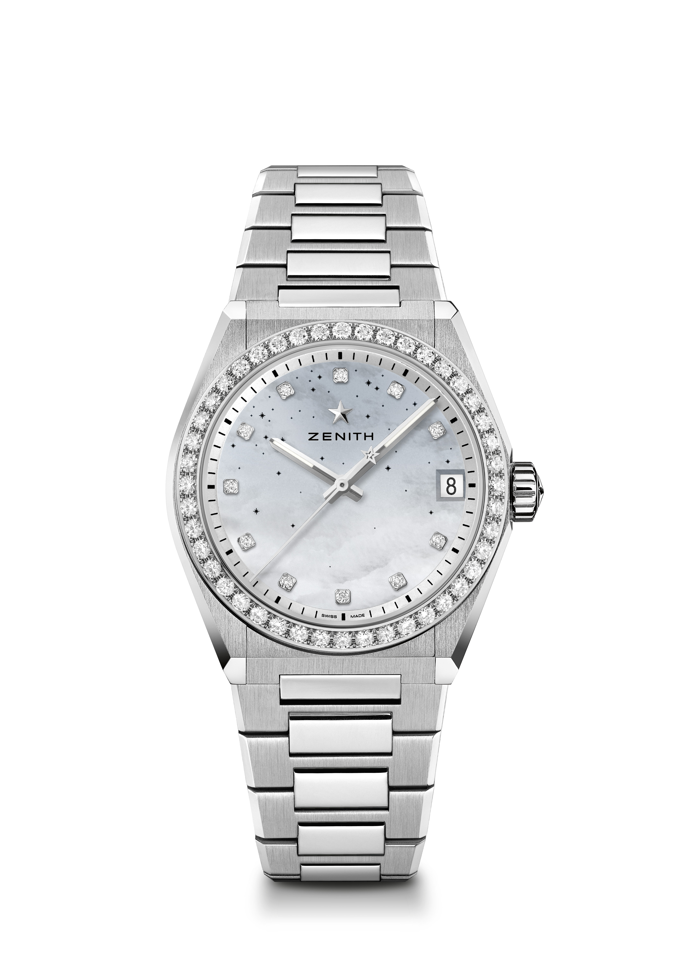
DEFY MIDNIGHT Reference: 16.9200.670/03.MI001
Key points: New 36-MM case dedicated for Women. Gradient dial with starry sky pattern. New Interchangeable strap system. Strap box included : 3 different colors straps + an interchangeable folding buckle
Movement: Elite 670 SK, Automatic
Frequency: 28,800 VpH (4Hz)
Power-reserve: min. 48 hours
Functions: Hours and minutes in the centre. Central seconds hand. Date indication at 3 o’clock
Price 10900 CHF
Gemsetting: Carats 1.48 cts, Bezel 44 VS brilliant-cut diamonds, Dial 11 VS brilliant-cut diamonds
Material: Stainless steel with diamond-set bezel
Water-resistance: 10 ATM
Dial: Gradient mother of pearl
Hour-markers: Diamond hour-markers
Hands: Rhodium-plated and faceted, coated with Super-Luminova SLN
Bracelet & Buckle: Stainless steel with interchangeable strap system. Comes with 3 different colored straps.
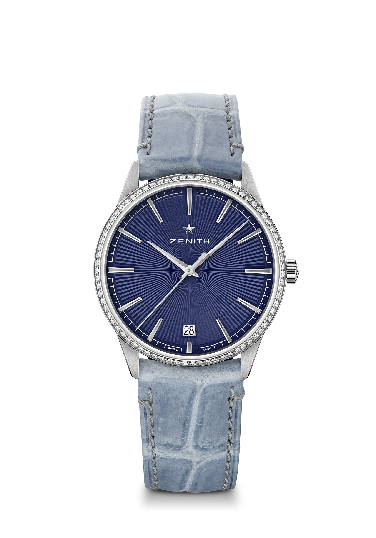
ELITE CLASSIC - 36MM Reference: 16.3200.670/02.C832

Key points: Entirely restyled case & dial : Redefine the codes of Elegance. Automatic Elite calibre beating at 28,800 VpH. Date indication at 6 o'clock. Stop second mechanism
Movement: Elite 670 SK, Automatic
Frequency: 28,800 VpH (4Hz)
Power-reserve: min. 48 hours
Functions: Hours and minutes in the centre. Central seconds hand. Date indication at 6 o’clock
Price 7900 CHF
Gemsetting: Carats 0.60 cts, Bezel 75 VS brilliant-cut diamonds
Material: Stainless steel with diamond-set bezel
Water-resistance: 5 ATM
Dial: Blue-toned sunray-patterned
Hour-markers: Rhodium-plated and faceted
Hands: Rhodium-plated and faceted
Bracelet & Buckle: Blue jean alligator leather with protective rubber lining. Stainless steel pin buckle

ELITE CLASSIC - 36MM Reference: 22.3200.670/01.C831
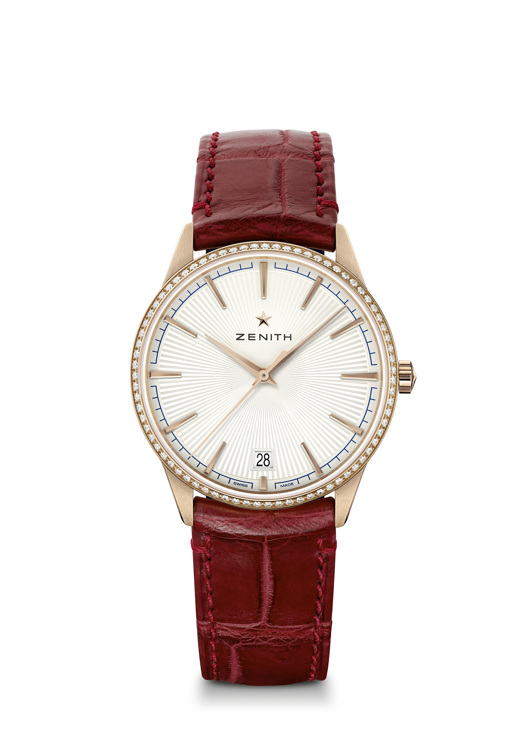
Key points: Entirely restyled case & dial : Redefine the codes of Elegance. Automatic Elite calibre beating at 28,800 VpH. Date indication at 6 o'clock. Stop second mechanism
Movement: Elite 670 SK, Automatic
Frequency: 28,800 VpH (4Hz)
Power-reserve: min. 48 hours
Functions: Hours and minutes in the centre. Central seconds hand. Date indication at 6 o’clock
Price 14900 CHF
Gemsetting: Carats 0.60 cts, Bezel 75 VS brilliant-cut diamonds
Material: 18-ct rose gold with diamond-set bezel
Water-resistance: 5 ATM
Dial: Silver-toned sunray-patterned
Hour-markers: Gold-plated and faceted
Hands: Gold-plated and faceted
Bracelet & Buckle: Burgundy alligator leather with protective rubber lining. Rose gold pin buckle
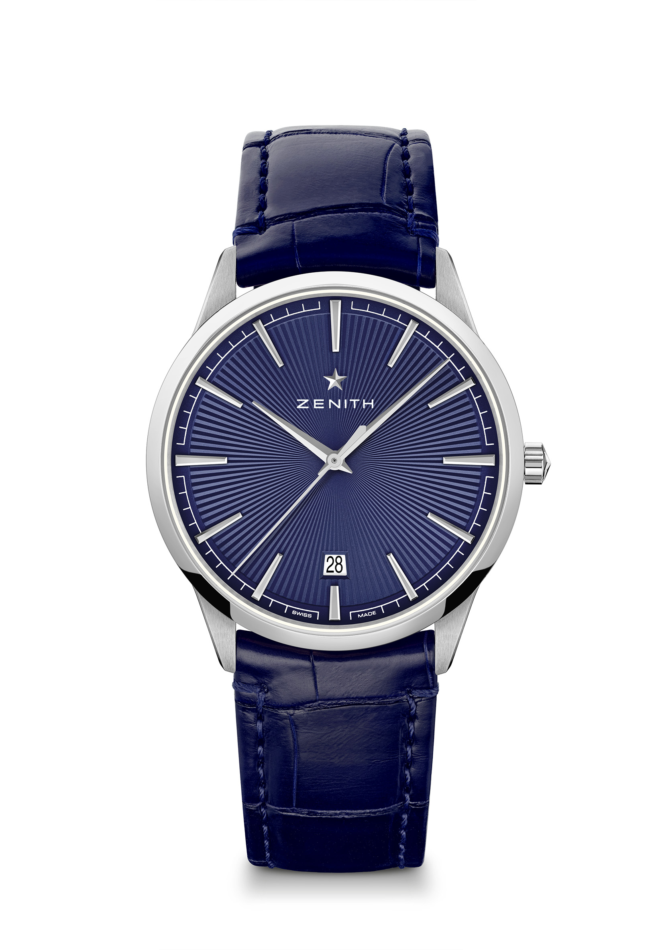
ELITE CLASSIC – 40.5MM Reference: 03.3100.670/02.C922

Key points: Entirely restyled case & dial : Redefine the codes of Elegance. Automatic Elite calibre beating at 28,800 VpH. Date indication at 6 o'clock. Stop second mechanism
Movement Elite 670 SK, Automatic
Frequency: 28,800 VpH (4Hz)
Power-reserve: min. 48 hours
Functions: Hours and minutes in the centre. Central seconds hand. Date indication at 6 o’clock
Price 5900 CHF
Material: Stainless steel
Water-resistance: 5 ATM
Dial: Blue-toned sunray-patterned
Hour-markers: Rhodium-plated and faceted
Hands: Rhodium-plated and faceted
Bracelet & Buckle: Blue alligator leather with protective rubber lining. Steel double folding clasp

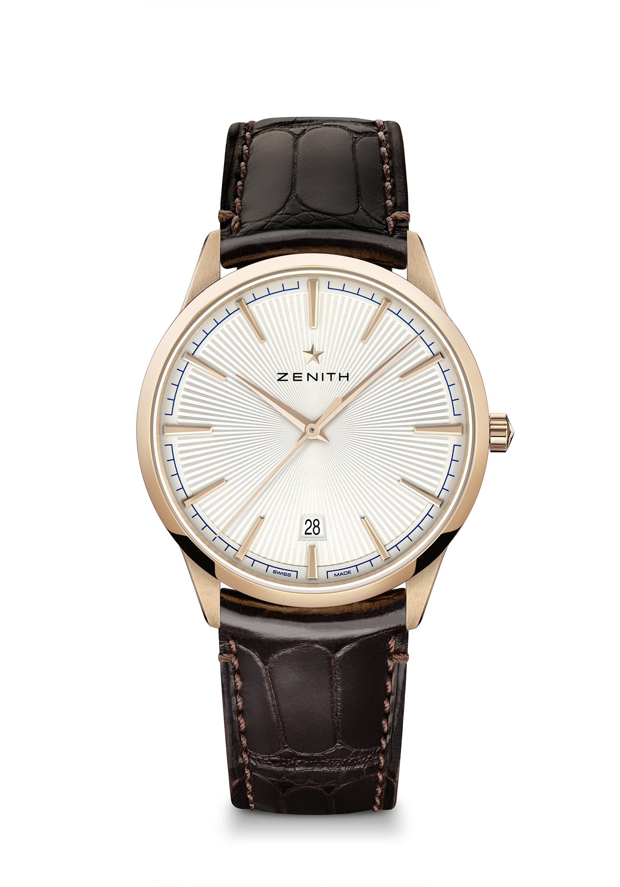
ELITE CLASSIC – 40.5MM Reference: 18.3100.670/01.C920
Key points: Entirely restyled case & dial : Redefine the codes of Elegance. Automatic Elite calibre beating at 28,800 VpH. Date indication at 6 o'clock. Stop second mechanism
Movement: Elite 670 SK, Automatic
Frequency: 28,800 VpH (4Hz)
Power-reserve: min. 48 hours
Functions: Hours and minutes in the centre. Central seconds hand. Date indication at 6 o’clock
Price 12900 CHF
Material: 18-ct Rose gold
Water-resistance: 5 ATM
Dial: Silver-toned sunray-patterned
Hour-markers: Gold-plated and faceted
Hands: Gold-plated and faceted
Bracelet & Buckle: Brown alligator leather with protective rubber lining. Rose gold pin buckle.

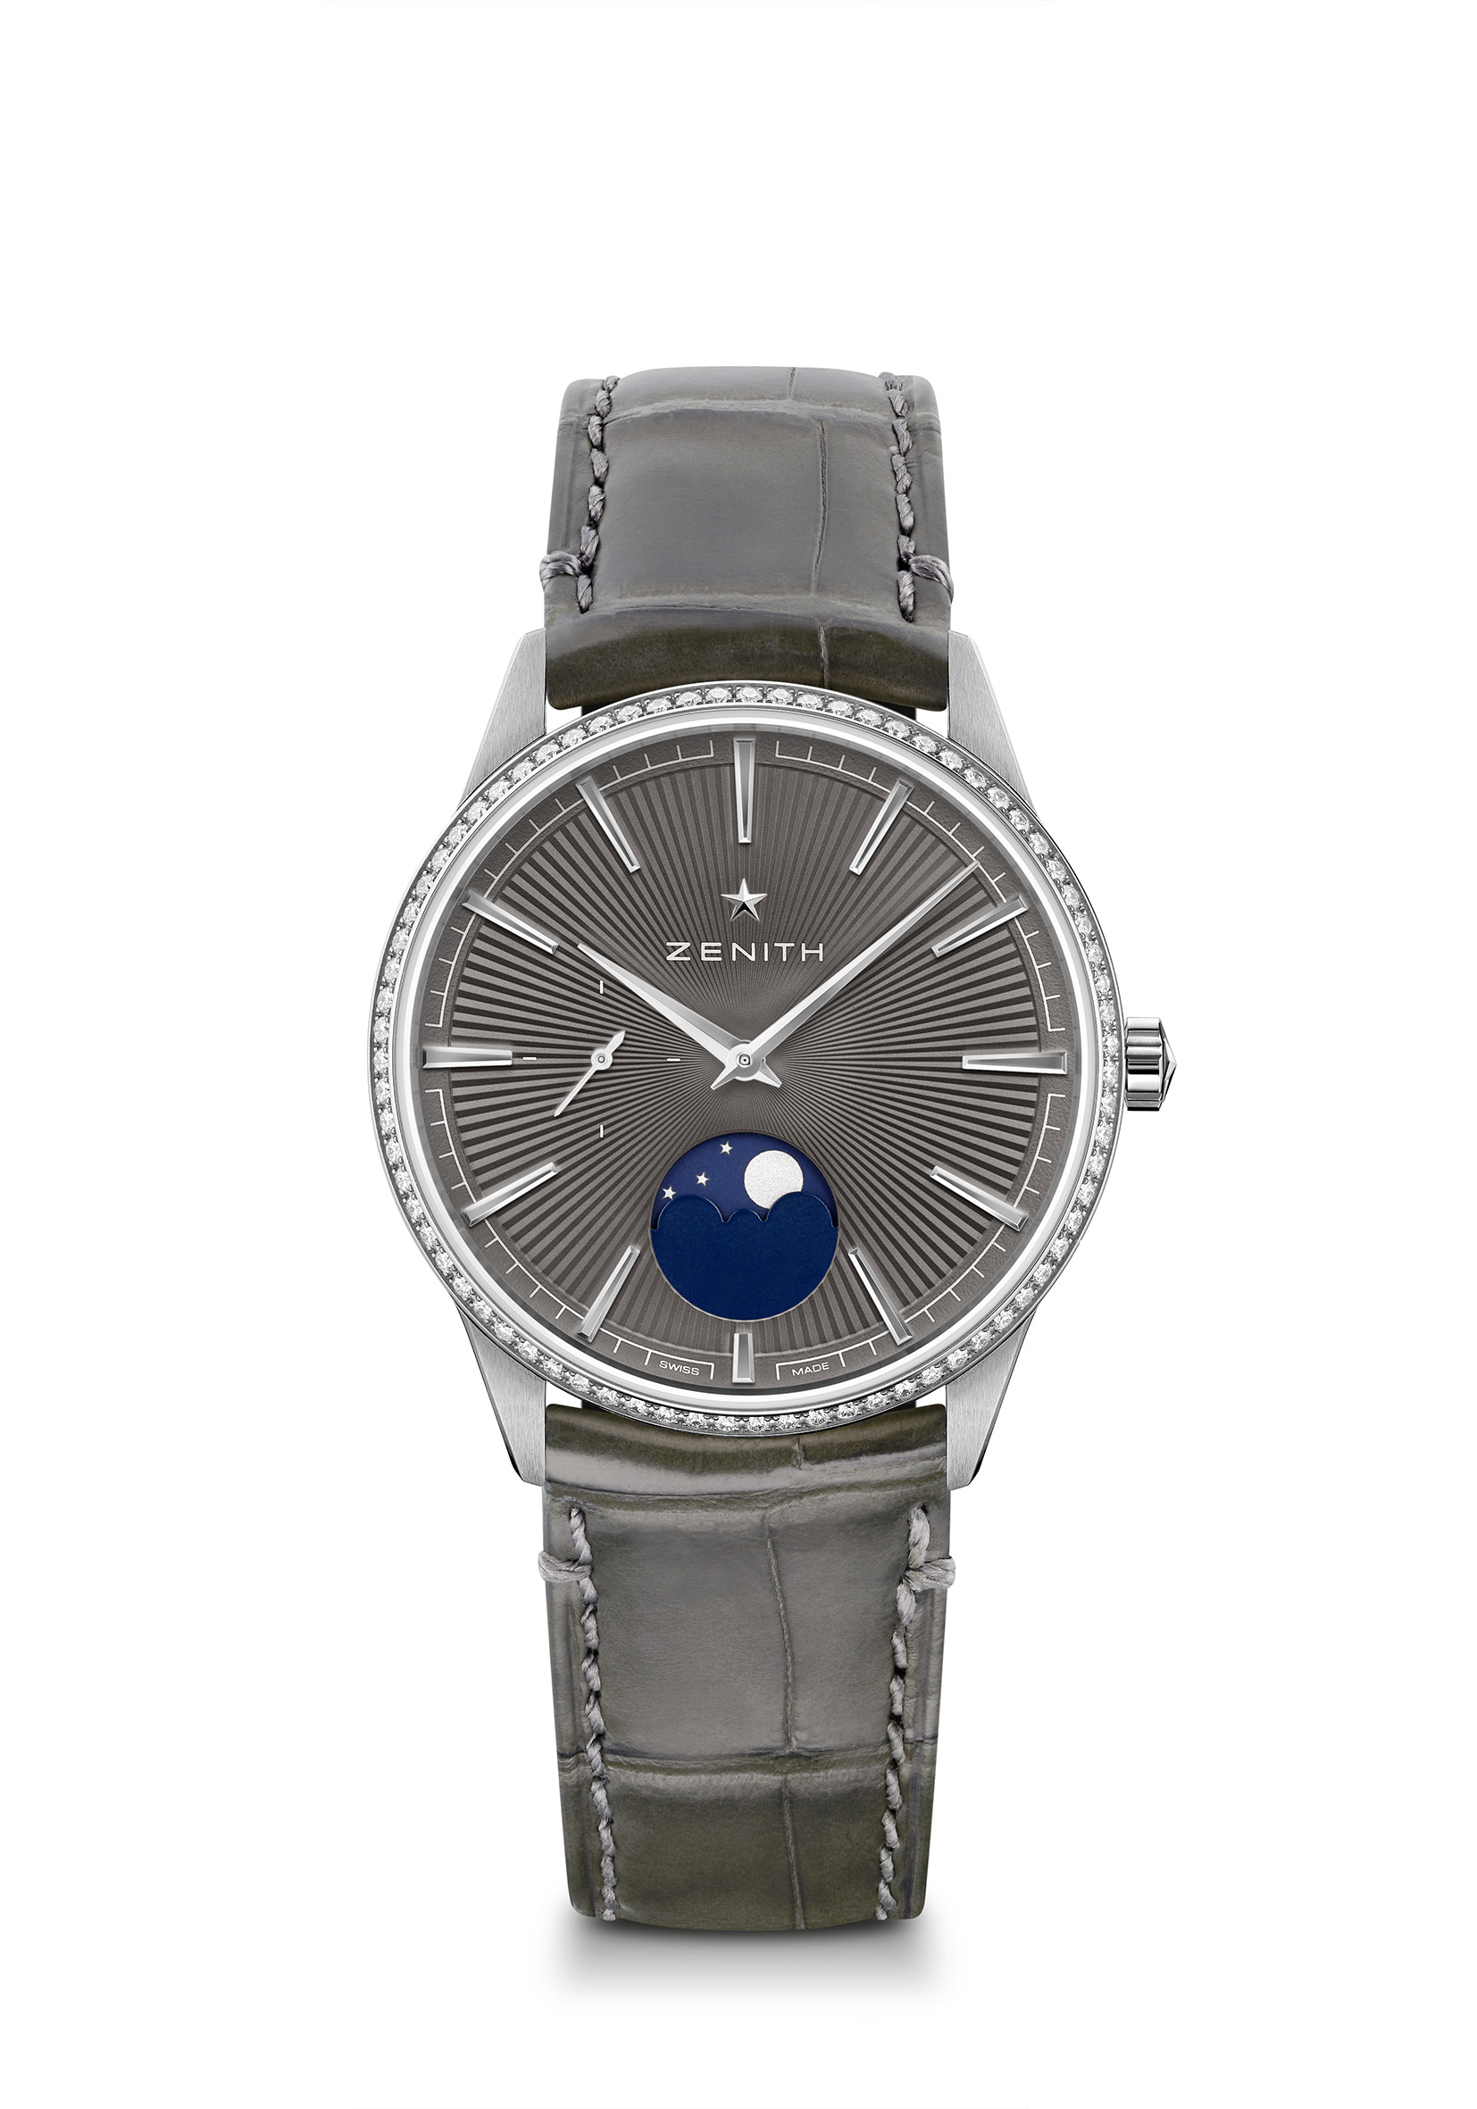
ELITE MOONPHASE - 36MM Reference: 16.3200.692/03.C833
Key points: Entirely restyled case & dial : Redefine the codes of Elegance. Elite Calibre 692: ultra-thin movement powering a moonphase indication. Crown-adjusted moonphase indication. Stop second mechanism
Movement: Elite 692
Frequency: 28,800 VpH (4Hz)
Power-reserve: min. 48 hours
Functions: Hours and minutes in the centre. Small second at 9 o’clock.
Moonphase indication at 6 o’clock
Price: 8900 CHF
Gemsetting: Carats 0.60 cts, Bezel 75 VS brilliant-cut diamonds
Material: Stainless steel with diamond-set bezel
Water-resistance: 5 ATM
Dial: Slate-grey-toned sunray-patterned
Hour-markers: Rhodium-plated and faceted
Hands: Rhodium-plated and faceted
Bracelet & Buckle: Grey alligator leather with protective rubber lining. Stainless steel pin buckle

ELITE MOONPHASE - 36MM Reference: 22.3200.692/01.C832

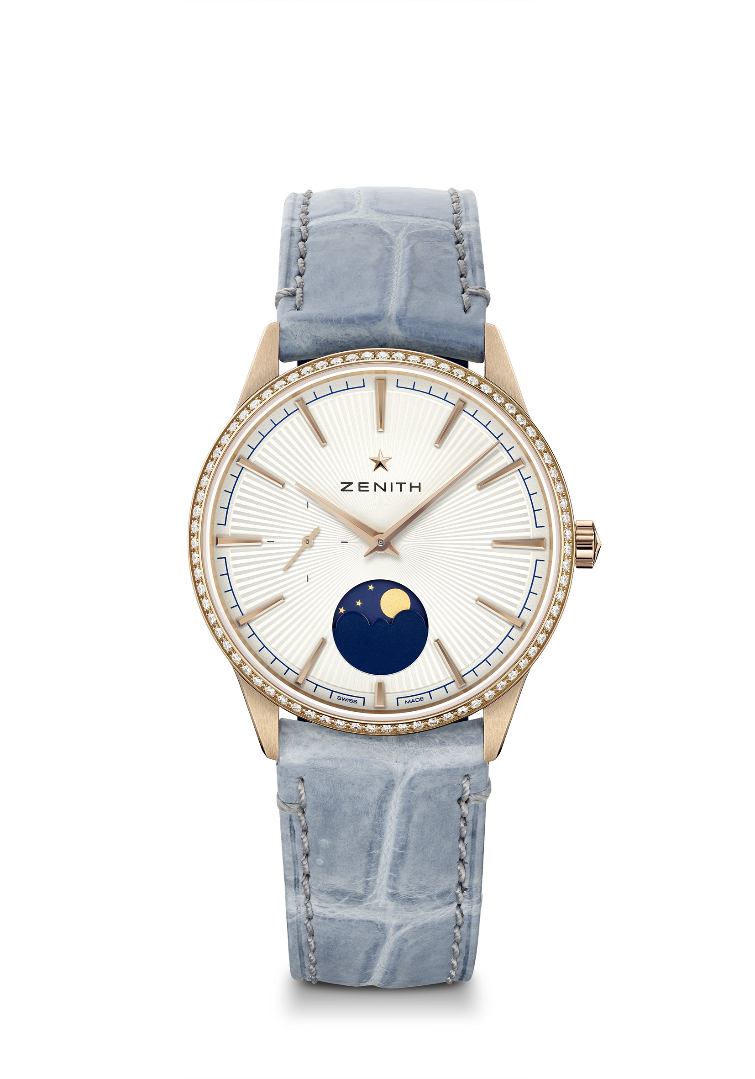
Key points : Entirely restyled case & dial : Redefine the codes of Elegance. Elite Calibre 692: ultra-thin movement powering a moonphase indication. Crown-adjusted moonphase indication. Stop second mechanism
Movement: Elite 692
Frequency: 28,800 VpH (4Hz)
Power-reserve: min. 48 hours
Functions: Hours and minutes in the centre. Small second at 9 o’clock.
Moonphase indication at 6 o’clock
Price 15900 CHF
Gemsetting: Carats 0.60 cts, Bezel 75 VS brilliant-cut diamonds
Material: Rose gold with diamond-set bezel
Water-resistance: 5 ATM
Dial: Silver-toned sunray-patterned
Hour-markers: Gold-plated and faceted
Hands: Gold-plated and faceted
Bracelet & Buckle: Blue jean alligator leather with protective rubber lining. Rose gold pin buckle
ELITE MOONPHASE – 40.5MM Reference: 18.3100.692/01.C922
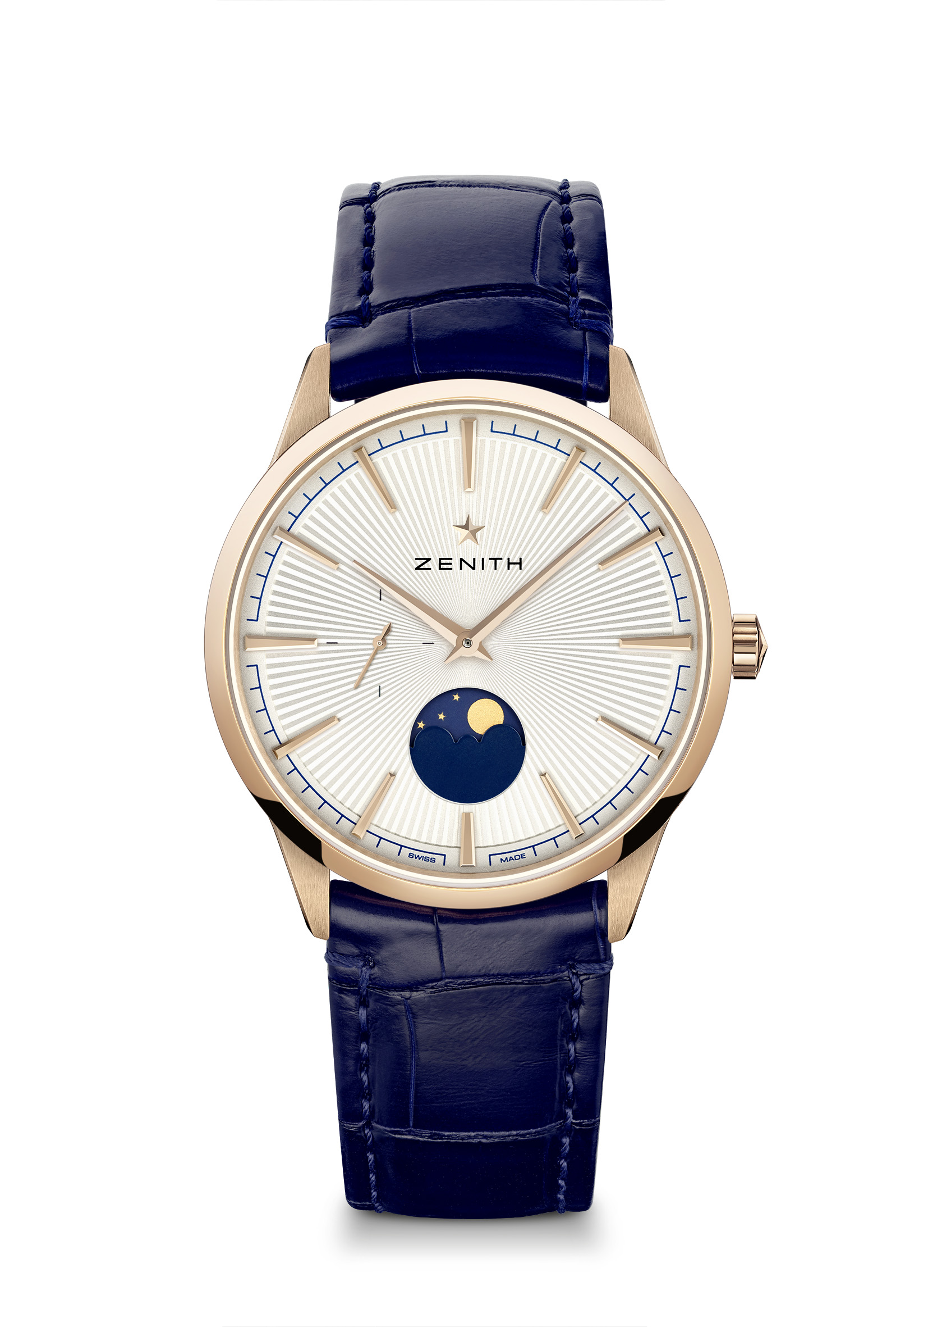
Key points: Entirely restyled case & dial : Redefine the codes of Elegance. Elite Calibre 692: ultra-thin movement powering a moonphase indication. Crown-adjusted moonphase indication. Stop second mechanism.
Movement: Elite 692
Frequency: 28,800 VpH (4Hz)
Power-reserve: min. 48 hours
Functions: Hours and minutes in the centre. Small second at 9 o’clock.
Moonphase indication at 6 o’clock
Price: 13900 CHF
Material: 18-ct Rose gold
Water-resistance: 5 ATM
Dial: Silver-toned sunray-patterned
Hour-markers: Gold-plated and faceted
Hands: Gold-plated and faceted
Bracelet & buckle: Blue alligator leather with protective rubber lining. Rose gold pin buckle

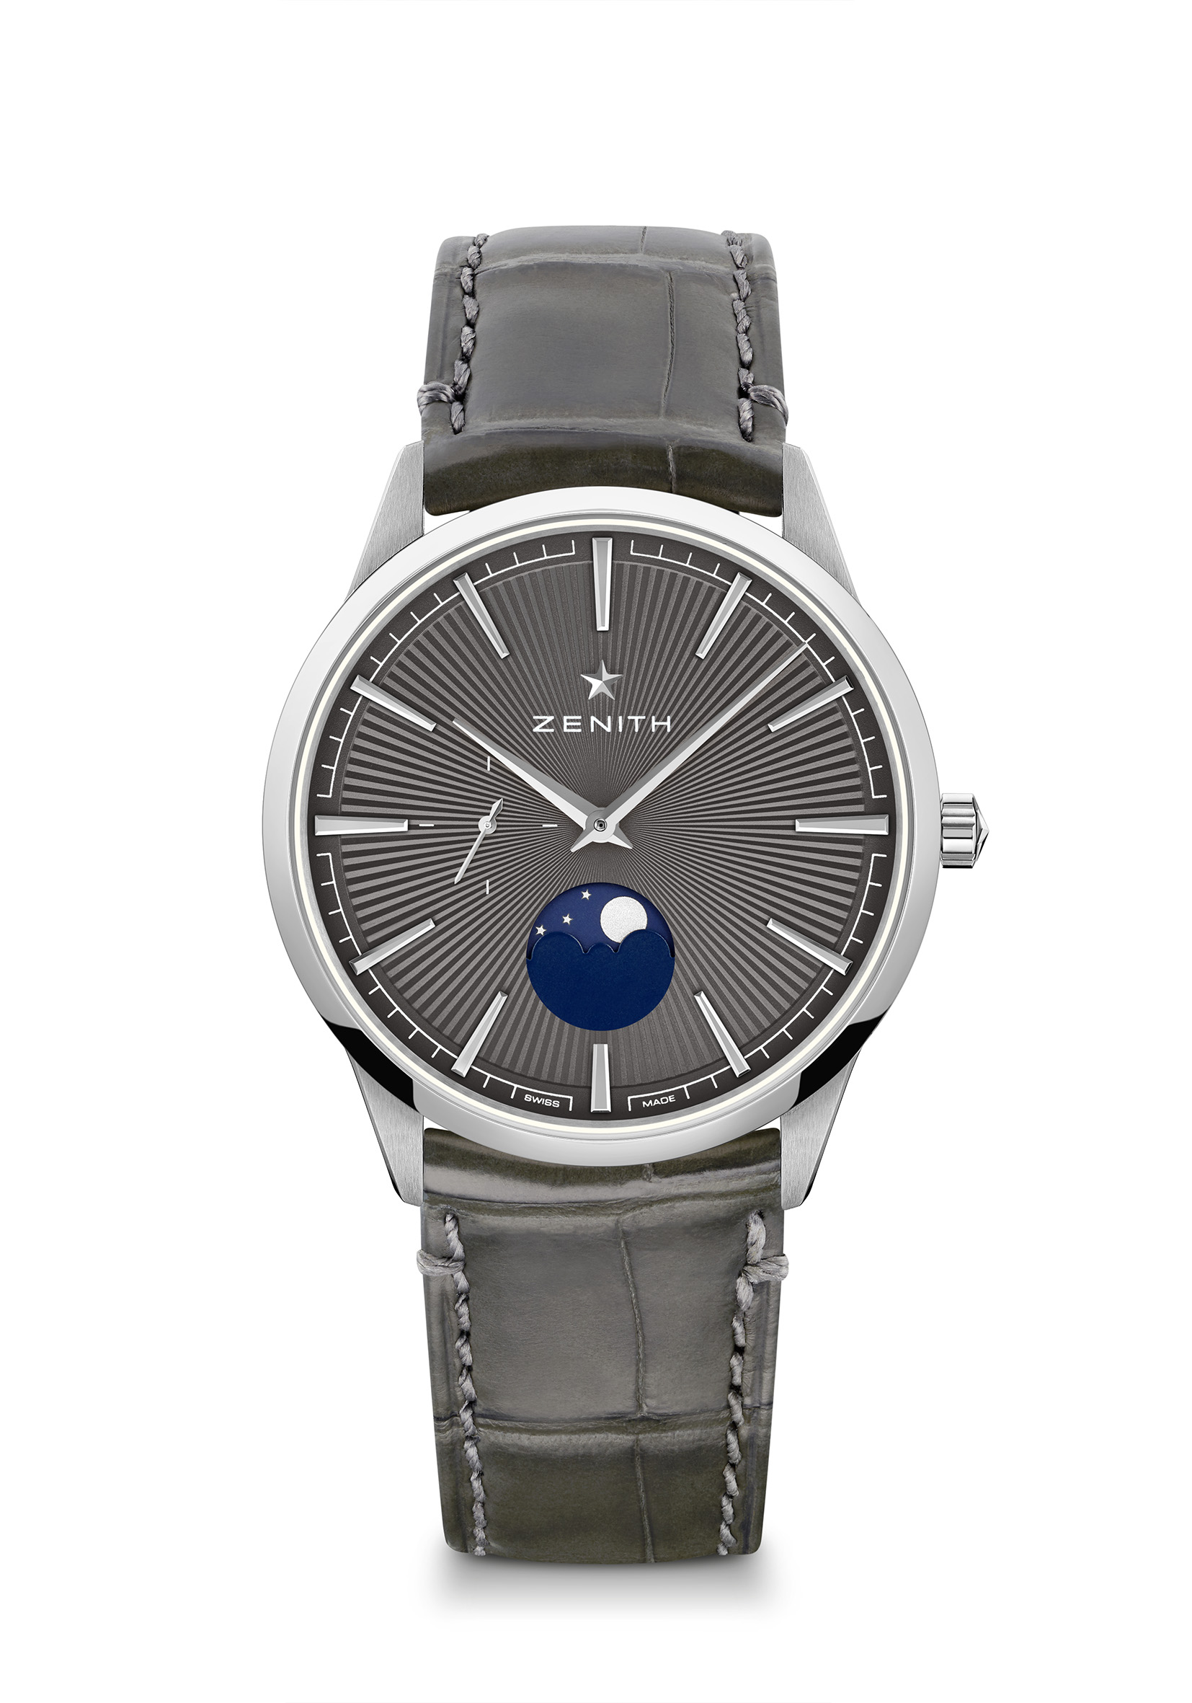
ELITE MOONPHASE – 40.5MM Reference: 03.3100.692/03.C923
Key points: Entirely restyled case & dial : Redefine the codes of Elegance. Elite Calibre 692: ultra-thin movement powering a moonphase indication. Crown-adjusted moonphase indication. Stop second mechanism
Movement: Elite 692
Frequency: 28,800 VpH (4Hz)
Power-reserve: min. 48 hours
Functions: Hours and minutes in the centre. Small second at 9 o’clock.
Moonphase indication at 6 o’clock
Price: 6900 CHF
Material: Stainless steel
Water-resistance: 5 ATM
Dial: Slate-grey-toned sunray-patterned
Hour-markers: Rhodium-plated and faceted
Hands: Rhodium-plated and faceted
Bracelet & buckle: Grey alligator leather with protective rubber lining. Stainless steel pin buckle

