ZENITH AND HABANOS ENTER A NEW PHASE IN THEIR PARTNERSHIP
WITH A SPECIAL PAIR OF ELITE MOONPHASE MODELS INSPIRED BY
ROMEO Y JULIETA CIGARS

Havana, Cuba, 27 February 2020: Zenith CEO Julien Tornare and Habanos VP of Development Jose María López welcomed guests to discover the latest collaboration between the watch Manufacture and the Habanos´ Company. After the Cohiba and Trinidad cigar brands, Zenith and Habanos break new ground in their partnership with two firsts: a Romeo Y Julieta watch collaboration, and the first special edition of the redesigned Elite collection introduced this year at the inaugural edition of the LVMH Watch Week. For this opulent creation, Zenith sought to create a whimsical, romantic reinterpretation of its timeless Elite Moonphase.

“Zenith has the immense pleasure of returning to Havana with our dear friends at Habanos for a new chapter in our partnership, which is all about celebrating the finer pleasures in life. With Romeo y Julieta, we have conceived a special his and hers set of watches that highlight the timeless beauty of our Elite collection and the enduring appeal of Romeo y Julieta’s exquisite cigars, as well as Zenith’s commitment to creating inimitable ladies’ watches unique in their kind” said Julien Tornare, Zenith CEO.

As the tale goes, Romeo and Juliet lived out their romance under the veil of night, with the moon and stars as their only witnesses. This is portrayed in the Elite Moonphase Romeo y Julieta edition, where the double hemispherical moonphase complication is set against a deep yet radiant blue sunray-patterned dial with a gradient effect on the men’s “Romeo” version and a gradient red dial on the women’s “Julieta” version, embellished with the Romeo y Julieta logo. The uniquely executed moonphase display depicts the two lovers in an eternal chase across the night sky, with their faces as drawn in Romeo y Julieta cigar boxes meticulously laser-engraved onto each of the two silvery moons. Instead of a traditional arch-shaped opening on the dial to display the moonphase, Zenith opted for two round apertures to keep the sunray-pattern of the dial intact.

Crafted in a 40.5mm “Romeo” stainless steel case and a 36mm “Julieta” stainless steel case with 75 diamonds set into the bezel, these special Elite models are offered with alligator leather straps in colors matching the dial, while the colours of the lining are inversed. The Elite Moonphase Romeo y Julieta models will be limited to 145 units in commemoration of Romeo y Julieta´s cigar brand 145th anniversary.

Romeo y Julieta: A Tale of Havana Passion
Established in 1875 and celebrating its 145th anniversary this year, Romeo y Julieta is one of the most revered names in the world of Cuban cigars. Between 1885 and 1900, the brand won numerous awards at different tasting exhibitions, which the brand honours as medals on its logo. The brand garnered international acclaim under the ownership of Jose "Pepin" Rodriguez Fernandez at the start of the 20th century. Being a very cosmopolitan man, Rodriguez constantly travelled across Europe and the Americas to promote the Romeo y Julieta brand, with his racing horse Julieta taking part in prestigious races across the globe. Among the many avid devotees of Romeo y Julieta was Sir Winston Churchill, to whom the brand has named its flagship vitola in his honour.

The brand’s choice to name its cigars after Shakespeare’s tale of forbidden love stems from the excitement the cigar rollers felt while they listened the romantic story read by the cigar factory lector. The lector, a traditional and central role in the making of Habano cigars, is in charge of stimulating the cigar rollers by reading classical literature to them while they roll the several leaves that shape a fine Habano cigar. It is said that all the passion one finds in a Habano cigar comes from the passion that cigar rollers transmits to the Habano, inspired by the stories he hears from the cigar factory lector.

“We have always said that our relationship with Zenith is marked by the emotion that unites our brands, and we are proud to witness the series of unique watches that are the result of the alliance of these two icons of luxury. In 2016, it was the time of Cohiba, the most prestigious Premium tobacco brand in the world, with which we started this partnership, reaffirmed with new special editions of Zenith watches for Cohiba in 2017 and 2018. Then it was the time to celebrate the 50th anniversary of our Trinidad brand in 2019, and Zenith surprised Habano collectors and lovers with 3 unique watches. Today, at the dawn of the new decade, it is the time of passion, of living every second with intensity. That's why Romeo y Julieta and Zenith have come together, so that we appreciate every moment that we carry this exclusive watch in our hands while enjoying this magnificent Habano” said José María Lopez, Habanos Vice-president of development.

ZENITH: TIME TO REACH YOUR STAR.

Zenith exists to inspire individuals to pursue their dreams and make them come true – against all odds. Since its establishment in 1865, Zenith became the first watch manufacture in the modern sense of the term, and its watches have accompanied extraordinary figures that dreamt big and strived to achieve the impossible – from Louis Blériot’s history-making flight across the English Channel to Felix Baumgartner’s record-setting stratospheric free-fall jump.

With innovation as its guiding star, Zenith features exceptional in-house developed and manufactured movements in all its watches. From the first automatic chronograph, the El Primero, to the fastest chronograph with a 1/100th of a second precision, the El Primero 21, as well as the Inventor that reinvents the regulating organ by replacing the 30+ components with a single monolithic element, the manufacture is always pushing the boundaries of what's possible. Zenith has been shaping the future of Swiss watchmaking since 1865, accompanying those who dare to challenge themselves and break barriers. The time to reach your star is now.

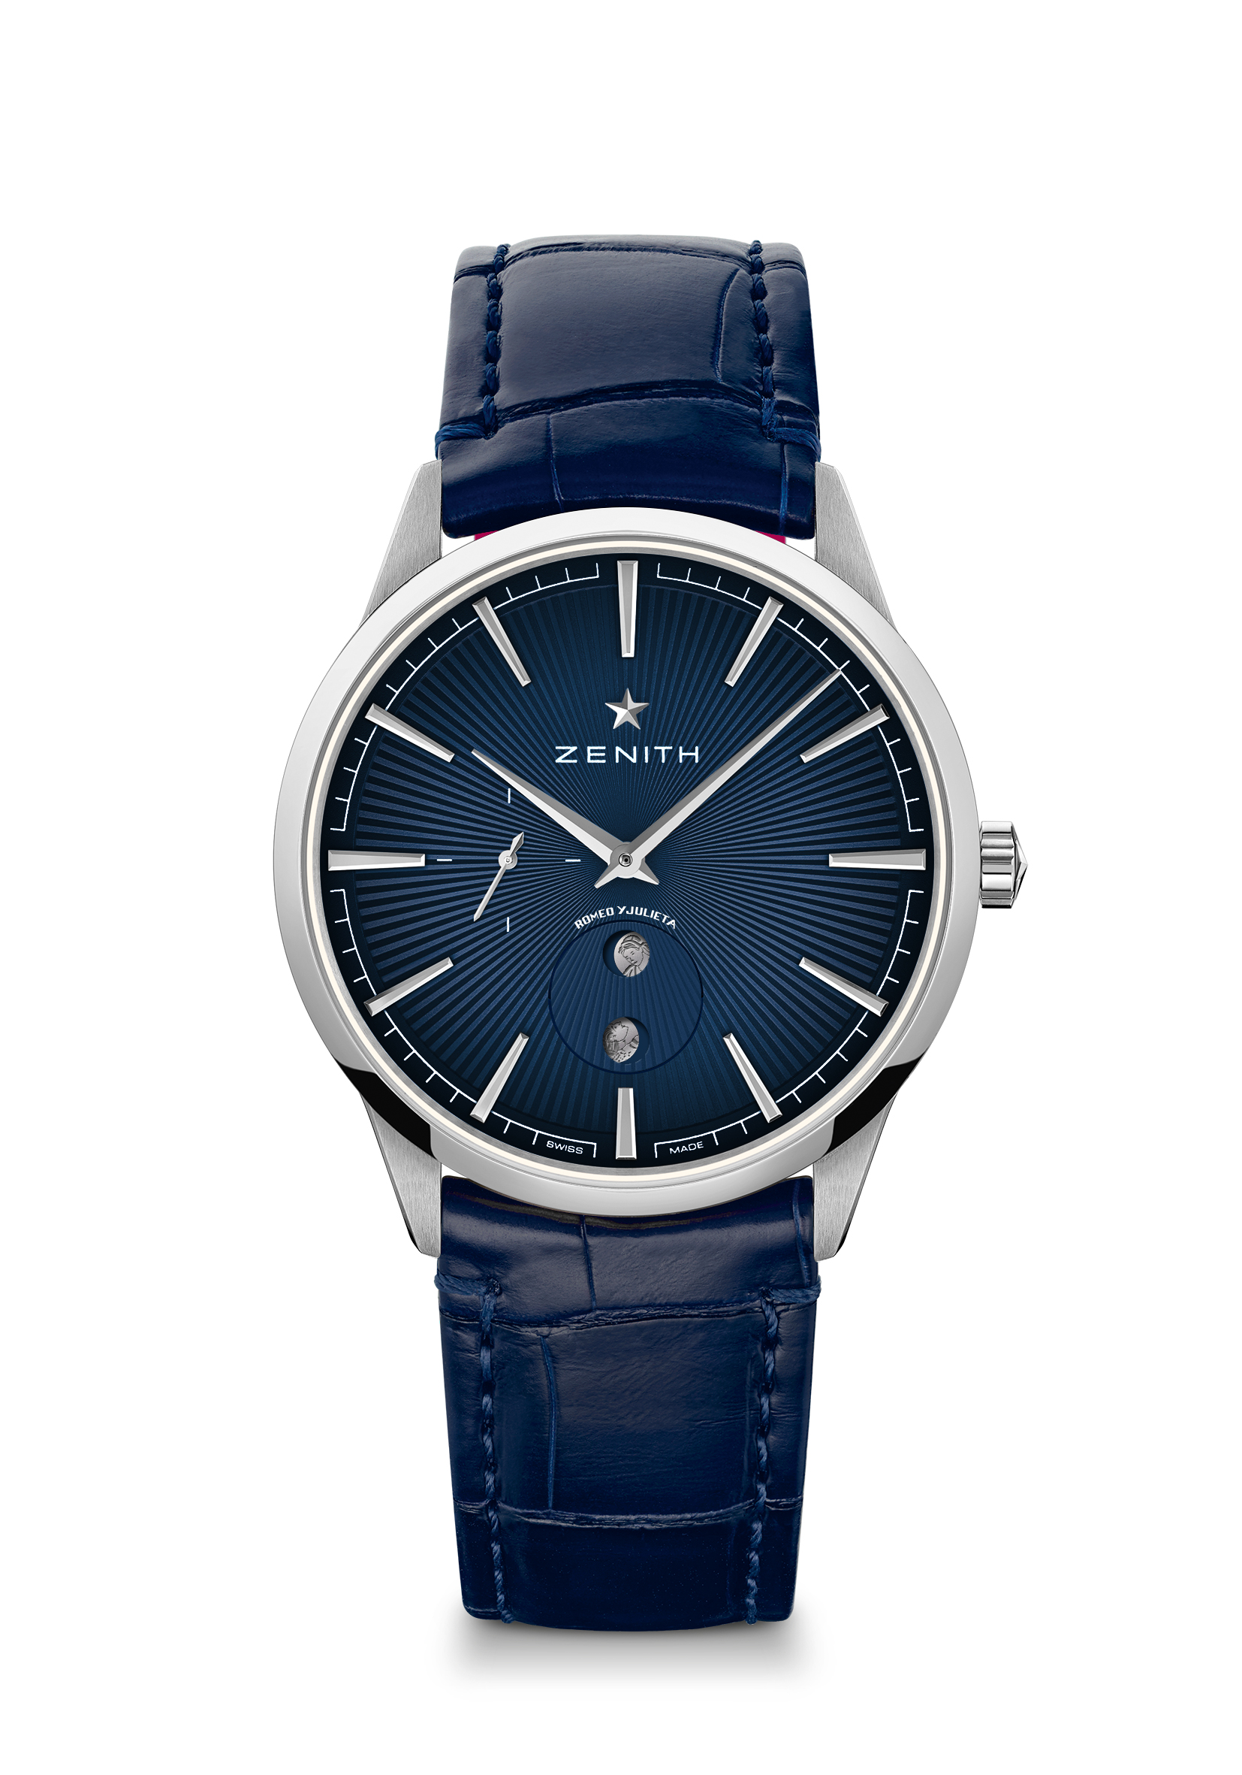
ELITE MOONPHASE – 40.5MM – ROMEO
Reference: 03.3101.692/02.C861

Key points: Tribute to cigars Brand Romeo y Julieta 145th Anniversary. Automatic Elite calibre beating at 28,800 VpH. Special Moonphase indicator to be adjusted by the crown. Stop second mechanism.
Limited Edition of 145 units
Movement Elite 692 manufacture, Automatic with Moonphase
Frequency: 28,800 VpH (4Hz)
Power-reserve: min. 48 hours
Functions: Hours and minutes in the centre. Central seconds hand. Special Moonphase featuring Romeo and Juliet.
Material: Stainless steel
Water-resistance: 5 ATM
Dial: Night blue gradient with solar pattern. Romeo and Juliet moonphase.
Hour-markers: Rhodium-plated and faceted
Hands: Rhodium-plated and faceted
Bracelet & Buckle: Night blue alligator leather with protective red alligator lining. Stainless Steel pin buckle

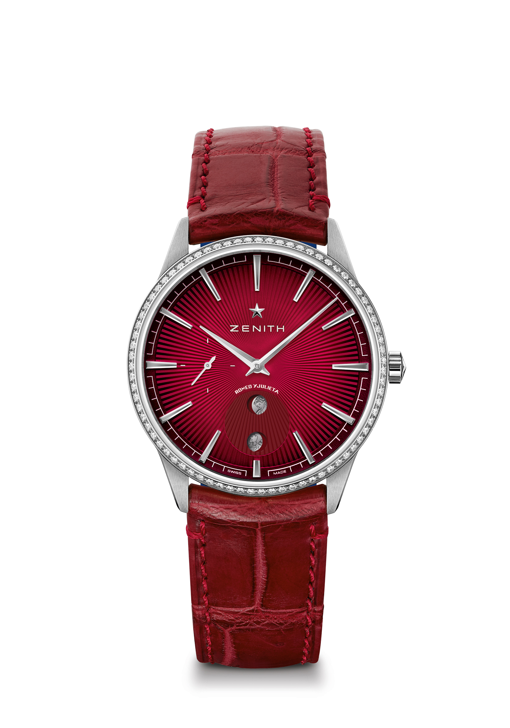
ELITE MOONPHASE - 36MM- JULIETA
Reference: 16.3201.692/04.C860

Key points: Tribute to cigars Brand Romeo y Julieta 145th Anniversary. Automatic Elite calibre beating at 28,800 VpH. Stop second mechanism. Special Moonphase indicator to be adjusted by the crown.
Limited Edition of 145 units
Movement: Elite 692 manufacture, Automatic with Moonphase
Frequency: 28,800 VpH (4Hz)
Power-reserve: min. 48 hours
Functions: Hours and minutes in the centre. Central seconds hand. Special Moonphase featuring Romeo and Juliet.
Gemsetting: Carats 0.60 cts, Bezel 75 VS brilliant-cut diamonds
Material: Stainless steel with diamond-set bezel
Water-resistance: 5 ATM
Dial: Red gradient dial with solar pattern. Romeo and Juliet moonphase.
Hour-markers: Rhodium-plated and faceted
Hands: Rhodium-plated and faceted
Bracelet & Buckle: Red alligator leather with protective blue alligator lining. Stainless steel pin buckle

