PINK FOR SUMMER, PINK FOR HOPE: ZENITH TAKES ON A WORTHY CAUSE FOR WOMEN WITH THE DEFY 21 PINK EDITION

2020 is a milestone year for Zenith in its creation of watches tailored exclusively for women. Never afraid to adopt colours rarely explored in watchmaking, Zenith has created its most flamboyantly feminine watch to date, the DEFY 21 Pink Edition featuring the world’s first pink-treated movement. In association with Pink Ribbon Switzerland, Zenith commits to supporting a cause that affects countless women around the world.

Fitting of the DEFY 21’s lightning-fast 1/100th of a second chronograph movement and edgy design, Zenith has created for the first time ever in a mechanical watch an astonishingly pink PVD treated movement in the DEFY 21 Pink Edition, which is sure to make an audacious statement this summer.

Its rose gold case with sharp facets exudes out a different kind of brilliance, with 288 white diamonds of varying sizes perfectly set into the case. The rose gold bezel adds another layer of vivid sparkle, with 44 scintillating baguette-cut pink sapphire stones. Echoing the dashing tones of the watch’s exterior, the open black and golden dial reveals the striking metallic pink treated movement, which extends from the dial side right through to the star-shaped oscillating rotor on the back.

Recognizing the need to spread positivity and hope to countless women around the world who are battling breast cancer, pink takes on another meaning with the DEFY 21 Pink Edition. The Pink Ribbon is the international symbol for those who have been affected by the indiscriminate disease, helping to spread awareness and support for those who need it.

Zenith is proud to announce that it will be joining the global Pink Ribbon awareness movement, where a portion of the proceeds from the sale of the DEFY 21 Pink Edition will be donated to Pink Ribbon Switzerland. Zenith will also take part in the 10th Anniversary Pink Ribbon Switzerland Music Gala as an auction partner, to be held on 26th September at the Dolder Grand in Zurich. To lend its support and help raise funds, Zenith will offer a unique execution of this watch, the DEFY 21 “Pink Ribbon” edition, for the charity auction, where all proceeds from the auction sale will finance the VISION I project of SAKK (The Swiss Group for Clinical Cancer Research), a non-profit organization which has been conducting clinical trials in oncology since 1965 and promises to provide breast cancer patients gentler and better care.

The DEFY 21 Pink Edition will be available at Zenith boutiques and retailers worldwide as of August 2020.

ZENITH: TIME TO REACH YOUR STAR.

Zenith exists to inspire individuals to pursue their dreams and make them come true – against all odds. Since its establishment in 1865, Zenith became the first watch manufacture in the modern sense of the term, and its watches have accompanied extraordinary figures that dreamt big and strived to achieve the impossible – from Louis Blériot’s history-making flight across the English Channel to Felix Baumgartner’s record-setting stratospheric free-fall jump.

With innovation as its guiding star, Zenith features exceptional in-house developed and manufactured movements in all its watches. From the first automatic chronograph, the El Primero, to the fastest chronograph with a 1/100th of a second precision, the El Primero 21, as well as the Inventor that reinvents the regulating organ by replacing the 30+ components with a single monolithic element, the manufacture is always pushing the boundaries of what's possible. Zenith has been shaping the future of Swiss watchmaking since 1865, accompanying those who dare to challenge themselves and break barriers. The time to reach your star is now.

DEFY EL PRIMERO 21 PINK EDITION

Reference: 22.9004.9004/73.R598

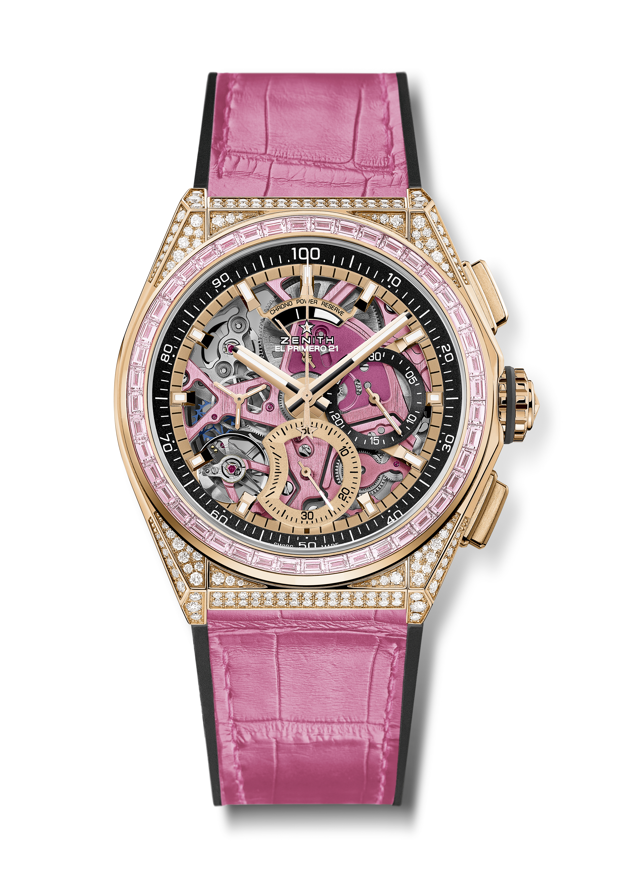
Key points: World premiere with a Pink PVD treated movement. Pink sapphires on the bezel : ~2.12 cts. Exclusive dynamic signature of one rotation per second. 1 escapement for the Watch (36,000 VpH - 5 Hz); 1 escapement for the Chronograph (360,000 VpH - 50 Hz). TIME LAB Chronometer certified.
Movement: El Primero 9004 automatic - Pink colored main plate on movement + Special pink colored oscillating weight with satined finishings
Frequency 36,000 VpH (5 Hz)
Power reserve min. 50 hours
Functions : 1/100th of a second chronograph functions. Chronograph power-reserve indication at 12 o'clock. Hours and minutes in the centre. Small seconds at 9 o'clock, Central chronograph hand, 30-minute counter at 3 o'clock, 60-second counter at 6 o'clock
Price 64900 CHF
Case Material: Rose gold set with sapphires & diamonds
Case 288 VVS brilliant-cut diamonds
Carats ~5.00 cts
Bezel 44 VVS pink baguette-cut sapphire
Dial: Openworked with two different-coloured counters
Water resistance: 3 ATM
Hour markers: gold-plated, faceted and coated with Super-LumiNova®SLN C1
Hands : gold-plated, faceted and coated with Super-LumiNova®SLN C1
Bracelet & Buckle: Black Rubber with Pink alligator leather coating. Gold & Titanium double folding clasp.

