AN ANIME-INSPIRED UNIQUE PIECE FOR A GREAT CAUSE:
PHILLIPS AUCTIONS A ONE-OF-A-KIND
ZENITH CHRONOMASTER REVIVAL LUPIN THE THIRD

On Sunday 8th of November 2020 in Geneva, during Phillips’ in Association with Bacs & Russo RETROSPECTIVE 2000-2020 auction held at La Réserve, the acclaimed auction house sold a one-off piece of the Zenith Chronomaster Revival Lupin the Third for the sum of CHF 189’000 (USD 210,016 / € 176,922).

The Chronomaster Revival Lupin the Third is an accurate and faithful rendering of the watch depicted in the anime series of the same name. Based on the A384, the watch worn by the character Daisuke Jigen in Lupin the Third, it featured an unusual black dial with gilt printing. Its markers were smaller and apparently printed rather than applied, while the ZENITH logo’s "Z" and "H" characters were darkened, possibly to avoid trademark infringements. This unique piece is the latest and rarest of the Chronomaster watches inspired by the seminal anime series.

In 2019, Zenith unveiled the Chronomaster Revival Lupin the Third, a Japan-exclusive limited edition hailed as the first watch ever to be inspired by a manga and anime series. After last year’s success, this year, Zenith released the Chronomaster Revival Lupin the Third – 2nd Edition, based on a second Zenith chronograph depicted later in the anime series with a high-contrast “panda” dial, available worldwide.

The fact that a Zenith El Primero was chosen to be featured in the acclaimed anime series is a testament to the worldwide impact the El Primero had when it was first released over 50 years ago. With the sale of this unique piece, Zenith and Lupin the Third have come full circle: a Zenith watch depicted in an anime from 1971, which was based on a real watch from 1969, and finally brought to life accurately in 2020.

For the second year, Zenith is donating proceeds from the auction sale of a unique piece to Zoé4life, a registered Swiss non-profit organization, recognized as a public service utility whose mission is to support cancer research, provide financial support to affected families in need, support children during their treatments and raise awareness about childhood cancer.
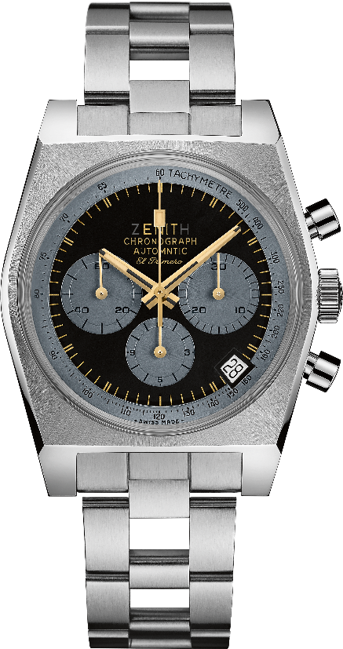
Chronomaster Revival Lupin the Third – The One Off
Reference: 03.L384-0.400/20.M384

Key points: Creation of the exact watch depicted in the Original Japanese manga "Lupin the Third".
Unique dial with original transgressions:
- Special bigger logo with Z and H hidden
- No ZENITH star logo
- Mistake in Automatic writing
- No subdivisions
- Small indices
Original 1969 case with 37 mm diameter.
Automatic El Primero column-wheel chronograph.
UNIQUE PIECE

Movement: El Primero 400 Automatic

Frequency: 36,000 VpH (5 Hz)

Power reserve: min. 50 hours

Functions: Hours and minutes in the centre. Small seconds at nine o’clock. Chronograph: central chronograph hand, 12-hour counter at six o’clock, 30-minute counter at three o’clock. Tachymetric scale. Date indication at 4:30.
Case: 37-mm

Material: stainless steel

Dial: UNIQUE Black dial with grey-coloured counters
Water-resistance: 5 ATM
Hour-markers: Gold-color transferred
Hands: Gold-plated, faceted and coated with beige Super-LumiNova®SLN

Bracelet & Buckle: Stainless steel "ladder" bracelet

ZENITH: TIME TO REACH YOUR STAR.

Zenith exists to inspire individuals to pursue their dreams and make them come true – against all odds. Since its establishment in 1865, Zenith became the first watch manufacture in the modern sense of the term, and its watches have accompanied extraordinary figures that dreamt big and strived to achieve the impossible – from Louis Blériot’s history-making flight across the English Channel to Felix Baumgartner’s record-setting stratospheric free-fall jump.

With innovation as its guiding star, Zenith features exceptional in-house developed and manufactured movements in all its watches. From the first automatic chronograph, the El Primero, to the fastest chronograph with a 1/100th of a second precision, the El Primero 21, as well as the Inventor that reinvents the regulating organ by replacing the 30+ components with a single monolithic element, the manufacture is always pushing the boundaries of what's possible. Zenith has been shaping the future of Swiss watchmaking since 1865, accompanying those who dare to challenge themselves and break barriers. The time to reach your star is now.

ABOUT PHILLIPS IN ASSOCIATION WITH BACS & RUSSO
The team of specialists at Phillips Watches is dedicated to an uncompromised approach to quality, transparency, and client service, achieving a sale total of $111 million in 2019 – its third consecutive year as the worldwide market leader in watch auctions.
A selection of our recent record-breaking prices:
1. Paul Newman’s Rolex “Paul Newman” Daytona reference 6239 (CHF 17,709,894 / US$17,752,500) – New York Auction: Winning Icons – 26 October 2017 – Highest result ever achieved for any vintage wristwatch at auction.

2. Patek Philippe reference 1518 in stainless steel (CHF 11,020,000 / US$11,112,020) – Geneva Watch Auction: FOUR – 12 November 2016 – Highest result ever achieved for a vintage Patek Philippe wristwatch at auction.

ABOUT PHILLIPS

Phillips is a leading global platform for buying and selling 20th and 21st century art and design. With dedicated expertise in the areas of 20th Century and Contemporary Art, Design, Photographs, Editions, Watches, and Jewelry, Phillips offers professional services and advice on all aspects of collecting. Auctions and exhibitions are held at salerooms in New York, London, Geneva, and Hong Kong, while clients are further served through representative offices based throughout Europe, the United States and Asia. Phillips also offers an online auction platform accessible anywhere in the world. In addition to providing selling and buying opportunities through auction, Phillips brokers private sales and offers assistance with appraisals, valuations, and other financial services. Visit www.phillips.com for further information.
*Estimates do not include buyer’s premium; prices achieved include the hammer price plus buyer’s premium.

