A DOUBLE TREAT FROM THE ZENITH DUBAI BOUTIQUE WITH
A HAUTE HORLOGERIE EXHIBITION AND ITS OWN DEFY 21 LIMITED EDITION

Over the years, the emirate of Dubai has become a global hub for fine watchmaking. Steeped in tradition yet unrelentingly reaching towards the future, Dubai and Zenith are a perfect match. Located in Dubai Mall, the booming emirate’s largest and most luxurious shopping destination, the Zenith boutique in Dubai hosts the entire Zenith collection in a prime location. And as of November, the Dubai Mall boutique becomes the first stop in a traveling pop-up exhibition that brings together a selection of current Haute Horlogerie pieces as well as a selection of rare and sought-after pieces from the past decade, some of which have never been presented in Dubai until now. Coinciding with this special exhibition, the Zenith Dubai Mall boutique is launching its own exclusive DEFY El Primero 21 edition.

For this special boutique edition of the DEFY El Primero 21, Zenith opted for tones of green – inside and out. Across the Middle East, green is the colour of, luck, fertility and wealth. Crafted in a light and robust titanium case, the DEFY 21 Dubai Mall edition features a green dial with white, red and black accents. The 1/100th of second automatic chronograph movement, visible through the partially open dial, is also finished in a metallic green tone – a first for Zenith. Unlike the regular DEFY 21 that has open chronograph counters, the DEFY 21 Dubai Mall edition mixes tradition and modernity with closed counters, appearing as if floating above the open dial and movement. Completing the green theme of this special DEFY 21 is a khaki green cordura-effect rubber strap. The watch also comes with a textured black rubber strap.

Visitors of the Zenith Dubai Mall boutique are in for a horological treat. Rare, exceptional and sought-after Zenith haute horlogerie creations from the last decade will be available for purchase for a limited time at the boutique. Highlights include a selection of groundbreaking and commemorative pieces from the Academy collection, including some of the earliest watches to feature Zenith’s revolutionary gyroscopic “Gravity Control” mechanism as well as special editions boasting exceptional métiers d’art artisanal crafts. Alongside these are more recent complicated pieces including the DEFY Zero G and DEFY Fusee Tourbillon. The exhibition is making its debut in Dubai for a few months, before moving to other Zenith boutiques around the world, including Singapore and Tokyo.

ZENITH: TIME TO REACH YOUR STAR.

Zenith exists to inspire individuals to pursue their dreams and make them come true – against all odds. Since its establishment in 1865, Zenith became the first watch manufacture in the modern sense of the term, and its watches have accompanied extraordinary figures that dreamt big and strived to achieve the impossible – from Louis Blériot’s history-making flight across the English Channel to Felix Baumgartner’s record-setting stratospheric free-fall jump.

With innovation as its guiding star, Zenith features exceptional in-house developed and manufactured movements in all its watches. From the first automatic chronograph, the El Primero, to the fastest chronograph with a 1/100th of a second precision, the El Primero 21, as well as the Inventor that reinvents the regulating organ by replacing the 30+ components with a single monolithic element, the manufacture is always pushing the boundaries of what's possible. Zenith has been shaping the future of Swiss watchmaking since 1865, accompanying those who dare to challenge themselves and break barriers. The time to reach your star is now.

DEFY 21 DUBAI MALL EDITION
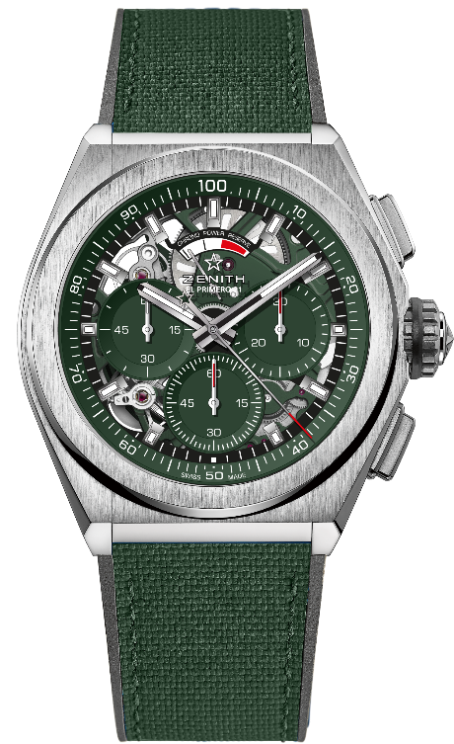
Reference: 95.9016.9004/08.R942

KEY POINTS : 1/100th of a second Chronograph movement. Exclusive dynamic signature of one rotation per second for the Chrono hand, 1 escapement for the Watch (36,000 VpH - 5 Hz) ; 1 escapement for the Chronograph (360,000 VpH - 50Hz). Certified Chronometer
Movement: El Primero 9004, Automatic
Calibre: 14 ½``` (Diameter: 32mm)
Frequency: 36,000 VpH (5 Hz)
Power-reserve: min. 50 hours
Finishing: Khaki green colored main plate on movement + Special khaki green colored oscillating weight with satined finishings
Functions: Hours and minutes in the centre. Small seconds at 9 o'clock. 1/100th of a second Chronograph: Central chronograph hand that makes one turn each second, 30-minute counter at 3 o'clock, 60-second counter at 6 o'clock, Chronograph power-reserve indication at 12 o'clock
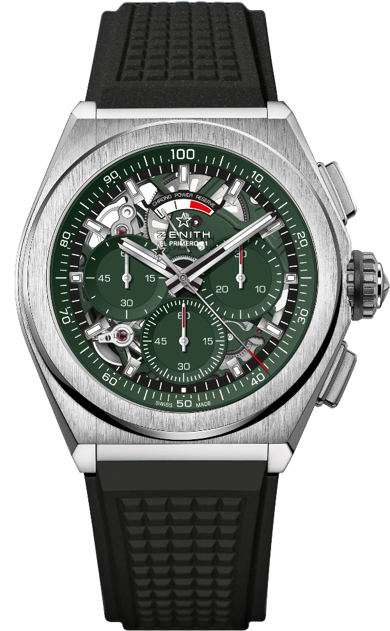
Price: 12900 CHF
Material: Brushed titanium
Diameter: 44mm
Dial: Openworked with 3 green subdials
Case-back: Transparent sapphire crystal
Water-resistance: 10 ATM
Hour-markers: Rhodium-plated, faceted and coated with Super-LumiNova® SLN C1
Hands: Rhodium -plated, faceted and coated with Super-LumiNova® SLN C1
Bracelet & Buckle: Green "Cordura effect" rubber strap. Also available on black rubber bracelet. Titanium double folding clasp.

