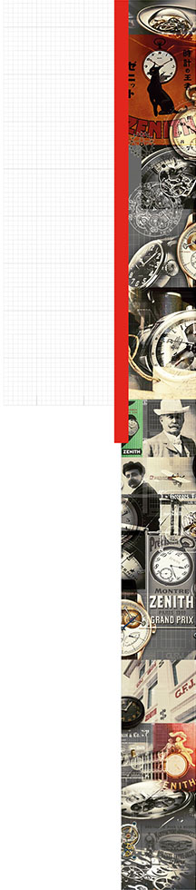

A DAY WITH ZENITH IN THE COMPANY OF MR JEAN-CLAUDE BIVER,
PRESIDENT OF THE LVMH WATCHES DIVISION AND CHAIRMAN OF THE ZENITH BOARD OF DIRECTORS, AND MR JULIEN TORNARE, CEO ZENITH

“Our joint challenge begins today”
Mr Jean-Claude Biver and Mr Julien Tornare welcomed the Swiss press this morning to the Manufacture Zenith in Le Locle, to present the brand’s short and medium-term strategic objectives.
It so happens that today’s date, May 19th, coincided with the 100th anniversary of the death of Georges Favre-Jacot, founder of the Manufacture Zenith.
On this symbolic occasion, Messrs Biver and Tornare took the opportunity to engage in frank and open discussions on the substantial task of innovation and renovation that they are currently putting in place.

