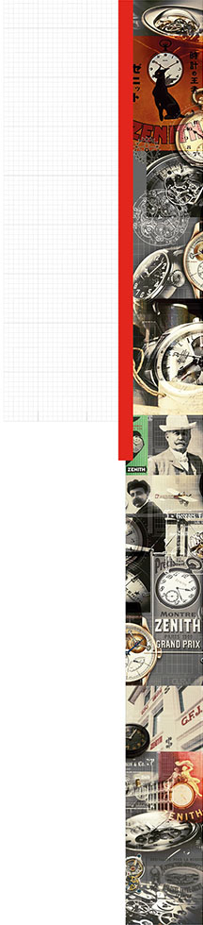

ELITE LADY MOONPHASE
A CELEBRATION OF COLOURS

The Elite collection welcomes a new model that enables its wearer to change the colour of time. Yellow, apple green, turquoise and red versions appear housed in a daintier than ever stainless steel case with diamond-set bezel: the new Elite Lady Moonphase 33 mm stands for a powerful temperament, original aesthetics and appealing colours.
The Elite Lady watch is an iconic style statement for women who never go unnoticed. This exquisitely feminine timepiece epitomising contemporary elegance offers a new perspective on time that will delight the hearts of women who looking for a watch that not only harbours a fine mechanism but is also a beautiful piece of jewellery.

A FINE MECHANISM IN A PRECIOUS JEWELLERY CREATION
The heart of this new ladies’ watch beats to the rhythm of the automatic Elite Calibre 692 bearing the inimitable Zenith signature. Endowed with a more than 50-hour power reserve, this ultra-thin movement operating at a frequency of 28,800 vibrations per hour and comprising 195 parts – while measuring an exceptionally slim 3.97 mm – powers indications of the hours, minutes, small seconds and moon phases.

The Elite Lady Moonphase with its ultra-thin 33 mm-diameter case expresses the contemporary elegance characteristic of Zenith through four diamond-set stainless steel variations that are water-resistant to 50 metres and fitted with a fluted crown enabling smooth moon-phase adjustments. Its exhibition case-back provides a chance to admire its mechanism powered by an oscillating weight adorned with a “Côtes de Genève” motif. Framed by a polished bezel, the pure mother-of-pearl dial is graced with a star-studded deep blue moon disc. Slender leaf-shaped hands sweep over stylised engraved hour-markers.

This stylish and exquisitely feminine interpretation of the Elite Lady Moonphase is fitted with a yellow, apple green, turquoise or red alligator leather strap featuring a protective rubber lining and secured by a stainless-steel pin buckle. These four new Elite references are the epitome of graceful femininity and sophisticated technical refinement.

ELITE COLLECTION: ELITE LADY MOONPHASE
Stainless steel ultra-thin case
Bezel set with 62 round diamonds: ~0.75 cts
Crown-adjusted moonphase indication
33 mm-diameter case
REF. :
16.2331.692/74.C815 Yellow
16.2332.692/64.C816 Apple green
16.2333.692/54.C817 Turquoise
16.2334.692/71.C818 Red

MOVEMENT
Elite 692, Automatic
Calibre 11½``` (Diameter: 25.60 mm)
Movement thickness: 3.97 mm
Components 195
Jewels: 27
Frequency: 28,800 VpH (4 Hz)
Power-reserve: min. 50 hours
Finishing: Oscillating weight with “Côtes de Genève” motif

FUNCTIONS
Hours and minutes in the centre
Small seconds at 9 o'clock
Moonphase indication at 6 o'clock

CASE, DIAL & HANDS
Diameter: 33 mm
Dial opening diameter: 26.75 mm
Thickness: 9.25 mm
Glass: Domed sapphire crystal with anti-reflective treatment on both sides
Case-back: Transparent sapphire crystal
Material: Stainless steel
Water-resistance 5 ATM
Dial
Yellow lacquered
Apple green lacquered
Turquoise lacquered
Red lacquered
Hour-markers: Engraved, rhodium-plated
Hands: Leaf-shaped, rhodium-plated

STRAPS & BUCKLES
Strap references:
27.00.1714.815 AC Shiny yellow alligator leather strap with protective rubber lining
27.00.1714.816 AC Shiny Apple green alligator leather strap with protective rubber lining
27.00.1714.817 AC Shiny turquoise alligator leather strap with protective rubber lining
27.00.1714.818 AC Shiny red alligator leather strap with protective rubber lining

Buckle:
27.01.0014.001 Stainless steel pin buckle

