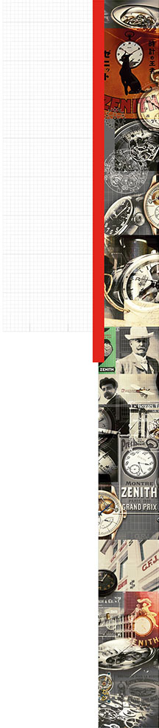

DEFY EL PRIMERO 21 ONLY WATCH EDITION

On 11th November 2017, Only Watch will host the seventh edition of the charity auction in Geneva. Zenith is proud to be able to support this campaign by donating a unique edition of the breathtaking innovation of 2017, the Defy El Primero 21 Only Watch Edition. It features a new 1/100th of a second chronograph and two completely independent movements, each driven by its own regulator. The 44 mm black DLC titanium case and signature yellow details on the dial make the Defy El Primero 21 a highly attractive, unique piece, further emphasized by the presentation box which has been exclusively designed for this watch. The lucky winner of the auction will also be able to enjoy a unique Zenith experience: a trip to the headquarters, to discover one of the most important Swiss watch Manufactures in the world. And Zenith has plans to ensure this visit will truly be an event to remember!

Created more than ten years ago, Only Watch has now become one of the largest charity events in the watchmaking industry's calendar, organized by the Monegasque Association against Muscular Dystrophy (AMM) and the Monaco Yacht Show. This annual auction sees all proceeds from the sale of one-of-a-kind timepieces donated to funding research into the extremely serious Duchenne form of muscular dystrophy, discovered by French neurologist Guillaume Duchenne in 1858, and to funding treatment, particularly for children.

This year, Swiss watch Manufacture Zenith is presenting a new special edition of the pioneering and revolutionary Defy El Primero 21. Launched at Baselword 2017, the Defy El Primero 21 is a masterpiece of modern engineering. Constructed using state-of-the-art methods and finished using the newest technologies and materials, the Defy El Primero 21 fulfils two objectives: a finish of the highest possible quality, and optimum performance and precision on the wrist. First released in 1969, the world’s most accurate series-made chronograph entered a whole new era of mechanical timekeeping with the Defy El Primero 21. An impressive frequency of 360,000 beats per hour is testament to the groundbreaking ingenuity of Zenith, and enables precise measurement of time periods to a hundredth of a second. The jump from tenths to hundredths of a second is a quantum leap in terms of watchmaking performance and engineering.

For Zenith, precision is the absolute priority. To avoid any risk of the chronograph affecting the accuracy of the time display, the Defy El Primero 21 is equipped with a “double chain structure”. This means that the time display and chronograph each have their own completely independent mechanism with its own barrel and high frequency escapement. For the chronograph, this oscillates at a breathtaking 50 Hz (360,000 vph). As standard for the El Primero, the time display escapement oscillates at 5 Hz (36,000 vph). This means that the El Primero 21 has no need for the clutch mechanism traditionally found in chronographs.

Alongside the double-chain structure of the caliber, and the remarkable precision this ensures, the El Primero 21 boasts other technical highlights: a new, patented start/stop/reset mechanism composed of three heart pieces, and an exclusive starter mechanism which ensures reliable operation under all circumstances, and allows all chronograph displays to be simultaneously reset. In addition, the springs in both regulators are fully carbon; more specifically created from the ultra-light and incredibly stable carbon nanotube metal matrix composite. This world first ensures that the Defy El Primero is unaffected by magnetic fields and temperature changes as well as the influence of gravity.

The Defy El Primero 21 speaks to all of the senses, reflecting the aesthetic and acoustic signature of this new era for Zenith. The central chronograph hand rotates once around the dial each second, while the 50 Hertz escapement emits a pleasant "buzzing". The passing of time becomes endlessly fascinating to observe, whilst also enabling the 1/100th of a second display to be read reliably at a glance.

This watch is a unique combination of materials and colors, boasting a powerful 44 mm black DLC titanium case and a black alligator leather strap featuring yellow stitching detail and lined with rubber. The double folding clasp holds the watch securely and elegantly on the wrist. The case back is specially engraved and the sapphire crystal bears the logos of Only Watch and the Monegasque Association against Muscular Dystrophy.

The Defy El Primero 21 Only Watch edition embodies the new generation of Zenith chronographs, combining pioneering technology with a timeless and dynamic exterior. As so often in the long history of the Zenith Manufacture, the Defy El Primero 21 is the first step towards the future of watchmaking. It also heralds many further pioneering innovations set to come from Zenith.

DEFY EL PRIMERO 21 ONLY WATCH EDITION
Reference
96.9000.9004/27.R583 (black DLC titanium – skeleton dial)

Unique piece

New 1/100th of a second Chronograph movement
Dynamic display, with the chronograph hand completing one full rotation per second
Double chain structure with 2 regulators
1 escapement for the time display (36,000 vph - 5 Hz)
1 escapement for the chronograph (360,000 vph - 50Hz)
MOVEMENT
El Primero 9004 automatic, COSC-certified chronometer calibre
Calibre 14¼’’’ (diameter: 32.80 mm)
Movement thickness 7.9 mm
203 components
53 jewels
Frequency: 36,000 vph (5 Hz)
Power reserve: 50 hours (min.)
Automatic oscillating weight with “Côtes de Genève” finish
FUNCTIONS
1/100th of a second chronograph:
Chronograph power reserve indication at 12 o'clock
Central hour and minute display
Small seconds at 9 o'clock
- central chronograph 1/100th of a second hand
- 30-minute counter at 3 o'clock
- 60-second counter at 6 o'clock
CASE, DIAL & HANDS
Diameter 44 mm
Dial diameter 35.5 mm
Thickness 14.5 mm
Domed sapphire crystal with anti-reflective treatment on both sides
Sapphire crystal case back
Case material: black DLC titanium
Water-resistance: 10 ATM
Skeleton dial with yellow details to tie in with the Only Watch logo
Hour indexes: rhodium-plated and coated with Yellow SuperLuminova
Hands: rhodium-plated and coated with Yellow SuperLuminova
STRAP & CLASP
Strap: 27.00.2322.583
(black alligator leather with yellow stitching, backed with natural rubber)
Clasp: 27.96.0022.930
(black DLC titanium double folding clasp)

