ZENITH DEFY EL PRIMERO 21
Midnight Black Ceramic

Black is the new gold in high-tech ceramic or ultra-comfort black rubber for the latest iteration of the groundbreaking ZENITH DEFY EL PRIMERO 21, the most accurate chronograph the world has ever seen.

In yet another master sleight of hand, Zenith stunned the world in 2017 with the grand release of the new Zenith DEFY EL PRIMERO 21. A chronometric reinvention of accuracy and reliability, the DEFY EL PRIMERO 21 is the ultimate embodiment of the spirit of innovation that has coursed through Zenith’s blood for the past 150 years.

In 1969, Zenith launched El Primero, the first ever fully integrated automatic column-wheel chronograph movement, enabling 1/10th of a second precision. The ultimate fulfilment of a quest for perfection and a proven ability to create watchmaking legends, this groundbreaking model laid a new milestone in watchmaking history that had never been surpassed – until now. Half a century later, Zenith has once again defied tradition and pushed all existing boundaries, leading us into the world of 1/100th of a second accuracy. A legend reborn, the Zenith DEFY EL PRIMERO 21 is the shining 21st century symbol of a new future for a brand with a truly unique guiding star.

When it comes to pursuing the extreme, Zenith knows no limits
The Zenith DEFY EL PRIMERO 21 represents a quantum leap in both performance and mechanical design. This is a competition against no-one but itself. The newly upgraded movement of this outstanding timepiece boasts a frequency of 360,000 A/H (50 Hz), ten times that of its world-famous El Primero predecessor, enabling 1/100th of a second precision. An exquisitely designed display magnifies the effect of this astonishing frequency: the inner bezel bears a scale graduated from 1 to 100 around which a 1/100th of a second hand sweeps at a lightning speed of one turn per second, offering unprecedented visual impact and a surreal time-travelling experience for the lucky wearer. Echoing the trend in modern engineering development and ensuring optimal performance, this incredible mechanical complication is achieved using a far smaller number of components, minimising tedious assembly and adjustments. In addition to significantly improved performance and mechanical structure, the design of the TIME LAB-chronometer certified DEFY EL PRIMERO 21 draws inspiration from the rugged good looks of its 1969 predecessor. Framed by a 44 mm ceramic case, the openworked dial of the DEFY EL PRIMERO 21 offers a resolutely contemporary background for the key identifying characteristics of the legendary original: a star-tipped sweep-seconds hand, large luminescent baton-type hands and facetted hour-markers all paying proud tribute in a stunning demonstration of futuristic brilliance.

Stealth interpretation
With a lustrous night-black ceramic case providing a perfect complement to its rich inner workings, black is unquestionably the new gold in the DEFY EL PRIMERO 21 BLACK CERAMIC. Sleek ruthenium-plated hour-markers and hands enliven an elegantly complex openworked dial featuring a chronograph power-reserve indication at 12 o'clock, hours and minutes in the centre, small seconds at 9 o'clock, black 60-second counter at 6 o'clock and distinctive blue 30-minute counter at 3 o'clock. The DEFY EL PRIMERO 21 BLACK CERAMIC presents a delightful dilemma with a choice of a supremely comfortable black rubber strap with a matching black DLC-coated titanium double folding clasp, or a magnificently stylish black ceramic bracelet. With a generous 50-hour power reserve, this exceptional timepiece is water-resistant to 100 metres, and is sure to catch the attention of the most discerning watch enthusiasts seeking to wish upon a star.

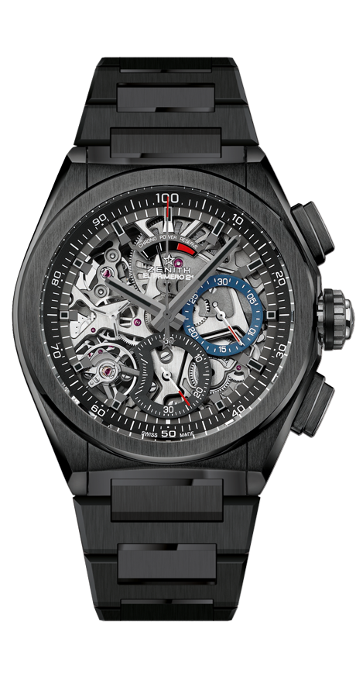

DEFY EL PRIMERO 21 BLACK CERAMIC
TECHNICAL DETAILS
Reference: 49.9000.9004/78.M9000

UNIQUE SELLING POINTS
New 1/100th of a second chronograph movement
Exclusive dynamic signature of one rotation per second
1 escapement for the Watch (36,000 VpH - 5 Hz);
1 escapement for the Chronograph (360,000 VpH - 50 Hz)
TIME LAB-Chronometer certified

MOVEMENT
El Primero 9004 automatic
Calibre: 14¼``` (Diameter: 32.80 mm)
Thickness: 7.9 mm
Components: 293
Jewels: 53
Frequency 36,000 VpH (5 Hz)
Power reserve approx. 50 hours
Special oscillating weight with “circular satin-brushed” motif

FUNCTIONS
1/100th of a second chronograph functions
Chronograph power-reserve indication at 12 o'clock
Hours and minutes in the centre
Small seconds at 9 o'clock
- Central chronograph hand
- 30-minute counter at 3 o'clock
- 60-second counter at 6 o'clock

CASE, DIAL & HANDS
Black Ceramic case
Diameter: 44 mm
Opening diameter: 35.5 mm
Thickness: 14.50 mm
Crystal: Domed sapphire crystal with anti-reflective treatment on both sides
Case back: Transparent sapphire crystal
Water resistance: 10 ATM
Dial: Openworked with two different-coloured counters
Hour markers: Ruthenium-plated, faceted and coated with Super-LumiNova®
Hands: Ruthenium-plated, faceted and coated with Super-LumiNova®

STRAP AND BUCKLE
Ceramic bracelet

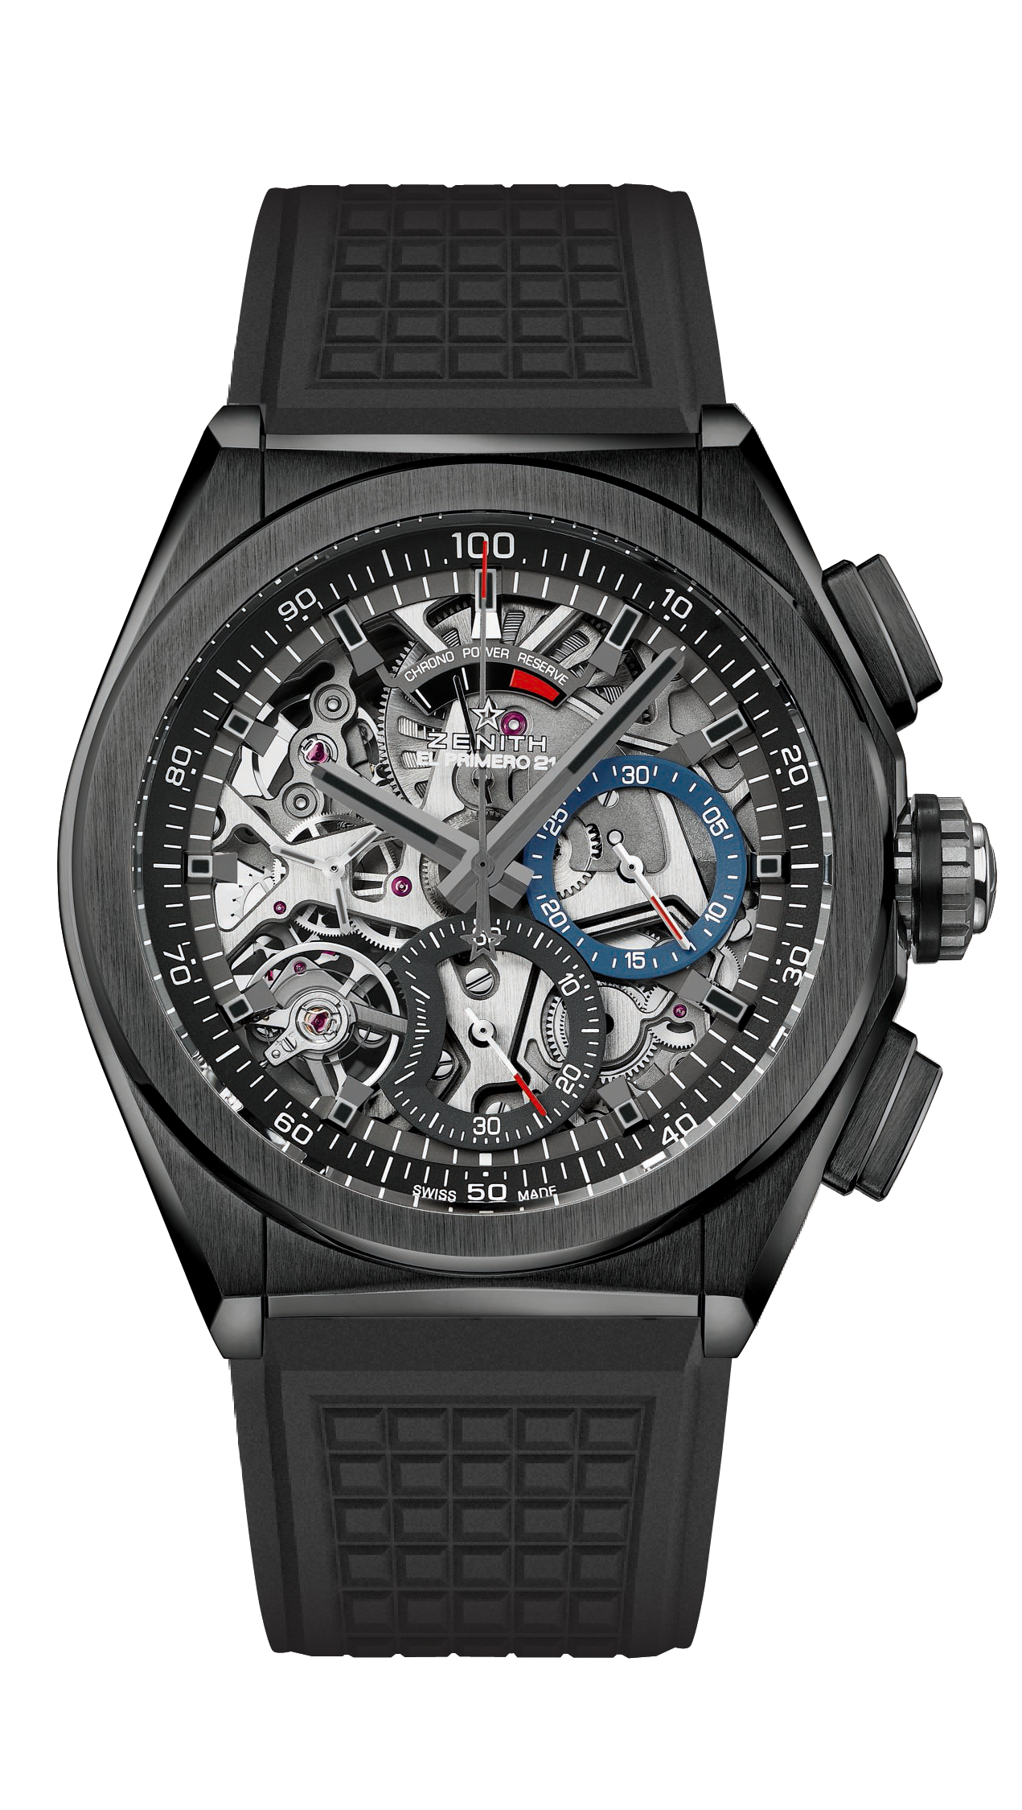

DEFY EL PRIMERO 21 BLACK CERAMIC
TECHNICAL DETAILS
Reference: 49.9000.9004/78.R782

UNIQUE SELLING POINTS
New 1/100th of a second chronograph movement
Exclusive dynamic signature of one rotation per second
1 escapement for the Watch (36,000 VpH - 5 Hz);
1 escapement for the Chronograph (360,000 VpH - 50 Hz)
TIME LAB-Chronometer certified

MOVEMENT
El Primero 9004 automatic
Calibre: 14¼``` (Diameter: 32.80 mm)
Thickness: 7.9 mm
Components: 293
Jewels: 53
Frequency 36,000 VpH (5 Hz)
Power reserve approx. 50 hours
Special oscillating weight with “circular satin-brushed” motif

FUNCTIONS
1/100th of a second chronograph functions
Chronograph power-reserve indication at 12 o'clock
Hours and minutes in the centre
Small seconds at 9 o'clock
- Central chronograph hand
- 30-minute counter at 3 o'clock
- 60-second counter at 6 o'clock

CASE, DIAL & HANDS
Black Ceramic case
Diameter: 44 mm
Opening diameter: 35.5 mm
Thickness: 14.50 mm
Crystal: Domed sapphire crystal with anti-reflective treatment on both sides
Case back: Transparent sapphire crystal
Water resistance: 10 ATM
Dial: Openworked with two different-coloured counters
Hour markers: Ruthenium-plated, faceted and coated with Super-LumiNova®
Hands: Ruthenium-plated, faceted and coated with Super-LumiNova®

STRAP AND BUCKLE
Black Rubber
Titanium double folding clasp with Black DLC coating

