ZENITH reflects far horizons with the Defy El Primero 21 BLUE

Zenith stunned the world in 2017 with the grand release of the new Zenith DEFY EL PRIMERO 21. A chronometric reinvention of accuracy and reliability, the DEFY EL PRIMERO 21 is the ultimate embodiment of the spirit of innovation that has coursed through Zenith’s blood for the past 150 years. Its natural charisma is beautifully showcased in this delightfully elegant true blue version.
In 1969, Zenith launched El Primero, the first ever fully integrated automatic column-wheel chronograph movement, enabling 1/10th of a second precision. The ultimate fulfilment of a quest for perfection and a proven ability to create watchmaking legends, this groundbreaking model laid a new milestone in watchmaking history that had never been surpassed – until now. Half a century later, Zenith has once again defied tradition and pushed all existing boundaries, leading us into the world of 1/100th of a second accuracy. A legend reborn, the Zenith DEFY EL PRIMERO 21 is the shining 21st century symbol of a new future for a brand with a truly unique guiding star.
When it comes to pursuing the extreme, Zenith knows no limits
The Zenith DEFY EL PRIMERO 21 represents a quantum leap in both performance and mechanical design. This is a competition against no-one but itself. The newly upgraded movement of this outstanding timepiece boasts a frequency of 360,000 A/H (50 Hz), ten times that of its world-famous El Primero predecessor, enabling 1/100th of a second precision. An exquisitely designed display magnifies the effect of this astonishing frequency: the inner bezel bears a scale graduated from 1 to 100 around which a 1/100th of a second hand sweeps at a lightning speed of one turn per second, offering unprecedented visual impact and a surreal time-travelling experience for the lucky wearer. Echoing the trend in modern engineering development and ensuring optimal performance, this incredible mechanical complication is achieved using a far smaller number of components, minimizing tedious assembly and adjustments. In addition to significantly improved performance and mechanical structure, the design of the TIME LAB-chronometer certified DEFY EL PRIMERO 21 draws inspiration from the rugged good looks of its 1969 predecessor. Framed by a 44 mm case made of grade 5 titanium, the openworked dial of the DEFY EL PRIMERO 21 offers a resolutely contemporary background for the key identifying characteristics of the legendary original: a star-tipped sweep-seconds hand, large luminescent baton-type hands and facetted hour-markers all paying proud tribute in a stunning demonstration of futuristic brilliance.

Paradoxically an instant fix for anyone’s blues, the elegant and efficient TIMELAB-chronometer certified DEFY EL PRIMERO 21 BLUE features a gleaming titanium case with matching rhodium-plated hour markers and hands. The openworked dial elegantly displays a chronograph power-reserve indication at 12 o'clock, hours and minutes in the centre, small seconds at 9 o'clock, black 60-second counter at 6 o'clock and the DEFY EL PRIMERO 21’s trademark blue 30-minute counter at 3 o'clock, offset by the unusual and visually striking blue mainplate. Designed to please a range of tastes, the DEFY EL PRIMERO 21 BLUE offers a choice of three striking straps from black rubber covered with a sophisticated blue alligator leather coating; the comfort of supple blue rubber; or the sleekness of unadulterated titanium, all with a titanium double folding clasp. This magnificent timepiece, endowed with a generous 50-hour power reserve and water-resistant to 100 metres, is sure to please the most discerning gentleman diver.

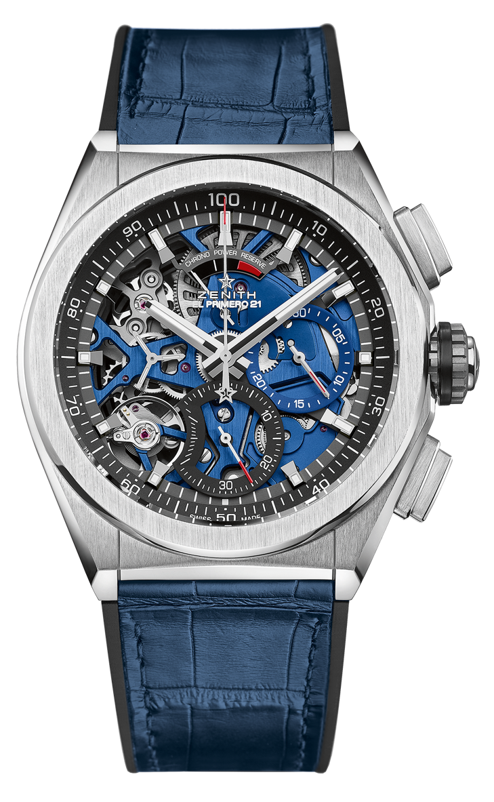
DEFY EL PRIMERO 21 BLUE
TECHNICAL DETAILS
Reference: 95.9002.9004/78.R584

UNIQUE SELLING POINTS
New 1/100th of a second chronograph movement
Exclusive dynamic signature of one rotation per second
Double-chain structure
1 escapement for the Watch (36,000 VpH - 5 Hz);
1 escapement for the Chronograph (360,000 VpH - 50 Hz)
TIME LAB-Chronometer certified

MOVEMENT
El Primero 9004 automatic
Calibre: 14¼``` (Diameter: 32.80 mm)
Thickness: 7.9 mm
Components: 293
Jewels: 53
Frequency 36,000 VpH (5 Hz)
Power reserve approx. 50 hours
Special oscillating weight with “circular satin-brushed” motif
Blue mainplate

FUNCTIONS
1/100th of a second chronograph functions
Chronograph power-reserve indication at 12 o'clock
Hours and minutes in the centre
Small seconds at 9 o'clock
- Central chronograph hand
- 30-minute counter at 3 o'clock
- 60-second counter at 6 o'clock

CASE, DIAL & HANDS
Brushed Titanium case
Diameter: 44 mm
Opening diameter: 35.5 mm
Thickness: 14.50 mm
Crystal: Domed sapphire crystal with anti-reflective treatment on both sides
Case back: Transparent sapphire crystal
Water resistance: 10 ATM
Dial: Openworked with two different-coloured counters
Hour markers: Rhodium-plated, faceted and coated with Super-LumiNova®
Hands: Rhodium-plated, faceted and coated with Super-LumiNova®

STRAP AND BUCKLE
Black rubber covered with blue alligator leather coating
Titanium double folding clasp

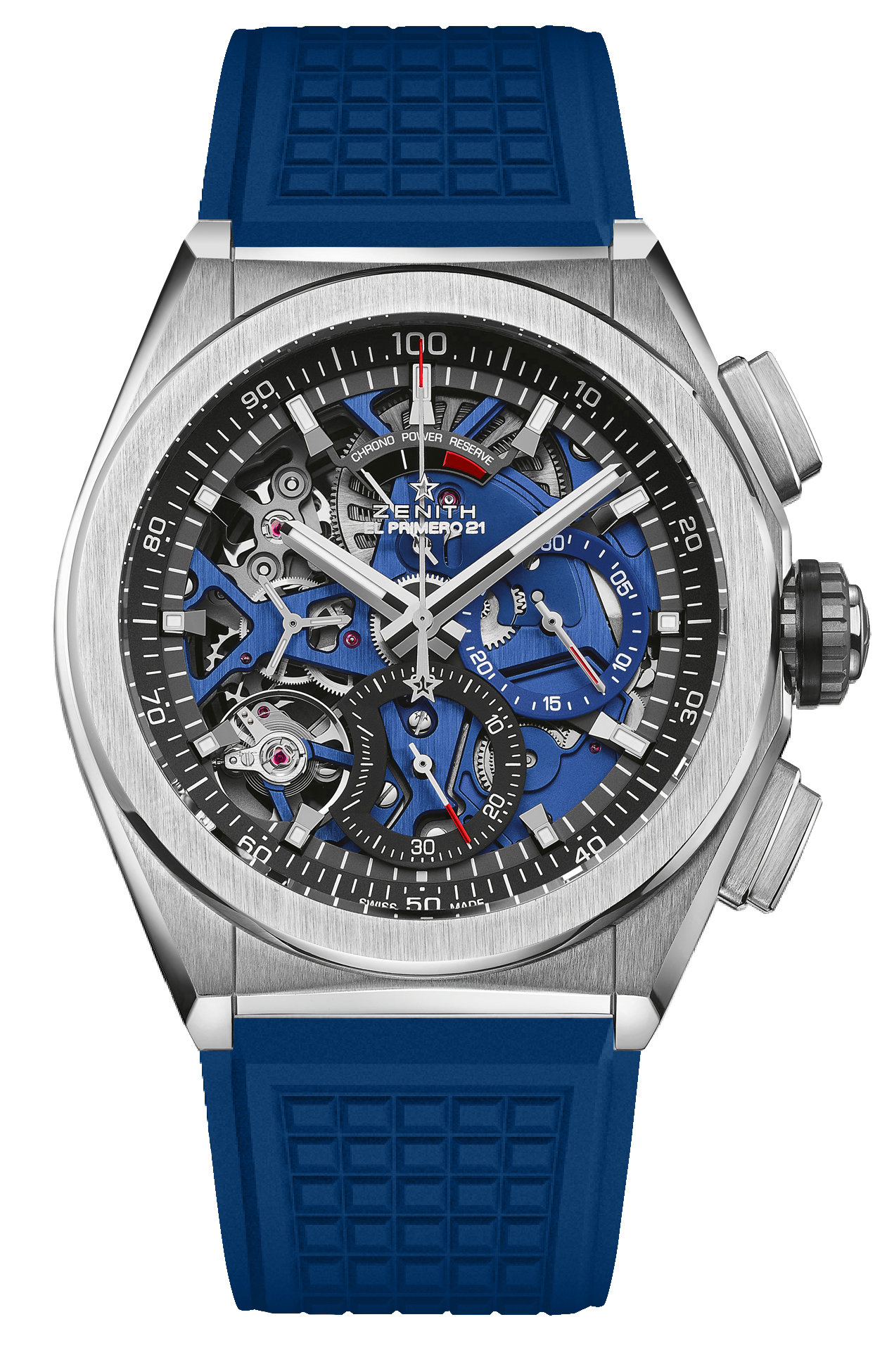
DEFY EL PRIMERO 21 BLUE
TECHNICAL DETAILS
Reference: 95.9002.9004/78.R591

UNIQUE SELLING POINTS
New 1/100th of a second chronograph movement
Exclusive dynamic signature of one rotation per second
Double-chain structure
1 escapement for the Watch (36,000 VpH - 5 Hz);
1 escapement for the Chronograph (360,000 VpH - 50 Hz)
TIME LAB-Chronometer certified

MOVEMENT
El Primero 9004 automatic
Calibre: 14¼``` (Diameter: 32.80 mm)
Thickness: 7.9 mm
Components: 293
Jewels: 53
Frequency 36,000 VpH (5 Hz)
Power reserve approx. 50 hours
Special oscillating weight with “circular satined” motif
Blue mainplate

FUNCTIONS
1/100th of a second chronograph functions
Chronograph power-reserve indication at 12 o'clock
Hours and minutes in the centre
Small seconds at 9 o'clock
- Central chronograph hand
- 30-minute counter at 3 o'clock
- 60-second counter at 6 o'clock

CASE, DIAL & HANDS
Brushed Titanium case
Diameter: 44 mm
Opening diameter: 35.5 mm
Thickness: 14.50 mm
Crystal: Domed sapphire crystal with anti-reflective treatment on both sides
Case back: Transparent sapphire crystal
Water resistance: 10 ATM
Dial: Openworked with two different-coloured counters
Hour markers: Rhodium-plated, faceted and coated with SuperLuminova
Hands: Rhodium-plated, faceted and coated with SuperLuminova

STRAP AND BUCKLE
Blue Rubber
Titanium double folding buckle

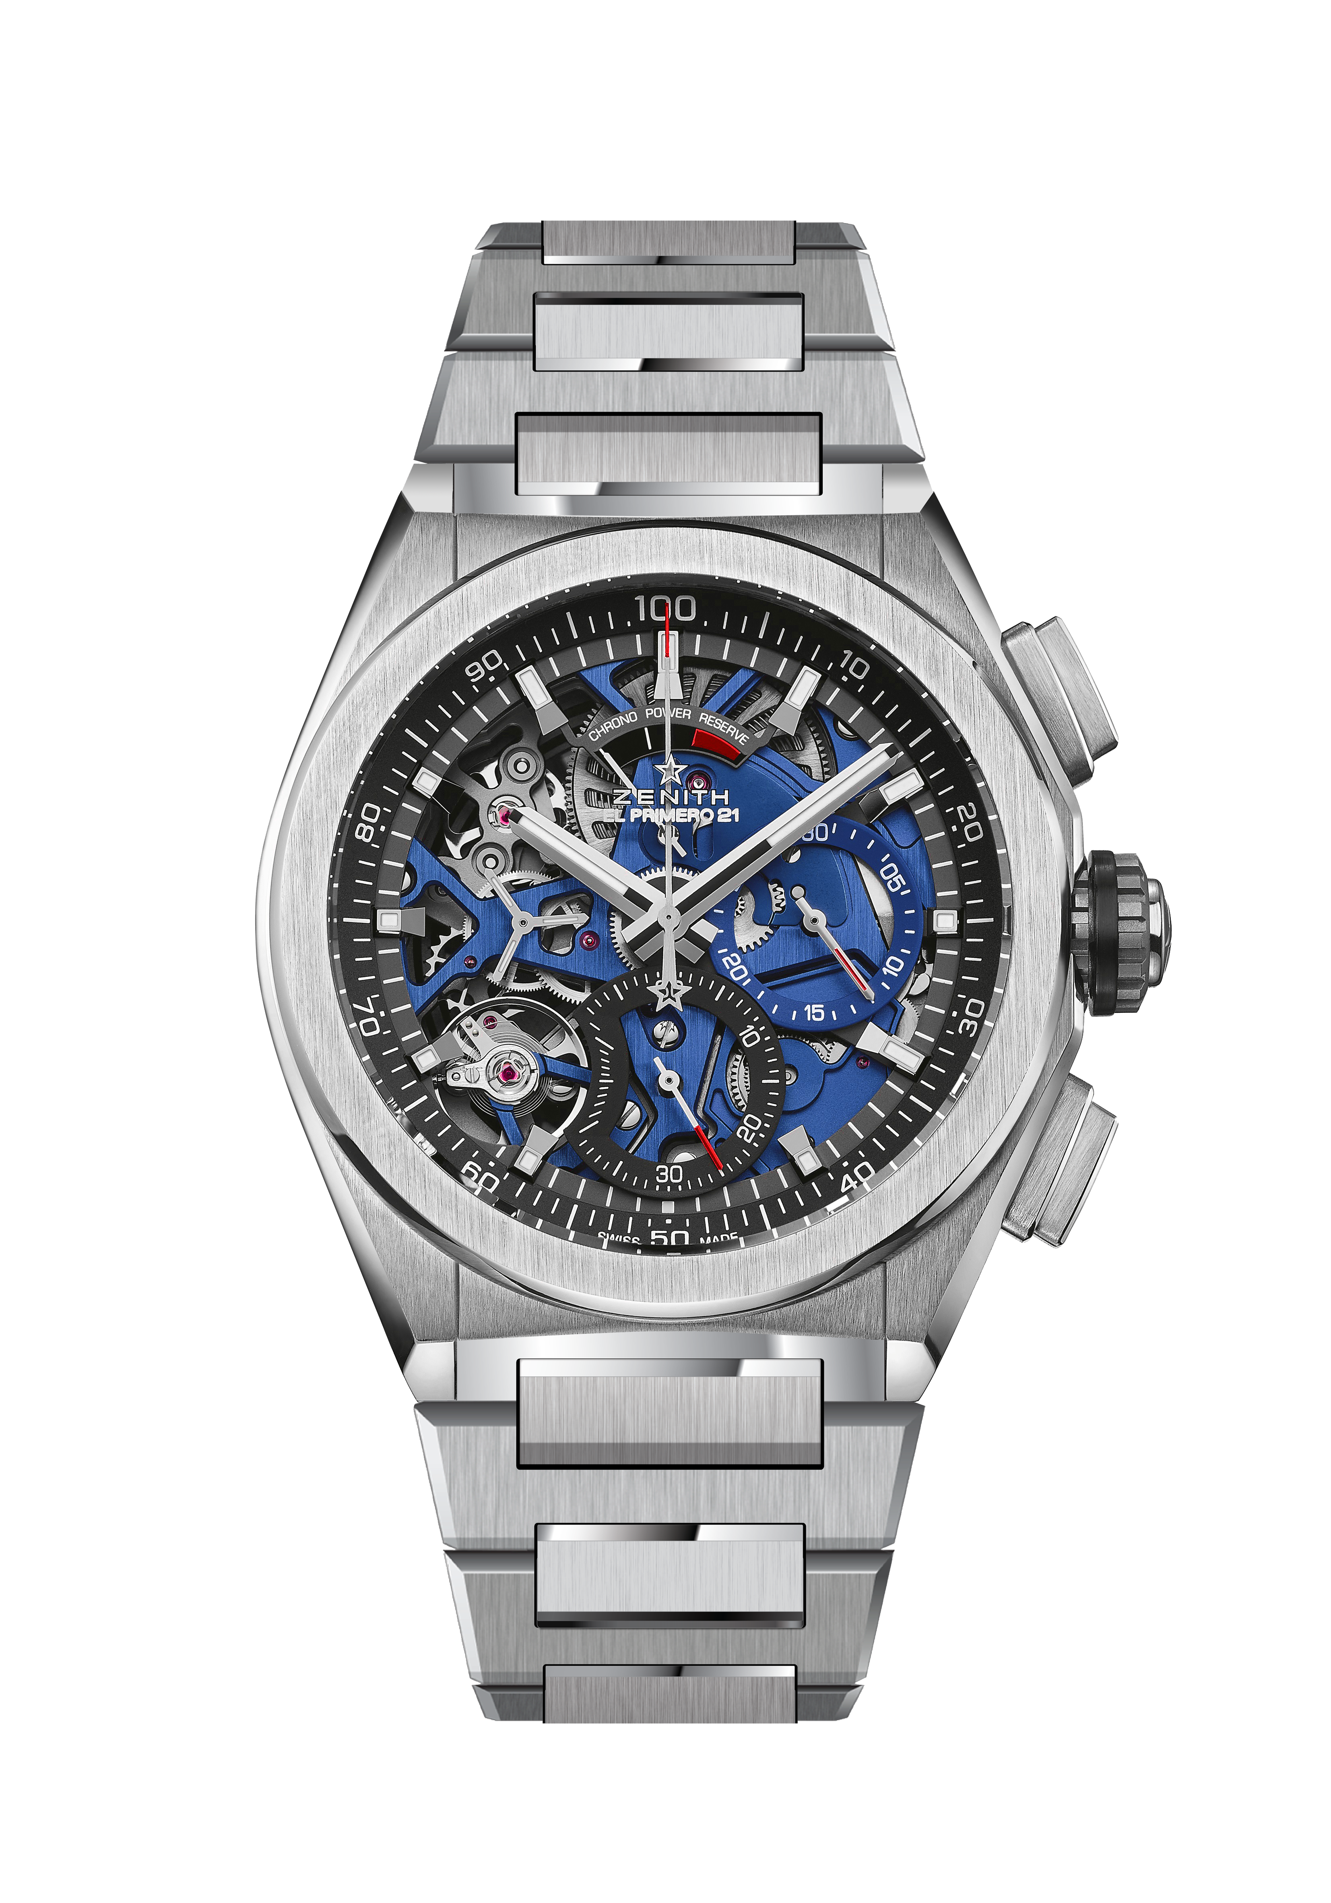
DEFY EL PRIMERO 21 BLUE
TECHNICAL DETAILS
Reference: 95.9002.9004/78.M9000

UNIQUE SELLING POINTS
New 1/100th of a second chronograph movement
Exclusive dynamic signature of one rotation per second
Double-chain structure
1 escapement for the Watch (36,000 VpH - 5 Hz);
1 escapement for the Chronograph (360,000 VpH - 50 Hz)
TIME LAB-Chronometer certified

MOVEMENT
El Primero 9004 automatic
Calibre: 14¼``` (Diameter: 32.80 mm)
Thickness: 7.9 mm
Components: 293
Jewels: 53
Frequency 36,000 VpH (5 Hz)
Power reserve approx. 50 hours
Special oscillating weight with “circular satined” motif
Blue mainplate

FUNCTIONS
1/100th of a second chronograph functions
Chronograph power-reserve indication at 12 o'clock
Hours and minutes in the centre
Small seconds at 9 o'clock
- Central chronograph hand
- 30-minute counter at 3 o'clock
- 60-second counter at 6 o'clock

CASE, DIAL & HANDS
Brushed Titanium case
Diameter: 44 mm
Opening diameter: 35.5 mm
Thickness: 14.50 mm
Crystal: Domed sapphire crystal with anti-reflective treatment on both sides
Case back: Transparent sapphire crystal
Water resistance: 10 ATM
Dial: Openworked with two different-coloured counters
Hour markers: Rhodium-plated, faceted and coated with SuperLuminova
Hands: Rhodium-plated, faceted and coated with SuperLuminova

STRAP AND BUCKLE
Titanium Bracelet

