ZENITH reaches for the skies with two diamond-studded Defy El Primero 21 models

ZENITH gets 2018 off to a star-studded start with the latest special edition of its recently launched Defy El Primero 21 in full diamond regalia. The Defy El Primero 21 Full Diamonds is accompanied by its simpler diamond bezel sibling, recently launched to mark the opening of the brand’s new pop-up store on Paris’ prestigious Place Vendôme.

The Defy El Primero 21 epitomises the new generation of Zenith chronographs, embodying contemporary mechanics endowed with an unprecedented visual, auditory and dynamic identity. Proudly representing the longstanding traditions of a Manufacture with well-proven expertise in the field of chronometry (precision timekeeping), it naturally incorporates the very latest technological breakthroughs.

Two sparkling models celebrate elegance, each in its own way. Naturally integrating all the groundbreaking technological characteristics for which the Defy El Primero 21 made watchmaking headlines in 2017, both variations feature a gleaming 44-mm titanium case and open-worked dial, with red-tipped small seconds at 9 o'clock, central chronograph hand, 60-second counter at 6 o'clock and of course, the Defy’s distinctive contrasting coloured 30-minute counter at 3 o’clock. Endowed with transparent sapphire crystal casebacks, 50-hour power reserve, and supremely comfortable black alligator-coated rubber straps complete with titanium double-folding clasp, both are water-resistant to 10 ATM.

In 2018, the Defy El Primero 21 offers a choice between a distinctive precious touch and no holds barred full diamonds. Epitomising understated elegance, the version that premiered at the exclusive launch of the Zenith pop-up store on the Place Vendôme features a bezel set with 44 baguette-cut diamonds, offset with clean, streamlined faceted rhodium-plated hands and hour-markers. In a spectacular alternative, the brand-new Defy El Primero 21 Full Diamonds takes extravagant style to the next level, complementing the diamond-set bezel by a magnificent array of 288 brilliant-cut diamonds adorning the case, along with 12 glittering diamond hour-markers, totalling a dazzling 5 carats.

These two remarkable Defy El Primero 21 models – beating at the remarkable pace set by the revolutionary TIMELAB chronometer-certified 1/100th of a second chronograph movement that took watchmaking by storm in 2017 – are clearly intended for women who delight in accentuating the precious nature of time.

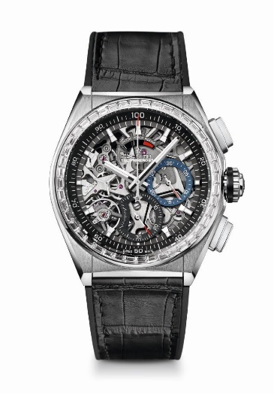
DEFY EL PRIMERO 21 DIAMOND
TECHNICAL DETAILS
Reference: 33.9000.9004/78.R582

New 1/100th of a second chronograph movement
Exclusive dynamic signature of one rotation per second
One escapement for the Watch (36,000 VpH - 5 Hz)
One escapement for the Chronograph (360,000 VpH - 50Hz)
Double-chain structure
TIME LAB Chronometer-certified

MOVEMENT
El Primero 9004 automatic
Calibre: 14¼``` (Diameter: 32.80 mm)
Thickness: 7.9 mm
Components: 293
Jewels: 53
Frequency 36,000 VpH (5 Hz)
Power reserve approx. 50 hours
Special oscillating weight with “circular satin-brushed” motif

FUNCTIONS
1/100th of a second chronograph functions
Chronograph power-reserve indication at 12 o'clock
Hours and minutes in the centre
Small seconds at 9 o'clock
- Central chronograph hand
- 30-minute counter at 3 o'clock
- 60-second counter at 6 o'clock

CASE, DIAL & HANDS
Titanium case
White gold bezel set with baguette-cut diamonds
Diameter: 44 mm
Opening diameter: 35.5 mm
Thickness: 14.50 mm
Crystal: Domed sapphire crystal with anti-reflective treatment on both sides
Case back: Transparent sapphire crystal
Water resistance: 10 ATM
Dial: Openworked
Hour markers: Rhodium-plated, faceted and coated with Super-LumiNova®
Hands: Rhodium-plated, faceted and coated with Super-LumiNova®

STRAP AND BUCKLE
Black rubber coated with black alligator leather
Titanium double folding clasp

GEMSETTING
Bezel: 44 VVS baguette-cut diamonds totalling approx. 2.46 cts

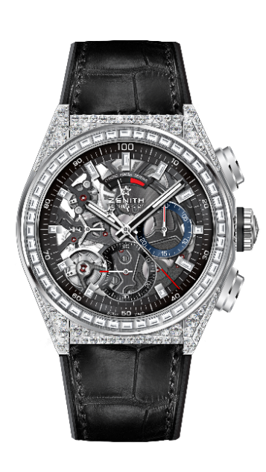

DEFY EL PRIMERO 21 FULL DIAMOND
TECHNICAL DETAILS
Reference: 32.9000.9004/78.R582

New 1/100th of a second chronograph movement
Exclusive dynamic signature of one rotation per second
One escapement for the Watch (36,000 VpH - 5 Hz)
One escapement for the Chronograph (360,000 VpH - 50Hz)
Double-chain structure
TIME LAB Chronometer-certified

MOVEMENT
El Primero 9004 automatic
Calibre: 14¼``` (Diameter: 32.80 mm)
Thickness: 7.9 mm
Components: 293
Jewels: 53
Frequency 36,000 VpH (5 Hz)
Power reserve approx. 50 hours
Special oscillating weight with “circular satin-brushed” motif

FUNCTIONS
1/100th of a second chronograph functions
Chronograph power-reserve indication at 12 o'clock
Hours and minutes in the centre
Small seconds at 9 o'clock
- Central chronograph hand
- 30-minute counter at 3 o'clock
- 60-second counter at 6 o'clock

CASE, DIAL & HANDS
Titanium case with diamonds
White gold bezel set with baguette-cut diamonds
Diameter: 44 mm
Opening diameter: 35.5 mm
Thickness: 14.50 mm
Crystal: Domed sapphire crystal with anti-reflective treatment on both sides
Case back: Transparent sapphire crystal
Water resistance: 10 ATM
Dial: Openworked
Hour markers: Rhodium-plated, faceted and coated with Super-LumiNova®
Hands: Rhodium-plated, faceted and coated with Super-LumiNova®

STRAP AND BUCKLE
Black rubber coated with black alligator leather
Titanium double folding clasp

GEMSETTING
Case: 288 VVS brilliant-cut diamonds
Bezel: 44 VVS baguette-cut diamonds
Carats : approx.. 5.00 cts

