PILOT CRONOMETRO TIPO CP-2 FLYBACK
A new uniform and a high-performance flyback function

Zenith’s iconic PILOT CRONOMETRO TIPO CP-2 is treated to brand-new gear and an eminently useful function for 2018 as the brand with the guiding star revives its famous 1960s Cairelli model with the Pilot TIPO CP-2 FLYBACK. In a choice of bronze or aged stainless steel and with a range of stylish modifications, this subtly altered icon gains a trendy edge while losing nothing of its traditional adventurous DNA.

In October 2016, Zenith presented its tribute to one of the most coveted military pieces, the HERITAGE CRONOMETRO TIPO CP-2, affectionately referred to by collectors as the ‘Cairelli’ watch. It belongs to the exclusive lineage of legendary chronographs that have earned the status of exceptional timepieces in both military and watchmaking history and is one of the historical treasures of the Manufacture in Le Locle. The original piece, a military chronograph created throughout a decade from the mid-1960s on, was commissioned by the Italian Army through the Italian dealership A. Cairelli in Rome. 'CP' stands for cronometro di polso (wrist chronometer). In recent years, the 2,500 units produced by Zenith in the 1960s for the Italian armed forces have fetched sky-high prices on the vintage market.

Today, the brand with a star defies fleeting fashions and indeed time itself with the launch of its Pilot TIPO CP-2 FLYBACK. Now equipped with a cutting-edge automatic El Primero column-wheel chronograph with flyback function, this latest revival of the famous Cairelli model from the 60’s is designed for intrepid adventurers, both male and female. Offering a choice of a bronze or aged stainless steel case, the 2018 Pilot TIPO CP-2 FLYBACK exudes all its intrepid DNA and demanding technical specifications in terms of reliability, indications, readability, and robustness in every situation of its iconic predecessors, while subtly morphing into a highly desirable fashion accessory.

Despite its undeniable appeal to fashion-conscious modern watch lovers, nothing is missing from the impressive range of assets offered by this historic chronograph: hands designed to ensure perfect readability even in tough conditions; bezel enabling reliable and accurate handling; easily accessible and responsive pushers… These signature characteristics testify to impeccable compliance with the drastic set of technical specifications imposed by the military.

Transcending time, the 2018 PILOT CRONOMETRO TIPO CP-2 FLYBACK features the imposing 43 mm stature of its illustrious predecessor, along with a high-precision movement, faceted arrow-shaped hands, Arabic numerals and trademark TIPO CP-2 dial with running seconds and minute counters at 9 o’clock and 3 o’clock respectively.

Ringing the changes
In 2018, however, in keeping with current trends, the troops have been issued with new kit and the retro good looks of the 2018 PILOT CRONOMETRO TIPO CP-2 FLYBACK come in two forms of dress. The first, echoing its aviation antecedents, is turned out in bronze with a matching bronze grained dial and brown oily nubuck leather strap with protective rubber lining. The second, in aged stainless steel, is designed to appeal to those with an affinity for the world of motorbikes, and sports a sober slate grey grained dial and green oily leather strap with protective rubber lining. Both straps are finished with a titanium pin buckle for total security, while the case backs are with a transparent sapphire crystal enabling the owner to have a look at the beautiful El Primero mechanism.

Traditionally powered by another history-maker, the famous Zenith El Primero, the 2018 Pilot TIPO CP-2 FLYBACK is endowed with the ruggedly reliable El Primero 405B version of the movement, beating to the rhythm of 36,000 vibrations per hour, and bringing the convenience of automatic winding with a 50-hour power reserve.

A vivid reminder of the fundamental role played by Zenith in the conquest of the skies, the 2018 Pilot TIPO CP-2 FLYBACK is guaranteed to be a sure-fire hit around adventurers with a thirst for wide horizons.

Xxxx

Keen to find out more?

Origins of an icon
The Manufacture Zenith has a longstanding tradition of supplying watches to armed forces around the world. From 1916 onwards, the U.S., British, German, Polish and Italian armed forces were among those who benefited from the expertise of the Zenith engineers and watchmakers.

In the late 1950s, the Italian armed forces wished to renew the Tipo CP1 chronographs that were standard equipment for pilots of the Aeronautica Militare Italiana and the Marina Militare. The technical specifications called for a model delivering perfect legibility; a 43 mm case that could be worn over pilots’ flight suits; immediate and secure access to the pushers and bezel; and of course a reliability worthy of the most accurate chronometers.
Hand-wound Zenith Calibre 146 DP was one of the most renowned and most reliable movements available at the time. The chronograph christened TIPO CP-2 by the Italian Air Force was delivered by A. Cairelli, the Manufacture’s Rome-based distributor.

The military chronograph code-named TIPO CP-2 featured two counters in its initial version and its 43 mm diameter ensured a degree of legibility that was essential for pilots. The Zenith Calibre DP 146 powering this top-flight instrument was a token of reliability that proved a determining factor in the precision of the missions on which it served. All models were delivered with chronometer-worthy precision timing as specified by the Italian Air Force. Worn by the pilots of the famous American Lockheed F104 Starfighter, these timepieces became an important extension of the onboard instruments installed in the cockpit and rarely left pilots’ wrists, even when they were not on missions, thus exemplifying the powerful ties between each wearer and his timepiece. Zenith’s TIPO CP-2 chronographs remained on the wrists of Italian pilots until the late 1970s and even as late as 1980.

Having now become some of the world’s most sought-after collector’s items, TIPO CP-2 chronographs – often identified by collectors under the name of the distributor “A. Cairelli” – are universally acknowledged as being among the most iconic timepieces in military history.

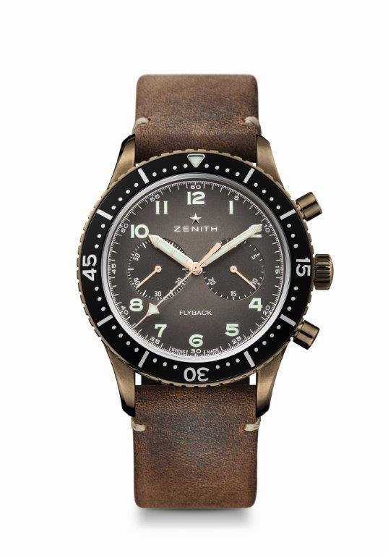

PILOT CRONOMETRO TIPO CP-2 FLYBACK
TECHNICAL DETAILS
Reference: 29.2240.405/18.C801

UNIQUE SELLING POINTS
Revival of the famous Cairelli model from the 1960s
Automatic El primero column-wheel chronograph with flyback function

MOVEMENT
El Primero 405B, Automatic
Calibre: 13¼``` (Diameter: 30 mm)
Thickness: 6.6 mm
Components: 254
Jewels: 31
Frequency: 36,000 VpH (5 Hz)
Power reserve: min. 50 hours
Oscillating weight with “Côtes de Genève” motif

FUNCTIONS
Hours and minutes in the centre
Small seconds at 9 o'clock
Flyback Chronograph:
- Central chronograph hand
- 30-minute counter at 3 o'clock

CASE, DIAL & HANDS
Bronze case
Diameter: 43 mm
Opening diameter: 32.5 mm
Thickness: 12.85 mm
Crystal: Domed sapphire crystal with anti-reflective treatment on both sides
Case back: Transparent sapphire crystal
Water resistance: 10 ATM
Dial: Bronze grained
Hour markers: Arabic numerals in Super-LumiNova®
Hands: Rhodium-plated, faceted and coated with Super-LumiNova®

STRAP AND BUCKLE
Brown oily nubuck leather strap with protective rubber lining
Titanium pin buckle

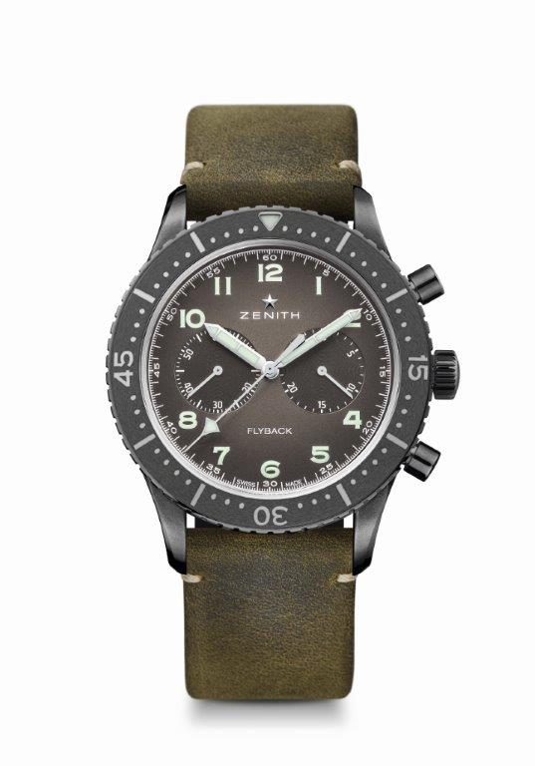

PILOT CRONOMETRO TIPO CP-2 FLYBACK
TECHNICAL DETAILS
Reference: 11.2240.405/21.C773

UNIQUE SELLING POINTS
Revival of the famous Cairelli model from the 60’s
Automatic El primero column-wheel chronograph with flyback function

MOVEMENT
El Primero 405B, Automatic
Calibre: 13¼``` (Diameter: 30 mm)
Thickness: 6.6 mm
Components: 254
Jewels: 31
Frequency: 36,000 VpH (5 Hz)
Power reserve: min. 50 hours
Oscillating weight with “Côtes de Genève” motif

FUNCTIONS
Hours and minutes in the centre
Small seconds at 9 o'clock
Flyback Chronograph:
- Central chronograph hand
- 30-minute counter at 3 o'clock

CASE, DIAL & HANDS
Aged stainless case
Diameter: 43 mm
Opening diameter: 32.5 mm
Thickness: 12.85 mm
Crystal: Domed sapphire crystal with anti-reflective treatment on both sides
Case back: Transparent sapphire crystal
Water resistance: 10 ATM
Dial: Slate grey grained
Hour markers: Arabic numerals in Super-LumiNova®
Hands: Rhodium-plated, faceted and coated with Super-LumiNova®

STRAP AND BUCKLE
Green oily nubuck leather strap with protective rubber lining
Titanium pin buckle

