A smoking start to 2018 for Zenith/Cohiba partnership with Pilot Type 20 special editions

Zenith’s partnership with high-end cigar brand manufacturer Cohiba gets off to a smoking start in 2018, at the 20th prestigious Cuban Habanos Festival, with the launch of two spicy new limited-edition versions of the brand’s celebrated Pilot Type 20 model: the 50-piece Pilot Type 20 Extra Special Cohiba Maduro 5 Edition in 18-carat rose gold and the 150-piece Pilot Type 20 Chronograph Cohiba Maduro 5 Edition in bronze.

An epic year for Zenith, 2017 saw the launch of a number of groundbreaking new references, including two stunning new iterations of the brand’s famous Pilot watch with its imposing presence and adventurous temperament. Showcasing a neo-retro look fuelled by the adventurous spirit of the aviation pioneers that the Manufacture has accompanied since the early days of flight, this famous aviator’s watch expressed its trailblazing style in chronograph mode as the Pilot Type 20 Chronograph Extra Special; and as an automatic alternative in the Pilot Type 20 Extra Special Special Edition.

With its virile bronze case, high-frequency El Primero ‘engine’ and black dial bearing green-emission SLN Arabic numerals, the Pilot Type 20 Chronograph is a natural heir to the onboard instruments developed by Zenith in the early years of aeronautics, known for their precision, sturdiness and outstanding legibility. Its counterpart, the Pilot Type 20 Extra Special Special Edition, is ppowered by an automatic Zenith Elite 679 calibre. Featuring elegant hues and ideal proportions, it naturally lends itself to the most stylish vintage variations while never losing sight of the spirit of adventure that forged its legend.
Like mechanical watches, Habanos cigars have a long cultural history and are a quintessential expression of lifestyle. Aged, full-bodied and with the classic Cohiba finish, the Maduro 5 is no exception to this rule. Contrary to what one might assume, Maduro is not a type of leaf, but a colour shade achieved through an extra fermentation of the wrapper leaves harvested from the very top levels of the shade- grown tobacco plants and ageing longer time than is usual for standard wrapper leaves. The wrapper leaves used for Maduro 5 line belonging Cohiba brand are specially aged for five years. This well-aged wrapper yields the top-quality maduro colour and flavour quality that makes the distinct tasting Maduro 5 cigars.

Shared noble bearing and vintage patina
This year, the partnership launched in 2016 between the iconic Swiss watchmaker and Cuban flagship cigar brand on the occasion of the latter’s 50th anniversary lights up again. What could be more natural for two luxury cult brands to come together in a pair of timepieces distinguished by this shared noble bearing and vintage patina?

So it is that in 2018, in tribute to these legendary and highly sought-after top-end cigars, ZENITH has produced the Pilot Type 20 Extra Special Cohiba Maduro 5 Edition and Pilot Type 20 Chronograph Cohiba Maduro 5 Edition in warm tones of rose gold and bronze respectively. Water resistant to 10 ATM and endowed with a 50-hour power reserve, the

trademark striking case, wide ratcheted easily adjustable crown (along with pushpieces in the case of the Pilot Type 20 Chronograph Cohiba Maduro 5 Edition), and oversized luminescent numerals of the Zenith/Cohiba Pilot watches proudly flaunt all the DNA of a line of airborne conquerors, while emulating the rich tones of the Maduro 5 wrapping.

Produced in a numbered edition of 50 for the Pilot Type 20 Chronograph Cohiba Maduro 5Edition and 150 in bronze for its Pilot Type 20 Cohiba Maduro 5 Edition counterpart, these magnificent timepieces display both the Zenith and the Cohiba logos on their sandblasted black dials. Both feature gold-plated hour and minute hands with a small seconds hand at 9 o’clock on the Pilot Type 20 Chronograph Cohiba Maduro 5 Edition, together with a central chrono hand and 30-minute counter at 3 o’clock. A special titanium caseback bearings the number of the piece in the series, along with the noble name ‘Cohiba Maduro 5’ atop an engraving of Cohiba’s “El Laguito” historical factory*. A brown oily nubuck strap with protective rubber lining, special stitching and titanium pin buckle on the Pilot Type 20 Chronograph Cohiba Maduro 5 Edition; and a brown alligator leather strap with protective rubber lining and matching 18-carat rose gold pin buckle on the Pilot Type 20 Extra Special Cohiba Maduro 5 Edition, set the perfect finishing touches to both these extraordinary collectors’ items.

While taste in any area is subjective, Maduro 5 connoisseurs have a very specific and highly desirable set of expectations and the same could be said of their watchmaking doppelgangers. United by a love of exceptional style and quality, aficionados of both fine Cuban cigars and magnificent timepieces are sure to be captivated by these latest spectacular embodiments of this unlikely, yet highly successful partnership between two totally unrelated but fully complementary industries.
* While it is possible to visit the Zenith location in Le Locle, Switzerland, and to experience how human hands seem to magically breathe life into an El Primero movement, the cigar manufacturer “El Laguito” appears virtually sealed off in its location in Cubanacán on the outskirts of the Cuban capital, Havana. Not because Cohiba has something to hide, but because the more than 300 employees must carefully attend to their work. A Cohiba cigar, as shown most impressively during a tour, still remains a totally handmade product.

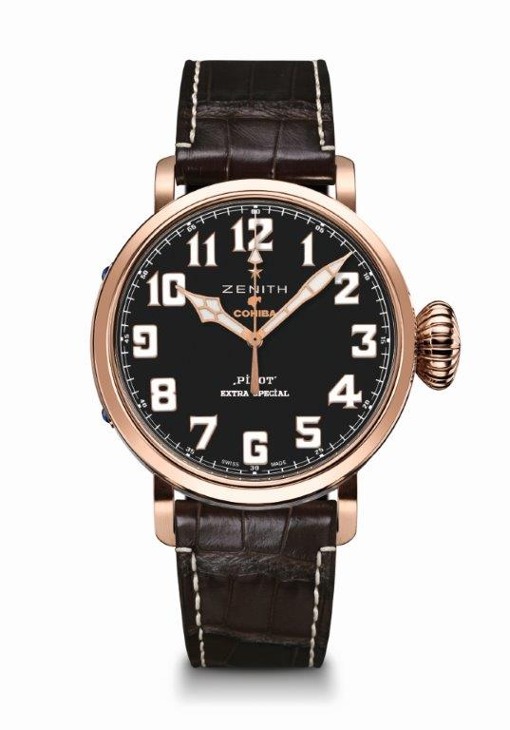
PILOT TYPE 20 EXTRA SPECIAL
COHIBA-MADURO 5 EDITION
TECHNICAL DETAILS

Limited Edition of 50 units
paying tribute to Cohiba’s high end collection (Maduro 5)

Reference: 18.2430.679/27.C721

MOVEMENT
Elite 679, Automatic
Calibre 11 ½``` (Diameter: 25.6 mm)
Movement thickness: 3.85 mm
Components: 126
Jewels: 27
Frequency: 28,800 VpH (4 Hz)
Power-reserve: min. 50 hours
Finishes: Oscillating weight with “Côtes de Genève” motif

FUNCTIONS
Hours and minutes in the centre
Central seconds hand

CASE, DIAL & HANDS
Material: 18-ct rose gold
Diameter: 45 mm
Dial-opening diameter: 37.80 mm
Thickness: 14.25 mm
Crystal: Domed sapphire crystal with anti-reflective treatment on both sides
Case-back: 18-ct rose gold engraved with “El Laguito” (Cohiba’s historical building)
Water-resistance: 10 ATM
Dial: Black adorned with Cohiba’s logo
Hour-markers: Arabic numerals in Super-LumiNova® SLN C1
Hands: gold-plated, faceted and coated with Super-LumiNova® SLN C1

STRAPS & BUCKLES
Strap reference: 27.00.2321.721
Brown alligator leather strap with protective rubber lining
Buckle reference: 27.18.0021.001
18-ct rose gold pin buckle

LIMITED EDITION OF 50 UNITS

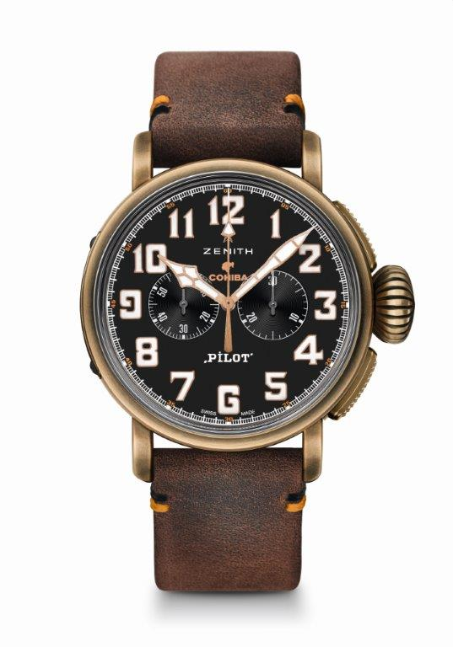
PILOT TYPE 20 EXTRA SPECIAL
CHRONOGRAPH COHIBA-MADURO 5 EDITION
TECHNICAL DETAILS

Limited Edition of 150 units
paying tribute to Cohiba’s high end collection (Maduro 5)

Reference: 29.2432.4069/27.C794

MOVEMENT
El Primero 4069, Automatic
Calibre 13 ¼ ``` (Diameter: 30 mm)
Movement thickness: 6.60 mm
Components: 254
Jewels: 35
Frequency: 36,000 VpH (5 Hz)
Power-reserve: min. 50 hours
Finishes: Oscillating weight with “Côtes de Genève” motif

FUNCTIONS
Hours and minutes in the centre
Small second at 9 o’clock
Chronograph :
Central chrono hand
30-min counter at 3 o’clock

CASE, DIAL & HANDS
Material: Bronze
Diameter: 45 mm
Dial-opening diameter: 37.80 mm
Thickness: 14.25 mm
Crystal: Domed sapphire crystal with anti-reflective treatment on both sides
Case-back: Titanium case-back engraved with “El Laguito” (Cohiba’s historical building)
Water-resistance: 10 ATM
Dial: Black adorned with Cohiba’s logo
Hour-markers: Arabic numerals in Super-LumiNova® SLN C1
Hands: gold-plated, faceted and coated with Super-LumiNova® SLN C1

STRAPS & BUCKLES
Strap reference: 27.00.2321.794
Brown oily nubuck strap with protective rubber lining
Buckle reference: 27.95.0021.001
Titanium pin buckle

LIMITED EDITION OF 150 UNITS

