Pilot Type 20 Extra Special 40 mm
Going for Bronze

Inspired by the legendary Zenith aviation watches of yesteryear, in 2018 the brand with a star adds a new dimension to its iconic Pilot Collection with a 40mm case in glowing bronze. Featuring the broad fluted crown, oversized luminescent numerals, and in-house automatic ‘engine’ of its predecessors, the latest in the line-up is magnificently offset by a choice of matt blue or black dials with matching blue or eminently military khaki green oily nubuck straps and contrasting stitching.

In 2018 Zenith’s famous Pilot Type 20 Extra Special 40 mm goes for bronze – vintage style, once again combining its imposing yet manageable 40mm presence and ideal proportions with a choice of elegant hues. Embodying all the attributes inherited from aviation’s pioneering days, and with its format suited to every wrist, this latest iteration of the Pilot Type 20 Extra Special 40 mm rounds out an already emblematic range from Zenith, thus far composed of large-size watches. Hailing from an all-conquering lineage, this distinctive model featuring more ‘democratic’ 21st century dimensions continues to house the same original attributes: an in-house movement, a broad fluted crown and large luminescent Arabic numerals swept over by finely crafted hands.
Authentic nature
While never losing sight of the spirit of adventure that forged its legend, this distinctive and classy watch lends itself to the most stylish vintage variations, setting the seal on its trendy neo-retro bronze look with black or blue matt-finish dials and oily nubuck straps in either khaki green or blue. Both feature protective rubber lining for optimum comfort and a titanium pin buckle. Optimal legibility is ensured by an aeronautically inspired font composed of white Super-LumiNova® blocks, along with white luminescent facetted hands to ensure daylight vision even at the darkest hour.
At the heart of the Pilot Type 20 Extra Special 40 mm beats the automatic Zenith Elite 679 calibre. This reliable and accurate in-house movement drives central hours, minutes and seconds hands, while delivering a 50-hour power reserve. In a nod to the history of the Maison, the solid bronze case-back depicts the plane flown by Louis Blériot when he crossed the Channel in 1909 with a ZENITH on his wrist, along with the ZENITH flight instruments logo, complemented by a motif inspired by the fuselage of the legendary French pilot’s aircraft
Ensuring its appeal to those with a penchant for both the skies and the deep, the Pilot Type 20 Extra Special 40 mm in bronze is water-resistant to 100m.

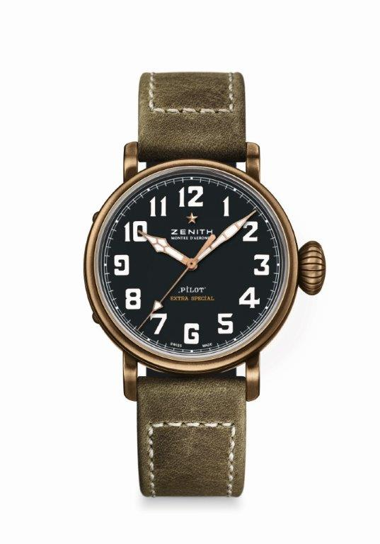
PILOT TYPE 20 EXTRA SPECIAL
40 MM BRONZE
TECHNICAL DETAILS

Reference: 29.1940.679/21.C800

KEY POINTS
New case in bronze
Inspired by the legendary Zenith aviation watches
Arabic numerals entirely made of Super-LumiNova®

MOVEMENT
Elite 679, Automatic
Calibre: 11 ½``` (Diameter: 25.60mm)
Movement thickness: 3.85mm
Components: 126
Jewels: 27
Frequency: 28,800 VpH (4Hz)
Power-reserve: min. 50 hours
Finishes: Oscillating weight with “Côtes de Genève” motif

FUNCTIONS
Hours and minutes in the centre
Central seconds hand

CASE, DIAL & HANDS
Diameter: 40mm
Opening diameter: 33.1mm
Thickness: 12.95mm
Crystal: Domed sapphire crystal with anti-reflective treatment on both sides
Case-back: Titanium case-back engraved with the ZENITH flying instruments logo
Material: Bronze
Water-resistance: 10 ATM
Dial: Matt black
Hour-makers: Arabic numerals in Super-LumiNova® SLN C1 [Hour-markers]
Hands: Gold-plated, faceted and coated with Super-LumiNova® SLN C1 [Hands]

STRAPS & BUCKLES
Bracelet: Reference: 27.00.2018.800
Designation: Green oily nubuck leather strap with protective rubber lining
Buckle: Reference: 27.95.0031.001
Designation: Titanium pin buckle

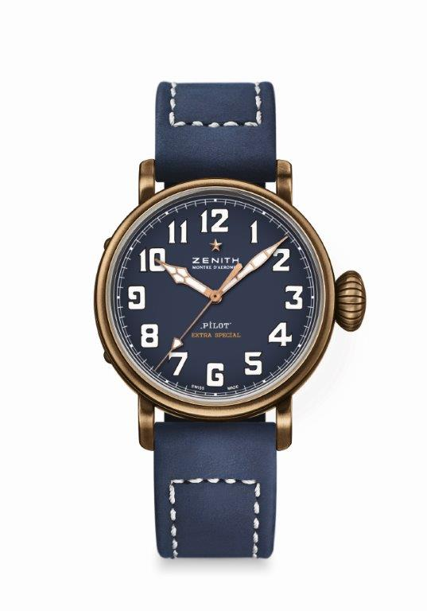
PILOT TYPE 20 EXTRA SPECIAL
40 MM BRONZE
TECHNICAL DETAILS

Reference: 29.1940.679/57.C808

KEY POINTS
New case in bronze
Inspired by the legendary Zenith aviation watches
Arabic numerals entirely made of Super-LumiNova®

MOVEMENT
Elite 679, Automatic
Calibre: 11 ½``` (Diameter: 25.60mm)
Movement thickness: 3.85mm
Components: 126
Jewels: 27
Frequency: 28,800 VpH (4Hz)
Power-reserve: min. 50 hours
Finishes: Oscillating weight with “Côtes de Genève” motif

FUNCTIONS
Hours and minutes in the centre
Central seconds hand

CASE, DIAL & HANDS
Diameter: 40mm
Diameter opening: 33.1mm
Thickness: 12.95mm
Crystal: Domed sapphire crystal with anti-reflective treatment on both sides
Case-back: Titanium case-back engraved with the ZENITH flying instruments logo
Material: Bronze
Water-resistance: 10 ATM
Dial: Matt blue
Hour-makers: Arabic numerals in Super-LumiNova® SLN C1 [Hour-markers]
Hands: Gold-plated, faceted and coated with Super-LumiNova® SLN C1 [Hands]

STRAPS & BUCKLES
Bracelet: Reference: 27.00.2018.808
Designation: Blue oily nubuck leather strap with protective rubber lining
Buckle: Reference: 27.95.0031.001
Designation: Titanium pin buckle

