Pilot Type 20 Extra Special Chronograph
A class of its own

With its imposing bronze case, easily adjustable wide fluted crown, oversized luminescent numerals and a high-beat El Primero mechanism, ZENITH’s Pilot Type 20 Extra Special Chronograph proudly flaunts the DNA of a line of airborne conquerors. In 2018, the trailblazing style of this famous aviator’s watch showcases its neo-retro chronograph look with a new matt blue dial. Combined with a blue oily nubuck leather straps, and fueled by an adventurous spirit exactly like that of the aviation pioneers that the Manufacture accompanied right from the early days of flight, what’s not to love?
_________________________________________________________________________
Distinguished by its noble bearing and vintage patina, the Pilot Extra Special Chronograph is imbued with the intrepid heritage of high-flying heroes. A natural heir to the onboard instruments developed by ZENITH in the early years of aeronautics and known for their precision, sturdiness and outstanding legibility, this chronograph – with its virile bronze case, its high-frequency El Primero ‘engine’ and its blue dial bearing white (green-emission) SLN Arabic numerals – sports the vigorous typology of these iconic pilot’s watches.
Bronze fuselage
Framing an oversized luminescent display guaranteeing peerless readability, the substantial 45 mm-diameter case – featuring a large crown and fluted pushpieces facilitating adjustment with gloved hands – is made of bronze: a highly resistant anti-magnetic alloy that acquires a natural patina giving it a unique vintage touch.
Topped by a domed sapphire crystal, the matt blue dial picks up the font of the original large Arabic numerals, made from blocks of white (green-emission) Super-LumiNova® SLN C1. The gold-plated luminescent facetted hands sweep over this distinctive watch face, also punctuated by two counters and a railway-type minutes track. The inscriptions “Montre d’Aéronef” and “Pilot” are a reminder that the Manufacture was one of the first producers of altimeters and cockpit watches at the dawn of military and civil aviation.
Dizzying mechanism
At the heart of its bronze case hums an ‘engine’ known for its legendary precision: El Primero Calibre 4069. This high-frequency column-wheel chronograph movement is a descendant of the world’s most accurate series-made chronograph, developed by ZENITH and presented in 1969. Beating at a rate of 5Hz enabling a tenth-of-a-second display, it drives the central hours and minutes, small seconds and chronograph functions, while ensuring a 50-hour power reserve.
In a nod to its aviation origins, the solid titanium case-back depicts the plane flown by Louis Blériot when he crossed the Channel in 1909 with a ZENITH on his wrist, along with the ZENITH flight instruments logo, complemented by a motif inspired by the fuselage of the legendary French pilot’s aircraft. Built for exploring far horizons, this Pilot Extra Special is harnessed to the wrist by a blue oily nubuck leather strap and secured by a titanium pin buckle. A bold and beautiful timepiece for high-flying watch enthusiasts.

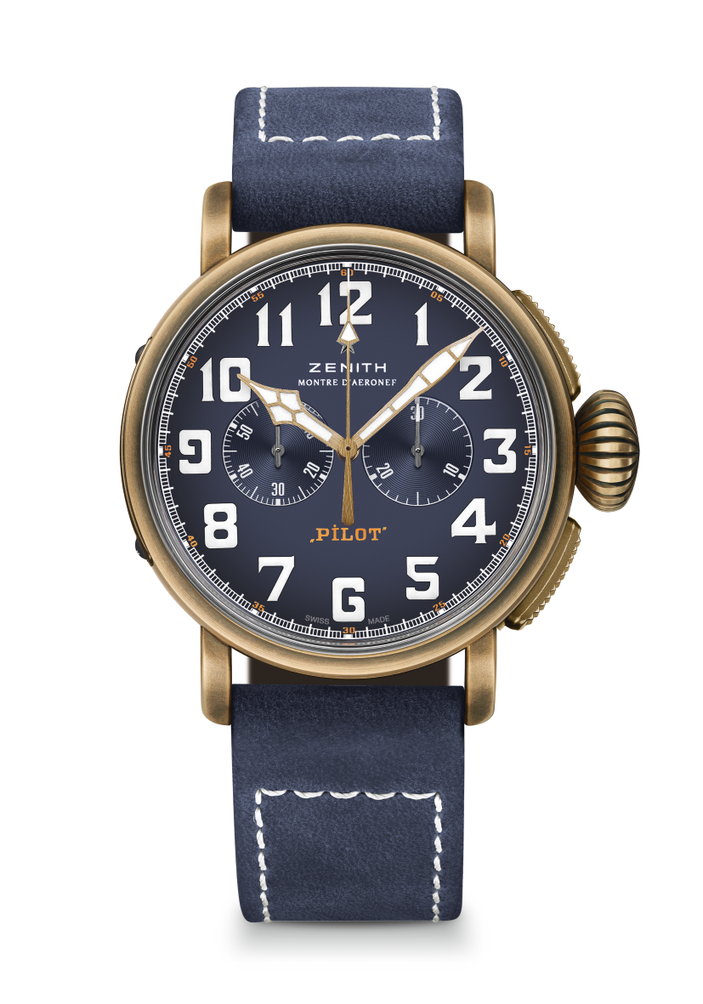
PILOT TYPE 20 EXTRA SPECIAL CHRONOGRAPH
BRONZE BLUE DIAL
TECHNICAL DETAILS

Reference: 29.2430.4069/57.C808

KEY POINTS
Bronze Case
Automatic El Primero column wheel chronograph
Case back engraved with ZENITH flying instruments logo
Arabic numerals entirely made of SuperLumiNova®

MOVEMENT
El Primero 4069, Automatic
Calibre: 13 ¼``` (Diameter: 30mm)
Movement thickness: 6.6mm
Components: 254
Jewels: 35
Frequency: 36,000 VpH (5Hz)
Power-reserve: min. 50 hours
Finishes: Oscillating weight with “Côtes de Genève” motif

FUNCTIONS
Hours and minutes in the centre
Small seconds at 9 o’clock
Chronograph: Central chronograph hand & 30-minute counter at 3 o’clock

CASE, DIAL & HANDS
Diameter: 45mm
Diameter opening: 37.8mm
Thickness: 14.25mm
Crystal: Domed sapphire crystal with anti-reflective treatment on both sides
Case-back: Titanium case-back engraved with the ZENITH flying instruments logo
Material: Bronze
Water-resistance: 10 ATM
Dial: Matt blue
Hour-makers: Arabic numerals with white SuperLumiNova® SLN C1
Hands: Gold-plated, faceted and coated with white SuperLumiNova®SLN C1 [Hands]

STRAPS & BUCKLES
Bracelet: Reference: 27.00.2321.808
Designation: Blue oily nubuck leather strap with protective rubber lining
Buckle: Reference: 27.95.0021.001
Designation: Titanium pin buckle

