The DEFY CLASSIC collection now available
in stores the world over

Following its successful launch at Baselworld 2018, the high-performance DEFY CLASSIC collection, radiating refined and sporty elegance is finding its place in ZENITH boutiques and at retailers representing the Maison.

A gateway into the contemporary universe of the DEFY collection, the new DEFY CLASSIC takes casual urban elegance to a whole new level. Designed for style-conscious urbanites, the charismatic DEFY CLASSIC with its 41mm ultra-light titanium case and star-themed openworked dial offers fascinating views of the reliable and accurate Manufacture ZENITH automatic Elite 670 base calibre. Blackened, structured and topped by a cut-out date disc read off on a white dot at 6 o’clock, the movement oscillates at 4 Hz and offers its owner over 50 hours of autonomy. In a nod to the collection’s legendary origins, the deep blue minutes ring is the exact same shade as its illustrious predecessor, the 1969 El Primero.
The choice of a closed dial will also appeal to those with a preference for timeless understatement.
The DEFY CLASSIC subtly combines casual chic with technical refinement and utterly reliable performance.

Fitted with an integrated metal bracelet composed of supple links, a strap version featuring rubber coated with alligator leather or an all-rubber option, the line is at home in any situation an active contemporary lifestyle may bring.

ZENITH: The Future of Swiss Watchmaking
Since 1865, Zenith has been guided by authenticity, daring and passion in pushing the boundaries of excellence, precision and innovation. Soon after its founding in Le Locle by visionary watchmaker Georges Favre-Jacot, Zenith gained recognition for the precision of its chronometers, with which it has won 2,333 chronometry prizes in just over a century and a half of existence: an absolute record. Famed for its legendary 1969 El Primero calibre enabling short-time measurements accurate to the nearest 1/10th of a second, the Manufacture has since developed over 600 movement variations. Today, Zenith offers new and fascinating vistas in time measurement, including 1/100th of a second timing with the Defy El Primero 21; and a whole new dimension in mechanical precision with the world’s most accurate watch, the 21st century Defy Lab. Energised by newly reinforced ties with a proud tradition of dynamic, avant-garde thinking, Zenith is writing its future… and the future of Swiss watchmaking.

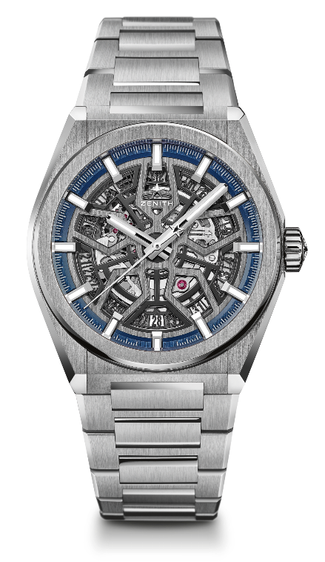
DEFY CLASSIC
TECHNICAL DETAILS

Reference: 95.9000.670/78.M9000

KEY POINTS
New Elite skeletonised movement
New 41mm brushed titanium case
Silicon escape-wheel and lever

MOVEMENT
Elite 670 SK, Automatic
Calibre: 11 ½``` (Diameter: 25.60mm)
Movement thickness: 3.88mm
Components: 187
Jewels: 27
Frequency: 28,800 VpH (4Hz)
Power-reserve: min. 48 hours
Finishing: Special oscillating weight with satin-brushed finish

FUNCTIONS
Hours and minutes in the centre
Central seconds hand
Date indication at 6 o’clock

CASE, DIAL & HANDS
Diameter: 41mm
Diameter opening: 32.5mm
Thickness: 10.75mm
Crystal: Domed sapphire crystal with anti-reflective treatment on both sides
Case-back: Transparent sapphire crystal
Material: Brushed Titanium
Water-resistance: 10 ATM
Dial: Openworked
Hour-markers: Rhodium-plated, faceted and coated with Super-LumiNova® SLN C1
Hands: Rhodium-plated, faceted and coated with Super-LumiNova® SLN C1

STRAP & BUCKLE
Bracelet: Reference: 27.95.9000.670
Designation: Titanium bracelet

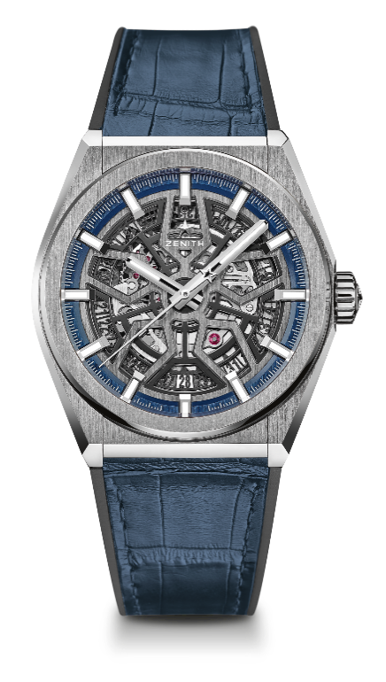
DEFY CLASSIC
TECHNICAL DETAILS

Reference: 95.9000.670/78.R584

KEY POINTS
New Elite skeletonised movement
New 41mm brushed titanium case
Silicon escape-wheel and lever

MOVEMENT
Elite 670 SK, Automatic
Calibre: 11 ½``` (Diameter: 25.60mm)
Movement thickness: 3.88mm
Components: 187
Jewels: 27
Frequency: 28,800 VpH (4Hz)
Power-reserve: min. 48 hours
Finishing: Special oscillating weight with satin-brushed finish

FUNCTIONS
Hours and minutes in the centre
Central seconds hand
Date indication at 6 o’clock

CASE, DIAL & HANDS
Diameter: 41mm
Diameter opening: 32.5mm
Thickness: 10.75mm
Crystal: Domed sapphire crystal with anti-reflective treatment on both sides
Case-back: Transparent sapphire crystal
Material: Brushed titanium
Water-resistance: 10 ATM
Dial: Openworked
Hour-markers: Rhodium-plated, faceted and coated with Super-LumiNova® SLN C1
Hands: Rhodium-plated, faceted and coated with Super-LumiNova® SLN C1

STRAP & BUCKLE
Strap: Reference: 27.00.2218.584
Designation: Black rubber with blue alligator leather coating
Buckle: Reference: 27.95.0018.930
Designation: Titanium double folding clasp

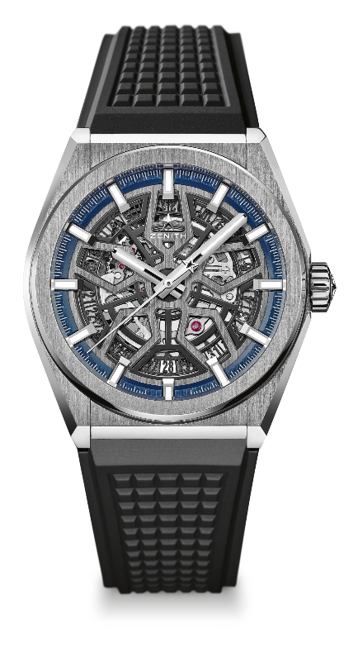
DEFY CLASSIC
TECHNICAL DETAILS

Reference: 95.9000.670/78.R782

KEY POINTS
New Elite skeletonised movement
New 41mm brushed titanium case
Silicon escape-wheel and lever

MOVEMENT
Elite 670 SK, Automatic
Calibre: 11 ½``` (Diameter: 25.60mm)
Movement thickness: 3.88mm
Components: 187
Jewels: 27
Frequency: 28,800 VpH (4Hz)
Power-reserve: min. 48 hours
Finishing: Special oscillating weight with satin-brushed finish

FUNCTIONS
Hours and minutes in the centre
Central seconds hand
Date indication at 6 o’clock

CASE, DIAL & HANDS
Diameter: 41mm
Diameter opening: 32.5mm
Thickness: 10.75mm
Crystal: Domed sapphire crystal with anti-reflective treatment on both sides
Case-back: Transparent sapphire crystal
Material: Brushed titanium
Water-resistance: 10 ATM
Dial: Openworked
Hour-markers: Rhodium-plated, faceted and coated with Super-LumiNova® SLN C
Hands: Rhodium-plated, faceted and coated with Super-LumiNova® SLN C1

STRAP & BUCKLE
Strap: Reference: 27.00.2218.782
Designation: Black rubber
Buckle: Reference: 27.95.0018.930
Designation: Titanium double folding clasp

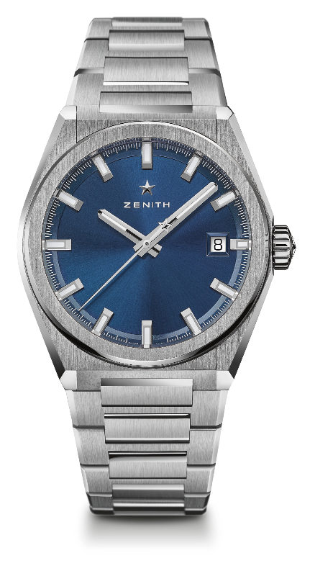
DEFY CLASSIC
TECHNICAL DETAILS

Reference: 95.9000.670/51.M9000

KEY POINTS
New Elite skeletonised movement
New 41mm brushed titanium case
Silicon escape-wheel and lever

MOVEMENT
Elite 670 SK, Automatic
Calibre: 11 ½``` (Diameter: 25.60mm)
Movement thickness: 3.88mm
Components: 187
Jewels: 27
Frequency: 28,800 VpH (4Hz)
Power-reserve: min. 48 hours
Finishing: Special oscillating weight with satin-brushed finish

FUNCTIONS
Hours and minutes in the centre
Central seconds hand
Date indication at 3 o’clock

CASE, DIAL & HANDS
Diameter: 41mm
Diameter opening: 32.5mm
Thickness: 10.75mm
Crystal: Domed sapphire crystal with anti-reflective treatment on both sides
Case-back: Transparent sapphire crystal
Material: Brushed titanium
Water-resistance: 10 ATM
Dial: Blue-toned sunray-patterned
Hour-markers: Rhodium-plated, faceted and coated with Super-LumiNova® SLN C1
Hands: Rhodium-plated and faceted gold, coated with Super-LumiNova® SLN C1

STRAP & BUCKLE
Bracelet: Reference: 27.95.9000.670
Designation: Titanium bracelet

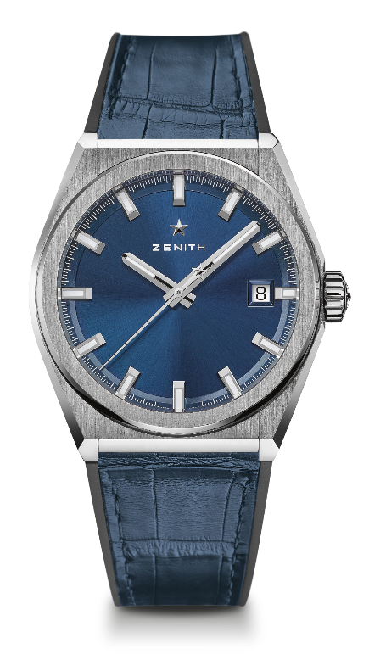
DEFY CLASSIC
TECHNICAL DETAILS

Reference: 95.9000.670/51.R584

KEY POINTS
New Elite skeletonised movement
New 41-MM Brushed Titanium case
Silicon escape-wheel and lever

MOVEMENT
Elite 670 SK, Automatic
Calibre: 11 ½``` (Diameter: 25.60mm)
Movement thickness: 3.88mm
Components: 187
Jewels: 27
Frequency: 28,800 VpH (4Hz)
Power-reserve: min. 48 hours
Finishing: Special oscillating weight with satin-brushed finish

FUNCTIONS
Hours and minutes in the centre
Central seconds hand
Date indication at 3 o’clock

CASE, DIAL & HANDS
Diameter: 41mm
Diameter opening: 32.5mm
Thickness: 10.75mm
Crystal: Domed sapphire crystal with anti-reflective treatment on both sides
Case-back: Transparent sapphire crystal
Material: Brushed titanium
Water-resistance: 10 ATM
Dial: Blue-toned sunray-patterned
Hour-markers: Rhodium-plated, faceted and coated with Super-LumiNova® SLN C1
Hands: Rhodium-plated and faceted gold, coated with Super-LumiNova® SLN C1

STRAP & BUCKLE
Strap: Reference: 27.00.2218.584
Designation: Black rubber with blue alligator leather coating
Buckle: Reference: 27.95.0018.930
Designation: Titanium double folding clasp

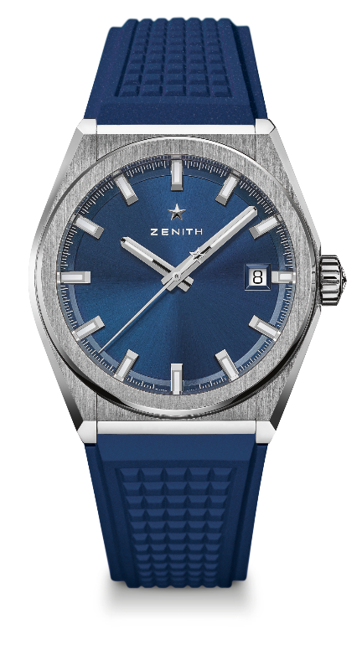
DEFY CLASSIC
TECHNICAL DETAILS

Reference: 95.9000.670/51.R790

KEY POINTS
New Elite skeletonised movement
New 41mm brushed titanium case
Silicon escape-wheel and lever

MOVEMENT
Elite 670 SK, Automatic
Calibre: 11 ½``` (Diameter: 25.60mm)
Movement thickness: 3.88mm
Components: 187
Jewels: 27
Frequency: 28,800 VpH (4Hz)
Power-reserve: min. 48 hours
Finishing: Special oscillating weight with satin-brushed finish

FUNCTIONS
Hours and minutes in the centre
Central seconds hand
Date indication at 3 o’clock

CASE, DIAL & HANDS
Diameter: 41mm
Diameter opening: 32.5mm
Thickness: 10.75mm
Crystal: Domed sapphire crystal with anti-reflective treatment on both sides
Case-back: Transparent sapphire crystal
Material: Brushed titanium
Water-resistance: 10 ATM
Dial: Blue-toned sunray-patterned
Hour-markers: Rhodium-plated, faceted and coated with Super-LumiNova® SLN C1
Hands: Rhodium-plated and faceted gold, coated with Super-LumiNova® SLN C1

STRAP & BUCKLE
Strap: Reference: 27.00.2218.790
Designation: Blue rubber
Buckle: Reference: 27.95.0018.930
Designation: Titanium double folding clasp

