ZENITH celebrates Porto Cervo

ZENITH, the brand with a guiding star, sets a course for its all-new Porto Cervo pop-up pod and the launch of a 25-piece special edition DEFY EL PRIMERO 21 PORTO CERVO in maritime dress.

June 29th 2018 will see ZENITH take up temporary residence on Sardinia’s Emerald Coast with the opening of an innovative pop-up pod featuring all the latest technology… and the launch of the DEFY EL PRIMERO 21 PORTO CERVO. Starring an interactive hologram of the groundbreaking Defy Lab, this ephemeral in-store experience will run through to September 8th 2018.

Dropping anchor in Porto Cervo
With its translucent waters and offshore islands, Porto Cervo is a one-of-a-kind location to which the brand with a guiding star is bringing its unique touch this summer with a celebratory model. Like its predecessors, the 25-piece limited edition TIME LAB-Chronometer certified DEFY EL PRIMERO 21 PORTO CERVO features a gleaming 44 mm titanium case inspired by the shape of the original El Primero models from the early 1970s. A pristine white ceramic bezel surrounds the DEFY EL PRIMERO 21 PORTO CERVO’s white skeleton dial revealing the contemporary decor and key identifying characteristics epitomising the face of the new Zenith range. Deep blue accents on the hour-markers, hands and crown offset its streamlined white and titanium good looks, with a blue and white chronograph power-reserve indication appearing at 12 o'clock, hours and minutes in the centre, small seconds at 9 o'clock, along with white 60-second and 30-minute counters at 6 o'clock and 3 o'clock respectively.

Riding the crest of a wave
The DEFY EL PRIMERO 21 PORTO CERVO offers a choice of two striking straps including white rubber covered with a sophisticated blue alligator leather coating and the comfort of supple white rubber both finished with the EL PRIMERO 21’s trademark titanium double folding clasp. Complete with a case back bearing the engraved design of a yacht on the crest of a wave and the name Porto Cervo, the DEFY EL PRIMERO 21 PORTO CERVO is the quintessential statement piece for aficionados of 21st century elegance and performance in search of a uniquely colourful and confident summer lifestyle. Driven by a movement enabling 1/100th of a second precision and endowed with a 50-hour power reserve, every one of these 25 numbered timepieces is an unmistakable reminder of its namesake’s lifestyle.

ZENITH: The Future of Swiss Watchmaking
Since 1865, Zenith has been guided by authenticity, daring and passion in pushing the boundaries of excellence, precision and innovation. Soon after its founding in Le Locle by visionary watchmaker Georges Favre-Jacot, Zenith gained recognition for the precision of its chronometers, with which it has won 2,333 chronometry prizes in just over a century and a half of existence: an absolute record. Famed for its legendary 1969 El Primero calibre enabling short-time measurements accurate to the nearest 1/10th of a second, the Manufacture has since developed over 600 movement variations. Today, Zenith offers new and fascinating vistas in time measurement, including 1/100th of a second timing with the Defy El Primero 21; and a whole new dimension in mechanical precision with the world’s most accurate watch, the 21st century Defy Lab. Energised by newly reinforced ties with a proud tradition of dynamic, avant-garde thinking, Zenith is writing its future… and the future of Swiss watchmaking.
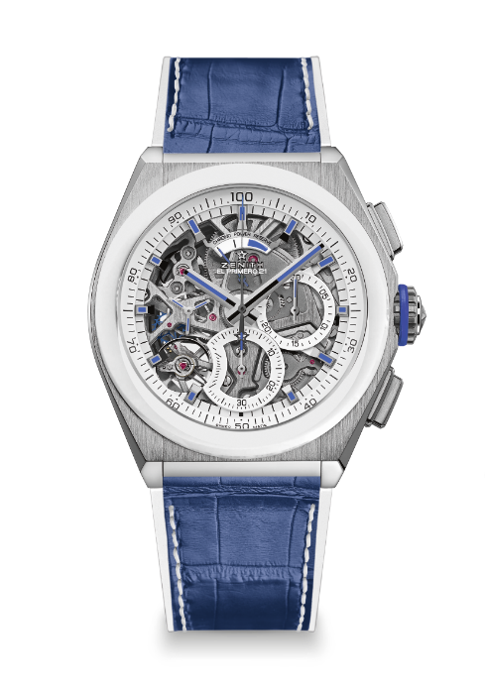
DEFY EL PRIMERO 21 PORTO CERVO EDITION
TECHNICAL DETAILS
Limited Edition of 25 units

Reference: 95.9007.9004/77.R594

KEY POINTS
New 1/100th of a second
Chronograph movement
Exclusive dynamic signature of one rotation per second
1 escapement for the Watch (36,000 VpH – 5 Hz);
1 escapement for the Chronograph (360,000 VpH – 50 Hz)
Certified Chronometer

MOVEMENT
El Primero 9004, Automatic
Calibre: 14 ½``` (Diameter: 32 mm)
Movement thickness: 7.9 mm
Components: 293
Jewels: 53
Frequency: 36,000 VpH (5 Hz)
Power-reserve: min. 50 hours
Finishing: Special oscillating weight with satined finishings

FUNCTIONS
Hours and minutes in the centre
Small seconds at 9 o’clock
1/100th of a second Chronograph:
- Central chronograph hand
- 30-minute counter at 3 o’clock
- 60-second counter at 6 o’clock
- Chronograph power-reserve indication at 12 o’clock

CASE, DIAL & HANDS
Material: Brushed Titanium & White Ceramic bezel
Diameter: 44 mm
Diameter opening: 35.5 mm
Thickness: 14.50 mm
Crystal: Domed sapphire crystal with anti-reflective treatment on both sides
Case-back: Transparent sapphire crystal bearing Porto Cervo representation
Water-resistance: 10 ATM
Dial: Openworked
Hour-markers: Rhodium-plated, faceted and coated with blue varnish
Hands: Rhodium-plated, faceted and coated with blue varnish

STRAP & BUCKLE
Bracelet: Reference 27.00.2322.594
Designation: White Rubber with Blue alligator leather coating
Buckle: Reference 27.95.0022.940
Designation: Titanium double folding clasp

