ZENITH SHINES IN SUMMERY BLUE

Reflecting the many charms of summer with matching blue accents evoking the spirit of the outdoor season, ZENITH extends an invitation to travel with it to far horizons.

In 2018, ZENITH welcomes summer with a range of on-trend blue models. Adventurers with a thirst for wide horizons can prepare to take off with runaway – and runway-ready – style wearing DEFY CLASSIC, the EL PRIMERO 21 BLUE, the 40 mm PILOT TYPE 20 EXTRA SPECIAL or the 45 mm PILOT TYPE 20 EXTRA SPECIAL CHRONOGRAPH.

True blue
The DEFY CLASSIC with its aqua blue inner bezel ring is at its summery best when teamed with a blue alligator-leather coated black rubber strap. Not to be outdone, the DEFY EL PRIMERO 21 BLUE sports a striking blue mainplate teamed with a choice of straps in matching seasonal shades.

Blue horizons
This summer, the 40 mm PILOT TYPE 20 EXTRA SPECIAL and the 45 mm PILOT TYPE 20 EXTRA SPECIAL CHRONOGRAPH reach for the skies by adopting a matt azure blue dial. Teamed with sporty blue oily nubuck leather straps, these numbers are also water-resistant to 100 m and thus ready for fun at sea as well as on land and in the air.

ZENITH: The Future of Swiss Watchmaking
Since 1865, Zenith has been guided by authenticity, daring and passion in pushing the boundaries of excellence, precision and innovation. Soon after its founding in Le Locle by visionary watchmaker Georges Favre-Jacot, Zenith gained recognition for the precision of its chronometers, with which it has won 2,333 chronometry prizes in just over a century and a half of existence: an absolute record. Famed for its legendary 1969 El Primero calibre enabling short-time measurements accurate to the nearest 1/10th of a second, the Manufacture has since developed over 600 movement variations. Today, Zenith offers new and fascinating vistas in time measurement, including 1/100th of a second timing with the Defy El Primero 21; and a whole new dimension in mechanical precision with the world’s most accurate watch, the 21st century Defy Lab. Energised by newly reinforced ties with a proud tradition of dynamic, avant-garde thinking, Zenith is writing its future… and the future of Swiss watchmaking.

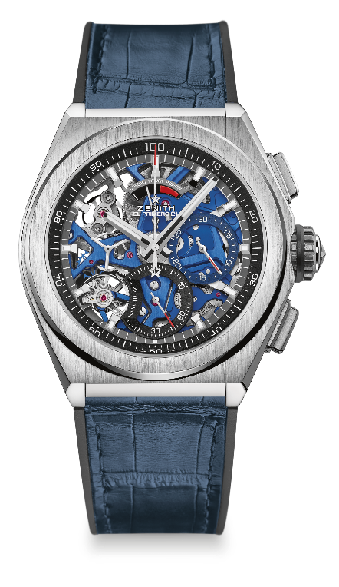
DEFY EL PRIMERO 21 BLUE
TECHNICAL DETAILS
Reference: 95.9002.9004/78.R584

UNIQUE SELLING POINTS
New 1/100th of a second chronograph movement
Exclusive dynamic signature of one rotation per second
Double-chain structure
1 escapement for the Watch (36,000 VpH - 5 Hz);
1 escapement for the Chronograph (360,000 VpH - 50 Hz)
TIME LAB-Chronometer certified

MOVEMENT
El Primero 9004 automatic
Calibre: 14¼``` (Diameter: 32.80 mm)
Thickness: 7.9 mm
Components: 293
Jewels: 53
Frequency 36,000 VpH (5 Hz)
Power reserve approx. 50 hours
Special oscillating weight with “circular satin-brushed” motif
Blue mainplate

FUNCTIONS
1/100th of a second chronograph functions
Chronograph power-reserve indication at 12 o'clock
Hours and minutes in the centre
Small seconds at 9 o'clock
- Central chronograph hand
- 30-minute counter at 3 o'clock
- 60-second counter at 6 o'clock

CASE, DIAL & HANDS
Brushed Titanium case
Diameter: 44 mm
Opening diameter: 35.5 mm
Thickness: 14.50 mm
Crystal: Domed sapphire crystal with anti-reflective treatment on both sides
Case back: Transparent sapphire crystal
Water resistance: 10 ATM
Dial: Openworked with two different-coloured counters
Hour markers: Rhodium-plated, faceted and coated with Super-LumiNova®
Hands: Rhodium-plated, faceted and coated with Super-LumiNova®

STRAP AND BUCKLE
Black rubber covered with blue alligator leather coating
Titanium double folding clasp

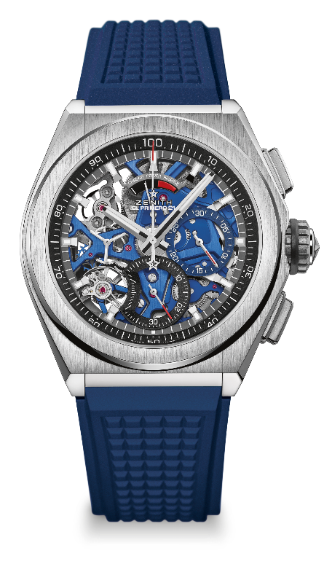
DEFY EL PRIMERO 21 BLUE
TECHNICAL DETAILS
Reference: 95.9002.9004/78.R591

UNIQUE SELLING POINTS
New 1/100th of a second chronograph movement
Exclusive dynamic signature of one rotation per second
Double-chain structure
1 escapement for the Watch (36,000 VpH - 5 Hz);
1 escapement for the Chronograph (360,000 VpH - 50 Hz)
TIME LAB-Chronometer certified

MOVEMENT
El Primero 9004 automatic
Calibre: 14¼``` (Diameter: 32.80 mm)
Thickness: 7.9 mm
Components: 293
Jewels: 53
Frequency 36,000 VpH (5 Hz)
Power reserve approx. 50 hours
Special oscillating weight with “circular satined” motif
Blue mainplate

FUNCTIONS
1/100th of a second chronograph functions
Chronograph power-reserve indication at 12 o'clock
Hours and minutes in the centre
Small seconds at 9 o'clock
- Central chronograph hand
- 30-minute counter at 3 o'clock
- 60-second counter at 6 o'clock

CASE, DIAL & HANDS
Brushed Titanium case
Diameter: 44 mm
Opening diameter: 35.5 mm
Thickness: 14.50 mm
Crystal: Domed sapphire crystal with anti-reflective treatment on both sides
Case back: Transparent sapphire crystal
Water resistance: 10 ATM
Dial: Openworked with two different-coloured counters
Hour markers: Rhodium-plated, faceted and coated with SuperLuminova
Hands: Rhodium-plated, faceted and coated with SuperLuminova

STRAP AND BUCKLE
Blue Rubber
Titanium double folding buckle

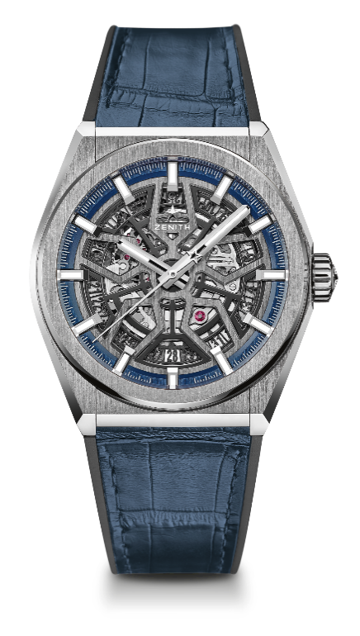
DEFY CLASSIC
TECHNICAL DETAILS

Reference: 95.9000.670/78.R584

KEY POINTS
New Elite skeletonised movement
New 41mm brushed titanium case
Silicon escape-wheel and lever

MOVEMENT
Elite 670 SK, Automatic
Calibre: 11 ½``` (Diameter: 25.60mm)
Movement thickness: 3.88mm
Components: 187
Jewels: 27
Frequency: 28,800 VpH (4Hz)
Power-reserve: min. 48 hours
Finishing: Special oscillating weight with satin-brushed finish

FUNCTIONS
Hours and minutes in the centre
Central seconds hand
Date indication at 6 o’clock

CASE, DIAL & HANDS
Diameter: 41mm
Diameter opening: 32.5mm
Thickness: 10.75mm
Crystal: Domed sapphire crystal with anti-reflective treatment on both sides
Case-back: Transparent sapphire crystal
Material: Brushed titanium
Water-resistance: 10 ATM
Dial: Openworked
Hour-markers: Rhodium-plated, faceted and coated with Super-LumiNova® SLN C1
Hands: Rhodium-plated, faceted and coated with Super-LumiNova® SLN C1

STRAP & BUCKLE
Strap: Reference: 27.00.2218.584
Designation: Black rubber with blue alligator leather coating
Buckle: Reference: 27.95.0018.930
Designation: Titanium double folding clasp

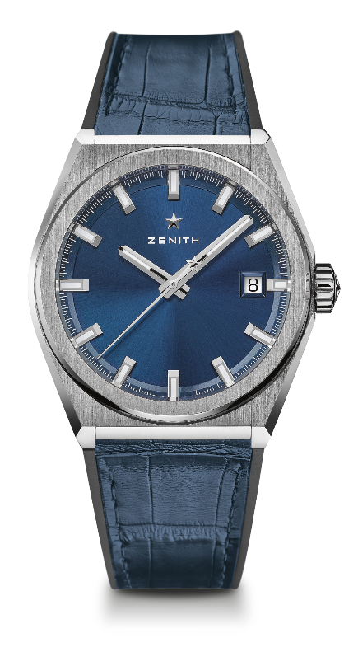
DEFY CLASSIC
TECHNICAL DETAILS

Reference: 95.9000.670/51.R584

KEY POINTS
New Elite skeletonised movement
New 41-MM Brushed Titanium case
Silicon escape-wheel and lever

MOVEMENT
Elite 670 SK, Automatic
Calibre: 11 ½``` (Diameter: 25.60mm)
Movement thickness: 3.88mm
Components: 187
Jewels: 27
Frequency: 28,800 VpH (4Hz)
Power-reserve: min. 48 hours
Finishing: Special oscillating weight with satin-brushed finish

FUNCTIONS
Hours and minutes in the centre
Central seconds hand
Date indication at 3 o’clock

CASE, DIAL & HANDS
Diameter: 41mm
Diameter opening: 32.5mm
Thickness: 10.75mm
Crystal: Domed sapphire crystal with anti-reflective treatment on both sides
Case-back: Transparent sapphire crystal
Material: Brushed titanium
Water-resistance: 10 ATM
Dial: Blue-toned sunray-patterned
Hour-markers: Rhodium-plated, faceted and coated with Super-LumiNova® SLN C1
Hands: Rhodium-plated and faceted gold, coated with Super-LumiNova® SLN C1

STRAP & BUCKLE
Strap: Reference: 27.00.2218.584
Designation: Black rubber with blue alligator leather coating
Buckle: Reference: 27.95.0018.930
Designation: Titanium double folding clasp

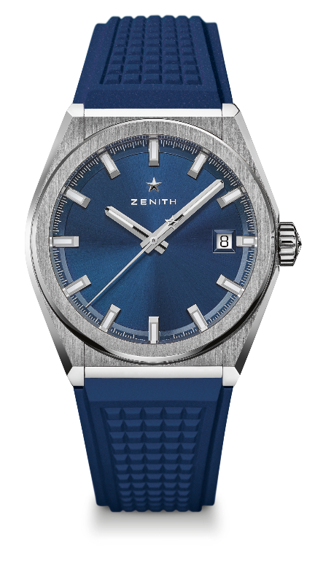
DEFY CLASSIC
TECHNICAL DETAILS

Reference: 95.9000.670/51.R790

KEY POINTS
New Elite skeletonised movement
New 41mm brushed titanium case
Silicon escape-wheel and lever

MOVEMENT
Elite 670 SK, Automatic
Calibre: 11 ½``` (Diameter: 25.60mm)
Movement thickness: 3.88mm
Components: 187
Jewels: 27
Frequency: 28,800 VpH (4Hz)
Power-reserve: min. 48 hours
Finishing: Special oscillating weight with satin-brushed finish

FUNCTIONS
Hours and minutes in the centre
Central seconds hand
Date indication at 3 o’clock

CASE, DIAL & HANDS
Diameter: 41mm
Diameter opening: 32.5mm
Thickness: 10.75mm
Crystal: Domed sapphire crystal with anti-reflective treatment on both sides
Case-back: Transparent sapphire crystal
Material: Brushed titanium
Water-resistance: 10 ATM
Dial: Blue-toned sunray-patterned
Hour-markers: Rhodium-plated, faceted and coated with Super-LumiNova® SLN C1
Hands: Rhodium-plated and faceted gold, coated with Super-LumiNova® SLN C1

STRAP & BUCKLE
Strap: Reference: 27.00.2218.790
Designation: Blue rubber
Buckle: Reference: 27.95.0018.930
Designation: Titanium double folding clasp

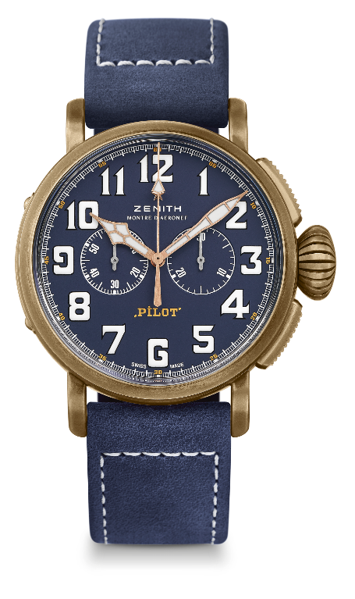
PILOT TYPE 20 CHRONOGRAPH EXTRA SPECIAL
BRONZE BLUE DIAL

TECHNICAL DETAILS

Reference: 29.2430.4069/57.C808

KEY POINTS
Bronze Case
Automatic El Primero column wheel chronograph
Case back engraved with ZENITH flying instruments logo
Arabic numerals entirely made of SuperLumiNova®

MOVEMENT
El Primero 4069, Automatic
Calibre: 13 ¼``` (Diameter: 30mm)
Movement thickness: 6.6mm
Components: 254
Jewels: 35
Frequency: 36,000 VpH (5Hz)
Power-reserve: min. 50 hours
Finishes: Oscillating weight with “Côtes de Genève” motif

FUNCTIONS
Hours and minutes in the centre
Small seconds at 9 o’clock
Chronograph: Central chronograph hand & 30-minute counter at 3 o’clock

CASE, DIAL & HANDS
Diameter: 45mm
Diameter opening: 37.8mm
Thickness: 14.25mm
Crystal: Domed sapphire crystal with anti-reflective treatment on both sides
Case-back: Titanium case-back engraved with the ZENITH flying instruments logo
Material: Bronze
Water-resistance: 10 ATM
Dial: Matt blue
Hour-makers: Arabic numerals with white SuperLumiNova® SLN C1
Hands: Gold-plated, faceted and coated with white SuperLumiNova®SLN C1 [Hands]

STRAPS & BUCKLES
Bracelet: Reference: 27.00.2321.808
Designation: Blue oily nubuck leather strap with protective rubber lining
Buckle: Reference: 27.95.0021.001
Designation: Titanium pin buckle

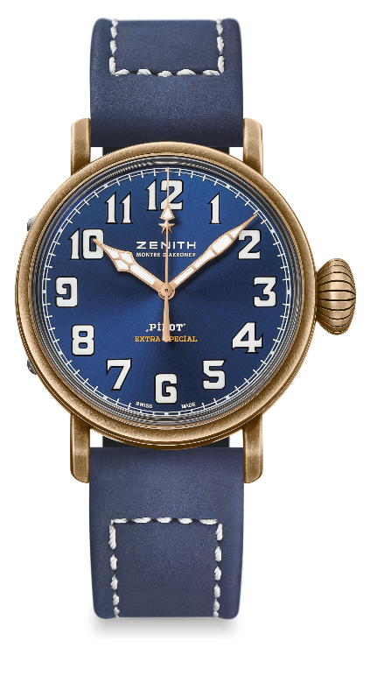
PILOT TYPE 20 EXTRA SPECIAL
40 MM BRONZE
TECHNICAL DETAILS

Reference: 29.1940.679/57.C808

KEY POINTS
New case in bronze
Inspired by the legendary Zenith aviation watches
Arabic numerals entirely made of Super-LumiNova®

MOVEMENT
Elite 679, Automatic
Calibre: 11 ½``` (Diameter: 25.60mm)
Movement thickness: 3.85mm
Components: 126
Jewels: 27
Frequency: 28,800 VpH (4Hz)
Power-reserve: min. 50 hours
Finishes: Oscillating weight with “Côtes de Genève” motif

FUNCTIONS
Hours and minutes in the centre
Central seconds hand

CASE, DIAL & HANDS
Diameter: 40mm
Diameter opening: 33.1mm
Thickness: 12.95mm
Crystal: Domed sapphire crystal with anti-reflective treatment on both sides
Case-back: Titanium case-back engraved with the ZENITH flying instruments logo
Material: Bronze
Water-resistance: 10 ATM
Dial: Matt blue
Hour-makers: Arabic numerals in Super-LumiNova® SLN C1 [Hour-markers]
Hands: Gold-plated, faceted and coated with Super-LumiNova® SLN C1 [Hands]

STRAPS & BUCKLES
Bracelet: Reference: 27.00.2018.808
Designation: Blue oily nubuck leather strap with protective rubber lining
Buckle: Reference: 27.95.0031.001
Designation: Titanium pin buckle

