Zenith gears up for the 2018 Distinguished Gentleman’s Ride

Old school teams up with classic and vintage style, as Zenith polishes its manners and prepares to get out there in force at this year’s Distinguished Gentleman’s Ride dedicated to supporting men’s health.

September 30th 2018 will see 120,000 elegant gentlefolk take to the streets in style, donning their finest suits and riding their vintage or classic motorcycles in aid of raising money and awareness for prostate cancer research and male suicide prevention on behalf of the event’s official charity partner, The Movember Foundation.
The Distinguished Gentleman’s Ride is based on an idea dreamed up in 2012 by Mark Hawwa in his native Australia. Since its inception, the DGR has transformed over 650 cities in 95 countries across the globe as enthusiastic riders proudly display their elegance on café racers, scramblers, choppers, bobbers or vintage scooters. Numerous bystanders in London, Paris, New York, Hong Kong, Munich, Vienna, Andorra and other cities observe from the sidelines in awe as hundreds of bikers ride through the city centre, often kindly posing for photos with enthusiastic tourists and wide-eyed youngsters.

The event has become one of the world’s biggest charity fundraisers for men’s health, raising over US $ 13 million to date, and with the goal of adding a further $6 million to the cause throughout the 2018 fundraising campaign.
Elegance and generosity
Team Zenith partners with the DGR in celebration of timeless style and selfless philanthropy. Keenly supported by Zenith ambassadors and friends of the brand, each driven by the same goal of helping to fund research, it has a proud reputation of being the largest to ride in the DGR. The resulting top fundraising achievements reflect the dedication and unwavering passion shown by brand partners who take the time to sign up.
No stranger to the world of motorcycles, Zenith also marks the occasion by offering enthusiasts and motorcycling aficionados alike an additional treat at the 2018 event. In supporting this global charity event for the third year running, the brand with a guiding star proudly presents the PILOT Type 20 Chronograph Ton Up Black.

Understated vintage appeal
Designed to celebrate the café racer biker community, also known as Ton-up boys, this timepiece is naturally named the ZENITH Heritage Pilot Ton-up. Part of a culture of rockers showing off fast motorcycles during gatherings, a café racer is a motorcycle that has been stripped of all unnecessary weight to gain speed and is renowned for its visual minimalism.

Like the namesake motorbikes, the PILOT Type 20 Chronograph Ton Up Black is magnificently free of all clutter. Sporting a manly 45 mm cunningly aged stainless-steel case, a trendy method of focusing on its vintage appeal and matching the overall design of the watch, the PILOT Type 20 Chronograph Ton Up Black’s sombre matt dial is teamed with a matching black case sporting a deep etching of a café racer on his motorcycle. For added comfort and longer life, the trademark oily nubuck leather strap features a protective rubber lining and is finished with contrasting white hand stitching and a titanium buckle. Driven by a legendary in-house El Primero automatic 4069 calibre operating at 5Hz (36,000b VpH) featuring a 50-hour power reserve, paired with the right leather jacket, this cool number is this year’s must-have kit for every gentleman biker seeking a watch that combines designer vintage allure with an unmistakably sporty demeanour!

ZENITH: The Future of Swiss Watchmaking
Since 1865, Zenith has been guided by authenticity, daring and passion in pushing the boundaries of excellence, precision and innovation. Soon after its founding in Le Locle by visionary watchmaker Georges Favre-Jacot, Zenith gained recognition for the precision of its chronometers, with which it has won 2,333 chronometry prizes in just over a century and a half of existence: an absolute record. Famed for its legendary 1969 El Primero calibre enabling short-time measurements accurate to the nearest 1/10th of a second, the Manufacture has since developed over 600 movement variations. Today, Zenith offers new and fascinating vistas in time measurement, including 1/100th of a second timing with the Defy El Primero 21; and a whole new dimension in mechanical precision with the world’s most accurate watch, the 21st century Defy Lab. Energised by newly reinforced ties with a proud tradition of dynamic, avant-garde thinking, Zenith is writing its future… and the future of Swiss watchmaking.

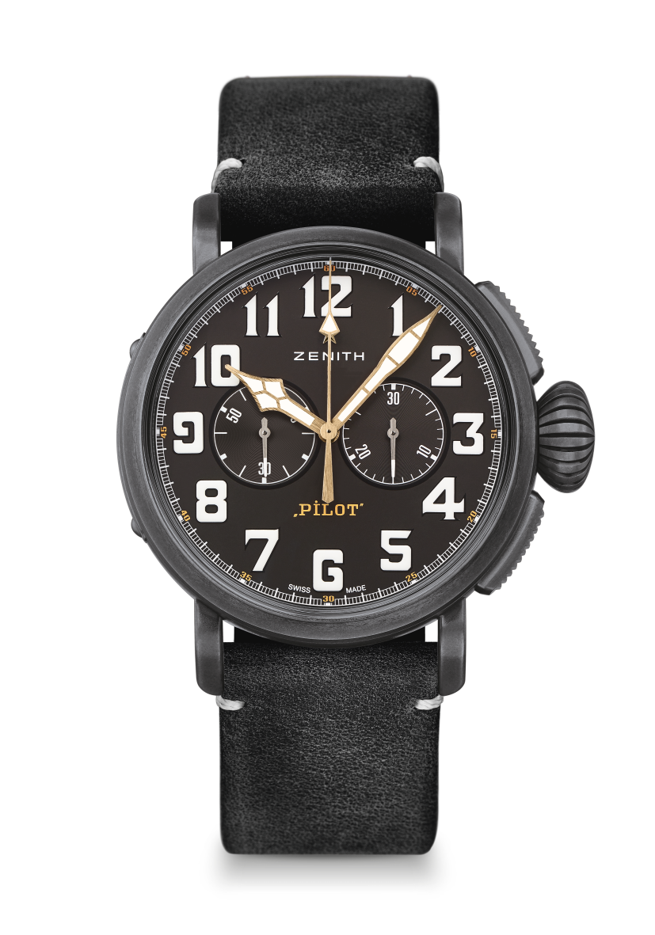
PILOT TYPE 20 CHRONOGRAPH
TON UP BLACK
TECHNICAL DETAILS

Reference: 11.2432.4069/21.C900

KEY POINTS
New aged stainless steel 45mm case
Tribute to the Café Racer Spirit
Automatic El Primero column-wheel chronograph

MOVEMENT
El Primero 4069, Automatic
Calibre: 13 ¼``` (Diameter: 30mm)
Movement thickness: 6.6mm
Components: 254
Jewels: 35
Frequency: 36,000 VpH (5Hz)
Power-reserve: min. 50 hours
Finishes: Oscillating weight with “Côtes de Genève” motif

FUNCTIONS
Hours and minutes in the centre
Small seconds at 9 o’clock
Chronograph: Central chronograph hand & 30-minute counter at 3 o’clock

CASE, DIAL & HANDS
Diameter: 45mm
Diameter opening: 37.8mm
Thickness: 14.25mm
Crystal: Domed sapphire crystal with anti-reflective treatment on both sides
Case-back: Case-back with Café Racer Spirit engravings
Material: Aged stainless steel
Water-resistance: 10 ATM
Dial: Matt black
Hour-markers: Arabic numerals with white SuperLumiNova® SLN C1
Hands: Gold-plated, faceted and coated with SuperLumiNova® SLN C1 [Hands]

STRAPS & BUCKLES
Bracelet: Reference: 27.00.2321.900
Designation: Black oily nubuck leather strap with protective rubber lining
Buckle: Reference: 27.95.0021.001
Designation: Titanium pin buckle

