2018 DISTINGUISHED GENTLEMAN’S RIDE: REACHING FOR THE STARS

More than 112’000 gentlefolk and their classic motorcycles took to the streets of 648 cities in 102 countries – all on behalf of a good cause: The Movember Foundation, dedicated to supporting prostate cancer research and men’s mental health.

Backing this impressive worldwide gathering for the third year running, Zenith celebrated the occasion by highlighting the arrival on markets worldwide of the Pilot Type 20 Chronograph Ton Up Black,
official watch of the event.

Le Locle, October 1st 2018: The brand with a guiding star shone especially brightly around the globe on Sunday September 30th, as 112’000 vintage and classic motorcycle enthusiasts rode through 648 cities spread across 102 countries to help raise money – and awareness – for cancer research and men’s mental health on behalf of The Movember Foundation, official partner of The Distinguished Gentleman’s Ride (DGR).

One of the world’s biggest charity fundraisers for men’s health, the DGR has raised over US $ 13 million to date, and the aim is to add a further $6 million to the cause with the 2018 fundraising campaign that will conclude on October 14th 2018. Among the many locations, the DGR New York event saw DGR founder Mark Hawwa, Zenith CEO Julien Tornare and various friends of the brand – including Dimitri Coste, official photographer of this particular gathering, fashion blogger, Ed Kavishe – join 112’000 other gentlefolk aboard their scramblers, choppers, bobbers or vintage scooters. Keenly supported by Zenith ambassadors and friends of the brand, Team Zenith is not only the largest to ride in the DGR, but also one of the top fundraising team.

Pilot Ton Up Black: vintage allure meets sportsmanship
Zenith joined in the spirit of the DGR by celebrating timeless style and selfless philanthropy – as well as the arrival on the market of its Pilot Type 20 Chronograph Ton Up Black. A tribute to the café racer biker community, also known as Ton Up boys, this resolutely masculine timepiece is magnificently free of all clutter. Sporting a manly 45 mm aged stainless-steel case, its somber matt dial is teamed with a matching black case bearing a deep etching of a café racer on his motorcycle. For added comfort and longer life, the trademark oily nubuck leather strap features a protective rubber lining and is finished with contrasting white stitching and a titanium buckle. Driven by a legendary in-house El Primero automatic 4069 calibre operating at 5Hz (36,000 VpH), this cool number combines designer vintage allure with an unmistakably sporty demeanour!

Further boosting motivation among participants, Zenith unveiled a specially created DGR five-piece limited edition. Enhanced with a DGR engraving, dial inscription and customized strap, these timepieces are destined for the three overall largest fundraisers, the most successful Team Zenith fundraiser, as well as the lucky winner of a prize draw among all participants.

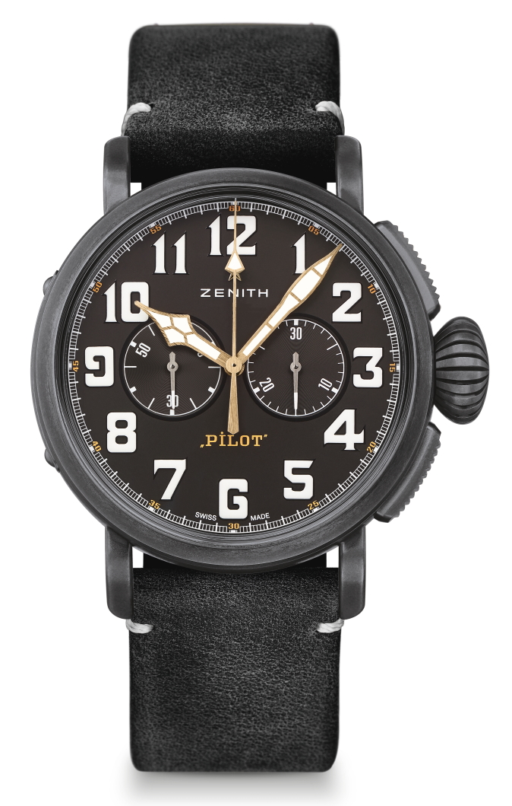
PILOT TYPE 20 CHRONOGRAPH TON UP BLACK
TECHNICAL DETAILS

Reference: 11.2432.4069/21.C900

KEY POINTS
New aged stainless steel 45mm case
Tribute to the Café Racer Spirit
Automatic El Primero column-wheel chronograph

MOVEMENT
El Primero 4069, Automatic
Calibre: 13 ¼``` (Diameter: 30mm)
Movement thickness: 6.6mm
Components: 254
Jewels: 35
Frequency: 36,000 VpH (5Hz)
Power-reserve: min. 50 hours
Finishes: Oscillating weight with “Côtes de Genève” motif

FUNCTIONS
Hours and minutes in the centre
Small seconds at 9 o’clock
Chronograph: Central chronograph hand & 30-minute counter at 3 o’clock

CASE, DIAL & HANDS
Diameter: 45mm
Diameter opening: 37.8mm
Thickness: 14.25mm
Crystal: Domed sapphire crystal with anti-reflective treatment on both sides
Case-back: Case-back with Café Racer Spirit engravings
Material: Aged stainless steel
Water-resistance: 10 ATM
Dial: Matt black
Hour-markers: Arabic numerals with white SuperLumiNova® SLN C1
Hands: Gold-plated, faceted and coated with SuperLumiNova® SLN C1 [Hands]

STRAPS & BUCKLES
Bracelet: Black oily nubuck leather strap with protective rubber lining
Buckle: Titanium pin buckle

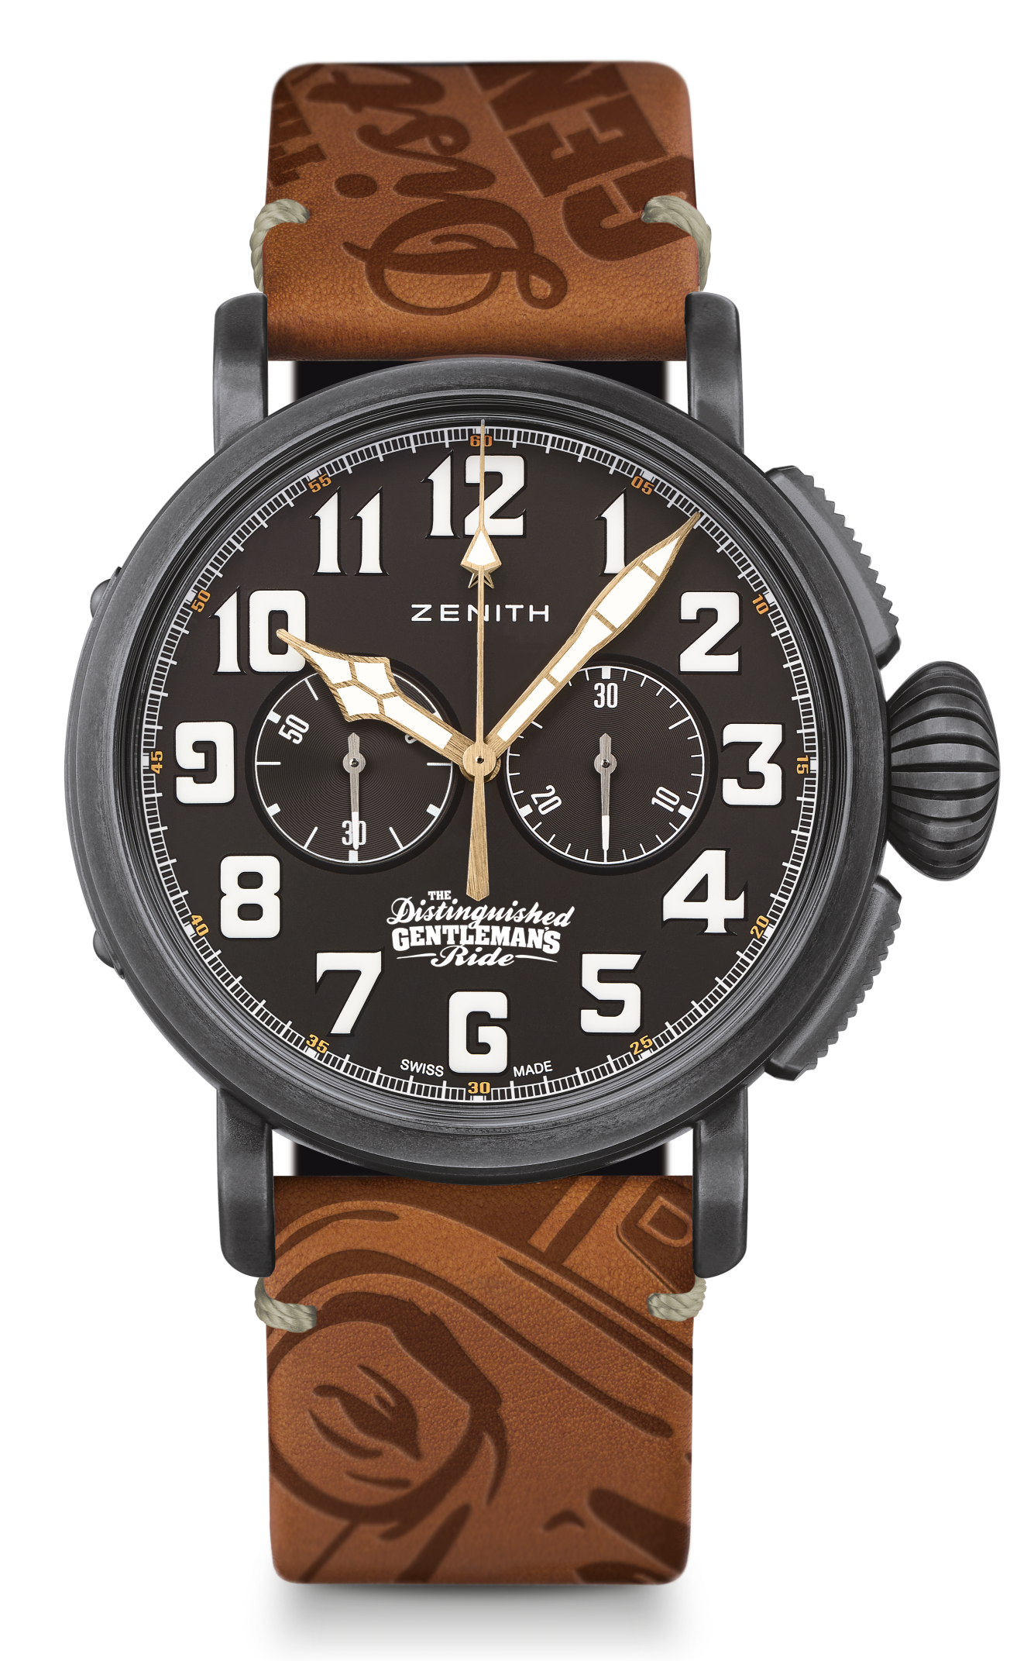
PILOT TYPE 20 CHRONOGRAPH TON UP – DGR EDITION
LIMITED EDITION OF 5 UNITS

TECHNICAL DETAILS

Reference: 11.2433.4069/27.C901

KEY POINTS
New aged stainless steel 45mm case
Automatic El Primero column-wheel chronograph
Tribute to The Distinguished Gentleman’s Ride

MOVEMENT
El Primero 4069, Automatic
Calibre: 13 ¼``` (Diameter: 30mm)
Movement thickness: 6.6mm
Components: 254
Jewels: 35
Frequency: 36,000 VpH (5Hz)
Power-reserve: min. 50 hours
Finishes: Oscillating weight with “Côtes de Genève” motif

FUNCTIONS
Hours and minutes in the centre
Small seconds at 9 o’clock
Chronograph: Central chronograph hand & 30-minute counter at 3 o’clock

CASE, DIAL & HANDS
Diameter: 45mm
Diameter opening: 37.8mm
Thickness: 14.25mm
Crystal: Domed sapphire crystal with anti-reflective treatment on both sides
Case-back: Case-back with DGR 2018 engravings
Material: Aged stainless steel
Water-resistance: 10 ATM
Dial: Matt black
Hour-markers: Arabic numerals with white SuperLumiNova® SLN C1
Hands: Gold-plated, faceted and coated with SuperLumiNova® SLN C1 [Hands]

STRAPS & BUCKLES
Bracelet: Brown oily nubuck leather strap with protective rubber lining and DGR logo
Buckle: Titanium pin buckle

