MR PORTER PARTNERS WITH ZENITH AND BAMFORD WATCH DEPARTMENT TO CREATE A LIMITED-EDITION TIMEPIECE DUE TO LAUNCH IN NOVEMBER

OCTOBER 2018 (GLOBAL) – MR PORTER, the award-winning online destination for men’s style, is pleased to announce it has partnered with Swiss fine-watch manufacturer Zenith and British watch customiser Bamford Watch Department in creating an exclusive 25-piece limited-edition watch, available for sale on 15 November 2018.

Mr George Bamford and his team worked alongside Zenith in the design of this watch, which was then entirely developed and produced in-house at Zenith’s Manufacture. Co-creating a project and product of this nature is a first for all three partners in this undertaking.

Based on the Zenith Heritage 146 model, the watch takes cues from several of the brand’s historical design elements. These subtle touches include the tachymeter inspired by a 1971 El Primero, a red seconds hand, aesthetic reminders of a vintage chronograph case and centric sub-dial rings hark back to the old Zenith recorder tell-tales and motion detecting clock.

Its unique “Solar Blue” dial is framed by a 38mm stainless steel case, fitted with a navy blue Alcantara strap featuring white stitching designed to complement the white dial markings. Combining all of these various touchpoints, Zenith, Bamford Watch Department and MR PORTER have created a watch that is both familiar and yet altogether modern and new.

Each of these limited-edition watches will feature a special open case-back engraved and individually numbered one to 25.

“This is a first for MR PORTER, working together with both Zenith and Bamford Watch Department, and we are thrilled with the result. Zenith’s approach to modern day watch-making, alongside George Bamford’s eye for contemporary customisation, has created a unique timepiece our customers and readers are sure to enjoy and appreciate. By diving into Zenith’s archive for technical references, this collaboration showcases genuine originality and storytelling – which certainly will make this watch special for years to come.”

Mr Toby Bateman, Managing Director, MR PORTER

“The relationship established last year with the customisation specialist Bamford Watch Department (BWD) has already confirmed the wide range of creative possibilities provided by such cooperation, and this is now the first time that we are producing a BWD design entirely in-house. In 2015, Zenith also became the first Swiss fine-watch brand available on MR PORTER.COM and this world-class online retail destination needs no introduction. The result of this three-way endeavour is liable to strike a chord with stylish men around the globe.”

Mr Julien Tornare, CEO, Zenith

“Since becoming the official customiser for Zenith in June last year, I have had this project in mind with MR PORTER. I am so excited to see it come to fruition and as always, it was a pleasure designing and working with both brands on the project. The engineering team at Zenith have blown me away with how the beautiful blue on this unique dial has come to life and the way in which the design nods to the past makes it truly special.”

Mr George Bamford, Founder, Bamford Watch Department

Prices
€7,100 EUR / £6,100 GBP / $7,500 USD

Customers can sign up and register interest at MR PORTER here

For more information, please contact:
Mr Mark Blundell | mark.blundell@mrporter.com | +44 (0)20 3471 5491

About MR PORTER
Since launching in February 2011, MR PORTER has established itself as the award-winning global retail and content destination for men’s style, with an unparalleled product offering from the world’s best menswear and lifestyle brands, including own labels Mr P. and Kingsman. MR PORTER publishes unmatched content through its weekly shoppable digital magazine, The Journal, its bimonthly newspaper, The MR PORTER Post, and its bite-sized, several-times-a-day digital news source, The Daily. MR PORTER offers express worldwide shipping to more than 170 countries, including same-day delivery to New York and London, and provides a seamless shopping experience across mobile, tablet, and desktop, with easy returns and multi-lingual customer care and personal-shopping teams who are available 24/7, 365 days a year.
mrporter.com
Instagram: @mrporterlive / Facebook: mrporterlive / Wechat: MRPORTERLIVE

About Zenith
Since 1865, Zenith has been guided by authenticity, daring and passion in pushing the boundaries of excellence, precision and innovation. Soon after its founding in Le Locle by visionary watchmaker Mr Georges Favre-Jacot, Zenith gained recognition for the precision of its chronometers, with which it has won 2,333 chronometry prizes in just over a century and a half of existence: an absolute record. Famed for its legendary 1969 El Primero calibre enabling short-time measurements accurate to the nearest 1/10th of a second, the Manufacture has since developed over 600 movement variations. Today, Zenith offers new and fascinating vistas in time measurement, including 1/100th of a second timing with the Defy El Primero 21; and a whole new dimension in mechanical precision with the world’s most accurate watch, the 21st-century Defy Lab. Energised by newly reinforced ties with a proud tradition of dynamic, avant-garde thinking, Zenith is writing its future… and the future of Swiss watchmaking.
zenith-watches.com

About Bamford Watch Department
As the world’s first company to offer fully customised steel sports watches, BWD has earned a reputation within the watch making world as a highly innovative, inspirational source of originality and flair, acknowledged as the final word in luxury timepiece customisation over the past 14 years. BWD become the first British customisation brand to be officially recognised and approved by a Swiss watchmaker. This blend of precision engineering, unique customisation techniques and enviable heritage ensures that the creative possibilities of this venture are practically limitless. With a modus operandi that puts the client in the driving seat, BWD is proud to offer an extensive catalogue of in-house designs and special series watches, as well as multiple online customisers to help customers achieve their perfect timepiece.
bamfordwatchdepartment.com

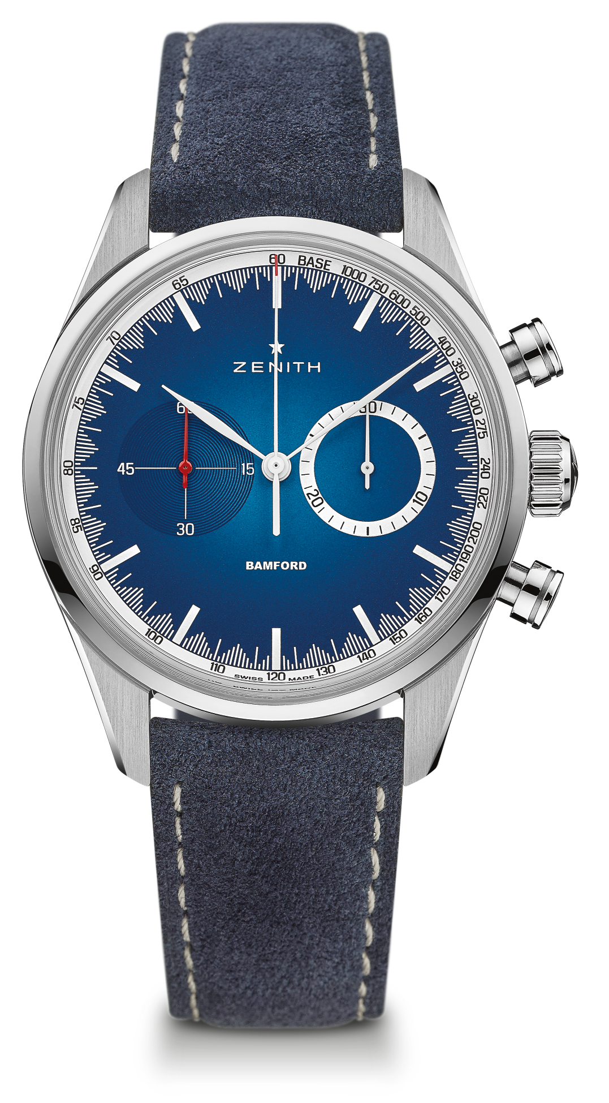
CHRONOMASTER EL PRIMERO – 38 MM - MR. PORTER
LIMITED EDITION OF 25 UNITS
TECHNICAL DETAILS

Reference: 03.2152.4069/57.C814

KEY POINTS
Automatic El Primero column-wheel chronograph
Special partnership with Mr. Porter and Bamford Watch Department
Exclusively available on Mr. Porter
Limited edition of 25 units

MOVEMENT
Movement: El Primero 4069, Automatic
Caliber: 13 ¼ ‘’’ (Diameter: 30 mm)
Movement thickness: 6.6 mm
Components: 254
Jewels: 35
Frequency: 36,000 VpH (5 Hz)
Power-reserve: min. 50 hours
Finishes: Oscillating weight with “Côtes de Genève” motif

FUNCTIONS
Hours and minutes in the center
Small seconds at 9 o’clock
Chronograph:
- Central chronograph hand
- 30-minute counter at 3 o’clock
Tachymeter scale

CASE, DIAL & HANDS
Dimeter: 38 mm
Dimeter opening: 33.1 mm
Thickness: 12.45 mm
Crystal: Domed sapphire crystal with anti-reflective treatment on both sides
Case-back: Special case-back with engravings
Material: Steel
Water-resistance: 10 ATM
Dial: Solar blue
Hour-makers: printed on the dial
Hands: Special set of white and red hands

STRAPS & BUCKLES
Bracelet: Blue Alcantara strap
Buckle: Steel pin buckle

