NEWS RELEASE

ZENITH DEFY CLASSIC RANGE ROVER SPECIAL EDITION

For the past three years, ZENITH has been associated with Land Rover. In 2017 the creative partnership launched the Chronomaster El Primero Range Rover Velar, a model celebrating the iconic Range Rover name. A new vehicle deserved a new timepiece, and the next-generation Range Rover Evoque is paired with the latest ZENITH watch from the DEFY Classic collection: a chic and sporty timepiece honouring a landmark design.

The new Range Rover Evoque is designed to expertly blend city living with country escapism, building on the original’s enduring luxury appeal with a purposeful and precise evolution of its instantly recognisable silhouette. A reductive design approach focused on simplicity, the most compact Range Rover is a vision of modernity and timeless design placing Evoque back at the top of the segment.

Gerry McGovern, Land Rover Chief Design Officer, said:
"A key component of the new Range Rover Evoque is Desirability. The new Zenith Defy Classic Range Rover watch represents a step change in collaborative watch design, the result being a highly desirable timepiece and a fitting tribute to the Zenith and Land Rover collaboration."

The latest addition to the associated timepiece collection, the new DEFY Classic Range Rover, is distinguished by its characterful design. It offers an evolution of the modern and graphic interpretation of this line. Like the Range Rover Evoque, its beautifully proportioned 41mm case endows it with a resolutely unisex appeal.

Specially co-developed by design and technical engineering teams working in close harmony, this 200-piece limited edition of the DEFY Classic Range Rover is a combination of its own streamlined looks and certain unmistakable elements drawn from its automotive inspiration. These notably include colour themes evoking the UK manufactured vehicle, such as the seconds hand and oscillating weight attired in Arctic Petrol (turquoise blue) inspired by the accents on Evoques steering wheel and seats.

The openworked dial of this sophisticated timepiece is inspired by the sculptural design of the wheel design of the Evoque, while the quilted-patterned upholstery of the premium SUV is picked up in the ‘diamond’ motif gracing the rubber strap of its horological alter ego. Powered by a new Elite skeletonised movement, ZENITH’s first reinterpretation of its Defy Classic collection radiates a unique allure based on an inspired and powerful design.

Julien Tornare, CEO ZENITH, said: “If Zenith was a car it would definitely be a Range Rover! Both are recognised as icons in their fields. Both share the same values as well as a number of key assets, including charisma, technical refinement and remarkable performance. Both have innovation in their very DNA. The Defy and the Range Rover are both desirable, luxurious trademarks and pioneering cornerstones of their industries – objects with which there is an immediate emotional connection. Both are inspired by the past, while looking firmly to the future.”

ENDS

ZENITH: The Future of Swiss Watchmaking
Since 1865, Zenith has been guided by authenticity, daring and passion in pushing the boundaries of excellence, precision and innovation. Soon after its founding in Le Locle by visionary watchmaker Georges Favre-Jacot, Zenith gained recognition for the precision of its chronometers, with which it has won 2,333 chronometry prizes in just over a century and a half of existence: an absolute record. Famed for its legendary 1969 El Primero calibre enabling short-time measurements accurate to the nearest 1/10th of a second, the Manufacture has since developed over 600 movement variations. Today, Zenith offers new and fascinating vistas in time measurement, including 1/100th of a second timing with the Defy El Primero 21; and a whole new dimension in mechanical precision with the world’s most accurate watch, the 21st century Defy Lab. Energised by newly reinforced ties with a proud tradition of dynamic, avant-garde thinking, Zenith is writing its future… and the future of Swiss watchmaking.

DEFY CLASSIC RANGE ROVER EDITION
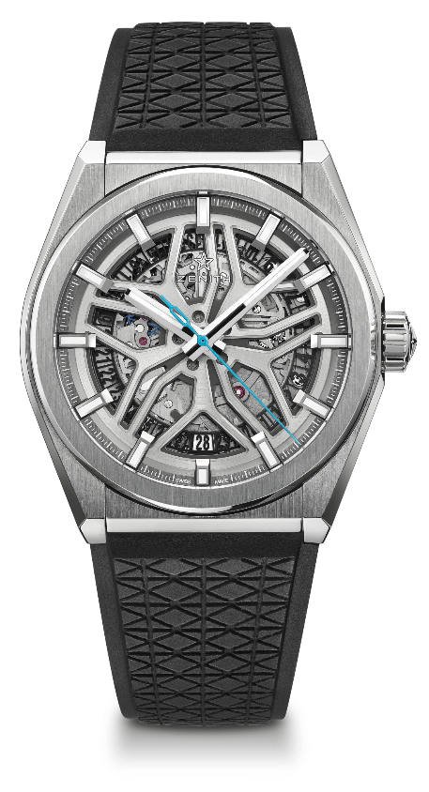
LIMITED EDITION OF 200 UNITS

TECHNICAL DETAILS
Reference: 95.9001.670/77.R791

KEY POINTS
New Elite skeletonised movement
New 41mm brushed titanium case
Silicon escape-wheel and lever
Special “Range Rover rim” dial

MOVEMENT
Elite 670 SK, Automatic
Calibre: 11 ½``` (Diameter: 25.60mm)
Movement thickness: 3.88mm
Components: 187
Jewels: 27
Frequency: 28,800 VpH (4Hz)
Power-reserve: min. 48 hours
Finishing: Special oscillating weight with satin-brushed finish

FUNCTIONS
Hours and minutes in the centre
Central seconds hand
Date indication at 6 o’clock

CASE, DIAL & HANDS
Diameter: 41mm
Diameter opening: 32.5mm
Thickness: 10.75mm
Crystal: Domed sapphire crystal with anti-reflective treatment on both sides
Case-back: Transparent sapphire crystal
Material: Brushed titanium
Water-resistance: 10 ATM
Dial: Openworked with Special “Range Rover rim”
Hour-markers: Rhodium-plated, faceted and coated with Super-LumiNova® SLN C
Hands: Rhodium-plated, faceted and coated with Super-LumiNova® SLN C1

STRAP & BUCKLE
Special Black Rubber strap
Titanium folding clasp

