ZENITH UNVEILS SPECIAL-EDITION WATCH IN A PHILANTHROPIC PARTNERSHIP
WITH WOUNDED WARRIOR PROJECT

November 11, 2018 [New York, NY] – Zenith has launched its first limited-edition timepiece in partnership with Wounded Warrior Project® (WWP). The Manufacture is proud to be expressing its support by making a donation to this charitable organization that honors and empowers injured service members who bravely volunteered to serve their nation on or after the events of September 11, 2001. The new Pilot Cronometro Tipo CP-2 USA Edition watch will be sold nationwide in a limited run of 50 units. This is particularly appropriate for a Manufacture reputed for equipping various armed forces with models meeting their demanding technical specifications in terms of reliability, readability and robustness.

Veteran pilot’s watch
The ranks of Manufacture Zenith historically include models that have made an indelible imprint on watchmaking, notably including its iconic pilot’s watches. The original 1960s TIPO CP-2 is often identified under that name. 'CP' stands for cronometro da polso (wrist chronograph). TIPO CP-2 chronographs belong to the exclusive circle of legendary chronographs that have earned the status of exceptional timepieces in both military and horological history and are now sought-after collector’s items. At Baselworld 2016, Zenith presented its tribute to one of the most coveted military pieces, the Heritage Cronometro Tipo CP-2, and is now paying a fresh tribute simultaneously serving a concrete philanthropic purpose.

Stars and stripes for the Pilot Cronometro Tipo CP-2 USA Edition
Commenting on the partnership, Julien Tornare, CEO of Zenith shared: “In recognition of Veteran’s Day, Zenith is honored to partner with Wounded Warrior Project to launch this very special limited-edition chronograph. We are happy to support the important work that Wounded Warrior Project is doing for the nation’s service members and their families through this project. We could not think of a better way to celebrate this moving annual commemoration.”

The 43mm case of the Pilot Cronometro Tipo CP-2 USA Edition features a rotating bezel inspired by the US flag, a theme picked up on the oscillating weight with its Côtes de Genève motif. In addition, for the very first time, the watch features a matte blue dial coordinated with a matching aluminum ring inside the bezel. The triangle marker and hand have both been changed to red. Fitted with a special blue kudu-hide strap with white and red stitching, the USA Edition puts on a modern spin on patriotism and pays tribute to the nation and its soldiers.

Gary Corless, warrior support for Wounded Warrior Project commented: “We’re extremely grateful for the support of Zenith and their newest campaign, which enables us to address the challenges warriors face head-on. Our warriors paid their dues on the battlefield, and never pay a penny for our programs and services.”
The latest in a series of legendary timepieces, the Pilot Cronometro Tipo CP-2 USA Edition indeed offers the ultimate tribute to a legion of brave men and women by celebrating courage, sacrifice and commitment.

ZENITH: The Future of Swiss Watchmaking
Since 1865, Zenith has been guided by authenticity, daring and passion in pushing the boundaries of excellence, precision and innovation. Soon after its founding in Le Locle by visionary watchmaker Georges Favre-Jacot, Zenith gained recognition for the precision of its chronometers, with which it has won over 2,330 chronometry prizes in just over a century and a half of existence: an absolute record. Famed for its legendary 1969 El Primero caliber enabling short-time measurements accurate to the nearest 1/10th of a second, the Manufacture has since developed over 600 movement variations. Today, Zenith offers new and fascinating vistas in time measurement, including 1/100th of a second timing with the Defy El Primero 21; and a whole new dimension in mechanical precision with the world’s most accurate watch, the 21st century Defy Lab, winner of the Innovation Prize in the 2017 Grand Prix d’Horlogerie de Genève. Energized by newly reinforced ties with a proud tradition of dynamic, avant-garde thinking, Zenith is writing its future… and the future of Swiss watchmaking.

About Wounded Warrior Project
Since 2003, Wounded Warrior Project® (WWP) has been meeting the growing needs of warriors, their families, and caregivers – helping them achieve their highest ambition. Learn more: http://newsroom.woundedwarriorproject.org/about-us.

PILOT CRONOMETRO TIPO CP-2 USA EDITION (Limited Edition: 50 units)
TECHNICAL DETAILS
Reference: 03.2241.405/51.C915

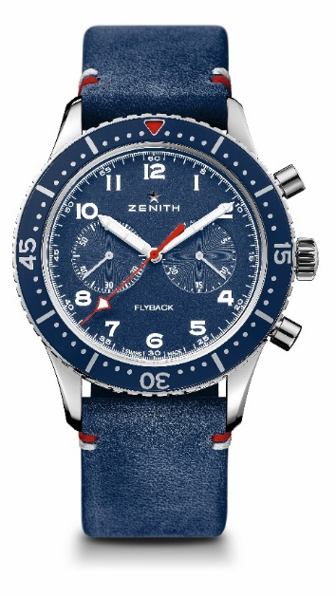
KEY POINTS
Reinterpretation of the famous Cairelli model from the 1960s
Automatic El Primero column-wheel chronograph
with Flyback function
Tribute to Wounded Warriors

MOVEMENT
Movement: El Primero 405 B, Automatic
Caliber: 13 ¼ ‘’’ (Diameter: 30 mm)
Movement thickness: 6.6 mm
Components: 254
Jewels: 31
Frequency: 36,000 VpH (5 Hz)
Power-reserve: min. 50 hours
Finishes: Oscillating weight with “Côtes de Genève” motif bearing the US flag

FUNCTIONS
Hours and minutes in the centre
Small seconds at 9 o’clock
Flyback Chronograph
- Central chronograph hand
- 30-minute counter at 3 o’clock

CASE, DIAL & HANDS
Dimater: 43 mm
Dimater opening: 32.5 mm
Thickness: 12.85 mm
Crystal: Domed sapphire crystal with anti-reflective treatment on both sides
Case-back: Transparent sapphire crystal
Material: Steel
Water-resistance: 10 ATM
Dial: Matte Blue
Bezel: Special Blue
Hour-makers: Arabic numerals in SuperLuminova SLN C1
Hands: Rhodium-plated, faceted and coated with SuperLuminova SLN C1

STRAPS & BUCKLES
Bracelet: Blue Kudu leather strap with special stitching
Buckle: Titanium pin buckle

