DEFY CLASSIC BLACK, WHITE & BLUE CERAMIC
The emblematic Zenith skeleton in three new ceramic cases.

Style and substance come together seamlessly in the new DEFY Classic Black, White and Blue Ceramic timepieces, marking the first time the ultra-hard and integrally colored material makes its way to the DEFY Classic collection. With an intriguing display of micro-mechanics accentuated by monochromatic tones, paired with the superlative performance that is synonymous with the Zenith manufacture and its in-house calibres, the new trio of DEFY Classic Ceramic resonates with the style-conscious urbanite.

A Striking Silhouette
The DEFY Classic has made its mark as Zenith’s expression of neo-futuristic watchmaking in its purest form. With the DEFY Classic collection in Black, White and Blue Ceramic, its distinguishing features are brought to life from its subtle nuances and the sense of volume it conveys through balanced geometry and a unique, visionary architecture – inside and out.
Forged from exceptionally durable and scratch-resistant ceramic that can take on a multitude of colors and tones, the DEFY Classic’s faceted 41mm case features a combination of polished and satin-brushed surfaces, emphasizing its geometric and resolutely contemporary case inspired by the original Zenith DEFY collection first launched in the 1970s. The angular, silhouette of the case is softened by the perfectly circular bezel that haloes above it.

Stellar Blackness
The centrepiece of the DEFY Classic Black Ceramic’s is its avant-garde open dial. Taking on a stellar form with ultramodern angles, the multi-layered element seamlessly blends the neoteric display with the movement.
In broad daylight, the faceted hands and applied markers appear as one with the blackened complex of the open dial and visible portions of the movement, with their polished ruthenium-treated surfaces gleaming through the darkness for surprisingly easy legibility. In darkness, they emit a subtle green glow from the Super-LumiNova® SLN C1 coating.

Polar Opposites
From the other end of the spectrum comes the DEFY Classic White Ceramic, a monochromatic take on the skeletonized Elite calibre housed in a bright white ceramic case and bezel. With its silvery multi-layer open dial, the urban landscape-inspired display comes to life in a most luminous way. The purity and unique lustre of the white ceramic and graphic details of the open dial lend the watch a voguish accent with a unisex appeal.

A Touch of Color
For those who prefer something more vibrant, the DEFY Classic Blue Ceramic is sure to tick the right boxes. Crafted in a striking blue ceramic case and bezel, the color is not just a superficial layer but an integral aspect of the material. The skeleton star-shaped dial provides a deeper dimension to the all-blue allure of the watch, adding a striking yet monochromatic cast to Zenith’s 21st century reinterpretation of the skeleton watch.

Form and function as one
Visible through the open dial as well as the sapphire case back of the DEFY Classic, the automatic Elite 670 manufacture movement beats unerringly. A staple movement in Zenith’s lineup for decades, the DEFY Classic represents the first time the Elite caliber has been openworked. Its entire anatomy has been reimagined – not just aesthetically, with its restructured and open bridges with cutting-edge finishing – but also in its performance, as the Elite caliber in the DEFY Classic features a silicon pallet-lever and escape-wheel.
Perfectly integrated with the contours of the case and following the structured lines of the dial and movement, the DEFY Classic Ceramic models are fitted with unistructure rubber straps in the same tones as the cases, offering sporty, casual elegance and comfort in all situations an urban explorer may encounter.

ZENITH: The Future of Swiss Watchmaking
Since 1865, Zenith has been guided by authenticity, daring and passion in pushing the boundaries of excellence, precision and innovation. Soon after its founding in Le Locle by visionary watchmaker Georges Favre-Jacot, Zenith gained recognition for the precision of its chronometers, with which it has won 2,333 chronometry prizes in just over a century and a half of existence: an absolute record. Famed for its legendary 1969 El Primero calibre enabling short-time measurements accurate to the nearest 1/10th of a second, the Manufacture has since developed over 600 movement variations. Today, Zenith offers new and fascinating vistas in time measurement, including 1/100th of a second timing with the Defy El Primero 21; and a whole new dimension in mechanical precision with the world’s most accurate watch, the 21st century Defy Lab. Energised by newly reinforced ties with a proud tradition of dynamic, avant-garde thinking, Zenith is writing its future… and the future of Swiss watchmaking.

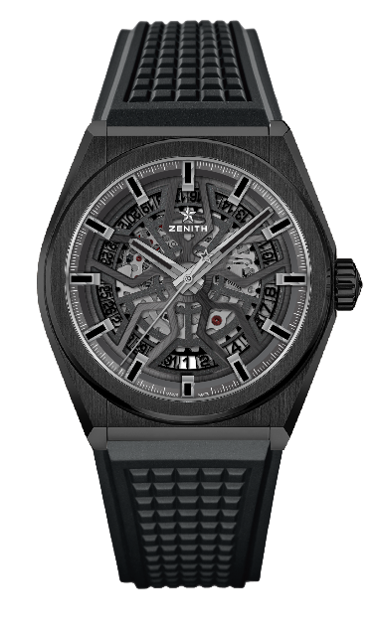
DEFY CLASSIC BLACK CERAMIC
TECHNICAL DETAILS

Reference: 49.9000.670/78.R782

KEY POINTS
NEW 41mm Black Ceramic case
In house Elite skeletonised movement
Silicon escape-wheel and lever

MOVEMENT
Elite 670 SK, Automatic
Calibre: 11 ½``` (Diameter: 25.60mm)
Movement thickness: 3.88mm
Components: 187
Jewels: 27
Frequency: 28,800 VpH (4Hz)
Power-reserve: min. 48 hours
Finishing: Special oscillating weight with satin-brushed finish

FUNCTIONS
Hours and minutes in the centre
Central seconds hand
Date indication at 6 o’clock

CASE, DIAL & HANDS
Diameter: 41mm
Diameter opening: 32.5mm
Thickness: 10.75mm
Crystal: Domed sapphire crystal with anti-reflective treatment on both sides
Case-back: Transparent sapphire crystal
Material: Black Ceramic
Water-resistance: 10 ATM
Dial: Openworked
Hour-markers: Ruthenium-plated, faceted and coated with Super-LumiNova® SLN C1
Hands: Ruthenium-plated, faceted and coated with Super-LumiNova® SLN C1

STRAP & BUCKLE
Black rubber with black DLC folding buckle
Also available on black rubber with black alligator leather coating

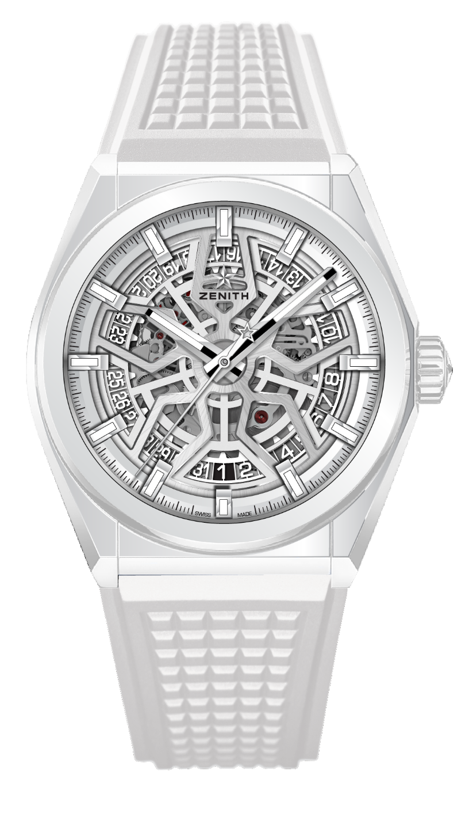
DEFY CLASSIC WHITE CERAMIC
TECHNICAL DETAILS

Reference: 49.9002.670/01.R792

KEY POINTS
NEW 41mm White Ceramic case
In house Elite skeletonised movement
Silicon escape-wheel and lever

MOVEMENT
Elite 670 SK, Automatic
Calibre: 11 ½``` (Diameter: 25.60mm)
Movement thickness: 3.88mm
Components: 187
Jewels: 27
Frequency: 28,800 VpH (4Hz)
Power-reserve: min. 48 hours
Finishing: Special oscillating weight with satin-brushed finish

FUNCTIONS
Hours and minutes in the centre
Central seconds hand
Date indication at 6 o’clock

CASE, DIAL & HANDS
Diameter: 41mm
Diameter opening: 32.5mm
Thickness: 10.75mm
Crystal: Domed sapphire crystal with anti-reflective treatment on both sides
Case-back: Transparent sapphire crystal
Material: White Ceramic
Water-resistance: 10 ATM
Dial: Silver Openworked
Hour-markers: Rhodium-plated, faceted and coated with Super-LumiNova® SLN C1
Hands: Rhodium-plated, faceted and coated with Super-LumiNova® SLN C1

STRAP & BUCKLE
White rubber HNBR Quality
Titanium double folding clasp

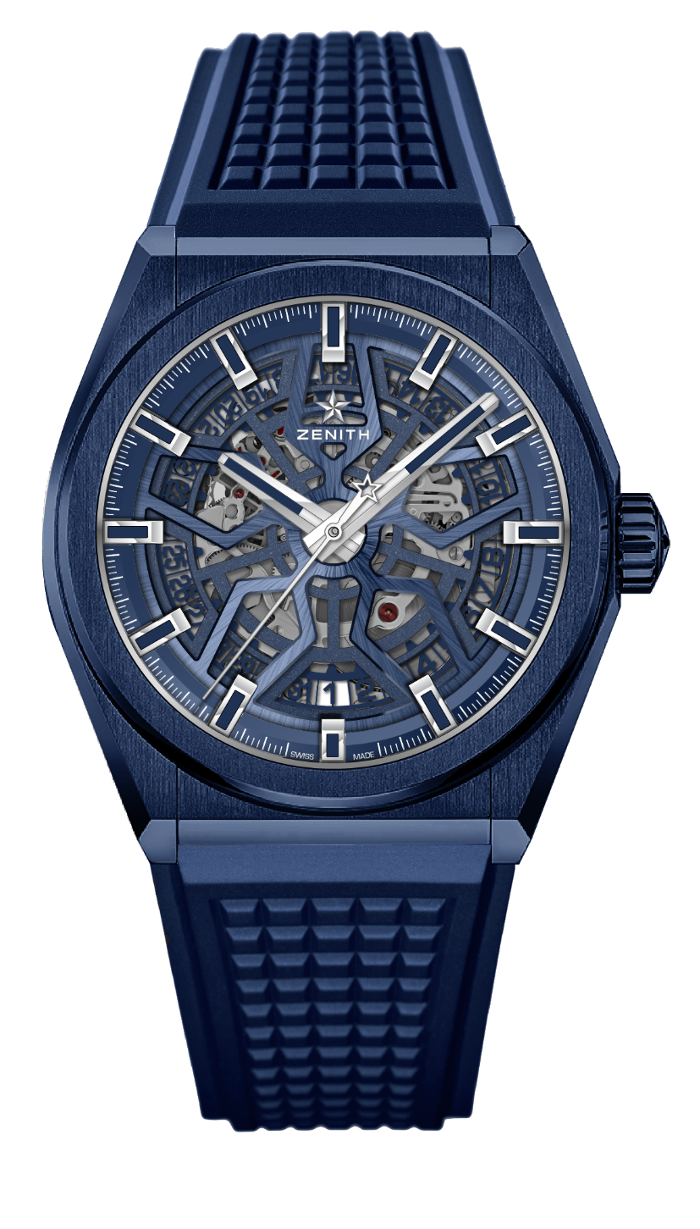
DEFY CLASSIC BLUE CERAMIC
TECHNICAL DETAILS

Reference: 49.9003.670/51.R793

KEY POINTS
NEW 41mm Blue Ceramic case
In house Elite skeletonised movement
Silicon escape-wheel and lever

MOVEMENT
Elite 670 SK, Automatic
Calibre: 11 ½``` (Diameter: 25.60mm)
Movement thickness: 3.88mm
Components: 187
Jewels: 27
Frequency: 28,800 VpH (4Hz)
Power-reserve: min. 48 hours
Finishing: Special oscillating weight with satin-brushed finish

FUNCTIONS
Hours and minutes in the centre
Central seconds hand
Date indication at 6 o’clock

CASE, DIAL & HANDS
Diameter: 41mm
Diameter opening: 32.5mm
Thickness: 10.75mm
Crystal: Domed sapphire crystal with anti-reflective treatment on both sides
Case-back: Transparent sapphire crystal
Material: Blue Ceramic
Water-resistance: 10 ATM
Dial: Blue Openworked
Hour-markers: Rhodium-plated, faceted and coated with Super-LumiNova® SLN C1
Hands: Rhodium-plated, faceted and coated with Super-LumiNova® SLN C1

STRAP & BUCKLE
Blue rubber (FKM Quality)
Titanium double folding clasp

