ZENITH DEFY CLASSIC TWO-TONE

In 2019, Zenith is pairing an 18-carat rose gold bezel with its trademark ultra-light brushed titanium case. This is the first-ever DEFY CLASSIC to welcome rose gold and also the first-ever two-tone version of the collection’s highly popular 41 mm model, making it an accessory of choice for men and women with a taste for casual elegance combined with proven reliability.

Designed to appeal to both male and female urbanites with its sensible dimensions, the rose gold and titanium case of the DEFY CLASSIC is water-resistant to 10 ATM and frames stand-out facetted gold-plated hands and hour markers, along with a cut-out date disc read off on a white dot at 6 o’clock. Showcasing the signature transparency of the collection, the subtle grey, star-themed openworked dial ensures an unobstructed view of the Manufacture ZENITH automatic Elite 670 base calibre powering this distinctive timepiece. Complete with a silicon escape-wheel and lever as well as a special oscillating weight with satined finishes, the movement operates at a frequency of 4 Hz and offers over 50 hours of autonomy. The finesse of this sophisticated engine can also be admired through a transparent sapphire crystal case-back. The two-tone nature of the model is reflected in the supple links of the titanium and rose gold bracelet complementing this artful combination of aesthetic sophistication and technical refinement.

ZENITH: The Future of Swiss Watchmaking
Since 1865, Zenith has been guided by authenticity, daring and passion in pushing the boundaries of excellence, precision and innovation. Soon after its founding in Le Locle by visionary watchmaker Georges Favre-Jacot, Zenith gained recognition for the precision of its chronometers, with which it has won 2,333 chronometry prizes in just over a century and a half of existence: an absolute record. Famed for its legendary 1969 El Primero calibre enabling short-time measurements accurate to the nearest 1/10th of a second, the Manufacture has since developed over 600 movement variations. Today, Zenith offers new and fascinating vistas in time measurement, including 1/100th of a second timing with the Defy El Primero 21; and a whole new dimension in mechanical precision with the world’s most accurate watch, the 21st century Defy Lab. Energised by newly reinforced ties with a proud tradition of dynamic, avant-garde thinking, Zenith is writing its future… and the future of Swiss watchmaking.

DEFY CLASSIC TITANIUM & GOLD
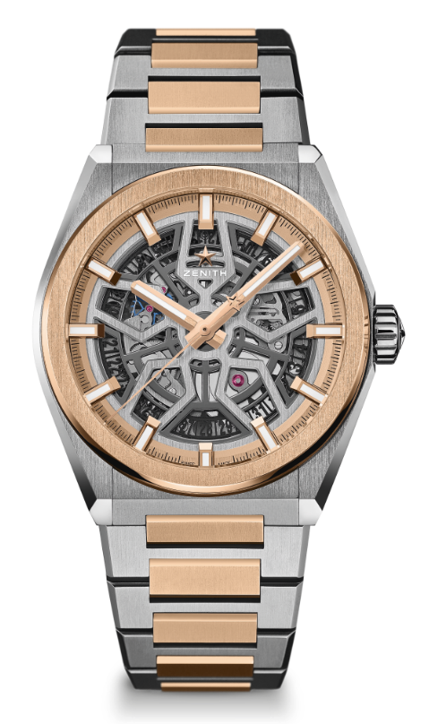
TECHNICAL DETAILS

Reference: 87.9001.670/79.M9001

KEY POINTS
New 41mm Brushed Titanium case with 18-carat rose gold bezel
In house Elite skeletonised movement
Silicon escape-wheel and lever

MOVEMENT
Elite 670 SK, Automatic
Calibre: 11 ½``` (Diameter: 25.60mm)
Movement thickness: 3.88mm
Components: 187
Jewels: 27
Frequency: 28,800 VpH (4Hz)
Power-reserve: min. 48 hours
Finishing: Special oscillating weight with satined finishings

FUNCTIONS
Hours and minutes in the centre
Central seconds hand
Date indication at 6 o’clock

CASE, DIAL & HANDS
Diameter: 41mm
Diameter opening: 32.5mm
Thickness: 10.75mm
Crystal: Domed sapphire crystal with anti-reflective treatment on both sides
Case-back: Transparent sapphire crystal
Material: Brushed titanium & 18-carat rose gold
Water-resistance: 10 ATM
Dial: Openworked
Hour-markers: Gold-plated, faceted and coated with Super-LumiNova® SLN C1
Hands: Gold-plated, faceted and coated with Super-LumiNova® SLN C1

STRAP & BUCKLE
Titanium & rose gold bracelet with folding buckle

