ZENITH PILOT COLLECTION STEP OUT IN BLACK AND BLUE

In 2019, the brand with the guiding star is complementing the retro look and sporting appeal of its Pilot collection with two distinctive new black and blue interpretations. Created for modern-day adventurers, whether taking to the skies or hitting the highway café racer style, Zenith’s Pilot timepieces are the perfect embodiment of the adventurous spirit propelling the aviation pioneers that the Manufacture has accompanied since the early days of flight. With its intense colours and fine proportions, the Pilot Type 20 lends itself particularly well to vintage variations while never losing sight of its legendary heritage.
A ruggedly virile pair
The imposing presence and venturesome temperament of this line make a striking appearance in the form of two muscled-up 45 mm diameter models. The Pilot Type 20 Extra Special Blue features a signature bronze case paired with a sober matt blue dial and matching blue nubuck strap. In a nod to the history of the Maison, its titanium case-back is engraved with the hallmark Zenith flying instruments logo. The latest tribute to the café racer biker community (also known as Ton-up boys), the Pilot Type 20 Ton Up Black features an aged stainless steel case, matt black dial and black oily nubuck leather strap lined with rubber for additional comfort. It offers a fresh interpretation of a model in which ZENITH has taken a pilot’s watch design and combined it with vintage motorcycle racing heritage.
Both these variations feature the easily identifiable, smoothly adjustable ratcheted wide Pilot crown and are powered by an automatic Zenith Elite 679 calibre. This reliable and accurate in-house movement drives central hours, minutes and seconds hands, while delivering a 50-hour power reserve. Devoid of date or calendar information, the dials stick to the bare minimum with outsize faceted luminous minute and seconds gold or black ruthenium-plated hands (typical of pilot’s watches) offering clear as day legibility, along with the oversized luminescent Arabic numerals emblematic of the line.
ZENITH: The Future of Swiss Watchmaking
Since 1865, Zenith has been guided by authenticity, daring and passion in pushing the boundaries of excellence, precision and innovation. Soon after its founding in Le Locle by visionary watchmaker Georges Favre-Jacot, Zenith gained recognition for the precision of its chronometers, with which it has won 2,333 chronometry prizes in just over a century and a half of existence: an absolute record. Famed for its legendary 1969 El Primero calibre enabling short-time measurements accurate to the nearest 1/10th of a second, the Manufacture has since developed over 600 movement variations. Today, Zenith offers new and fascinating vistas in time measurement, including 1/100th of a second timing with the Defy El Primero 21; and a whole new dimension in mechanical precision with the world’s most accurate watch, the 21st century Defy Lab. Energised by newly reinforced ties with a proud tradition of dynamic, avant-garde thinking, Zenith is writing its future… and the future of Swiss watchmaking.
PILOT TYPE 20 TON UP BLACK
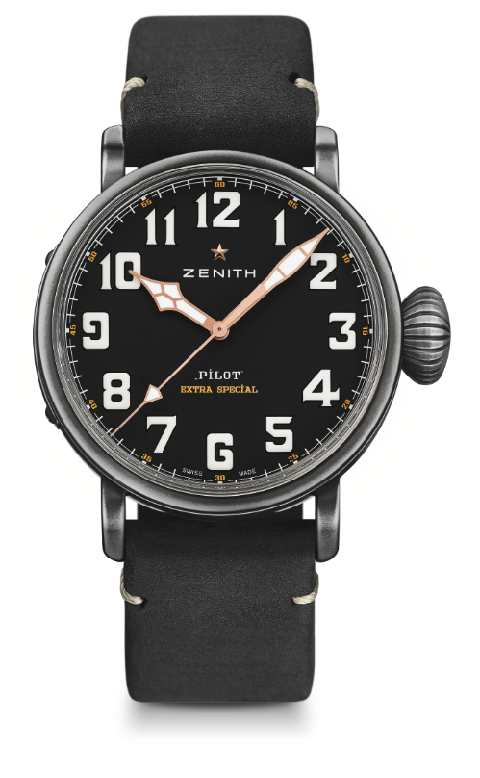
TECHNICAL DETAILS

Reference: 11.2432.679/21.C900

KEY POINTS
Aged stainless steel 45 mm case
Tribute to the Café Racer Spirit

MOVEMENT
Elite 679, Automatic
Calibre: 11 ½``` (Diameter: 25.60mm)
Movement thickness: 3.85mm
Components: 126
Jewels: 27
Frequency: 28,800 VpH (4Hz)
Power-reserve: min. 50 hours
Finishing: Oscillating weight with “Côtes de Genève” motif

FUNCTIONS
Hours and minutes in the centre
Central seconds hand

CASE, DIAL & HANDS
Diameter: 45mm
Diameter opening: 37.8mm
Thickness: 14.25mm
Crystal: Domed sapphire crystal with anti-reflective treatment on both sides
Case-back: Case-back with Café Racer Spirit engravings
Material: Aged stainless steel
Water-resistance: 10 ATM
Dial: Matt black
Hour-markers: Arabic numerals in Super-Luminova SLN C1
Hands: Black ruthenium-plated, faceted and coated with Super-LumiNova® SLN C1

STRAP & BUCKLE
Black oily nubuck leather strap with protective rubber lining
Titanium pin buckle

PILOT TYPE 20 EXTRA SPECIAL BLUE
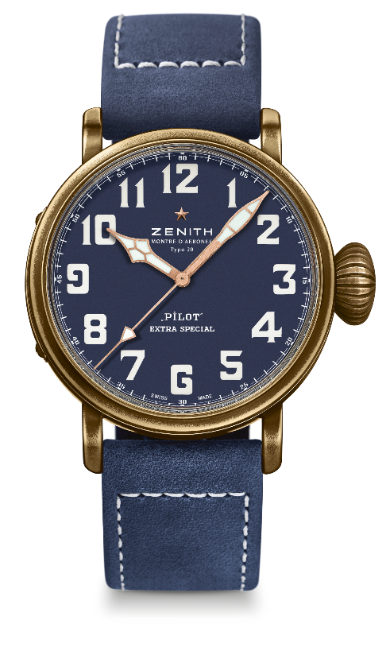
TECHNICAL DETAILS

Reference: 29.2432.679/57.C808

KEY POINTS
Bronze Case that will develop his own patina
Case-back engraved with Zenith flying instruments logo
Inspired by the legendary Zenith aviation watches
Arabic numerals entirely made of Super-Luminova

MOVEMENT
Elite 679, Automatic
Calibre: 11 ½``` (Diameter: 25.60mm)
Movement thickness: 3.85mm
Components: 126
Jewels: 27
Frequency: 28,800 VpH (4Hz)
Power-reserve: min. 50 hours
Finishing: Oscillating weight with “Côtes de Genève” motif

FUNCTIONS
Hours and minutes in the centre
Central seconds hand

CASE, DIAL & HANDS
Diameter: 45mm
Diameter opening: 37.8mm
Thickness: 14.25mm
Crystal: Domed sapphire crystal with anti-reflective treatment on both sides
Case-back: Titanium case-back with the Zenith flying instrument logo
Material: Bronze
Water-resistance: 10 ATM
Dial: Matt blue
Hour-markers: Arabic numerals in Super-Luminova SLN C1
Hands: Black ruthenium-plated, faceted and coated with Super-LumiNova® SLN C1

STRAP & BUCKLE
Blue oily nubuck leather strap with protective rubber lining
Titanium pin buckle

