ZENITH PILOT TYPE 20 EXTRA SPECIAL SILVER

Zenith has chosen its iconic Pilot line to introduce its first ever timepiece with a silver case. Renowned for its unique heritage and extensive range of appealing choices, the Pilot line offers the ideal platform for this new high-flyer issued in a 250-piece limited edition.

Zenith is the watch brand that holds the trademark for the ‘Pilot’ name, naturally giving it special legitimacy in the realm of aviation timepieces. Powered by high-precision mechanical ‘engines’ in the shape of Zenith Manufacture movements, these are models distinguished by reliability, readability and robustness.

The Pilot Type 20 Extra Special Silver channels the collection’s pioneering spirit as well as Zenith’s acclaimed history of onboard instruments developed during the early years of aeronautics. Water-resistant to 100 metres, the 45 mm-diameter silver case is duly inscribed on the back with the Zenith flying instruments logo in tribute to its origins. The instantly identifiable wide ratcheted Pilot crown ensuring quick and easy adjustment, while the clearly legible brushed silver riveted dial bears the line’s emblematic outsize hour-markers and likewise oversized faceted luminescent hours, minutes and seconds hands. The accuracy of these indications is ensured by an automatic Zenith Elite 679 calibre endowed with a generous 50-hour power reserve. Securing this rugged model securely to the wrist is a brown calfskin leather strap with a rivet and silver pin buckle, along with a distinctive tab recalling those featured on vintage pilot helmets.

While never losing sight of the adventurous mindset that forged its legend, the imposing presence and sporting spirit of the Pilot Type 20 Extra Special Silver offers a standout silver spin on a proud heritage.

ZENITH: The Future of Swiss Watchmaking
Since 1865, Zenith has been guided by authenticity, daring and passion in pushing the boundaries of excellence, precision and innovation. Soon after its founding in Le Locle by visionary watchmaker Georges Favre-Jacot, Zenith gained recognition for the precision of its chronometers, with which it has won 2,333 chronometry prizes in just over a century and a half of existence: an absolute record. Famed for its legendary 1969 El Primero calibre enabling short-time measurements accurate to the nearest 1/10th of a second, the Manufacture has since developed over 600 movement variations. Today, Zenith offers new and fascinating vistas in time measurement, including 1/100th of a second timing with the Defy El Primero 21; and a whole new dimension in mechanical precision with the world’s most accurate watch, the 21st century Defy Lab. Energised by newly reinforced ties with a proud tradition of dynamic, avant-garde thinking, Zenith is writing its future… and the future of Swiss watchmaking.

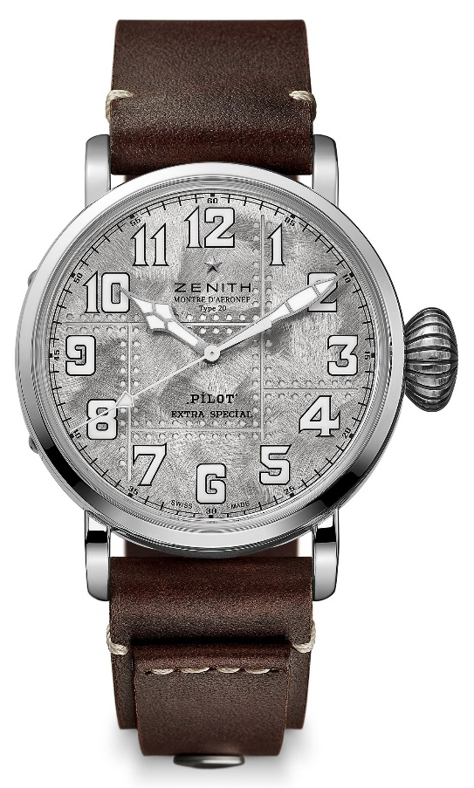
PILOT TYPE 20 EXTRA SPECIAL SILVER
TECHNICAL DETAILS

Reference: 05.2430.679.17.C902

KEY POINTS
Genuine Silver 925 case: Limited Edition of 250 units
Case-back engraved with Zenith flying instruments logo
Inspired by the legendary Zenith aviation watches
Arabic numerals entirely made of SuperLuminova

MOVEMENT
Elite 679, Automatic
Calibre: 11 ½``` (Diameter: 25.60mm)
Movement thickness: 3.85mm
Components: 126
Jewels: 27
Frequency: 28,800 VpH (4Hz)
Power-reserve: min. 50 hours
Finishing: Oscillating weight with “Côtes de Genève” motif

FUNCTIONS
Hours and minutes in the centre
Central seconds hand

CASE, DIAL & HANDS
Diameter: 45mm
Diameter opening: 37.8mm
Thickness: 14.25mm
Crystal: Domed sapphire crystal with anti-reflective treatment on both sides
Case-back: Silver case-back engraved with the Zenith flying instruments logo
Material: Silver 925
Water-resistance: 10 ATM
Dial: Brushed riveted dial with shiny reflections
Hour-markers Arabic numerals in SuperLuminova SLN C1
Hands Rhodium-plated, faceted and coated with SuperLuminova SLN C1

STRAP & BUCKLE
Brown calfskin leather strap with a rivet
Silver pin buckle

