ZENITH PAYS HOT TRIBUTE TO
TRINIDAD CIGAR 50TH ANNIVERSARY

Marking the jubilee of the one of the most luxurious and trendy cigar in the Habanos collection, Zenith introduces a precious new Pilot Type 20 Chronograph Trinidad Edition trilogy at Cuba’s 21st Habanos Festival. The latter is the most prestigious event dedicated to Premium Cigars and will be held from February 18th to 22nd 2019 in Havana City, which is also celebrating its 500th anniversary.

The Trinidad 50 anniversary cigar is made at Cohiba's exclusive El Laguito factory; this Habano is renowned for its rich, aromatic and medium flavour. Embodying all the richness of this iconic cigar, the Pilot Type 20 Chronograph Trinidad Edition appears in a trio of 45 mm rose, yellow and white gold cases, each available in 50-piece limited editions and engraved on the back with the Trinidad 50th Anniversary logo.

Beating inside is the automatic El Primero column-wheel chronograph movement, a descendant of the world’s most accurate series-made chronograph calibre that also turns 50 in 2019. It drives the central hours and minutes, small seconds and chronograph functions, displayed on a clearly legible dial bearing oversized beige luminescent numerals, a distinctive tobacco leaf pattern as well as Zenith and Trinidad logos.

These collector’s items are teamed with Trinidad logo patterned Havana brown calfskin leather straps featuring a protective rubber lining with the same logo on the inner side, secured by a pin buckle in 18-carat rose, yellow or white gold matching the case. An identical once-off Pilot Type 20 Chronograph Trinidad Edition in platinum will be auctioned during the Habanos Festival as a part of the exclusive Trinidad humidor developed in honour of the anniversary of the brand.

Both legendary Maisons with a shared universe of authenticity, precision and excellence, Zenith and Habanos, S.A., each infuse passion and expertise into exceptional creations so as to bring unmatched enjoyment to experienced connoisseurs. The collaboration between Habanos S.A. and Zenith has been consistently successful with the Cohiba brand and now continues with the Trinidad brand. Zenith and Habanos brands share the same philosophy of excellence, sophistication and exclusivity. The former: a Swiss watchmaking Manufacture building on more than 150 years of innovation and expertise; the latter: the celebrated name of the world’s most sought-after cigars.

ZENITH: The Future of Swiss Watchmaking
Since 1865, Zenith has been guided by authenticity, daring and passion in pushing the boundaries of excellence, precision and innovation. Soon after its founding in Le Locle by visionary watchmaker Georges Favre-Jacot, Zenith gained recognition for the precision of its chronometers, with which it has won 2,333 chronometry prizes in just over a century and a half of existence: an absolute record.
Famed for its legendary 1969 El Primero calibre enabling short-time measurements accurate to the nearest 1/10th of a second, the Manufacture has since developed over 600 movement variations. Today, Zenith offers new and fascinating vistas in time measurement, including 1/100th of a second timing with the Defy El Primero 21; and a whole new dimension in mechanical precision with the world’s most accurate watch, the 21st century Defy Lab. Energised by newly reinforced ties with a proud tradition of dynamic, avant-garde thinking, Zenith is writing its future… and the future of Swiss watchmaking.

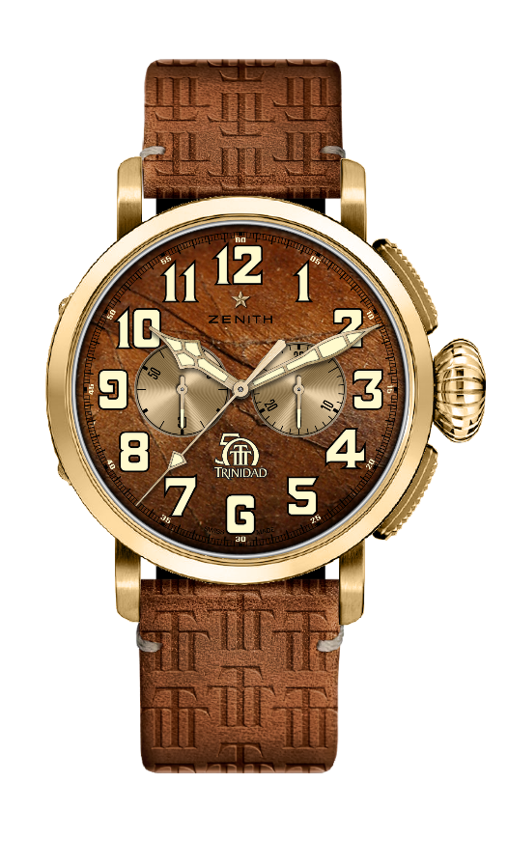
PILOT TYPE 20 CHRONOGRAPH TRINIDAD EDITION
LIMITED EDITION OF 50 UNITS

Reference: 30.2430.4069/78.C811

KEY POINTS
Special model part of a trilogy paying tribute to
The 50th Anniversary of Trinidad Cigars
Automatic El Primero column-wheel chronograph
Tobacco leaf pattern on the dial
Arabic numerals entirely made of SuperLuminova
Case-back engraved with Trinidad 50th Anniversary logo
Yellow gold version: Limited Edition of 50 units

MOVEMENT
Movement: El Primero 4069, Automatic
Calibre: 13¼``` (Diameter: 30 mm)
Movement thickness: 6.6 mm
Components: 254
Jewels: 35
Frequency: 36,000 VpH (5 Hz)
Power-reserve: min. 50 hours
Finishes: Oscillating weight with “Côtes de Genève” motif

FUNCTIONS
Hours and minutes in the centre
Small seconds at 9 o'clock
Chronograph:
- Central chronograph hand
- 30-minute counter at 3 o'clock

CASE, DIAL & HANDS
Material: yellow gold
Diameter: 45 mm
Diameter opening: 37.8 mm
Thickness: 14.25 mm
Water-resistance: 10 ATM
Dial: Havana brown with tobacco leaf pattern
Hour-markers: Arabic numerals in beige SuperLuminova SLN
Hands: Gold-plated, faceted and coated with beige SuperLuminova SLN
Case-back: yellow gold case-back engraved with Trinidad 50th Anniversary logo

STRAP & BUCKLE
Havana Brown calfskin leather with Trinidad logo pattern.
Protective rubber lining with Trinidad logo on the inner side
Yellow gold pin buckle
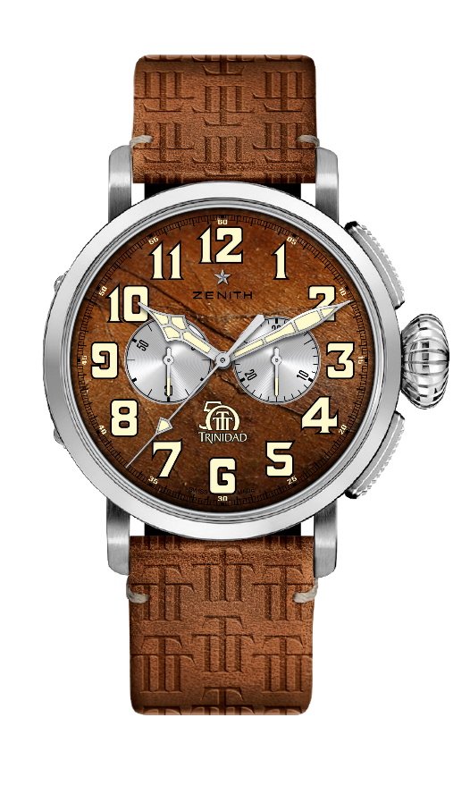
PILOT TYPE 20 CHRONOGRAPH TRINIDAD EDITION
LIMITED EDITION OF 50 UNITS

Reference: 65.2430.4069/78.C811

KEY POINTS
Special model part of a trilogy paying tribute to
The 50th Anniversary of Trinidad Cigars
Automatic El Primero column-wheel chronograph
Tobacco leaf pattern on the dial
Arabic numerals entirely made of SuperLuminova
Case-back engraved with Trinidad 50th Anniversary logo
White gold version : Limited Edition of 50 units

MOVEMENT
Movement : El Primero 4069, Automatic
Calibre : 13¼``` (Diameter: 30 mm)
Movement thickness : 6.6 mm
Components : 254
Jewels : 35
Frequency : 36,000 VpH (5 Hz)
Power-reserve : min. 50 hours
Finishes : Oscillating weight with “Côtes de Genève” motif

FUNCTIONS
Hours and minutes in the centre
Small seconds at 9 o'clock
Chronograph:
- Central chronograph hand
- 30-minute counter at 3 o'clock

CASE, DIAL & HANDS
Material : white gold
Diameter : 45 mm
Diameter opening : 37.8 mm
Thickness : 14.25 mm
Water-resistance : 10 ATM
Dial : Havana brown with tobacco leaf pattern
Hour-markers : Arabic numerals in beige SuperLuminova SLN
Hands : rhodium-plated, faceted and coated with beige SuperLuminova SLN
Case-back : white gold case-back engraved with Trinidad 50th Anniversary logo

STRAP & BUCKLE
Havana Brown calfskin leather with Trinidad logo pattern.
Protective rubber lining with Trinidad logo on the inner side
White gold pin buckle
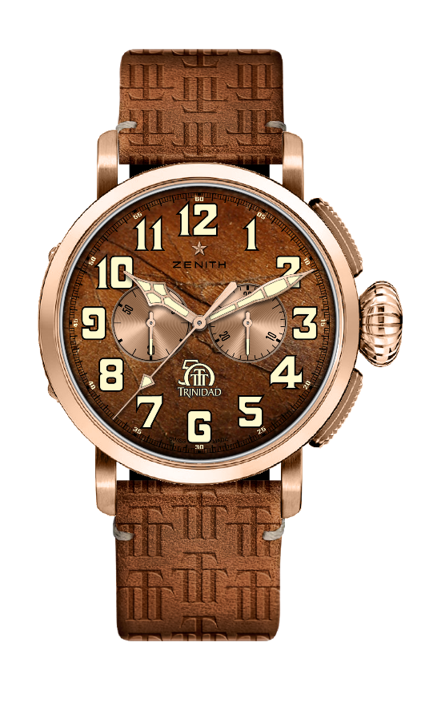
PILOT TYPE 20 CHRONOGRAPH TRINIDAD EDITION
LIMITED EDITION OF 50 UNITS

Reference: 18.2430.4069/77.C811

KEY POINTS
Special model part of a trilogy paying tribute to
The 50th Anniversary of Trinidad Cigars
Automatic El Primero column-wheel chronograph
Tobacco leaf pattern on the dial
Arabic numerals entirely made of SuperLuminova
Case-back engraved with Trinidad 50th Anniversary logo
18-ct rose gold version : Limited Edition of 50 units

MOVEMENT
Movement : El Primero 4069, Automatic
Calibre : 13¼``` (Diameter: 30 mm)
Movement thickness : 6.6 mm
Components : 254
Jewels : 35
Frequency : 36,000 VpH (5 Hz)
Power-reserve : min. 50 hours
Finishes : Oscillating weight with “Côtes de Genève” motif

FUNCTIONS
Hours and minutes in the centre
Small seconds at 9 o'clock
Chronograph:
- Central chronograph hand
- 30-minute counter at 3 o'clock

CASE, DIAL & HANDS
Material : 18-ct rose gold
Diameter : 45 mm
Diameter opening : 37.8 mm
Thickness : 14.25 mm
Water-resistance : 10 ATM
Dial : Havana brown with tobacco leaf pattern
Hour-markers : Arabic numerals in beige SuperLuminova SLN
Hands : Gold-plated, faceted and coated with beige SuperLuminova SLN
Case-back : 18-ct rose gold case-back engraved with Trinidad 50th Anniversary logo

STRAP & BUCKLE
Havana Brown calfskin leather with Trinidad logo pattern.
Protective rubber lining with Trinidad logo on the inner side
18-ct rose gold pin buckle

