DEFY EL PRIMERO 21 CARBON
A chronograph wristwatch at the pinnacle of precision, the DEFY El Primero 21 is equipped with a revolutionary movement that marks the 21st century chapter of the El Primero chronograph calibre’s enduring legacy, once again raising the bar in performance in a uniquely styled package. Now, the futuristic chronograph comes in its most outstanding iteration to date: DEFY El Primero 21 Carbon.

A high-performance, unprecedented calibre such as the El Primero 21 deserves a resolutely contemporary design, while remaining faithful to the Zenith El Primero heritage of boundary-pushing precision. Featuring a combination of straight lines and angles, the geometric facets of the case perfectly complement the voluminous architecture of the openworked movement. The highest frequency chronograph ever to be serially produced now comes in a lightweight and robust carbon fibre case.

Precision in Futuristic Form
There’s something truly inimitable about carbon fibre. The high-tech composite material is lightweight yet extremely durable. It makes a statement while remaining subdued. It plays with light and reveals a unique visual effect caused by the alternating layers of carbon fibres that are randomly arranged, making each case essentially unique. Its captivating visual effect is stealthy and edgy at once, giving the material a versatile and easily wearable aspect. And with this version of the DEFY El Primero 21, it’s not just the faceted case and round bezel that are forged from carbon, but also the crown and chronograph pushers.
Completing the ergonomics of the DEFY El Primero 21 Carbon is a choice of two straps: a black textured rubber strap with “cordura” effect coating, and a special rubber strap with a carbon effect for the ultimate urbanite look.

Edgier Look for an Unrivaled Function
With a case as otherworldly as carbon, it’s only natural that the movement and dial are made to match its mysterious allure. For the first time in the DEFY El Primero 21, the cutting-edge 1/100 second chronograph calibre operating at a phenomenal and unrivaled rate of 360’000 vibrations per hour (50 Hz) is given a deep black treatment, allowing the gleaming edges of the innovatory skeleton movement to shine through the dark. The open dial is also black, yet remains effortlessly legible with its contrasting white markings. The hour, minute and constant seconds hands, like the applied hour markers, are faceted with a dark ruthenium coating and filled with black SuperLuminova that gives off a subtle glow in the dark. Keeping the emphasis on its unrivaled high-speed chronograph function, the central 1/100 second hand and seconds and minutes totalisers have blackened hands with bright red tips. A look that embodies Zenith’s neo-futuristic, architectural design ethos to create the timepieces of tomorrow for the style-conscious watch aficionados of today.

ZENITH: the future of Swiss watchmaking
Since 1865, Zenith has been guided by authenticity, daring and passion in pushing the boundaries of excellence, precision and innovation. Soon after its founding in le Locle by visionary watchmaker Georges Favre-Jacot, Zenith gained recognition for the precision of its chronometers, which it has won 2,333 chronometry prizes in just over a century and a half of existence: an absolute record. Famed for its legendary 1969 El Primero calibre enabling short-time measurement accurate to the nearest 1/10th of a second, Zenith has since developed over 600 movement variations. Today, Zenith offers new and fascinating vistas, including 1/100th of a second timing with the Defy El Primero 21. Energised by newly reinforced ties with a proud tradition of dynamic, avant-garde thinking, Zenith is writing its future… and the future of Swiss watchmaking.

PRESS ROOM
For additional pictures please access the below link
http://pressroom.zenith-watches.com/login/?redirect_to=%2F&reauth=1

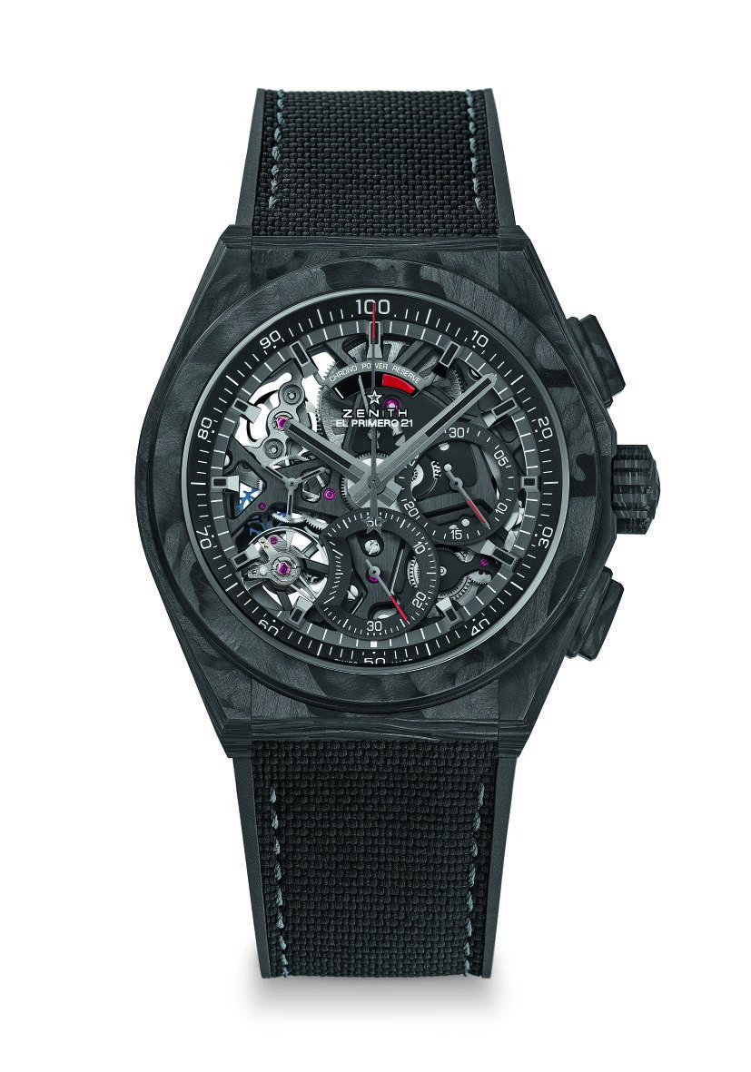
DEFY EL PRIMERO 21 CARBON
TECHNICAL DETAILS

Reference: 10.9000.9004/96.R921

UNIQUE SELLING POINTS
New 44 mm Full Carbon case (included pushers & Crown)
1/100th of a second chronograph movement
Exclusive dynamic signature of one rotation per second
1 escapement for the Watch (36,000 VpH - 5 Hz);
1 escapement for the Chronograph (360,000 VpH - 50 Hz)
TIME LAB-Chronometer certified
Black movement finish

MOVEMENT
El Primero 9004 automatic
Calibre: 14¼``` (Diameter: 32.80 mm)
Thickness: 7.9 mm
Components: 293
Jewels: 53
Frequency 36,000 VpH (5 Hz)
Power reserve approx. 50 hours
Special oscillating weight with “circular satin-brushed” motif

FUNCTIONS
1/100th of a second chronograph functions
Chronograph power-reserve indication at 12 o'clock
Hours and minutes in the centre
Small seconds at 9 o'clock
- Central chronograph hand
- 30-minute counter at 3 o'clock
- 60-second counter at 6 o'clock

CASE, DIAL & HANDS
Diameter: 44 mm
Diameter opening: 35.5 mm
Thickness: 14.50 mm
Crystal: Domed sapphire crystal with anti-reflective treatment on both sides
Case back: Transparent sapphire crystal
Material: Carbon
Water resistance: 10 ATM
Dial: Black Openworked
Hour markers: Ruthenium-plated, faceted and coated with black Super-LumiNova®
Hands: Ruthenium-plated, faceted and coated with black Super-LumiNova®

STRAPS AND BUCKLE
Black Rubber Strap with “Cordura” effect coating
Titanium & Carbon double folding clasp with Black DLC coating
Additional special Black Rubber strap with Carbon effect included

