DEFY EL PRIMERO DOUBLE TOURBILLON
Power, speed and precision

Two years ago, Zenith introduced the revolutionary Defy El Primero 21, the only high-frequency automatic chronograph designed to measure hundredths of a second, ushering watchmaking firmly into the 21st century. In 2019, the Swiss Manufacture is taking another big leap with the Defy El Primero Double Tourbillon: an innovative model powered by the El Primero 9020 calibre and its two separate escapements. One of the latter serves to keep the chronograph beating at an exceptional frequency and power the 1/100th of a second display, while the other ensures the lasting precision of the watch. This model is available in two limited editions: a 10-piece platinum version and a 50-unit carbon interpretation.

One sweep of the dial per second
With its DEFY collection, Zenith is constantly innovating and setting the standard for tomorrow's watchmaking: after the unequalled Defy El Primero 21, the first serially produced mechanical chronograph to provide hundredth of a second measurement; followed by the Defy Lab, the world’s most accurate mechanical watch with an unprecedented oscillator, the Haute Horlogerie manufacturer is unveiling the Defy El Primero Double Tourbillon. This unprecedented combination of horological complications – two tourbillons and a 1/100th of a second chronograph – features truly exceptional qualities.
A distillation of technology, innovation, performance and design, the latest addition to the Defy collection asserts itself in terms of both its construction and its aesthetics. For this model, Zenith has developed two tourbillons, a first for the Maison. In an additional feat, one of the tourbillons (at 10 o'clock) is coupled with and regulates the chronograph measuring and displaying hundredths of a second in a perfectly legible manner. Beating a frequency of 50 Hz (360,000 vibrations per hour) with its carriage performing a complete rotation every five seconds, this tourbillon is the fastest in the world. It drives the chronograph hand at the amazing speed of one full turn of the dial per second. The second tourbillon (at 8 o'clock), operating at 5 Hz with a carriage performing one rotation per minute, regulates the rate of the watch, meaning the hours, minutes and seconds.

A vivid expression of futuristic horology
Echoing this dual architecture, two dedicated barrels – one for the watch and the other for the chronograph – store and deliver energy. They respectively provide 60 hours of power reserve for the watch and 50 minutes for the 1/100th of a second chronograph. Heir to the legendary 1969 El Primero, this new high-frequency in-house movement drives the hours, minutes, 1/100th of a second chronograph, 60-second and 30-minute counters (at 6 and 9 o'clock respectively), along with a chronograph power-reserve indicator at 12 o'clock. As a further guarantee of precision, the El Primero 9020 calibre is chronometer-certified by an independent body (TimeLab).
While vividly expressing futuristic, technical and assertive watchmaking, the Defy El Primero Double Tourbillon also stands out for its powerful aesthetics. With its generously openworked dial accentuated by a two-tone treatment – a new signature of Zenith Haute Horlogerie movements – El Primero 9020 and its 311 components are shown to full advantage. The blue-treated tourbillon carriages with the Zenith star, along with the bridges and baseplate, feature polished angles that further enhance the 3D view of this stunning mechanism in motion.
Whether crafted in platinum with the collection’s characteristic satin-brushed and polished finishes and a sapphire case-back, or entirely made of carbon, the case is water-resistant to 100 metres. It is secured to the wrist with a luxurious high-tech black rubber strap, coated with alligator leather or Cordura-patterned. Effectively combining aesthetics, functionality and polymorphism, its composition is resistant, durable and hypoallergenic, while offering infinite possibilities for variations in textures, colours and topstitching. The platinum Defy El Primero Double Tourbillon is available in a 10-piece limited edition, while the carbon model is limited to 50 units.

ZENITH: the future of Swiss watchmaking
Since 1865, Zenith has been guided by authenticity, daring and passion in pushing the boundaries of excellence, precision and innovation. Soon after its founding in le Locle by visionary watchmaker Georges Favre-Jacot, Zenith gained recognition for the precision of its chronometers, which it has won 2,333 chronometry prizes in just over a century and a half of existence: an absolute record. Famed for its legendary 1969 El Primero calibre enabling short-time measurement accurate to the nearest 1/10th of a second, Zenith has since developed over 600 movement variations. Today, Zenith offers new and fascinating vistas, including 1/100th of a second timing with the Defy El Primero 21. Energised by newly reinforced ties with a proud tradition of dynamic, avant-garde thinking, Zenith is writing its future… and the future of Swiss watchmaking.

PRESS ROOM
For additional pictures please access the below link
http://pressroom.zenith-watches.com/login/?redirect_to=%2F&reauth=1

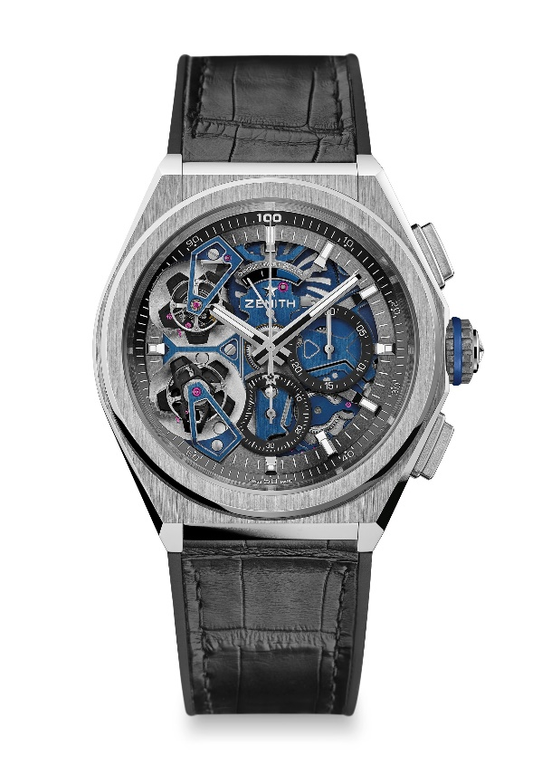
DEFY EL PRIMERO DOUBLE TOURBILLON
LIMITED EDITION 10
TECHNICAL DETAILS

Reference: 40.9000.9020/78.R582

UNIQUE SELLING POINTS
1/100th of a second Double Tourbillon Chronograph movement
1 Tourbillon escapement for the Watch (36,000 VpH - 5 Hz) ;
1 Tourbillon escapement for the Chronograph (360,000 VpH - 50Hz)
Exclusive dynamic signature of one rotation per second for the chronograph hand
Chronometer-certified by Timelab

MOVEMENT
Movement El Primero 9020, Automatic
Calibre 15 ¾ ``` (Diameter: 35.8 mm)
Movement thickness: 7.9 mm
Components: 311
Exclusive two-tone signature on plates and bridges
Jewels: 59
Frequency: 36,000 VpH (5 Hz)
Power-reserve approx.: 50 hours
Finishes: Special oscillating weight with satin-brushed finishes

FUNCTIONS
Hours and minutes in the centre
Double Tourbillon:
1 escapement for the Watch (36,000 VpH / 5 Hz – the carriage makes one full turn in 60 seconds)
1 escapement for the Chronograph (360,000 VpH / 50 Hz – the carriage performs a complete rotation in 5 sec)
1/100th of a second chronograph:
- Central chronograph hand that makes one sweep of the dial per second
- 30-minute counter at 3 o'clock
- 60-second counter at 6 o'clock
- Chronograph power-reserve indication at 12 o'clock

CASE, DIAL & HANDS
Diameter: 46 mm
Diameter opening: 36 mm
Thickness: 14.50 mm
Case-back: Transparent sapphire crystal
Material: Platinum 950
Water-resistance: 10 ATM
Dial: Openworked
Hour-markers: Rhodium-plated, faceted and coated with Super-LumiNova® SLN C1
Hands : Rhodium-plated and faceted gold, coated with Super-LumiNova® SLN C1

STRAP AND BUCKLE
Strap: Black rubber with black alligator leather coating
Buckle: Titanium & white gold double folding clasp
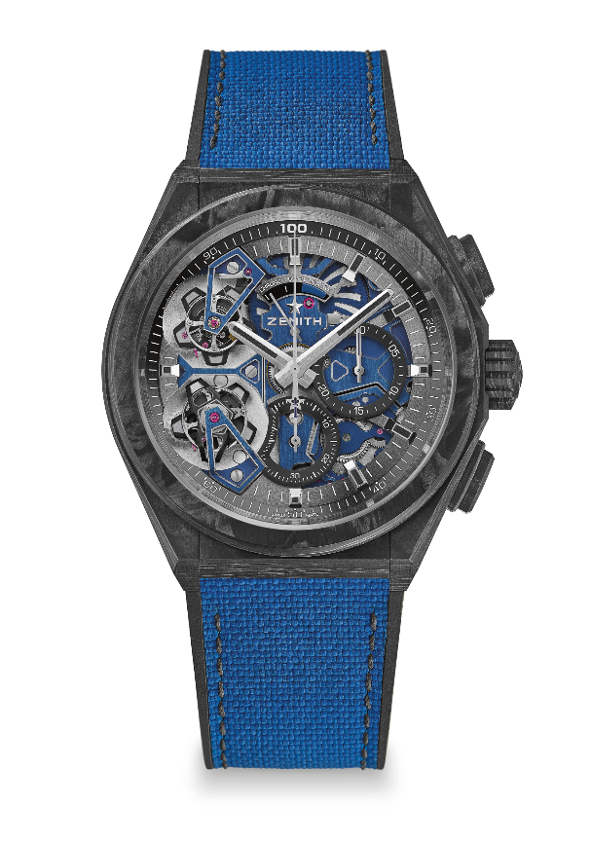
DEFY EL PRIMERO DOUBLE TOURBILLON
LIMITED EDITION 50
TECHNICAL DETAILS

Reference: 10.9000.9020/79.R918

UNIQUE SELLING POINTS
1/100thof a second Double Tourbillon Chronograph movement
1 Tourbillon escapement for the Watch (36,000 VpH - 5 Hz) ;
1 Tourbillon escapement for the Chronograph (360,000 VpH - 50Hz)
Full carbon model: Case, pushers, crown and buckle head
Exclusive dynamic signature of one rotation per second for the chronograph hand
Chronometer-certified by Timelab

MOVEMENT
Movement El Primero 9020, Automatic
Calibre 15 3/4``` (Diameter: 35.8 mm)
Movement thickness: 7.9 mm
Components: 311
Exclusive two-tone signature on plates and bridges
Jewels 59
Frequency 36,000 VpH (5 Hz)
Power-reserve :approx. 50 hours
Finishes: Special oscillating weight with satin-brushed finishes

FUNCTIONS
Hours and minutes in the centre
Double Tourbillon
1 escapement for the Watch (36,000 VpH / 5 Hz – the carriage makes one full turn in 60 seconds)
1 escapement for the Chronograph (360,000 VpH / 50 Hz – the carriage performs a complete rotation in 5 sec)
1/100th of a second chronograph:
- Central chronograph hand that makes one sweep of the dial per second
- 30-minute counter at 3 o'clock
- 60-second counter at 6 o'clock
- Chronograph power-reserve indication at 12 o'clock

CASE, DIAL & HANDS
Diameter: 46 mm
Diameter opening: 36 mm
Thickness: 14.50 mm
Case-back: Transparent sapphire crystal
Material: Black carbon
Water-resistance 10 ATM
Dial: Openworked
Hour-markers: Black ruthenium-plated, faceted and coated with black Super-LumiNova®
Hands: Black ruthenium-plated, faceted and coated with black Super-LumiNova®

STRAPS AND BUCKLE
Bracelet: Black rubber with Cordura-patterned blue rubber
Buckle: Titanium double folding clasp with black carbon head

