EL PRIMERO A386 REVIVAL
Iconic trio

Zenith sets the crowning touch to the festivities honouring its legendary 1969 El Primero high-frequency chronograph with a solid gold "revival" trilogy. The 38 mm case of this watchmaking icon, which is celebrating half a century of avant-garde and precision, appears clothed in this precious metal. To mark this anniversary, the three unisex models in white, rose or yellow gold are issued in 50-piece limited editions with a 50-year guarantee.
El Primero has been writing the epic Zenith saga since 1969. For this golden jubilee, the world's most accurate automatic chronograph arrays its original attributes in the radiant glow of white, pink or yellow gold. Its revolutionary mechanics capable of tenth-of-a-second measurement, together with its three emblematic counters, have made it a legend. A cadence of 36,000 vibrations per hour; an integrated column-wheel construction; a ballbearing-mounted central rotor; and over 50 hours of power reserve (a real feat for such a high frequency) have been the signature features of El Primero creations for half a century. As a fitting tribute, Zenith presents three 50-piece re-editions of the original model, complete with a 50-year guarantee ensuring the bright future and heirloom stature of this anniversary series.

Living legend
Apart from its precious metal, this anniversary edition faithfully reproduces the initial characteristics of the 1969 El Primero: a 38 mm diameter case, a domed crystal, three-coloured counters, a tachymeter scale, as well as the shape of the hands and hour-markers. The mushroom-type pushers and lugs are also identical to the original, thanks to the "reverse engineering" process adopted. In designing this vintage series, each component of an original El Primero chronograph was digitised so as to ensure accurate reproduction of its properties. The only exceptions are the initially closed caseback that now fully reveals the movement, as well as the updated logo adorning the crown. Meanwhile, this model’s ‘engine’ is the current version of the El Primero automatic calibre powering the hours, minutes, small seconds, chronograph, tachymeter and date functions, with the latter appearing between 4 and 5 o’clock on the white lacquered dial. Nods to the past continue with a brown or black leather strap depending on the model – pictured here in rubber-lined alligator leather – fitted with a buckle made of the same gold as the case, as well as with the composition of the case. The latter contains a bright red travel pouch, like the one from 1969, as well as a microfibre cloth adorned on one side with an El Primero chronograph movement plan and on the other with a picture of the original user manual.

ZENITH: the future of Swiss watchmaking
Since 1865, Zenith has been guided by authenticity, daring and passion in pushing the boundaries of excellence, precision and innovation. Soon after its founding in le Locle by visionary watchmaker Georges Favre-Jacot, Zenith gained recognition for the precision of its chronometers, which it has won 2,333 chronometry prizes in just over a century and a half of existence: an absolute record. Famed for its legendary 1969 El Primero calibre enabling short-time measurement accurate to the nearest 1/10th of a second, Zenith has since developed over 600 movement variations. Today, Zenith offers new and fascinating vistas, including 1/100th of a second timing with the Defy El Primero 21. Energised by newly reinforced ties with a proud tradition of dynamic, avant-garde thinking, Zenith is writing its future… and the future of Swiss watchmaking.

PRESS ROOM
For additional pictures please access the below link
http://pressroom.zenith-watches.com/login/?redirect_to=%2F&reauth=1

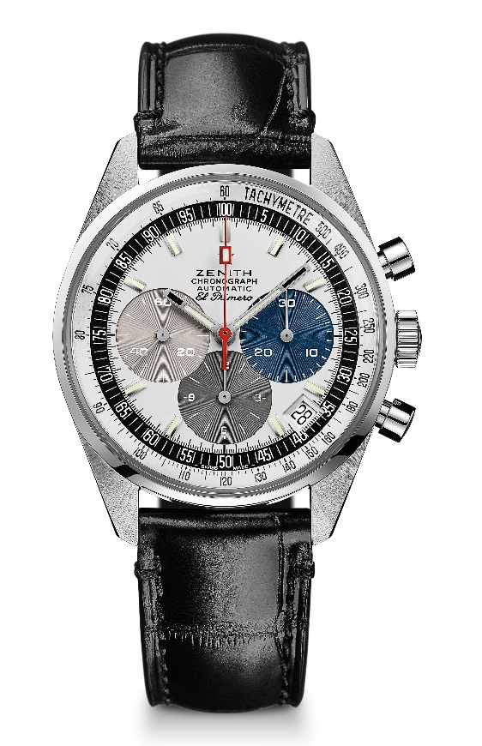
EL PRIMERO A386 REVIVAL
TECHNICAL DETAILS

Reference: 65.A386.400.69.C815

KEY POINTS
Revival of the first ever El Primero Model from 1969
Original revival of the case with 38 mm diameter
Automatic El Primero column-wheel chronograph
White gold version: Limited Edition of 50 units
50 Years of Warranty

MOVEMENT
El Primero 400, Automatic
Calibre: 13 ¼ ``` (Diameter: 30 mm)
Movement thickness: 6.6.mm
Components: 278
Jewels: 31
Frequency: 36,000 VpH (5 Hz)
Power-reserve: min. 50 hours
Finishes: Oscillating weight with “Côtes de Genève”. motif

FUNCTIONS
Hours and minutes in the centre
Small seconds at 9 o'clock
Chronograph:
- Central chronograph hand
- 12-hour counter at 6 o'clock
- 30-minute counter at 3 o'clock
Tachymetric scale
Date indication at 4:30

CASE, DIAL & HANDS
Diameter: 38 mm
Diameter opening: 33.05 mm
Thickness: 12.60 mm
Crystal: Domed sapphire crystal with anti-reflective treatment on both sides
Case-back: Transparent sapphire crystal
Material: White gold
Water-resistance: 10 ATM
Dial: White-lacquered dial with three different-coloured counters
Hour-markers: Rhodium-plated, faceted and coated with Super-LumiNova SLN C3
Hands: Rhodium-plated, faceted and coated with Super-LumiNova SLN C3

STRAP & BUCKLE
Black alligator leather strap with protective rubber lining
White gold pin buckle

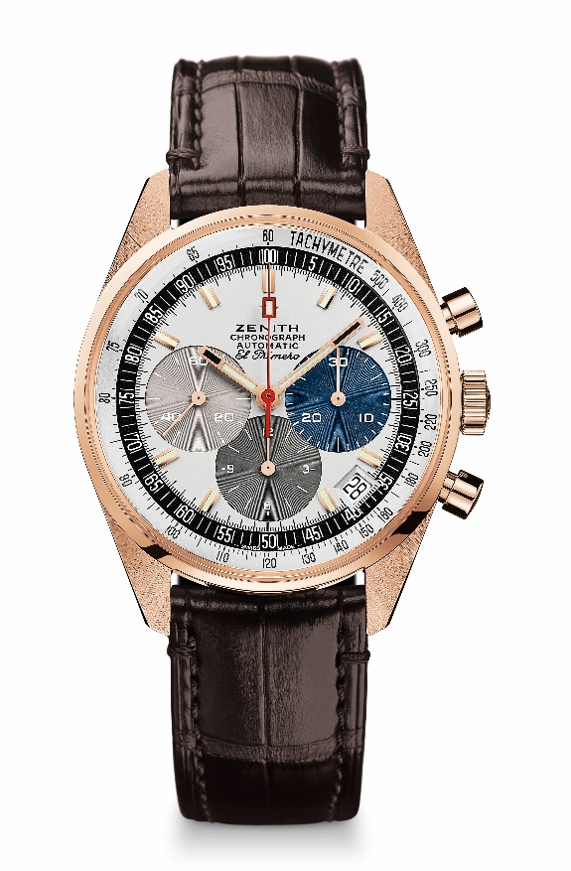
EL PRIMERO A386 REVIVAL
TECHNICAL DETAILS

Reference: 18.A386.400/69.C807

KEY POINTS
Revival of the first ever El Primero Model from 1969
Original revival of the case with 38 mm diameter
Automatic El Primero column-wheel chronograph
Rose gold version: Limited Edition of 50 units
50 Years of Warranty

MOVEMENT
El Primero 400, Automatic
Calibre: 13 ¼ ``` (Diameter: 30 mm)
Movement thickness: 6.6.mm
Components: 278
Jewels: 31
Frequency: 36,000 VpH (5 Hz)
Power-reserve: min. 50 hours
Finishes: Oscillating weight with “Côtes de Genève”. motif

FUNCTIONS
Hours and minutes in the centre
Small seconds at 9 o'clock
Chronograph:
- Central chronograph hand
- 12-hour counter at 6 o'clock
- 30-minute counter at 3 o'clock
Tachymetric scale
Date indication at 4:30

CASE, DIAL & HANDS
Diameter: 38 mm
Diameter opening: 33.05 mm
Thickness: 12.60 mm
Crystal: Box sapphire crystal with anti-reflective treatment on both sides
Case-back: Transparent sapphire crystal
Material: Rose gold
Water-resistance: 10 ATM
Dial: White-lacquered dial with three different-coloured counters
Hour-markers: Gold-plated, faceted and coated with Super-LumiNova SLN C3
Hands: Gold-plated, faceted and coated with Super-LumiNova SLN C3

STRAP & BUCKLE
Brown alligator leather strap with protective rubber lining
Rose gold pin buckle
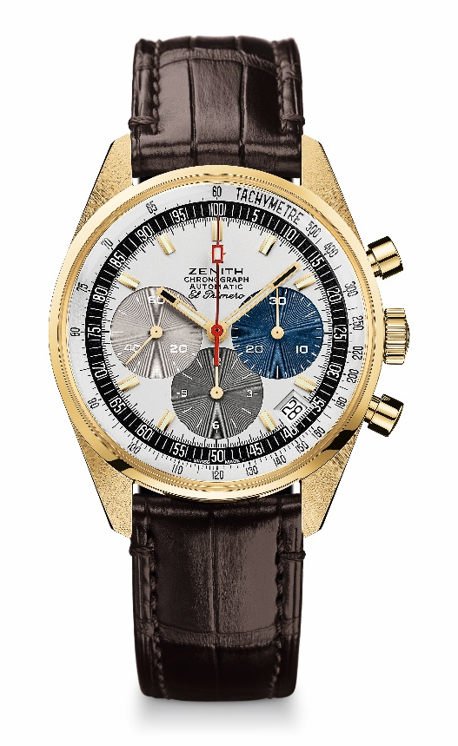
EL PRIMERO A386 REVIVAL
TECHNICAL DETAILS

Reference: 30.A386.400/69.C807

KEY POINTS
Revival of the first ever El Primero Model from 1969
Original revival of the case with 38 mm diameter
Automatic El Primero column-wheel chronograph
Yellow gold version: Limited Edition of 50 units
50 Years of Warranty

MOVEMENT
El Primero 400, Automatic
Calibre: 13 ¼ ``` (Diameter: 30 mm)
Movement thickness: 6.6.mm
Components: 278
Jewels: 31
Frequency: 36,000 VpH (5 Hz)
Power-reserve: min. 50 hours
Finishes: Oscillating weight with “Côtes de Genève”. motif

FUNCTIONS
Hours and minutes in the centre
Small seconds at 9 o'clock
Chronograph:
- Central chronograph hand
- 12-hour counter at 6 o'clock
- 30-minute counter at 3 o'clock
Tachymetric scale
Date indication at 4:30

CASE, DIAL & HANDS
Diameter: 38 mm
Diameter opening: 33.05 mm
Thickness: 12.60 mm
Crystal: Box sapphire crystal with anti-reflective treatment on both sides
Case-back: Transparent sapphire crystal
Material: Yellow gold
Water-resistance: 10 ATM
Dial: White-lacquered dial with three different-coloured counters
Hour-markers: Gold-plated, faceted and coated with Super-LumiNova SLN C3
Hands: Gold-plated, faceted and coated with Super-LumiNova SLN C3

STRAP & BUCKLE
Brown alligator leather strap with protective rubber lining
Yellow gold pin buckle

