ZENITH PILOT TYPE 20 ADVENTURE

Zenith Pilot Type 20 Adventure combines a wholly urban outlook with unparalleled versatility. Expressing reliability, comfort and robustness, the Pilot Type 20 Adventure also comes in a chronograph version, the Pilot Type 20 Chronograph Adventure. Guaranteeing trademark Pilot easy readability for adrenalined-up thrill-seekers and city slickers alike, along with two fully-interchangeable strap options, these additions to the Zenith Pilot line are set to be a high-energy hit for every occasion.

A natural heir to the onboard instruments developed by Zenith in the early years of aeronautics, the Pilot Type 20 Chronograph Adventure is powered by an automatic El Primero column-wheel chronograph movement. Not to be outdone, the Pilot Type 20 Adventure is equipped with an automatic Zenith Elite 679 calibre, ensuring total reliability and a 50-hour power reserve designed to outlast the most tenacious ambush.

Featuring the wide easily adjustable ratcheted crown of the original aviation instruments that inspired these must-have pieces of 21st century kit, both Pilot Type 20 Adventure have 45mm cases in bronze. While titanium casebacks bear the ZENITH Flying Instruments logo in a final salute to the pioneering spirit of their role models, the very latest in urban must-haves is issued with grained khaki green dials packing oversized Arabic numerals entirely made of Super-LumiNova®.

Making the Pilot Type 20 Adventurer the ultimate accessory if you’re into where the action is, these high-flying timepieces come in a choice of camouflage fabric strap or suave khaki matrix calfskin leather straps, both with protective rubber lining and a titanium pin buckle.

ZENITH: The Future of Swiss Watchmaking
Since 1865, Zenith has been guided by authenticity, daring and passion in pushing the boundaries of excellence, precision and innovation. Soon after its founding in Le Locle by visionary watchmaker Georges Favre-Jacot, Zenith gained recognition for the precision of its chronometers, with which it has won 2,333 chronometry prizes in just over a century and a half of existence: an absolute record. Famed for its legendary 1969 El Primero calibre enabling short-time measurements accurate to the nearest 1/10th of a second, the Manufacture has since developed over 600 movement variations. Today, Zenith offers new and fascinating vistas in time measurement, including 1/100th of a second timing with the Defy El Primero 21; and a whole new dimension in mechanical precision with the world’s most accurate watch, the 21st century Defy Lab. Energised by newly reinforced ties with a proud tradition of dynamic, avant-garde thinking, Zenith is writing its future… and the future of Swiss watchmaking.

PRESS ROOM
For additional pictures please access the below link
http://pressroom.zenith-watches.com/login/?redirect_to=%2F&reauth=1

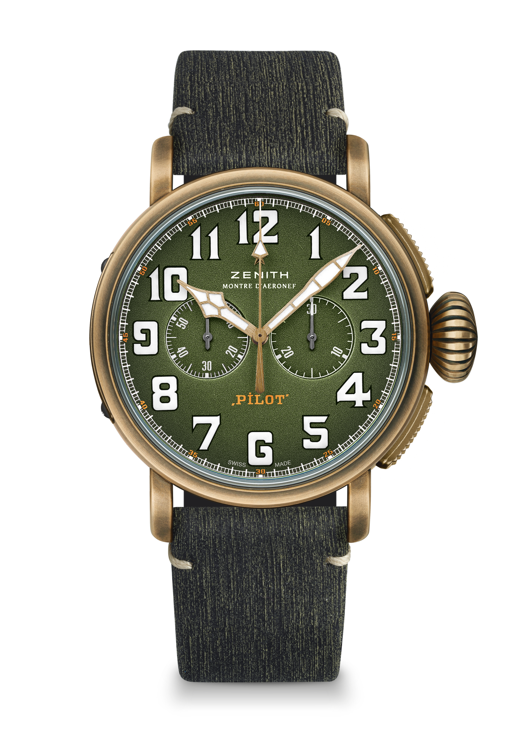
PILOT TYPE 20 CHRONOGRAPH ADVENTURE
Reference: 29.2430.4069.63.I001

TECHNICAL DETAILS

KEY POINTS
45 mm Bronze Case
Automatic El Primero column wheel chronograph
Military inspired model with khaki green dial and camo strap
Arabic numerals entirely made of SuperLumiNova®

MOVEMENT
El Primero 4069, Automatic
Calibre: 13 ¼``` (Diameter: 30mm)
Movement thickness: 6.6mm
Components: 254
Jewels: 35
Frequency: 36,000 VpH (5Hz)
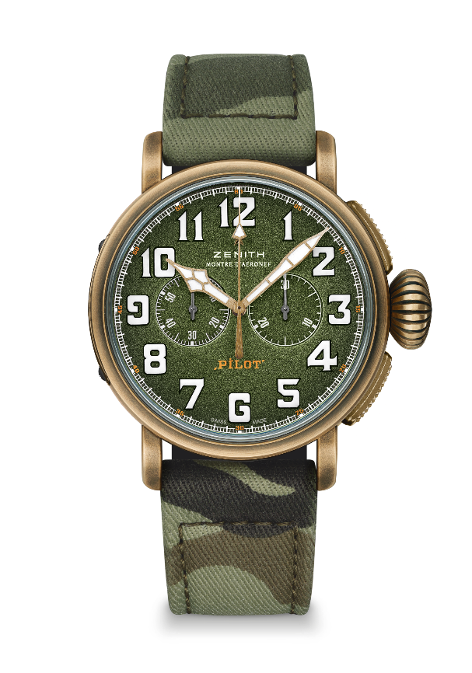
Power-reserve: min. 50 hours
Finishes: Oscillating weight with “Côtes de Genève” motif

FUNCTIONS
Hours and minutes in the centre
Small seconds at 9 o’clock
Chronograph: Central chronograph hand & 30-minute counter at 3 o’clock

CASE, DIAL & HANDS
Diameter: 45mm
Diameter opening: 37.8mm
Thickness: 14.25mm
Crystal: Domed sapphire crystal with anti-reflective treatment on both sides
Case-back: Titanium engraved with ZENITH Flying instruments logo
Material: Bronze
Water-resistance: 10 ATM
Dial: Grained Khaki green
Hour-makers: Arabic numerals with white SuperLumiNova® SLN C1
Hands: Gold-plated, faceted and coated with white SuperLumiNova®SLN C1

STRAPS & BUCKLES
Camouflage fabric strap with protective rubber lining
2nd strap included: Khaki matrix calfskin leather strap with protective rubber lining
Titanium pin buckle

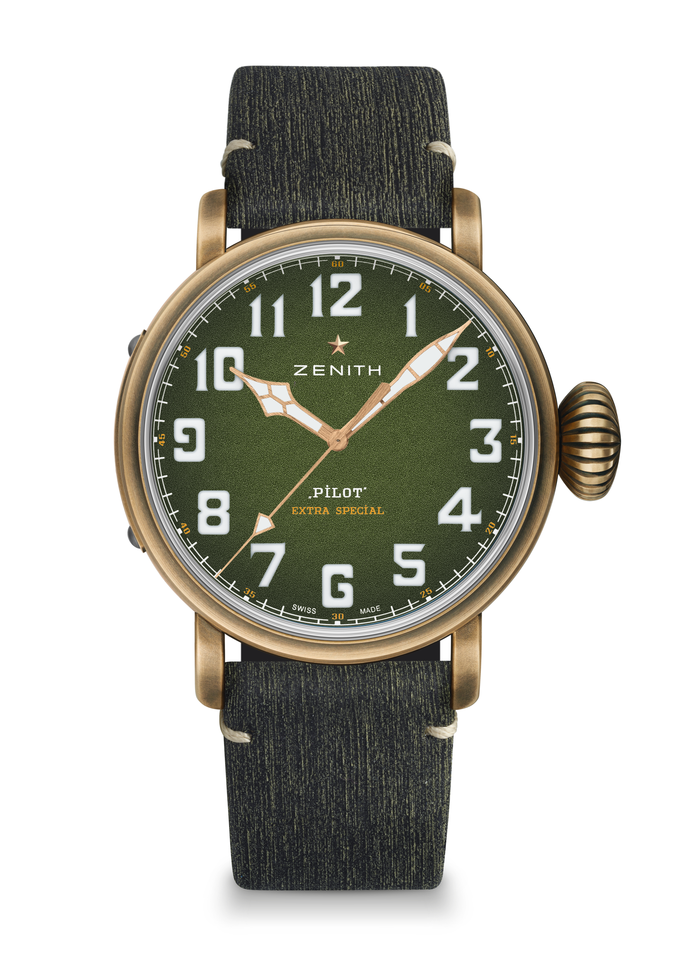
PILOT TYPE 20 EXTRA SPECIAL ADVENTURE

Reference: 29.2430.679.63.I001

TECHNICAL DETAILS

KEY POINTS
45 mm Bronze Case
Automatic Elite movement
Military inspired model with khaki green dial and camo strap
Arabic numerals entirely made of SuperLumiNova®

MOVEMENT
Elite 679, Automatic
Calibre: 11 ½``` (Diameter: 25.60mm)
Movement thickness: 3.85mm
Components: 126
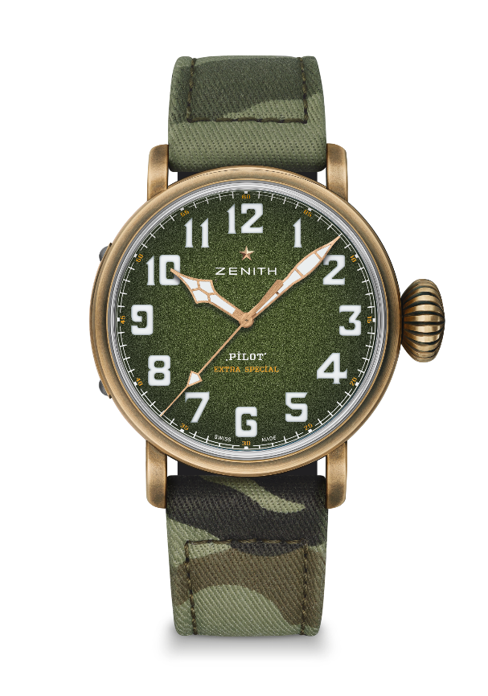
Jewels: 27
Frequency: 28,800 VpH (4Hz)
Power-reserve: min. 50 hours
Finishing: Oscillating weight with “Côtes de Genève” motif

FUNCTIONS
Hours and minutes in the centre
Central seconds hand

CASE, DIAL & HANDS
Diameter: 45mm
Diameter opening: 37.8mm
Thickness: 14.25mm
Crystal: Domed sapphire crystal with anti-reflective treatment on both sides
Case-back: Titanium engraved with ZENITH Flying instruments logo
Material: Bronze
Water-resistance: 10 ATM
Dial: Grained Khaki green
Hour-markers: Arabic numerals in Super-Luminova SLN C1
Hands: Gold-plated, faceted and coated with Super-LumiNova® SLN C1

STRAPS & BUCKLE
Camouflage fabric strap with protective rubber lining
2nd strap included: Khaki matrix calfskin leather strap with protective rubber lining
Titanium pin buckle

