DEFY EL PRIMERO FUSEE TOURBILLON
Since the dawn of precision timekeeping, watchmakers have sought to produce timepieces that offer unfaltering performance through the use of “constant force”. Zenith reinterprets the fusee & chain constant force mechanism in a modernistic style in the new DEFY Fusee Tourbillon. Housing the new El Primero 4805 SK calibre, a manual-winding movement that follows the DEFY code of avant-garde movement architecture with an open three-dimensional impact, the DEFY Fusee Tourbillon is available in two distinct editions in Carbon and Platinum.
A New Vision of Haute Horlogerie
Upon a first glance, it’s immediately clear that the DEFY Fusee Tourbillon’s calibre is out of the ordinary. The spoke design of the bridges is amplified by their bicolor finish, where the top satin-finished surface is given a black treatment, while its polished sides are a lighter grey rhodium tone. The layout of the bridges offers a balanced layout of the various functions and complications. On the top half of the movement, one can admire the uniquely conceived fusee and chain constant force mechanism. The chain, which consists of 575 individually hand-assembled components, features a bold blued treatment: a first for a wristwatch fusee and chain system. On the opposite end at 6 o’clock, a tourbillon cage with an entirely new construction featuring an off-centered balance wheel makes a full rotation every 60 seconds. Like the chain, the tourbillon cage is embellished with a striking blue colour, reinforcing the visual effect of the DEFY Fusee Tourbillon’s unique moving parts. Positioned at the edge of the dial between 4 and 5 o’clock, a red-tipped hand indicates the power reserve, a handy feature when manually winding the DEFY Fusee Tourbillon with its 50-hour power reserve.

One extraordinary movement – two entirely different executions
As a mechanical movement’s mainspring unwinds, the torque it delivers to the regulating organ drops, resulting in less efficient chronometric performance of the movement. A centuries-old solution to counter this and achieve constant force lies within the power source and its transmission. Known as the “fusee and chain” system, it features miniature chain is coiled around a conical “fusee” and attached to the mainspring barrel. As the mainspring unwinds, more of the chain wraps around the barrel, detaching itself from the wide conical base of the fusee. The greater turning movement provided by the fusee compensates the weakening mainspring pull, thus maintaining the torque and, consequently, the amplitude of the regulating organ constant throughout the duration of the mainspring’s autonomy.

By combining the fusee and chain mechanism with a tourbillon regulating organ, Zenith places precision at the forefront of its unique take on haute horlogerie. Highlighting the unique technical and aesthetic prowess of the piece, the DEFY Fusee Tourbillon is produced in two different editions.
The first version features a light yet robust carbon case, crown and buckle head. The carbon fibre treatment even extends to the open dial, with the central skeletal element and surrounding flange ring giving off the unique shimmer of this material. To complete the high-tech look, the DEFY Fusee Tourbillon in carbon is fitted on a black rubber strap with a “Cordura” fabric effect and blue stitching. A second strap is also supplied, in black rubber with a woven carbon effect. The DEFY Fusee Tourbillon in carbon is limited to 50 pieces.
The second version of the DEFY Fusee Tourbillon, limited to just 10 pieces, is crafted in platinum. The exposed movement provides a vibrant, voluminous view, where the mix of materials and tones add visual depth, from the anthracite base plate of the movement to the blued chain and tourbillon cage topped with a set of geometrical bridges in two tones. The strap is made of a black rubber core coated with black alligator leather.

While each version will appeal to a different kind of forward-thinking watch aficionado, one thing is certain: the DEFY Fusee Tourbillon solidifies Zenith’s position as a leader in building the future of watchmaking.

ZENITH: the future of Swiss watchmaking
With innovation as its guiding star, Zenith features exceptional in-house developed and manufactured movements in all its watches, such as the DEFY Inventor with its monolithic oscillator of exceptional precision, and the DEFY El Primero 21 with its high-frequency 1/100th of a second chronograph. Since its establishment in 1865, Zenith has consistently redefined the notions of precision and innovation, including the first “Pilot Watch” at the dawn of aviation and the first serially produced “El Primero” automatic chronograph calibre. Always one step ahead, Zenith is writing a new chapter in its unique legacy by setting new standards of performance and inspired design. Zenith is here to shape the future of Swiss watchmaking, accompanying those who dare to challenge time itself and reach for the stars.

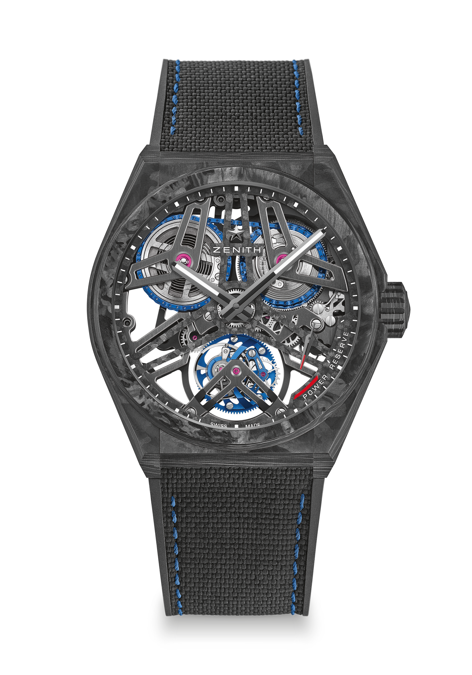
DEFY FUSEE TOURBILLON
LIMITED EDITION 50

Reference: 10.9000.4805/78.R916

UNIQUE SELLING POINTS
Full Carbon model: Case, crown and buckle head
Exclusive combination : Tourbillon Fusee-Chain Calibre
Chain made of 575 components
Manual winding El Primero Tourbillon with Fusée-Chain escapement
Constant force fusée-chain transmission connected to the barrel

MOVEMENT
Movement El Primero 4805 SK, Manual
Calibre 16½``` (Diameter: 37 mm)
Movement thickness: 5.9 mm
Components: 807
Exclusive bicolor signature on plates and bridges
Jewels: 34
Frequency: 36,000 VpH (5 Hz)
Power-reserve approx.: 50 hours

FUNCTIONS
Hours and minutes in the centre
Tourbillon:
- The carriage is positioned at 6 o'clock
- The carriage makes one turn per minute
Power-reserve indication between 4 and 5 o'clock
Fusée-chain transmission connected to the barrel
CASE, DIAL & HANDS
Diameter: 44 mm
Diameter opening: 36.5 mm
Thickness: 13.35 mm
Crystal: Domed sapphire crystal with anti-reflective treatment on both sides
Case-back: Transparent sapphire crystal
Material: Black carbon
Water-resistance: 10 ATM
Dial: Carbon Openworked
Hour-markers: Transferred
Hands: Black ruthenium-plated, faceted and coated with SuperLuminova SLN C1
STRAP & BUCKLE
Strap: Black rubber with black rubber "cordura effect"
Buckle: Titanium double folding clasp with black carbon head
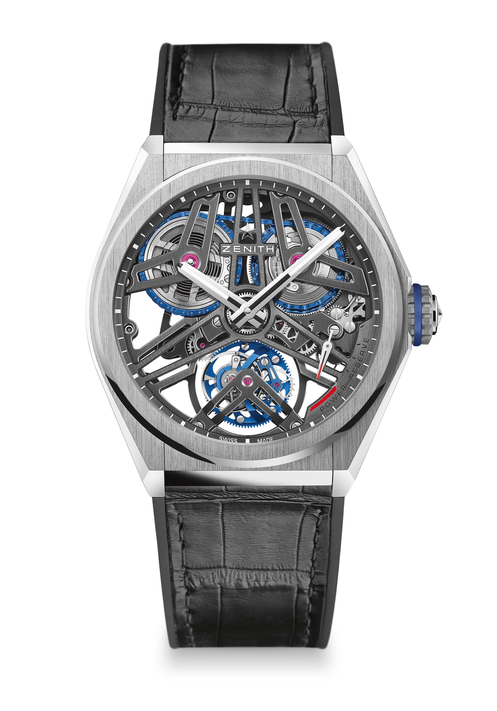
DEFY FUSEE TOURBILLON
LIMITED EDITION 10

Reference: 40.9000.4805/75.R582
UNIQUE SELLING POINTS
Exclusive combination: Tourbillon Fusee-Chain Calibre
Chain made of 575 components
Manual winding El Primero Tourbillon with Fusée-Chain escapement
Constant force fusée-chain transmission connected to the barrel
MOVEMENT
Movement El Primero 4805 SK, Manual
Calibre 16½``` (Diameter: 37 mm)
Movement thickness: 5.9 mm
Components: 807
Exclusive bicolor signature on plates and bridges
Jewels: 34
Frequency: 36,000 VpH (5 Hz)
Power-reserve approx.: 50 hours

FUNCTIONS
Hours and minutes in the centre
Tourbillon:
- The carriage is positioned at 6 o'clock
- The carriage makes one turn per minute
Power-reserve indication between 4 and 5 o'clock
Fusée-chain transmission connected to the barrel
CASE, DIAL & HANDS
Diameter: 44 mm
Diameter opening: 36.5 mm
Thickness: 13.35 mm
Crystal: Domed sapphire crystal with anti-reflective treatment on both sides
Case-back: Transparent sapphire crystal
Material: Platinum 950
Water-resistance: 10 ATM
Dial: Openworked
Hour-markers: Transferred
Hands: Rhodium-plated, faceted and coated with SuperLuminova SLN C1
STRAPS & BUCKLES
Strap: Black rubber with black alligator leather coating
Buckle: Titanium & white gold double folding clasp

