DEFY Classic Mykonos Edition
Zenith celebrates the arrival of summer in Europe with a special edition of the DEFY Classic made exclusively for Zenith’s Greek retailer GOFAS, the DEFY Classic Mykonos Edition.
Mykonos is without a doubt one of the most coveted summer destinations. Just like Zenith, the Greek island on the Aegean Sea seamlessly melds history and tradition with forward-thinking modernism. To celebrate the uniquely upbeat spirit of Mykonos, Zenith has created a special rendition of its DEFY Classic for its retailer in Greece, GOFAS, in a Limited Edition of only 25 pieces.
The faceted DEFY Classic case, measuring 41mm in diameter, is made of blue ceramic. Besides its superlative performance properties such as hardness and high scratch-resistance, the deep blue color is embedded in the material and is not just a superficial layer. With its mix of polished satin-brushed and micro-blasted matte surfaces, the case amplifies the futuristic lines of the DEFY Classic.
Recalling the colors of the Greek flag while remaining inherently Zenith, the open dial brings forth a mix of blue, white and silvery tones that create a sense of harmonic visual depth against a contemporary architectural backdrop. For the Mykonos Edition, the central star element of the open dial is fashioned in the same blue tone as the case, while the central seconds hand with a star-shaped counterweight is painted in white exceptionally for this special series. The raised flange ring is also white, with blue markers and applied rhodium indexes filled with blue SuperLumiNova, just like the faceted hands.
Visible through the dial as well as the case back, the DEFY Classic Mykonos Edition’s movement is a modern remake of Zenith’s staple automatic movement, the Elite. With a skeleton execution of the main plate, bridges and even the date wheel, the Elite calibre’s modernism extends beyond just aesthetics, featuring a silicon escape-wheel and lever offering precision at a frequency of 28,800 VpH (4 Hz). When fully wound, the automatic Elite movement provides a minimum power reserve of 50 hours. Keeping with the Mykonian theme of this exclusive edition, the sapphire display on the back of the case is emblazoned with the silhouette of Mykonos’ iconic white windmills that have become a symbol of the unique island.
For the perfect finishing touch to the summery Mykonos theme of this special series, the DEFY Classic Mykonos Edition comes on a special strap developed just for this series, featuring a white rubber backing with a blue central element featuring a pattern inspired by the pavements of Mykonos’ cobbled streets. A second strap is also delivered with watch, in textured white rubber. The double folding Titanium buckle also features a touch of blue with a blue ceramic element on the buckle head. Whether soaking up the sun on a sandy Mykonian beach or dancing the night away, the DEFY Classic Mykonos edition, limited to 25 pieces and available exclusively at GOFAS, is a compelling choice for summer adventures.

ZENITH: the future of Swiss watchmaking
With innovation as its guiding star, Zenith features exceptional in-house developed and manufactured movements in all its watches, such as the DEFY Inventor with its monolithic oscillator of exceptional precision, and the DEFY El Primero 21 with its high-frequency 1/100th of a second chronograph. Since its establishment in 1865, Zenith has consistently redefined the notions of precision and innovation, including the first “Pilot Watch” at the dawn of aviation and the first serially produced “El Primero” automatic chronograph calibre. Always one step ahead, Zenith is writing a new chapter in its unique legacy by setting new standards of performance and inspired design. Zenith is here to shape the future of Swiss watchmaking, accompanying those who dare to challenge time itself and reach for the stars.

PRESS ROOM
For additional pictures please access the below link
http://pressroom.zenith-watches.com/login/?redirect_to=%2F&reauth=1

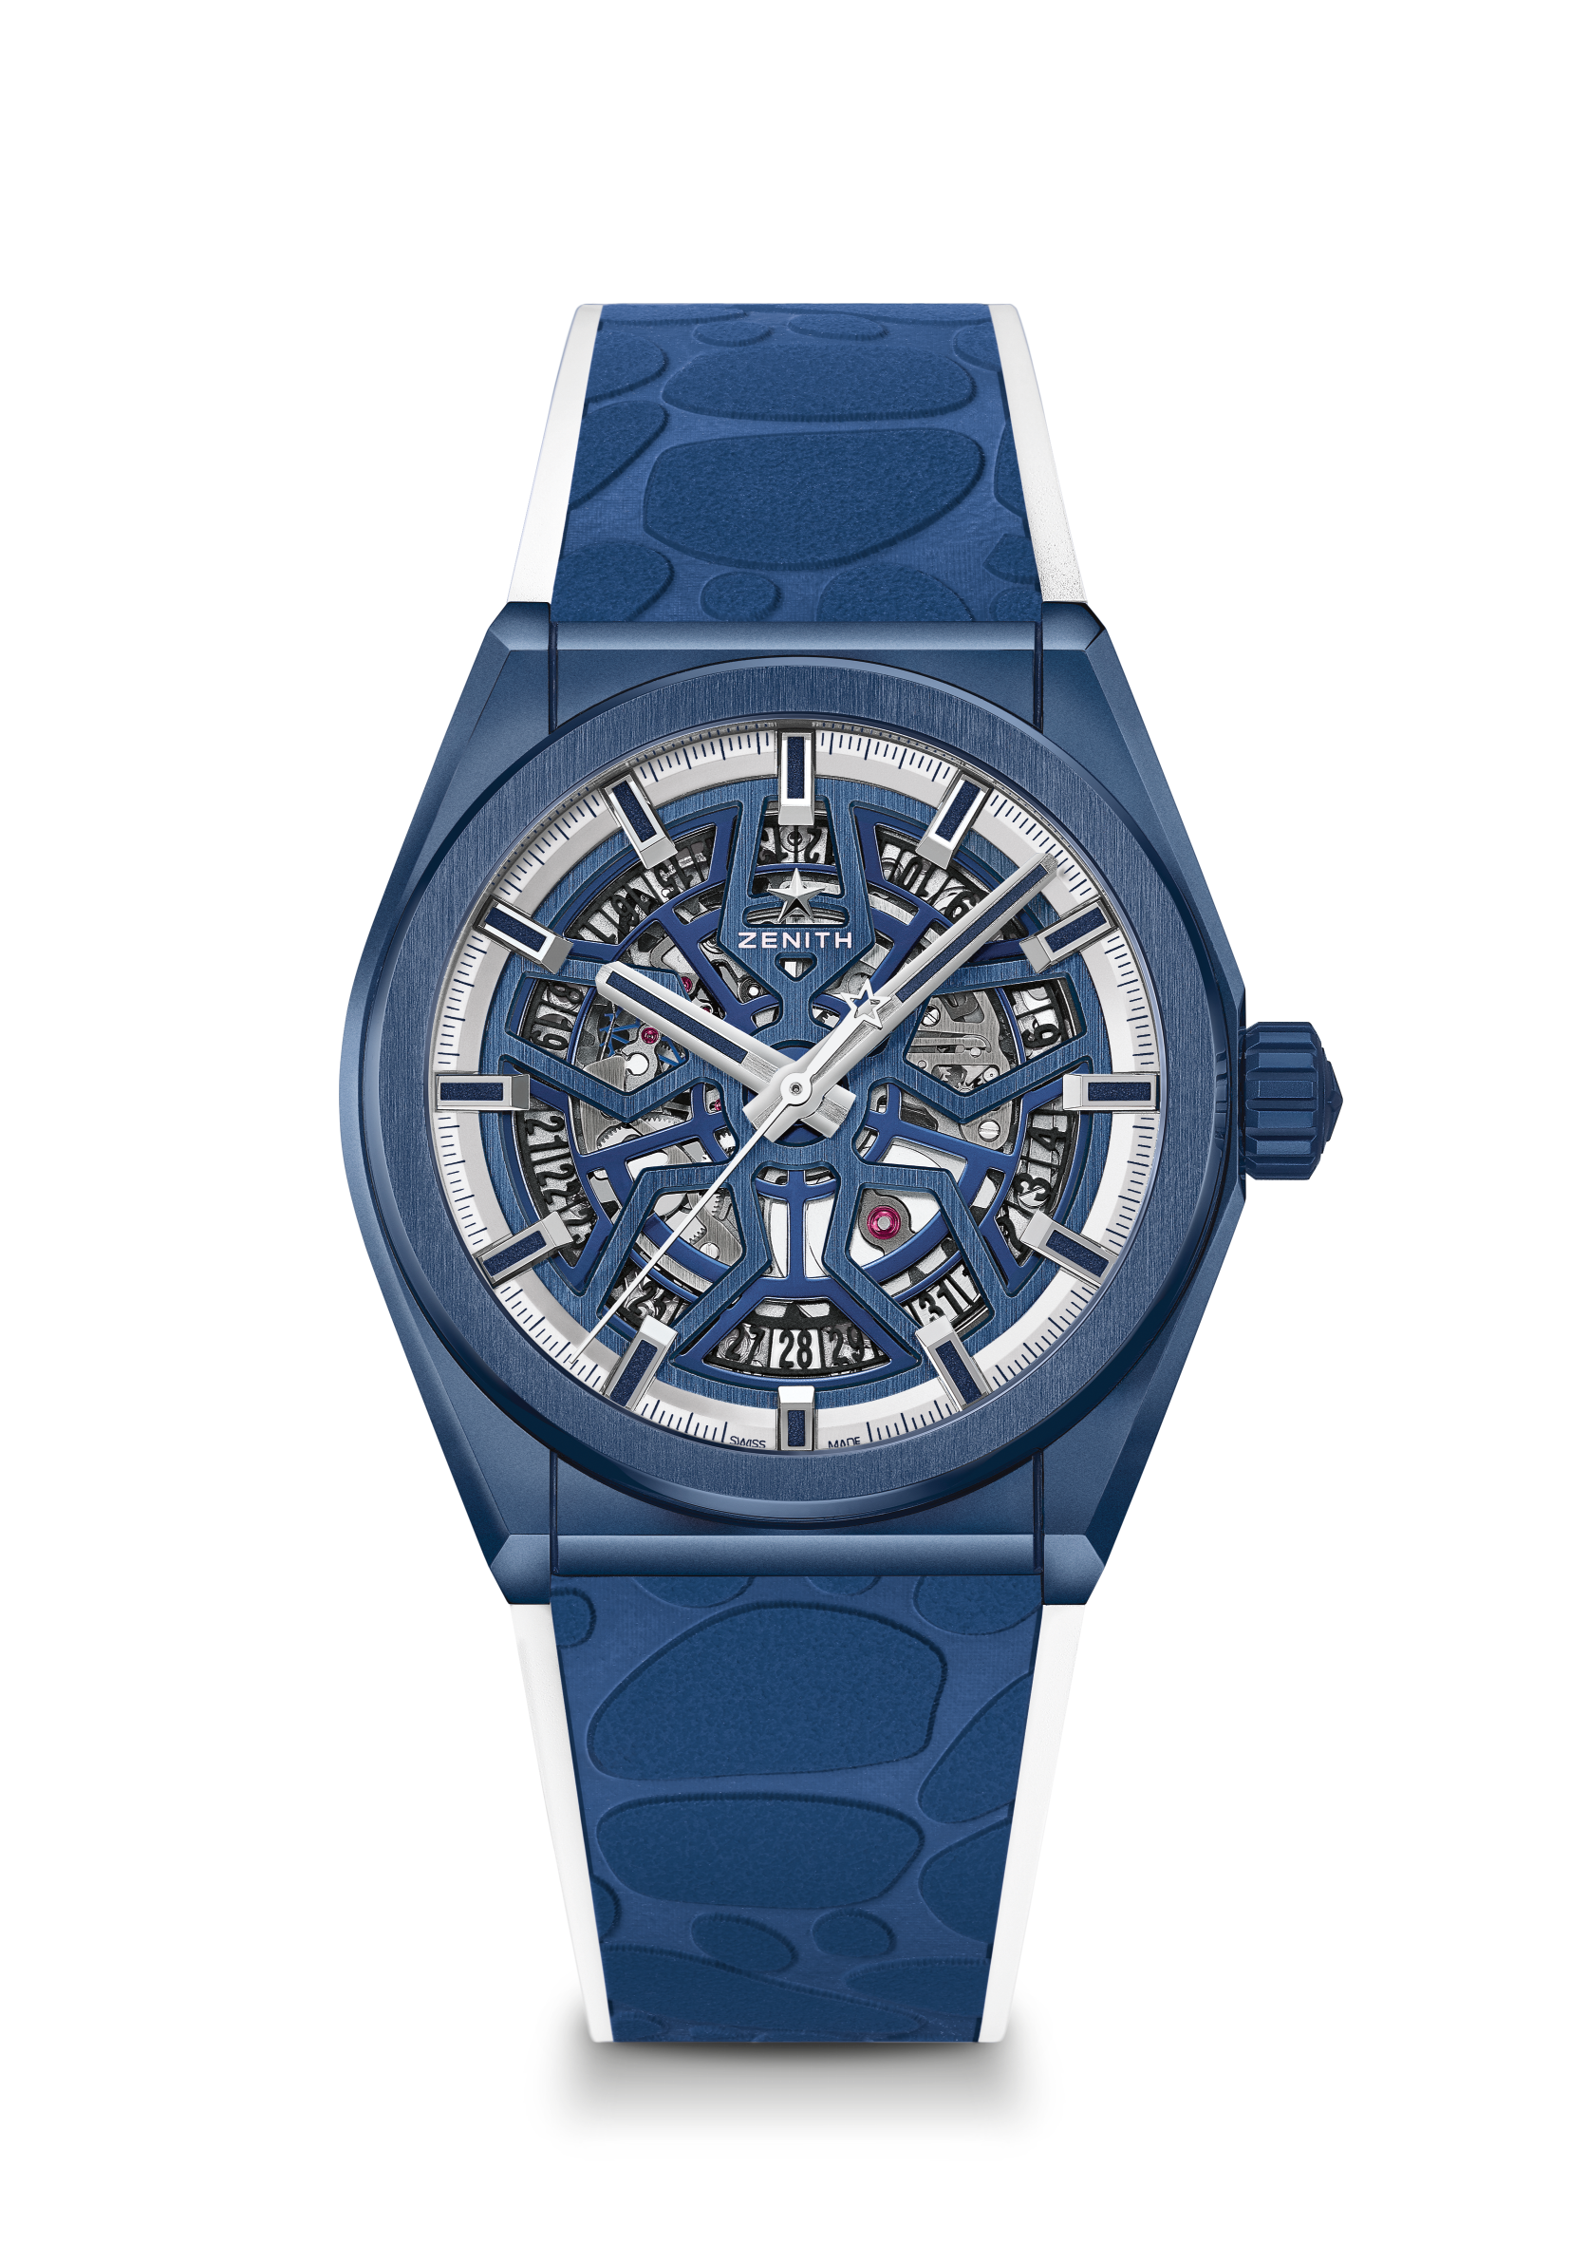
DEFY CLASSIC MYKONOS EDITION
LIMITED EDITION 25 PIECES

Reference: 49.9004.670/51.R599

KEY POINTS
Elite skeletonised movement
NEW 41mm Blue Ceramic case
Silicon escape-wheel and lever

MOVEMENT
Elite 670 SK, Automatic
Calibre: 11 ½``` (Diameter: 25.60mm)
Movement thickness: 3.88mm
Components: 187
Jewels: 27
Power-reserve: min. 50 hours
Finishing: Special oscillating weight with satin-brushed finish

FUNCTIONS
Hours and minutes in the centre
Central seconds hand
Date indication at 6 o’clock

CASE, DIAL & HANDS
Diameter: 41mm
Diameter opening: 32.5mm
Thickness: 10.75mm
Crystal: Domed sapphire crystal with anti-reflective treatment on both sides
Case-back: Special transparent sapphire crystal adorned with a special Mykonos logo
Material: Blue Ceramic
Water-resistance: 10 ATM
Dial: Blue Openworked
Hour-markers: Rhodium-plated, faceted and coated with Blue Super-LumiNova®
Hands: Rhodium-plated, faceted and coated with Blue Super-LumiNova®

STRAP & BUCKLE
Strap: Special white rubber strap with blue “Mykonos pavement” pattern effect
It additionally comes with a white rubber strap (27.00.2218.792)
Buckle: Titanium double folding clasp with blue ceramic buckle head

