Zenith and Farfetch gear up for summer with an exclusive edition of the DEFY Classic
17th July, Switzerland - Marking the one-year anniversary of the first year since Zenith joined Farfetch, the leading global technology platform for the luxury fashion industry, the brand and platform have teamed up to produce an exclusive edition of the DEFY Classic with an inspired summer-ready look, limited to 25 pieces and available exclusively only on farfetch.com.
Edgy and instantly recognisable, the faceted DEFY Classic case, measuring 41mm in diameter, is made of gleaming white ceramic. With its mix of polished, satin-brushed and micro-blasted matt surfaces, the case amplifies the bold and retro-futuristic lines of the DEFY Classic.

Adding the perfect couture touch to the watch is the fashion-forward strap, crafted in white rubber with a nude colour insert featuring a shimmery satin effect. With its unmistakable avantgarde style, the DEFY Classic Farfetch edition will appeal to more than just seasoned watch lovers.

Visible through the open dial with a futuristic central star motif as well as the caseback, the DEFY Classic Farfetch Edition’s movement is a modern remake of Zenith’s staple automatic movement, the Elite. With a skeleton execution of the main plate, bridges and even the date wheel, the Elite calibre’s modernism extends beyond just aesthetics, featuring a silicon escape-wheel and lever offering precision at a frequency of 28,800 VpH (4 Hz). When fully wound, the automatic Elite movement provides a minimum power reserve of 50 hours.

Maxim de Turckheim, Farfetch Senior Development Manager – Watches said: "This collaboration with Zenith was born of a desire to create a timepiece that would truly resonate with our global customers. At Farfetch, we pride ourselves on having the strongest curation of luxury timepieces and this unique keepsake is testament to our commitment to this growing category. Our customers are looking for future heirlooms and this gender-neutral wristwatch captures that desire. This exclusive partnership is a perfect celebration of the first-year anniversary of Zenith being stocked on Farfetch.”

Said Julien Tornare, CEO, ZENITH: “Enhancing our online presence is a key element of ZENITH’s strategy going forward and our partnership with Farfetch is the ideal embodiment of this philosophy. As aware as we are of the importance of our proud tradition, we are equally excited about being part of this important initiative.”

Notes to Editors
ZENITH: the future of Swiss watchmaking
With innovation as its guiding star, Zenith features exceptional in-house developed and manufactured movements in all its watches, such as the DEFY Inventor with its monolithic oscillator of exceptional precision, and the DEFY El Primero 21 with its high-frequency 1/100th of a second chronograph. Since its establishment in 1865, Zenith has consistently redefined the notions of precision and innovation, including the first “Pilot Watch” at the dawn of aviation and the first serially produced “El Primero” automatic chronograph calibre. Always one step ahead, Zenith is writing a new chapter in its unique legacy by setting new standards of performance and inspired design. Zenith is here to shape the future of Swiss watchmaking, accompanying those who dare to challenge time itself and reach for the stars.

About Farfetch
Farfetch Limited is the leading global technology platform for the luxury fashion industry. Founded in 2007 by José Neves for the love of fashion, and launched in 2008, Farfetch began as an e-commerce marketplace for luxury boutiques around the world. Today the Farfetch.com Marketplace connects customers in over 190 countries with items from more than 50 countries and over 1,000 of the world’s best brands, boutiques and department stores, delivering a truly unique shopping experience and access to the most extensive selection of luxury on a single platform. Through its business units, which also include Farfetch Platform Solutions (incorporating Store of The Future and Farfetch Black & White Solutions), as well as Browns and Stadium Goods, Farfetch continues to invest in innovation and develop key technologies, business solutions, and services for the luxury fashion industry.

For more information, please visit www.farfetch.com.

PRESS ROOM
For additional pictures please access the below link
http://pressroom.zenith-watches.com/login/?redirect_to=%2F&reauth=1

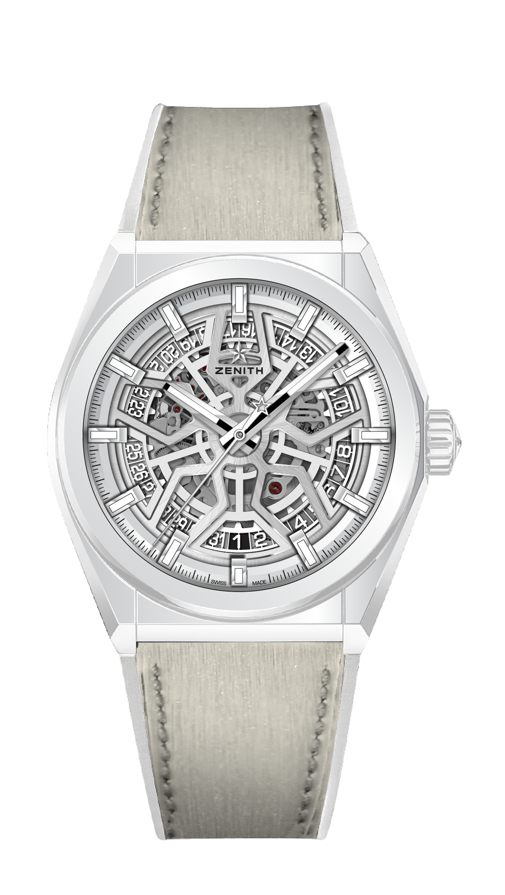
DEFY CLASSIC FARFETCH
LIMITED EDITION 25 PIECES

Reference: 49.9002.670/01.R794

KEY POINTS
New 41mm White Ceramic case
In house Elite skeletonised movement
Silicon escape-wheel and lever

MOVEMENT
Elite 670 SK, Automatic
Calibre: 11 ½``` (Diameter: 25.60mm)
Movement thickness: 3.88mm
Components: 187
Jewels: 27
Frequency: 28,800 VpH (4Hz)
Power-reserve: min. 48 hours
Finishing: Special oscillating weight with satin-brushed finish

FUNCTIONS
Hours and minutes in the centre
Central seconds hand
Date indication at 6 o’clock

CASE, DIAL & HANDS
Diameter: 41mm
Diameter opening: 32.5mm
Thickness: 10.75mm
Crystal: Domed sapphire crystal with anti-reflective treatment on both sides
Case-back: Transparent sapphire crystal
Material: White Ceramic
Water-resistance: 10 ATM
Dial: Silver Openworked
Hour-markers: Rhodium-plated, faceted and coated with Super-LumiNova® SLN C1
Hands: Rhodium-plated, faceted and coated with Super-LumiNova® SLN C1

STRAP & BUCKLE
White rubber strap with nude coloured rubber coating
Titanium double folding clasp

