Ladies, Zenith has you covered this Summer

Driven by a desire for perpetual innovation and the creation of timeless icons, Zenith has been steering its own course since its foundation over 150 years ago. With a unique blend of past, present and future aesthetics, each of its collections embody a different spirit. And while men have traditionally enjoyed the attention of watchmakers, Zenith is here to prove that iconic designs look just as good – if not better – on the wrists of confident, daring and stylish women.
Sporty in White
White is usually synonymous with delicate, but that's not the case with the DEFY Classic. Its bright white ceramic case is incredibly durable, and its intense white tone is embedded in the material and will never fade or tarnish with time and wear. With bold geometric lines and a futuristic overtone with its open, layered display, the DEFY Classic White Ceramic goes from sporty to chic without a flinch. Whether soaking up some sun on a coastal summer getaway or roaming a modern metropolis, the DEFY Classic White Ceramic is a show-stopping piece for all seasons.
The Urban Dweller
For the free-spirited woman with a keen sense of bold, adventurous style, the Type 20 Pilot is the perfect companion. Something of a watchmaking icon, Zenith’s emblematic aviation-themed watch looks as striking today as the watch that inspired it a century ago did. Reimagined in an easily wearable 40mm bronze case paired with a satin-brushed black dial, its oversized numerals provide a racy accent with a touch of old-world charm, true to Zenith’s pioneering spirit. The timeless appeal and rugged yet elegant silhouette of the Pilot makes it an incredibly versatile timepiece, perfectly suited for whatever adventure you throw its way - from the workplace to a workout and everything in between.
Elegantly Retro
Some icons are truly forever. Groundbreaking at its introduction and still outstanding today, the A386 El Primero Revival pays tribute to a Zenith chronograph icon by reproducing the 60s classic faithfully, right down to the smallest detail. From a night out in a cocktail dress to just keeping it cozy and casual, the El Primero A386 Revival’s enduring combination of a precious rose gold case in timelessly elegant proportions and distinctly retro multicolored counters on the dial make it a staple go-to piece.

ZENITH: the future of Swiss watchmaking
With innovation as its guiding star, Zenith features exceptional in-house developed and manufactured movements in all its watches, such as the DEFY Inventor with its monolithic oscillator of exceptional precision, and the DEFY El Primero 21 with its high-frequency 1/100th of a second chronograph. Since its establishment in 1865, Zenith has consistently redefined the notions of precision and innovation, including the first “Pilot Watch” at the dawn of aviation and the first serially produced “El Primero” automatic chronograph calibre. Always one step ahead, Zenith is writing a new chapter in its unique legacy by setting new standards of performance and inspired design. Zenith is here to shape the future of Swiss watchmaking, accompanying those who dare to challenge time itself and reach for the stars.

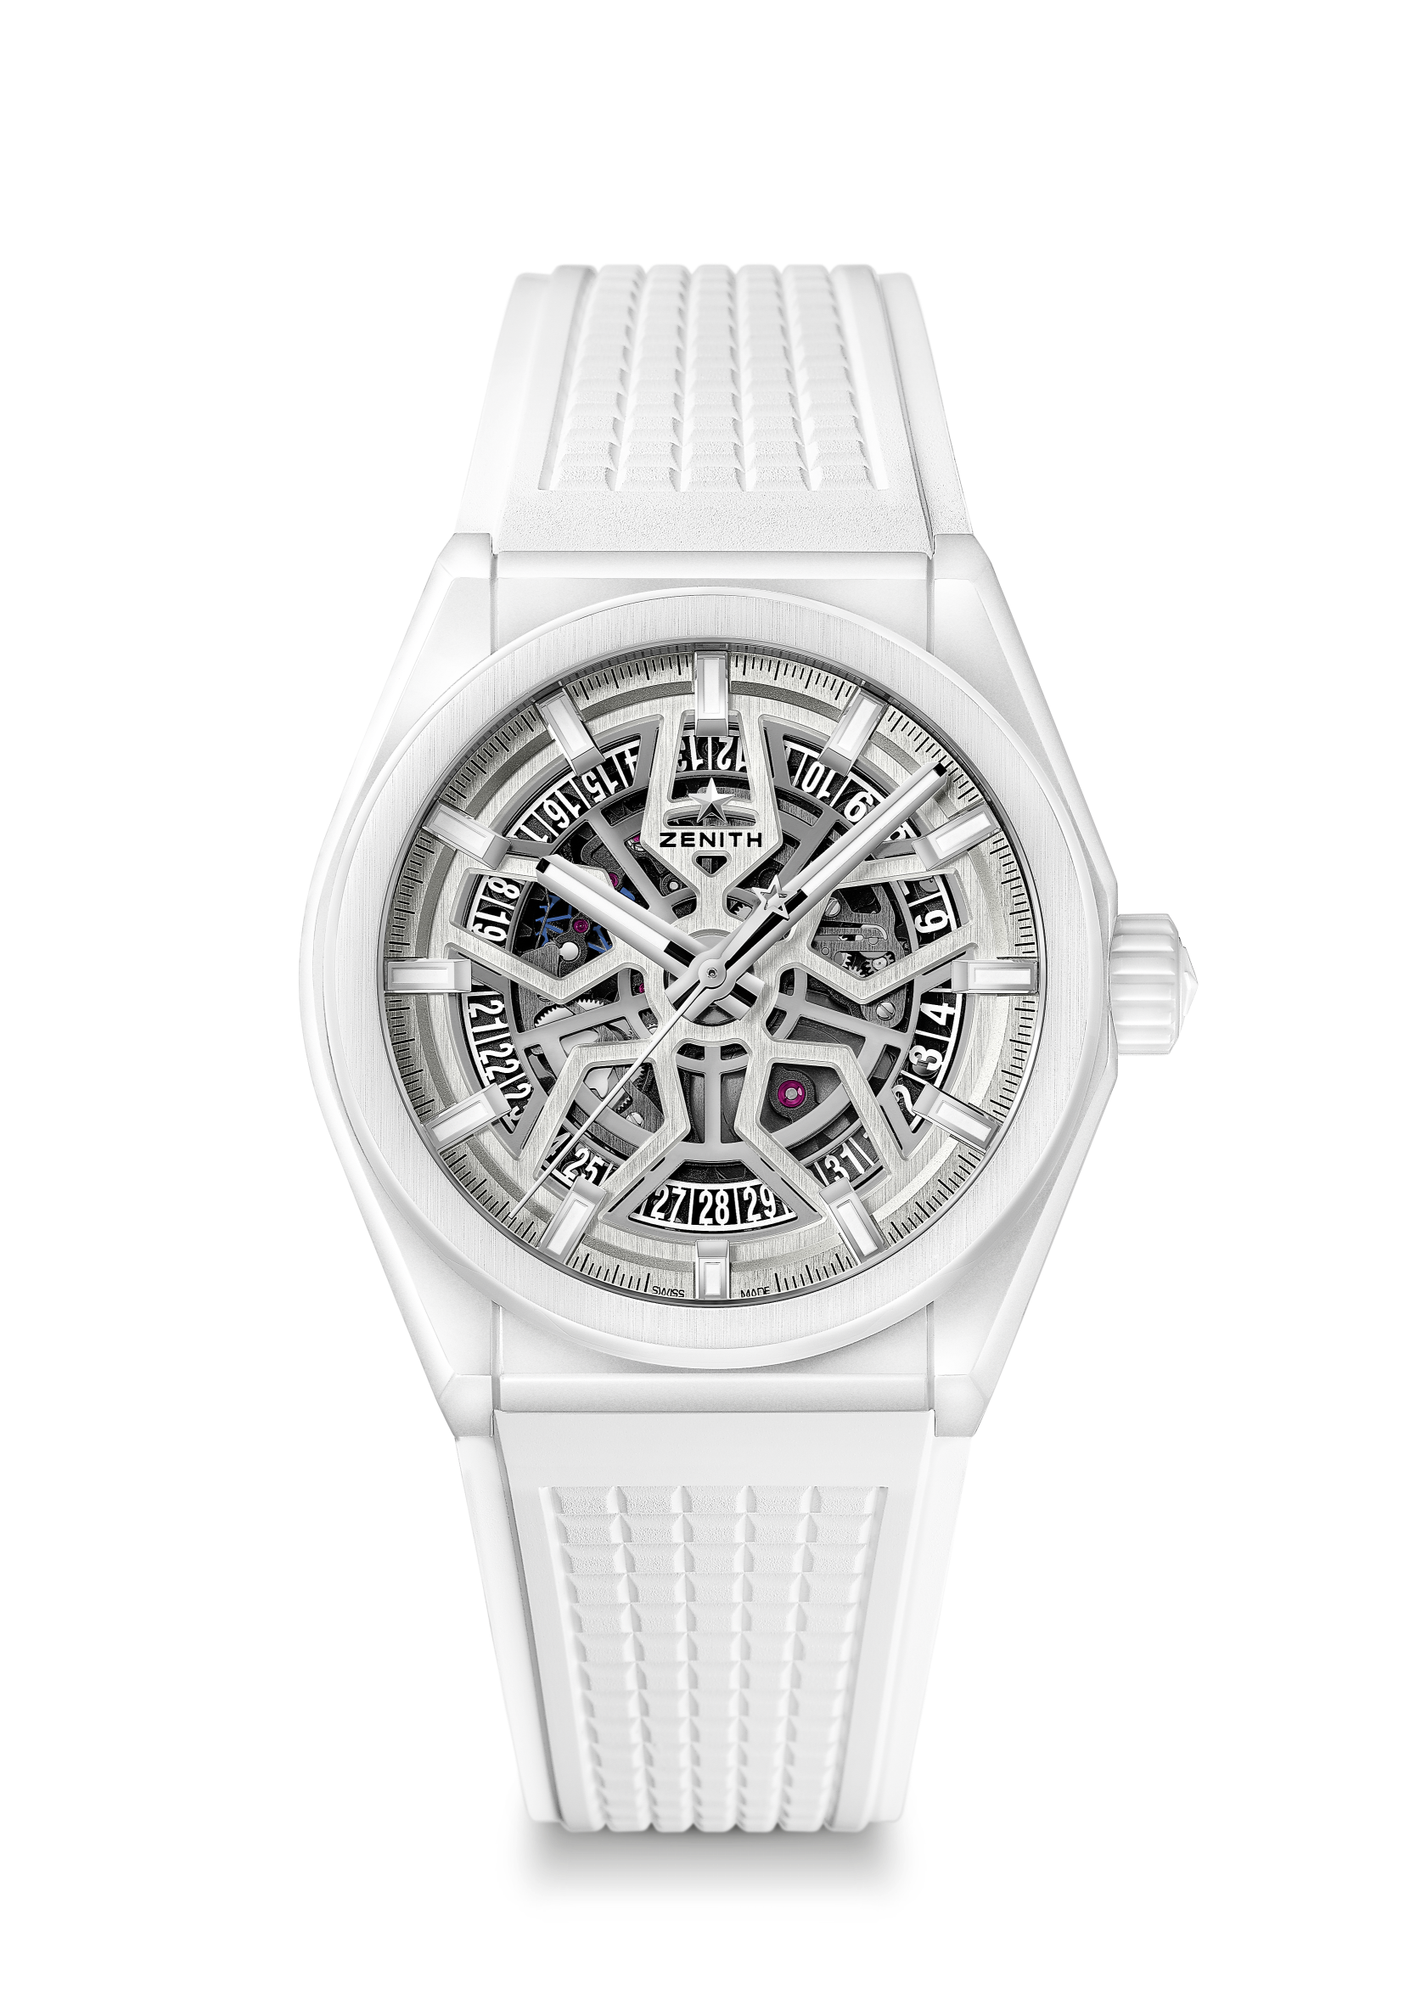
DEFY CLASSIC WHITE CERAMIC
TECHNICAL DETAILS

Reference: 49.9002.670/01.R792

KEY POINTS
NEW 41mm White Ceramic case
In house Elite skeletonised movement
Silicon escape-wheel and lever

MOVEMENT
Elite 670 SK, Automatic
Calibre: 11 ½``` (Diameter: 25.60mm)
Movement thickness: 3.88mm
Components: 187
Jewels: 27
Frequency: 28,800 VpH (4Hz)
Power-reserve: min. 48 hours
Finishing: Special oscillating weight with satin-brushed finish

FUNCTIONS
Hours and minutes in the centre
Central seconds hand
Date indication at 6 o’clock

CASE, DIAL & HANDS
Diameter: 41mm
Diameter opening: 32.5mm
Thickness: 10.75mm
Crystal: Domed sapphire crystal with anti-reflective treatment on both sides
Case-back: Transparent sapphire crystal
Material: White Ceramic
Water-resistance: 10 ATM
Dial: Openworked
Hour-markers: Rhodium-plated, faceted and coated with Super-LumiNova® SLN C1
Hands: Rhodium-plated, faceted and coated with Super-LumiNova® SLN C1

STRAP & BUCKLE
White rubber HNBR Quality
Titanium double folding clasp

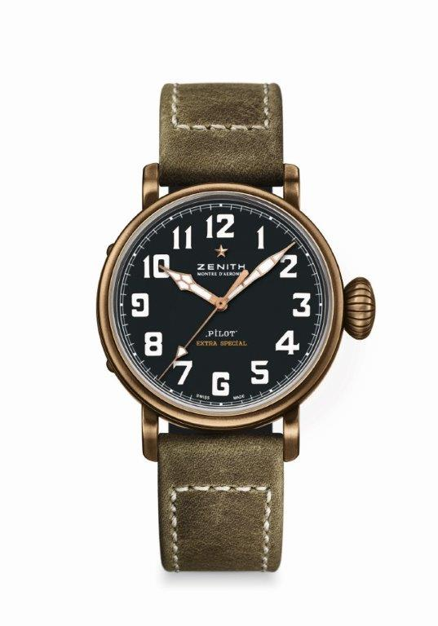
PILOT TYPE 20 EXTRA SPECIAL
40 MM BRONZE
TECHNICAL DETAILS

Reference: 29.1940.679/21.C800

KEY POINTS
New case in bronze
Inspired by the legendary Zenith aviation watches
Arabic numerals entirely made of Super-LumiNova®

MOVEMENT
Elite 679, Automatic
Calibre: 11 ½``` (Diameter: 25.60mm)
Movement thickness: 3.85mm
Components: 126
Jewels: 27
Frequency: 28,800 VpH (4Hz)
Power-reserve: min. 50 hours
Finishes: Oscillating weight with “Côtes de Genève” motif

FUNCTIONS
Hours and minutes in the centre
Central seconds hand

CASE, DIAL & HANDS
Diameter: 40mm
Opening diameter: 33.1mm
Thickness: 12.95mm
Crystal: Domed sapphire crystal with anti-reflective treatment on both sides
Case-back: Titanium case-back engraved with the ZENITH flying instruments logo
Material: Bronze
Water-resistance: 10 ATM
Dial: Matt black
Hour-makers: Arabic numerals in Super-LumiNova® SLN C1 [Hour-markers]
Hands: Gold-plated, faceted and coated with Super-LumiNova® SLN C1 [Hands]

STRAPS & BUCKLES
Bracelet: Reference: 27.00.2018.800
Designation: Green oily nubuck leather strap with protective rubber lining
Buckle: Reference: 27.95.0031.001
Designation: Titanium pin buckle

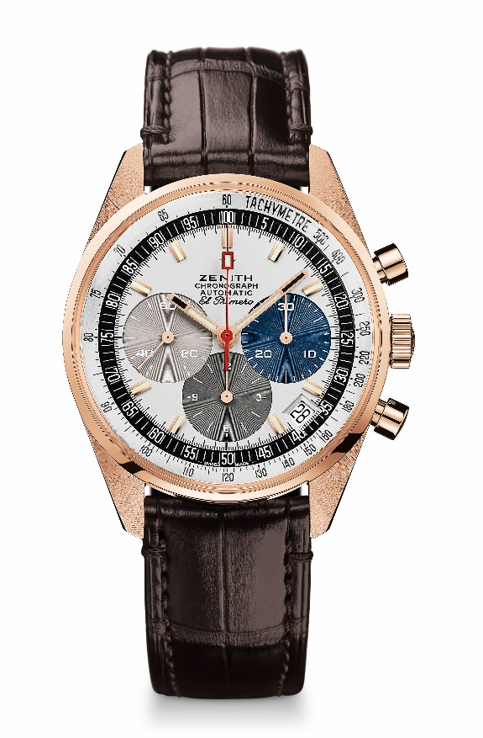
EL PRIMERO A386 REVIVAL
TECHNICAL DETAILS

Reference: 18.A386.400/69.C807

KEY POINTS
Revival of the first ever El Primero Model from 1969
Original revival of the case with 38 mm diameter
Automatic El Primero column-wheel chronograph
Rose gold version: Limited Edition of 50 units
50 Years of Warranty

MOVEMENT
El Primero 400, Automatic
Calibre: 13 ¼ ``` (Diameter: 30 mm)
Movement thickness: 6.6.mm
Components: 278
Jewels: 31
Frequency: 36,000 VpH (5 Hz)
Power-reserve: min. 50 hours
Finishes: Oscillating weight with “Côtes de Genève”. motif

FUNCTIONS
Hours and minutes in the centre
Small seconds at 9 o'clock
Chronograph:
- Central chronograph hand
- 12-hour counter at 6 o'clock
- 30-minute counter at 3 o'clock
Tachymetric scale
Date indication at 4:30

CASE, DIAL & HANDS
Diameter: 38 mm
Diameter opening: 33.05 mm
Thickness: 12.60 mm
Crystal: Box sapphire crystal with anti-reflective treatment on both sides
Case-back: Transparent sapphire crystal
Material: Rose gold
Water-resistance: 10 ATM
Dial: White-lacquered dial with three different-coloured counters
Hour-markers: Gold-plated, faceted and coated with Super-LumiNova SLN C3
Hands: Gold-plated, faceted and coated with Super-LumiNova SLN C3

STRAP & BUCKLE
Brown alligator leather strap with protective rubber lining
Rose gold pin buckle

