Unique experiences with the El Primero A386 Revival for Only Watch

One particular El Primero aficionado has a lot to look forward to this year with the release of a one-of-a-kind white gold iteration of the original ZENITH El Primero A386 Revival at this year’s exclusive Only Watch auction – accompanied by a set of equally unique experiences. Nestling in a customised presentation box, this one-of-a-kind El Primero A386 Revival features a singular turquoise subdial in tribute to this year’s Only Watch theme colour, as well as a caseback engraved with Only Watch and Unique Piece inscriptions.

The buyer of this one-off timepiece will also be rewarded with an unprecedented array of watchmaking experiences offering an immersion into luxury according to Zenith. Like the watches in the 50th anniversary commemoration box, the Only Watch special edition comes with a lifetime warranty (including service) in honour of the current El Primero 50th anniversary celebration. It also includes an invitation for the purchaser to visit the Monde étoile de Zenith and the famous grenier of its Manufacture in Le Locle, the attic where Charles Vermot hid the famous tools for the El Primero movement that was to revolutionise Zenith’s future.
Lastly and most significantly of all, the owner will be a guest at the splendid closing event in Geneva that will conclude the El Primero 50th anniversary “Le Grenier Club” tour in due style. Hosted by Zenith in celebration of half a century of innovation and precision represented by the legendary El Primero high-frequency chronograph, the world tour consists of dinners characterised by an exclusive atmosphere and held in unexpected locations such as art galleries and exceptional private properties, in some of the world’s greatest cities including Milan, London, Hong Kong, Singapore – before the grand finale in Geneva.
In another nod to the significant number 50, each dinner hosts 50 special guests including retailers, friends of the brand, final customers, collectors, press, and influencers, who are treated to a number of surprises. In addition to attending this once in a lifetime event, the proud owner of the Only Watch El Primero A386 White Gold will be presented with a VIP package for two including hotel accommodation and a range of exclusive experiences to prolong the magic of this iconic celebration.
ZENITH: the future of Swiss watchmaking
With innovation as its guiding star, Zenith features exceptional in-house developed and manufactured movements in all its watches, such as the DEFY Inventor with its monolithic oscillator of exceptional precision, and the DEFY El Primero 21 with its high-frequency 1/100th of a second chronograph. Since its establishment in 1865, Zenith has consistently redefined the notions of precision and innovation, including the first “Pilot Watch” at the dawn of aviation and the first serially produced “El Primero” automatic chronograph calibre. Always one step ahead, Zenith is writing a new chapter in its unique legacy by setting new standards of performance and inspired design. Zenith is here to shape the future of Swiss watchmaking, accompanying those who dare to challenge time itself and reach for the stars.

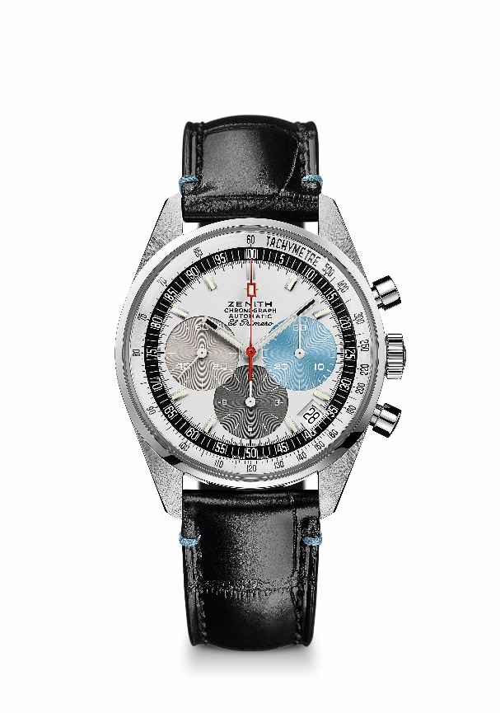
EL PRIMERO A386 ONLY WATCH
TECHNICAL DETAILS
Reference: 65.O386.400/69.C820

KEY POINTS
Revival of the first ever El Primero Model from 1969
Original revival of the case with 38 mm diameter
Automatic El Primero column-wheel chronograph
White gold version: unique piece for Only Watch
Lifetime Warranty and service

MOVEMENT
El Primero 400, Automatic
Calibre: 13 ¼ ``` (Diameter: 30 mm)
Movement thickness: 6.6.mm
Components: 278
Jewels: 31
Frequency: 36,000 VpH (5 Hz)
Power-reserve: min. 50 hours
Finishes: Oscillating weight with “Côtes de Genève”. motif

FUNCTIONS
Hours and minutes in the centre
Small seconds at 9 o'clock
Chronograph:
- Central chronograph hand
- 12-hour counter at 6 o'clock
- 30-minute counter at 3 o'clock
Tachymetric scale
Date indication at 4:30

CASE, DIAL & HANDS
Diameter: 38 mm
Diameter opening: 33.05 mm
Thickness: 12.60 mm
Crystal: Domed sapphire crystal with anti-reflective treatment on both sides
Case-back: Transparent sapphire crystal. Unique engraving on the caseback.
Material: 18-ct White Gold unique piece
Water-resistance: 10 ATM
Dial: White-lacquered dial with three different-coloured counters.
Unique 3 o’clock subdial with turquoise color (Only Watch 2019 theme color).
Hour-markers: Rhodium-plated, faceted and coated with Super-LumiNova SLN C3
Hands: Rhodium-plated, faceted and coated with Super-LumiNova SLN C3

STRAP & BUCKLE
Black alligator leather strap with protective rubber lining and special turquoise stitchings
White gold pin buckle

