Introducing: The Zenith Limited Edition El Primero Revival G381

A Stunning and Faithful Tribute to One of the Brand’s Most Legendary Models

New York, NY (21 August 2019) – HODINKEE, the world’s preeminent resource for all things watches, is pleased to announce the exclusive release of the limited edition Zenith El Primero Revival G381, available only in the HODINKEE Shop. Limited to just 50 pieces to honor the 50th anniversary of the industry-changing El Primero movement, the Revival G381 sets out to capture the charm of the original model in a fitting tribute to the golden era of sporty vintage chronographs.

A cult item in the ranks of the Zenith and vintage chronograph collectors, the G381 was born alongside the A386 in the earliest days of the El Primero, as several brands raced to be the first to bring their automatic chronograph to the market. Made up in yellow gold, an unconventional choice for a sports watch material in 1969 - the G381 features the easily recognizable black-on-white “Panda” dial. Highly sought after today, the G381 was an undoubtedly special creation from Zenith that offered the El Primero technology in a distinctive and eye-catching object. The original G381 was produced in fewer than 700 examples, making it one of the most sought after vintage Zenith El Primeros by collectors today. Fifty years later, the G831 still maintains its allure and collectability due to its mix of style, elegance and everyday versatility - and made for the perfect canvas for a collaboration.

The Zenith Limited Edition El Primero Revival G381 is a faithful interpretation of the Swiss brand’s iconic timepiece. With its yellow gold 38mm case, white lacquered dial with overlapping black “Panda” subdials, and slightly smaller chronograph pushers and crown, the Zenith El Primero Revival G381 pays homage to the original watch born alongside the revolutionary El Primero movement. Housed inside this limited edition is the Zenith caliber 400 El Primero chronograph movement, visible via the sapphire caseback. The caliber 400 is the modern iteration of the same high-beat heart that powered the original G381 in 1969. Like the original El Primero, the caliber 400 is a fully integrated column wheel chronograph movement that ticks at 5 Hz and has a power reserve of 50 hours.

With its elegant proportions surrounded by a bright white dial and a bold red seconds hand, the Revival G381 is a tip of the hat to the enduring style and bravado of the 1960s and the sporty forward thinking nature of the 1970s. The G381 remains classically stylish and endlessly entertaining to wear on the wrist. From a Sunday drive down the perfect road to a pit lane and the snarl of a Cosworth V8, the Limited Edition Zenith El Primero Revival G381 is cool, classic, and the perfect El Primero tribute for any well-read Zenith collector.

Available exclusively in The Hodinkee Shop, the Limited Edition Zenith El Primero Revival G381 is limited to only 50 pieces, with pre-orders now open for delivery by end of September. Whether you're a savvy collector looking for something special or someone who simply wants a gorgeous, sporty chronograph from one of the first names in the game, the Limited Edition Zenith El Primero G381 is a cool modern example with vintage touchpoints that honors the birth of the legendary El Primero.

ZENITH
Founded in 1865 by a then 24-year-old Georges-Favre Jacot, Zenith has enjoyed a reputation as one of the few real movement manufacturers in Switzerland since long before the current industry trend of vertical integration. Among Zenith’s stable of in-house movements, the most famous by far is the El Primero, which ushered in the era of automatic chronographs that took the industry by storm in the late 1960s and early 1970s. With its high-beat of 36,000 VpH and straightforward column-wheel construction, it remains at the core of many new Zenith watches.

Press Room
For additional pictures please access the below link
http://pressroom.zenith-watches.com/login/?redirect_to=%2F&reauth=1

HODINKEE
Established in 2008, HODINKEE is the foremost destination for all things in the world of horology. Over the past decade, founder Ben Clymer and team have grown HODINKEE into a robust media and retail platform by providing Its respected point of view on industry news and releases, investing in engaging and creative storytelling, producing a designated podcast, printing a bi-annual publication and launching and growing its own retail outlet, HODINKEE Shop. At its core, HODINKEE’s goal is to bring its readers and consumers the best in wristwatches in a way that is approachable, authentic and honest. HODINKEE.com

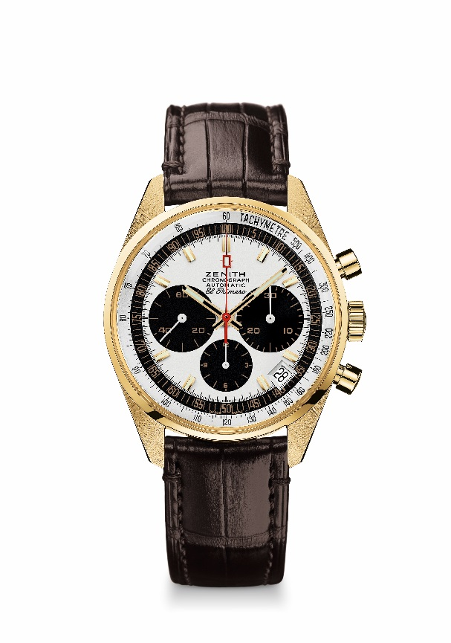
ELPRIMERO REVIVAL G381
Reference: 30.G381.400/21.C807

KEY POINTS
Revival of the El Primero Model from 1969
Original revival of the case with 38 mm diameter
Automatic El Primero column-wheel chronograph
Yellow gold version: Limited Edition of 50 units
50 Years warranty & Services

MOVEMENT
El Primero 400, Automatic
Calibre: 13 ¼ ``` (Diameter: 30 mm)
Movement thickness: 6.6.mm
Components: 278
Jewels: 31
Frequency: 36,000 VpH (5 Hz)
Power-reserve: approx. 50 hours
Finishes: Oscillating weight with “Côtes de Genève”. motif

FUNCTIONS
Hours and minutes in the centre
Small seconds at 9 o'clock
Chronograph:
- Central chronograph hand
- 12-hour counter at 6 o'clock
- 30-minute counter at 3 o'clock
Tachymetric scale
Date indication at 4:30

CASE, DIAL & HANDS
Diameter: 38 mm
Diameter opening: 33.05 mm
Thickness: 12.60 mm
Crystal: Box sapphire crystal with anti-reflective treatment on both sides
Case-back: Transparent sapphire crystal
Material: Yellow gold
Water-resistance: 5 ATM
Dial: White lacquered with black dials (“Panda”)
Hour-markers: Gold-plated, faceted and coated with Super-LumiNova SLN C3
Hands: Gold-plated, faceted and coated with Super-LumiNova SLN C3

STRAP & BUCKLE
Brown alligator leather strap with protective rubber lining
Yellow gold pin buckle

