Introducing: Chronomaster El Primero C.01
Zenith announces its collaboration with Silicon Valley based collector’s club ‘Collective’ for the launch of a limited edition Chronomaster El Primero

This year, to coincide with the 50th Anniversary of the legendary El Primero movement, Zenith has collaborated with Collective to create a unique edition of the Chronomaster El Primero, made available exclusively to the group’s members. The group is comprised of creatives, executives and makers, many of whom are in tech and live in Silicon Valley (San Francisco Bay Area), Silicon Alley (New York City) and Silicon Beach (Los Angeles). Collective is founded on the idea that as watch collectors, members want a dedicated place to share, enjoy one another’s company and celebrate their love for watchmaking. This commitment toward watchmaking’s legacy made Zenith an excellent partner.

As a watch that Collective’s founders, Gabe Reilly and Asher Rapkin have always loved, the El Primero was where the duo wanted to begin. Partnering closely with Zenith’s Switzerland based design team and established Bay Area jeweler Topper Jewelers to create this unique timepiece, the team first focused on the dial. In Silicon Valley, where simplicity and usability are key elements of quality product design, they wanted to apply that same aesthetic and approach to the C.01. While the structure of the iconic subdials remains true to the original, the approach to their design is wholly unique. The entire dial has been finished in matte white, with a subtle but highly legible and uniform grey making up all the printing on the dial. In order to ensure maximum balance, the date was removed, and the classic red chronograph hand has been replaced with a unique rhodium plated hand created just for this piece.

To serve a desire to make the watch a tool, utilizing modern design principles to put functionality at the forefront, the 38mm case features alternating satin-brushed and polished surfaces, and unique to this watch, satin-brushed pushers. The caseback displays the beautiful El Primero movement and features an XX/50 engraving along with a “C.01” engraving celebrating the launch piece of Collective.

Finally, the strap. Most Chronomasters utilize a leather strap with a deployant buckle, but Collective wanted to ensure that the “tool watch” aesthetic carried through all the way to the strap and the buckle. Every C.01 will ship on a custom-sourced cordura strap to provide the watch with a more industrial feel.

ZENITH: the future of Swiss watchmaking
With innovation as its guiding star, Zenith features exceptional in-house developed and manufactured movements in all its watches, such as the DEFY Inventor with its monolithic oscillator of exceptional precision, and the DEFY El Primero 21 with its high-frequency 1/100th of a second chronograph. Since its establishment in 1865, Zenith has consistently redefined the notions of precision and innovation, including the first “Pilot Watch” at the dawn of aviation and the first serially produced “El Primero” automatic chronograph calibre. Always one step ahead, Zenith is writing a new chapter in its unique legacy by setting new standards of performance and inspired design. Zenith is here to shape the future of Swiss watchmaking, accompanying those who dare to challenge time itself and reach for the stars.

PRESS ROOM
For additional pictures please access the below link
https://we.tl/t-yjXLUIMEZ8

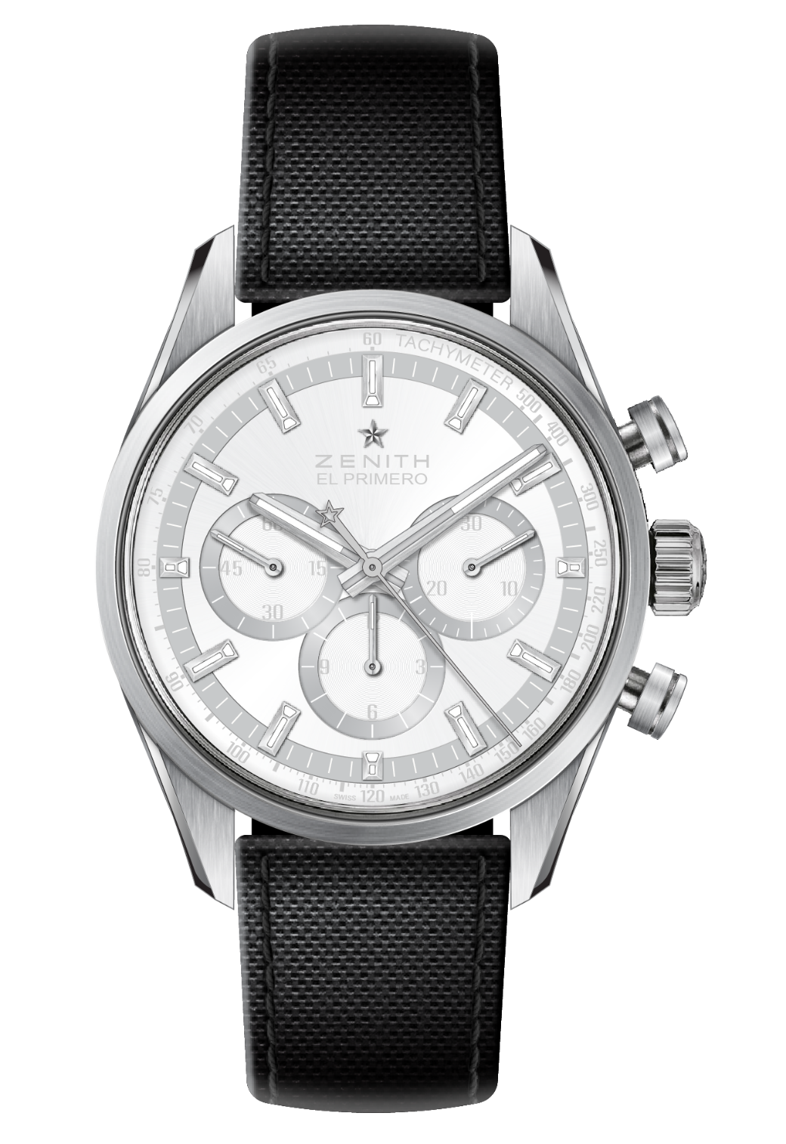
CHRONOMASTER EL PRIMERO C.01
Reference: 03.2152.4061/80.R825

KEY POINTS
Limited edition Chronomaster El Primero created in collaboration with Collective
Satined sides/upper lugs and pushers
Special White/Grey dial

MOVEMENT
El Primero 4061, Automatic
Calibre: 13 ¼ ``` (Diameter: 30 mm)
Movement thickness: 6.6.mm
Components: 282
Jewels: 31
Frequency: 36,000 VpH (5 Hz)
Power-reserve: min. 50 hours
Finishes: Oscillating weight with “Côtes de Genève”. Motif

FUNCTIONS
Hours and minutes in the center
Small seconds at 9 o'clock
Chronograph:
- Central chronograph hand
- 12-hour counter at 6 o'clock
- 30-minute counter at 3 o'clock
Tachymetric scale

CASE, DIAL & HANDS
Material: Steel
Diameter: 38 mm
Opening diameter: 33.10 mm
Thickness: 12.45 mm
Crystal: Domed sapphire crystal with anti-reflective treatment on both sides
Case-back: Transparent sapphire crystal.
Water-resistance: 10 ATM
Dial: Special White/Grey dial
Hour-markers: Rhodium-plated, faceted and coated with SuperLuminova SLN C1 (blue emission)
Hands: Rhodium-plated, faceted and coated with SuperLuminova SLN C1 (blue emission)

STRAP & BUCKLE
“Black Cordura effect” rubber strap
Satined/polished folding clasp

