Zenith and Bamford Watch Department come together for their first boutique-exclusive edition
Paris, October 2, 2019: At the Zenith boutique in Le Bon Marché, George Bamford presented the latest Zenith collaboration to a selection of VIP clients.
As the first watch brand to adopt a bespoke approach in partnership with the leading watch customizer, Zenith and Bamford Watch Department have come together to unveil a collaborative special edition available exclusively for Zenith boutiques: the Chronomaster El Primero Radar.

The Chronomaster El Primero Radar, limited to 50 pieces, draws inspiration from Zenith’s archive pieces, while looking steadfast to the future. During one of George Bamford’s first visits to the Zenith manufacture, he stumbled upon a pocket watch from 1916 that left a lasting impression on him. It featured striking red accents all over the dial, and would become the main source of inspiration for the Radar series. But rather than simply recreating the past, Bamford took this design cue to create a Chronomaster El Primero with a distinctly retro-futuristic aesthetic.
The Radar reimagines the signature Zenith chronograph in a striking new manner, keeping the essentials while introducing new design codes. For one, the stainless steel case is given a matte finish all over, including the crown and pushers. The El Primero tri-compax dial with oversized counters is revisited with a few unique twists, fashioned in a burnt brown hue that darkens towards the edge for a striking visual impact. Sharply contrasting around its periphery is a white tachymeter scale, with a radial design, featured in numerous historical El Primero watches.

Each of the three chronograph subdials is different, further highlighting the uniqueness of this collaborative series. On the left, the small seconds display features concentric circles that recall the design of some of George Bamford’s favourite vintage Zenith watches. The chronograph hour totalizer at 6 o’clock features a more traditional Chronomaster design, while the minutes counter at 3 o’clock befits the Radar name with its bold red register that glows in the dark with SuperLuminova for a “night vision” effect. As George Bamford puts it, “the little lines inside the subdial represent the negative of the star, the missing elements of a star, as if a star was sitting in the middle. This is something that really inspired me”. In this way, the subdial creates a pattern that subtly evokes the Zenith star.
The finishing touch that truly sets the Chronomaster El Primero Radar apart and emphasizes the theme is the strap, made of rubber with a cordura effect on top. With a vintage vibe yet modern construction, the strap features double stitching with red threads, something of an obsession for George Bamford.
Available from November at Zenith boutiques only. Complimentary first maintenance service.

ZENITH: the future of Swiss watchmaking
With innovation as its guiding star, Zenith features exceptional in-house developed and manufactured movements in all its watches, such as the DEFY Inventor with its monolithic oscillator of exceptional precision, and the DEFY El Primero 21 with its high-frequency 1/100th of a second chronograph. Since its establishment in 1865, Zenith has consistently redefined the notions of precision and innovation, including the first “Pilot Watch” at the dawn of aviation and the first serially produced “El Primero” automatic chronograph calibre. Always one step ahead, Zenith is writing a new chapter in its unique legacy by setting new standards of performance and inspired design. Zenith is here to shape the future of Swiss watchmaking, accompanying those who dare to challenge time itself and reach for the stars.
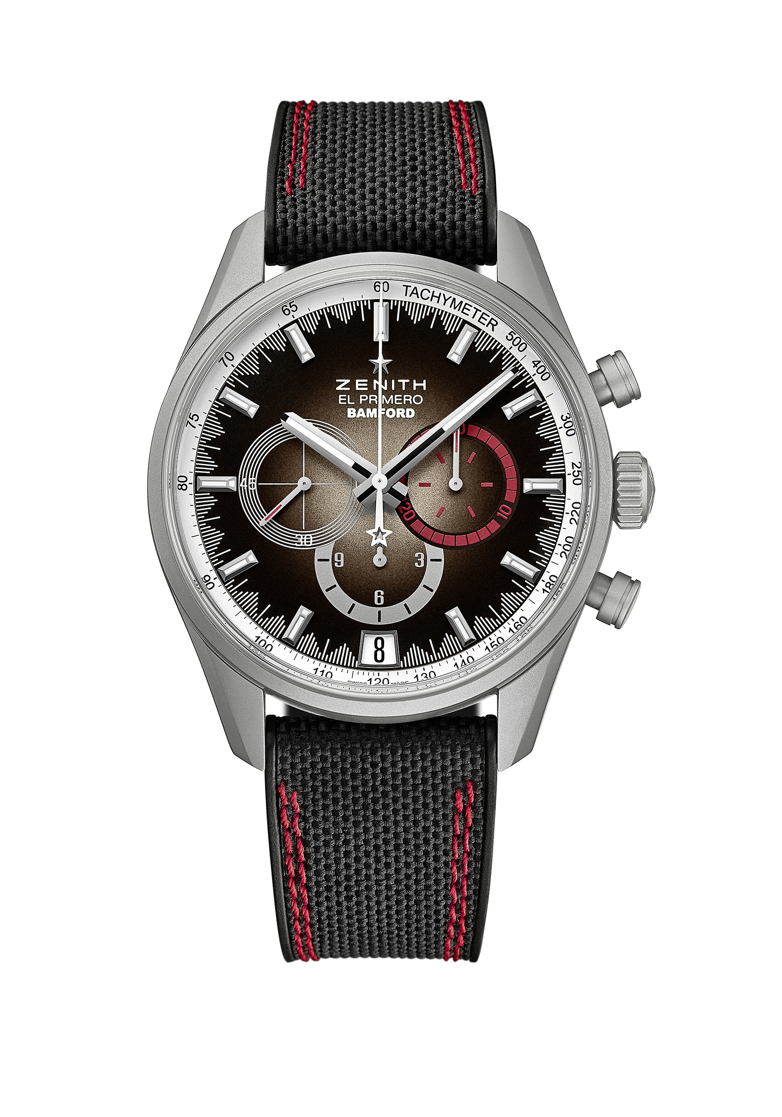
CHRONOMASTER EL PRIMERO – RADAR
BOUTIQUES EDITION - LIMITED EDITION OF 50 UNITS

Reference : 03.2082.400/02.R830

KEY POINTS
El Primero Caliber 400 B: 326 components, 31 jewels and 36,000 VpH
Automatic El Primero column-wheel chronograph
Date indication at 6 o’clock
Tachymetric scale

MOVEMENT
El Primero 400 B, Automatic
Caliber: 13 ¼ ``` (Diameter: 30 mm)
Movement thickness: 6.6 mm
Components: 326
Jewels: 31
Frequency: 36,000 VpH (5Hz)
Power-reserve: min. 50 hours
Finishes: Oscillating weight with “Côtes de Genève” motif

FUNCTIONS
Hours and minutes in the centre
Small seconds at 9 o’clock
Chronograph:
- Central chronograph hand
- 12-hour counter at 6 o’clock
- 30-minute counter at 3 o’clock
Tachymeter scale
Date indication at 6 o’clock

CASE, DIAL & HANDS
Diameter: 42 mm
Diameter opening: 37.1 mm
Thickness: 12.75 mm
Crystal: Domed sapphire crystal with anti-reflective treatment on both sides
Case-back: Transparent sapphire crystal
Material: Stainless steel with microblasted finishings
Water-resistance: 10 ATM
Dial: Burnt brown dial with red accents
Hour-markers: Ruthenium-plated, faceted and coated with Super-LumiNova®
Hands: Ruthenium-plated, faceted and coated with Super-LumiNova®

STRAP & BUCKLE
Black rubber with “Cordura effect” & double red stitchings
Microblasted Stainless steel triple folding clasp

