Zenith El Primero A386 Revival « Fine Watch Club Edition »

For its second opus, the Fine Watch Club, the first international club for multi brand watch owners, will offer its members this October, one of the most iconic pieces in Swiss watchmaking: The El Primero. More than a movement, a calibre, or a model, this watch and movement has become almost a brand of its own and a unique story in watchmaking.

El Primero is the mouthpiece of the Zenith manufacture. Since 1865, the movement has accumulated 2,333 awards for its chronometry. Mechanical precision is at the heart of its DNA, and the El Primero is in a constant quest for that precision. With the capability of beating at 36,000VpH per hour ever since 1969, this calibre has been at the heart of the manufacture’s collections as well as that of other brands, such as the inevitable Cosmograph Daytona from Rolex, of which the first vibrations were powered by the El Primero.

24 pieces for members of the Fine Watch Club
Today, the Zenith Revival series in precious metals that celebrates the legendary movement’s 50th anniversary is sold out. It’s for this reason that the brand has created with the Fine Watch Club a limited edition of 24 pieces of its emblematic A386: the “Zenith El Primero A386 Revival Fine Watch Club Edition”. This exclusive iteration of the capsule collection is a reminder of the popularity of this watchmaking legend still widespread among collectors, in the quest of a horological myth, a sort of Holy Grail. The Fine Watch Club edition opens a door into a tight-knit circle of collectors who look for what others don’t have; a watch only they can possess.

For the first time, this model features a bronzed “tobacco” dial. The piece is paired with a leather or alligator strap of a similar shade. For the dial, purists will appreciate the three variations of the iconic blue/grey counters, the famous “tri-compax” dial layout that made its mark on watchmaking history. The piece preserves its sports chic aesthetic with a 38mm case in stainless steel that anchors its functionality in sports.

At 4:30, Zenith kept the date window that you can find on its models dating back 50 years. Classy and elegant, the Zenith El Primero A386 Revival Fine Watch Club Edition is destined for those who want to sport 50 years of watchmaking heritage.

Heavy-duty time
Versatile and elegant, the El Primero united trends of its time. The incarnation of absolute precision in the 20th century, the movement entered the 21st century by becoming visible through an open dial showcasing the escapement and by defying its own standards (El Primero Defy 21 with a 1/100th of a second chronograph movement).

Initially introduced in 1969 in Baselworld’s Hall 1.0, the movement took the industry by storm for its frequency, beating at 36,000 vibrations per hour, setting a new standard few could meet. And this world premiere movement? It was housed in the reference A386, a watch with a bold dial design with three different coloured subdials and an angled date at 4:30. Back then, a completely modern take on the chronograph design, the A386 is now a highly sought-after model on the vintage market.

The El Primero remains lauded for what it represents in watchmaking history as well as for its technical achievements. The fact that it can measure up to one tenth of a second makes it precise enough for the majority of cases. Anything more than that can be, and has been, measured using electronic instruments, and the El Primero remains the modern-day de facto leader in pure mechanical chronometry.

ZENITH: the future of Swiss watchmaking
With innovation as its guiding star, Zenith features exceptional in-house developed and manufactured movements in all its watches, such as the DEFY Inventor with its monolithic oscillator of exceptional precision, and the DEFY El Primero 21 with its high-frequency 1/100th of a second chronograph. Since its establishment in 1865, Zenith has consistently redefined the notions of precision and innovation, including the first “Pilot Watch” at the dawn of aviation and the first serially produced “El Primero” automatic chronograph calibre. Always one step ahead, Zenith is writing a new chapter in its unique legacy by setting new standards of performance and inspired design. Zenith is here to shape the future of Swiss watchmaking, accompanying those who dare to challenge time itself and reach for the stars.

Press Room
For additional pictures please access the below link
http://pressroom.zenith-watches.com/login/?redirect_to=%2F&reauth=1

Zenith El Primero A386 Revival « Fine Watch Club Edition »
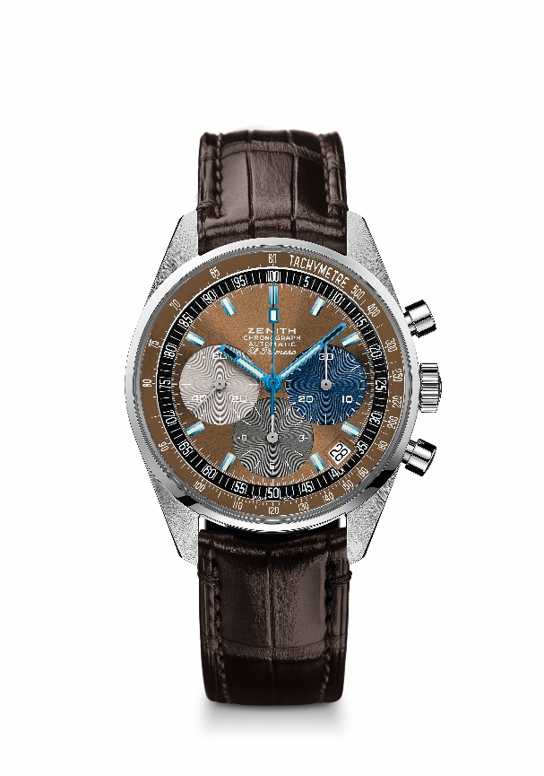
TECHNICAL DETAILS
LIMITED EDITION OF 24 PIECES

Reference: 03.F386.400/70.C807

KEY POINTS
Revival of the first ever El Primero Model from 1969
Original revival of the case with 38 mm diameter
Automatic El Primero column-wheel chronograph

MOVEMENT
El Primero 400, Automatic
Calibre: 13 ¼ ``` (Diameter: 30 mm)
Movement thickness: 6.6.mm
Components: 278
Jewels: 31
Frequency: 36,000 VpH (5 Hz)
Power-reserve: min. 50 hours
Finishes: Oscillating weight with “Côtes de Genève”. motif

FUNCTIONS
Hours and minutes in the centre
Small seconds at 9 o'clock
Chronograph:
- Central chronograph hand
- 12-hour counter at 6 o'clock
- 30-minute counter at 3 o'clock
Tachymetric scale
Date indication at 4:30

CASE, DIAL & HANDS
Diameter: 38 mm
Diameter opening: 33.05 mm
Thickness: 12.60 mm
Crystal: Domed sapphire crystal with anti-reflective treatment on both sides
Case-back: Transparent sapphire crystal. Special case back with stamp of logo FWC
Material: steel
Water-resistance: 5 ATM
Dial: Special bown tabacco dial with blue indexes and blue hands
Hour-markers: blue and covered in SuperLuminova SLN C3
Hands: blue and covered in SuperLuminova SLN C3

STRAP & BUCKLE
Brown alligator leather strap with protective rubber lining
Steel pin buckle

