Rarest one-off Zenith El Primero
achieves highest auction price ever.

50th Anniversary celebrations for Zenith’s legendary El Primero chronograph end on high note at Geneva Watch Auction X, on 10 November 2019,
raising a record USD 250’650, CHF 250’000, EUR 196’125
benefiting Zoé4life, part of the Childhood Cancer International network.

The highlight of this year’s must-attend auction for watch aficionados and collectors from around the world was when the gavel fell for the highest bid on the one-off El Primero chronograph. The first and only Zenith A386 reference to be made of platinum, this unique El Primero was designed by Phillips in Association with Bacs & Russo to commemorate the 50th Anniversary of Zenith’s history-making timepiece. The exceptional moment was all the more noteworthy as the proceeds went to benefit Zoe4Life, a Swiss non-profit that is part of the Childhood Cancer International network. The event crowns the Zenith El Primero 50th Anniversary celebrations throughout 2019, which included a World Tour across 5 continents – culminating in a gala show on the eve of the auction – to celebrate the first automatic integrated chronograph in watchmaking history introduced by Zenith in 1969.

Geneva, Switzerland – 10 November 2019 – It was the bang heard around the world as auctioneer Aurel Bacs brought his gavel down for the winning bid on the one-off El Primero in platinum at Geneva Watch Auction X today. The 50th Anniversary celebrations of Zenith’s legendary timepiece, the first-ever automatic integrated chronograph – hence the famous name El Primero – introduced in 1969 could not have ended on a higher note. Indeed, this truly unique exemplar, designed exclusively to commemorate this historic milestone, went for a stunning USD 250’650 (CHF 250’000).

The gala event held on the eve of the auction at Geneva’s fabled La Réserve resort on 8 November presented the perfect occasion for setting the stage. The select circle of around 300 guests, great collectors, friends and journalists were invited on a fascinating tour of the year 1969 moderated by none other than Nick Foulkes, author and horological connoisseur of taste extraordinaire. Julien Tornare, CEO of Zenith, peppered his account of the extraordinary journey behind the making of the El Primero legend with memorable anecdotes. If the show performed by Romain the Illusionist had everybody spellbound in their seats, the standing ovation for the makers of the El Primero made for a truly magical experience as well.

An especially touching moment: Charles Vermot, the man without whose engineering genius and determination there would be no El Primero, was represented by his son Michel who graciously accepted the applause.
It was the perfect lead-in for the pièce de resistance: the unveiling of the one-off 50th Anniversary El Primero in platinum by Zenith CEO Julien Tornare and Aurel Bacs, Senior Consultant of Phillips in association with Bacs & Russo, auctioned at The Geneva Watch Auction X. Met with the same applause moments later was this announcement by Julien Tornare: the proceeds of the winning bid at the auction would go to Zoe4Life, a Swiss non-profit that is part of the Childhood Cancer International network.

Amid the cheers came the encore: Aurel Bacs took center stage to present two Zenith El Primero limited editions designed by Phillips, one in yellow gold limited to 20 pieces, the other in stainless steel kept at 49 pieces. Together, the production runs of these two exclusive watches created for the renowned auction house rarities in creations add up to 69 pieces, in reference to 1969, the year the legend was born.

Julien Tornare, CEO of Zenith said: “All of us at Zenith are so proud to be part of the still unfolding legend that began 50 years ago with the first (El Primero!) automatic integrated chronograph in watchmaking history. As we set out at the beginning of 2019 to celebrate the 50th Anniversary of an icon, we never imagined the interest and goodwill that would come our way.

Working with the passionate team at Phillips in association with Bacs & Russo, and seeing the vision of an El Primero worthy of this historic moment become reality was a uniquely rewarding experience for all of us at Zenith. Just as the simple and wonderful fact that the star of Zenith could also shine for a cause as important as helping kids battle cancer through Zoé4life,”

Aurel Bacs, Senior Consultant Bacs & Russo and Alex Ghotbi, Head of Watches, Continental Europe and Middle East jointly declared: “It was an absolute honor to have been contacted by Julien Tornare, CEO of Zenith Watches who announced that he wanted to entrust Phillips with the sale of a unique El Primero in celebration of the iconic movement’s 50th anniversary and whose proceeds would be given to Zoé4Life, a charitable organization dedicated to the well-being of children with cancer.

The cherry on the cake was when we were invited to Le Locle to participate in the creative and design of the piece, an eye opening endeavor that enabled us to experience the talent and passion of the Zenith management and design teams and learn about the complexity and challenges that watch manufactures come by day to day. We are incredibly proud to have been associated with this incredible project for a worthy cause.”

ABOUT THE ONE-OFF ZENITH EL PRIMERO IN PLATINUM - 50TH ANNIVERSARY EDITION
Designed by Phillips in Association with Bacs & Russo in collaboration with Zenith — a first for the auctioneer — this one-off creation celebrates the invention 50 years ago of the Zenith El Primero, the first ever automatic integrated chronograph – with a surprising take on the iconic reference A386. Exceptionally for this one-off creation, and for the first time for an El Primero, the watch is made in PT 950 platinum. Another first for Zenith: The unique and precious dial with a vintage touch is crafted from lapis lazuli, a vividly blue stone with flecks of gold. The strap is made from calfskin for elegant simplicity. As a testament to its time-tested robustness and reliability, it comes with a special 50-year international warranty. The final result is a visually captivating timepiece that is sure to please connoisseurs, enthusiasts and collectors.

ABOUT ZENITH: the future of Swiss watchmaking
With innovation as its guiding star, Zenith features exceptional in-house developed and manufactured movements in all its watches, such as the DEFY Inventor with its monolithic silicon oscillator manufactured with the highest technical process, and the DEFY El Primero 21 with its high-frequency 1/100th of a second chronograph. Since its establishment in 1865, Zenith has consistently redefined the notions of precision and innovation, including the first “Pilot Watch” at the dawn of aviation and the first serially produced “El Primero” automatic integrated chronograph calibre. Always one step ahead, Zenith is writing a new chapter in its unique legacy by setting new standards of performance and inspired design. Zenith is here to shape the future of Swiss watchmaking, accompanying those who dare to challenge time itself and reach for the stars. Please visit: www.zenith-watches.com

ABOUT PHILLIPS IN ASSOCIATION WITH BACS & RUSSO
The team of specialists at Phillips Watches is dedicated to an uncompromised approach to quality, transparency, and client service, achieving a sale total of US$ 108 million in 2018 – its third consecutive year as the worldwide market leader in watch auctions. A selection of our recent record-breaking prices:
- Paul Newman’s Rolex “Paul Newman” Daytona reference 6239 (CHF 17,709,894/US$17,752,500) – New York Auction: Winning Icons – 26 October 2017 – Highest result ever achieved for any wristwatch at auction.
- Patek Philippe reference 1518 in stainless steel (CHF 11,020,000 /US$11,112,020) – Geneva Watch Auction: FOUR – 12 November 2016 – Highest result ever achieved for a Patek Philippe wristwatch at auction.

ABOUT PHILLIPS
Phillips is a leading global platform for buying and selling 20th and 21st century art and design. With dedicated expertise in the areas of 20th Century and Contemporary Art, Design, Photographs, Editions, Watches, and Jewelry, Phillips offers professional services and advice on all aspects of collecting. Auctions and exhibitions are held at salerooms in New York, London, Geneva, and Hong Kong, while clients are further served through representative offices based throughout Europe, the United States and Asia. Phillips also offers an online auction platform accessible anywhere in the world. In addition to providing selling and buying opportunities through auction, Phillips brokers private sales and offers assistance with appraisals, valuations, and other financial services. Visit www.phillips.com for further information.

About Zoé4life
Zoé4life is a registered non-profit organization, recognized as a public service utility whose mission is to support research, provide financial support to families in need, support kids during their treatments and raise awareness about childhood cancer. All donations are tax deductible. Please visit: www.zoe4life.org

Press Contacts
ZENITH | PHILLIPS in Association with Bacs & Russo
Minh-Tan-Bui | Asta Ponzo
minh-tan.bui@zenith-watches.com | aponzo@phillips.com
T +41 79 515 47 54 | T +41 79 961 85 66

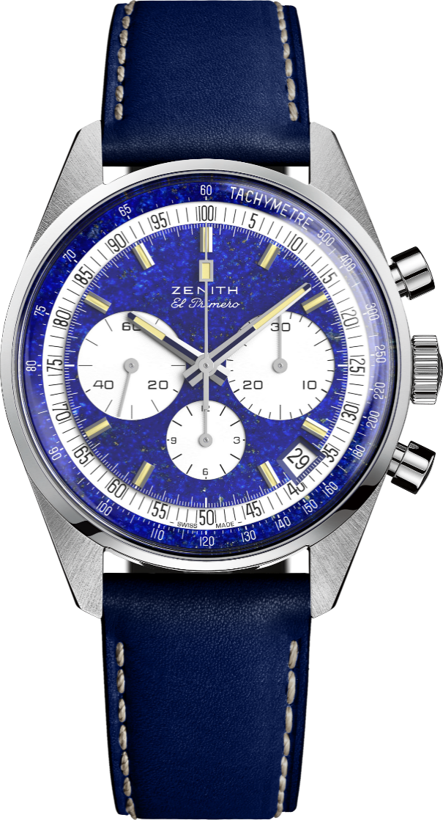
EL PRIMERO A386 – THE ONE-OFF
Reference: 40.P386.400/57.C842

KEY POINTS
Tribute to the 50th Anniversary of the Legendary El Primero
Original revival of the 1969 38-mm case
Unique Piece in Platinum with Lapis Lazuli dial
Automatic El Primero column-wheel chronograph
Lifetime Warranty

MOVEMENT
El Primero 400, Automatic
Calibre: 13 ¼ ``` (Diameter: 30 mm)
Movement thickness: 6.6.mm
Components: 278
Jewels: 31
Frequency: 36,000 VpH (5 Hz)
Power-reserve: min. 50 hours
Finishes: Oscillating weight with “Côtes de Genève”. motif

FUNCTIONS
Hours and minutes in the centre
Small seconds at 9 o'clock
Chronograph:
- Central chronograph hand
- 12-hour counter at 6 o'clock
- 30-minute counter at 3 o'clock
Tachymetric scale
Date indication at 4:30

CASE, DIAL & HANDS
Diameter: 38 mm
Diameter opening: 33.05 mm
Thickness: 12.60 mm
Crystal: Domed sapphire crystal with anti-reflective treatment on both sides
Case-back: Transparent sapphire crystal
Material: Platinum
Water-resistance: 5 ATM
Dial: Lapis Lazuli dial with white lacquered counters
Hour-markers: Rhodium-plated, faceted and coated with beige Super-LumiNova SLN
Hands: Rhodium-plated, faceted and coated with beige Super-LumiNova SLN

STRAP & BUCKLE
Blue calfskin leather strap with protective rubber lining
White gold pin buckle
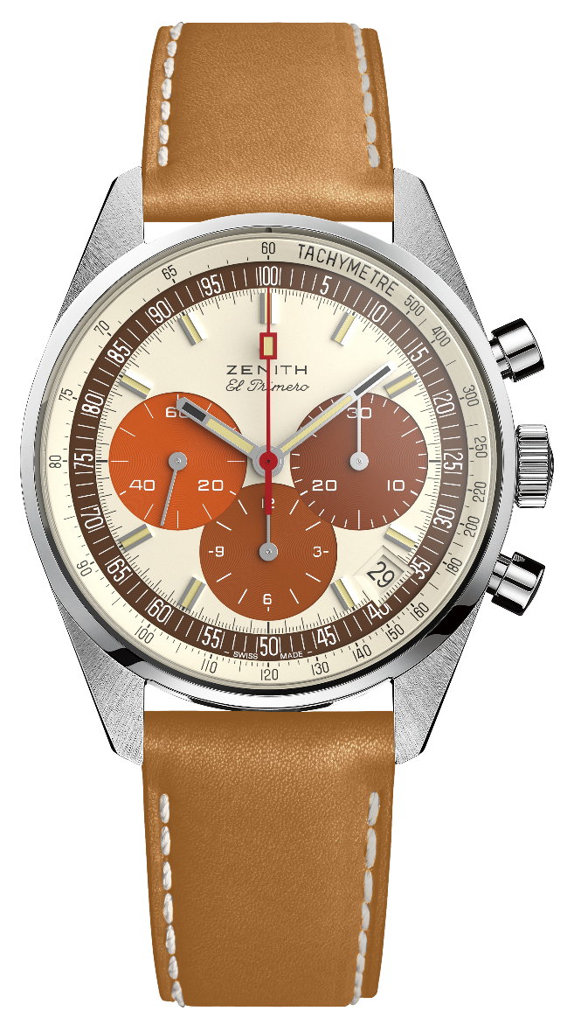
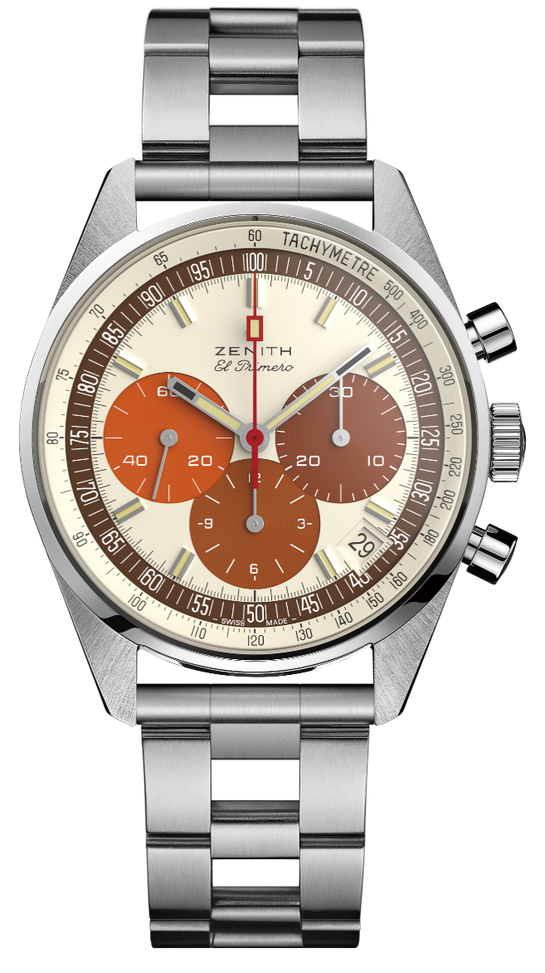
EL PRIMERO A386 REVIVAL - STEEL
Reference: 03.P386.400/07.C840

KEY POINTS
Tribute to the 50th Anniversary of the Legendary El Primero
Original revival of the 1969 38-mm case
Automatic El Primero column-wheel chronograph
Available on straight end links ladder bracelet
Limited Edition of 49 units

MOVEMENT
El Primero 400, Automatic
Calibre: 13 ¼ ``` (Diameter: 30 mm)
Movement thickness: 6.6.mm
Components: 278
Frequency: 36,000 VpH (5 Hz)
Power-reserve: min. 50 hours
Finishes: Oscillating weight with “Côtes de Genève” motif

FUNCTIONS
Hours and minutes in the centre. Small seconds at 9 o'clock
Chronograph:
- Central chronograph hand
- 12-hour counter at 6 o'clock
- 30-minute counter at 3 o'clock
Tachymetric scale
Date indication at 4:30

CASE, DIAL & HANDS
Diameter: 38 mm
Diameter opening: 33.05 mm
Thickness: 12.60 mm
Crystal: Domed sapphire crystal with anti-reflective treatment on both sides
Case-back: Transparent sapphire crystal with PHILLIPS logo
Material: steel
Water-resistance: 5 ATM
Dial: Eggshell dial with 3 shades of brown colored counters. “Tropical” dial.
Hour-markers: Rhodium-plated, faceted and coated with beige Super-LumiNova SLN
Hands: Rhodium-plated, faceted and coated with beige Super-LumiNova SLN

STRAP & BUCKLE
Honey Calfskin leather strap with protective rubber lining.
Metal bracelet included (Revival of the original “Gay Frères” ladder bracelet). Steel pin buckle.

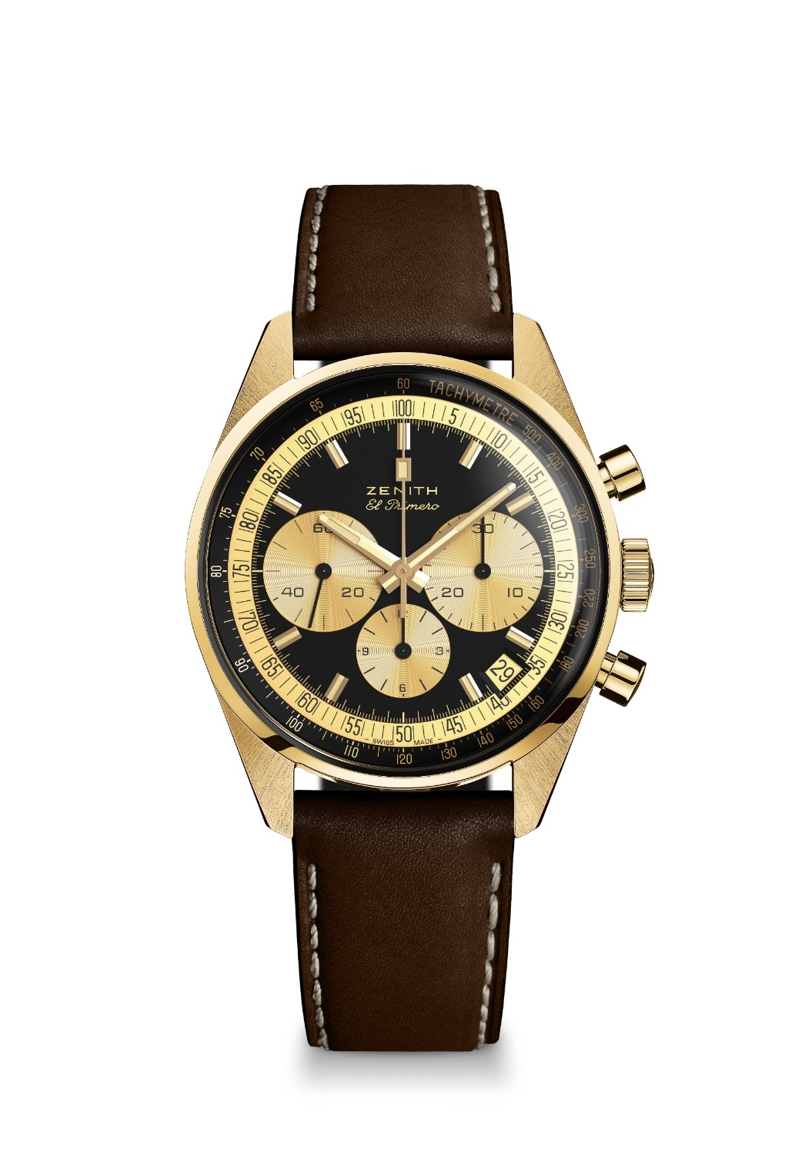
EL PRIMERO A386 REVIVAL – YELLOW GOLD

Reference: 30.P386.400/27.C841

KEY POINTS
Tribute to the 50th Anniversary of the Legendary El Primero
Original revival of the 1969 38-mm case
Automatic El Primero column-wheel chronograph
Limited Edition of 20 units

MOVEMENT
El Primero 400, Automatic
Calibre: 13 ¼ ``` (Diameter: 30 mm)
Movement thickness: 6.6.mm
Components: 278
Frequency: 36,000 VpH (5 Hz)
Power-reserve: min. 50 hours
Finishes: Oscillating weight with “Côtes de Genève”. motif

FUNCTIONS
Hours and minutes in the centre
Small seconds at 9 o'clock
Chronograph:
- Central chronograph hand
- 12-hour counter at 6 o'clock
- 30-minute counter at 3 o'clock
Tachymetric scale
Date indication at 4:30

CASE, DIAL & HANDS
Diameter: 38 mm
Diameter opening: 33.05 mm
Thickness: 12.60 mm
Crystal: Box sapphire crystal with anti-reflective treatment on both sides
Case-back: Transparent sapphire crystal with PHILLIPS logo
Material: Yellow gold
Water-resistance: 5 ATM
Dial: Black dial with gold colored counters
Hour-markers: Gold-plated, faceted and coated with beige Super-LumiNova SLN
Hands: Gold-plated, faceted and coated with beige Super-LumiNova SLN

STRAP & BUCKLE
Brown calfskin leather strap with protective rubber lining. Yellow gold pin buckle.

