CHRONOMASTER 2

New-gen El Primero

El Primero is celebrating its 50th anniversary. An opportunity to unveil this cult movement in its modernised version, fitted in the emblematic Chronomaster. The new El Primero lineage is inaugurated with series of 250 titanium models featuring an original ceramic bezel and skeleton dial.
Reinterpreted to ensure greater modularity, the El Primero 3600 calibre has been designed using the latest technologies, while preserving the DNA of the original movement. Also beating at the high frequency of 36,000 vibrations per hour, it measures and displays tenths of a second. Alongside the original El Primero, it will gradually be introduced on other models in the range and equipped with various functions.
Faithful optimisation
At Zenith, celebrating the mythical El Primero – a high-frequency star born in 1969 – is about showing respect for the past, taking root in the present and looking resolutely towards future horizons. In this spirit, the Manufacture's engineers have redesigned the world’s most accurate automatic chronograph movement, offering a modernised version that is faithful to the architecture and proven performance of the original. The strict specifications stipulated modularity, optimised industrial production, assembly and adjustment, the addition of a stop-seconds device and autonomy increased to a full 60 hours. As an added bonus, it was to provide the option of integrating several functions and displays as well as ensuring enhanced user friendliness – all the while complying with the absolute necessity of preserving the integrity and identity of the original El Primero.
Modern heritage
Renamed El Primero 3600, this optimised calibre is thus endowed with the main attributes of its predecessor: a 1/10th of a second chronograph function, along with integrated construction incorporating a lateral clutch, column wheel and ballbearing-mounted central rotor. The difference lies in the fact that it has been developed using the latest technologies and performance algorithms. The most obvious modifications are as follows: a tenth-of-a-second display on a scale with 100 graduations; the addition of a balance-stop device; a reversal of the crown sequence; adjustment of the wheels and gears; enlarged and centred design of the column wheel; and most visibly of all, an optimised lateral clutch that now includes two intermediate wheels.
Living legend
To inaugurate the new-gen El Primero, Zenith has chosen an emblematic contemporary collection: the Chronomaster. Its imposing stature and distinctive design are in line with the DNA of the Maison. Equipped with the El Primero 3600 movement, the Chronomaster 2 also flaunts a modernised look with a light titanium case, black or blue ceramic graduated bezel, skeleton dial with solid counters and star-shaped oscillating weight. Graced with three distinctive colours - light grey, blue and anthracite - the display is distinguished by a direct tenth-of-a-second read-off. The red chronograph hand makes a full sweep of the dial in ten seconds, indicating with each jump successive tenths of a second on the 100 graduations of the flange and bezel.
In addition to measuring and displaying tenths of a second, this Chronomaster, operating at 36,000 vibrations per hour, features hour and minute functions in the centre, 60-minute and 60-second chronograph counters, running small seconds and date, while delivering a minimum 60-hour power reserve – meaning a whole weekend without having to wind the watch even if is not worn! Available in two limited series of 250 pieces each, fitted with a blue or black ceramic bezel, the Chronomaster 2 is a powerful distillation of Zenith's modern and sporty identity.

ZENITH: the future of Swiss watchmaking
With innovation as its guiding star, Zenith features exceptional in-house developed and manufactured movements in all its watches, such as the DEFY Inventor with its monolithic oscillator of exceptional precision, and the DEFY El Primero 21 with its high-frequency 1/100th of a second chronograph. Since its establishment in 1865, Zenith has consistently redefined the notions of precision and innovation, including the first “Pilot Watch” at the dawn of aviation and the first serially produced “El Primero” automatic chronograph calibre. Always one step ahead, Zenith is writing a new chapter in its unique legacy by setting new standards of performance and inspired design. Zenith is here to shape the future of Swiss watchmaking, accompanying those who dare to challenge time itself and reach for the stars.

PRESS ROOM
For additional pictures please access the below link
http://pressroom.zenith-watches.com/login/?redirect_to=%2F&reauth=1

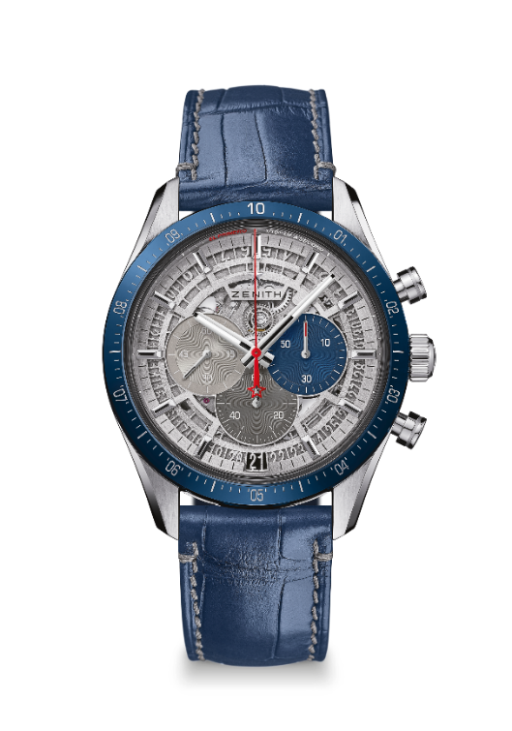
CHRONOMASTER 2
LIMITED EDITION 250

Reference: 95.3002.3600/69.C818

KEY POINTS
Entirely redesigned movement to pay tribute to the 50th Anniversary of the legendary El Primero movement
Automatic El Primero column-wheel chronograph able to measure and display the 1/10th of a second
1/10th of a second indication on the ceramic bezel
Increased power reserve of min 60 hours
Stop second mechanism
Certified Chronometer

MOVEMENT
El Primero 3600, Automatic
Calibre: 13¼``` (Diameter: 30 mm)
Movement thickness: 6.6mm
Frequency: 36,000 VpH (5 Hz)
Power-reserve: min. 60 hours
Finishes: New star-shaped oscillating weight with satined finishings

FUNCTIONS
Hours and minutes in the centre
Small seconds at 9 o'clock
1/10th of a second Chronograph:
- Central chronograph hand that makes one turn in 10 seconds
- 60-minute counter at 6 o'clock
- 60-second counter at 3 o'clock
Date indication at 6 o'clock

CASE, DIAL & HANDS
Diameter: 42 mm
Diameter opening: 37.1 mm
Thickness: 12.75 mm
Crystal: Domed sapphire crystal with anti-reflective treatment on both sides
Case-back: Transparent sapphire crystal
Material: Titanium with blue ceramic bezel
Water-resistance: 10 ATM
Dial: Openworked with three different-coloured counters
Hour-markers: Rhodium-plated, faceted and coated with Super-LumiNova®SLN C1
Hands: Rhodium-plated, faceted and coated with Super-LumiNova®SLN C1

STRAP & BUCKLE
Bracelet: Blue alligator strap with protective rubber lining & grey stitching
Buckle: Steel double folding clasp

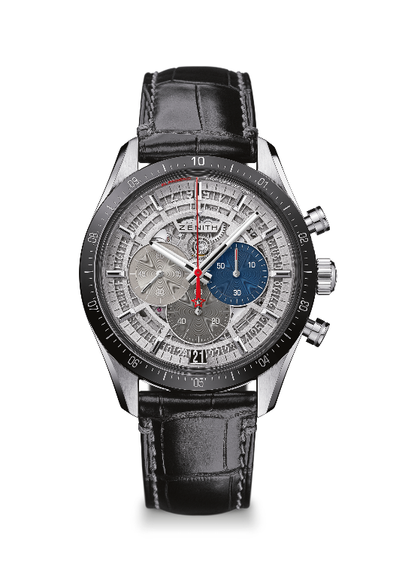
CHRONOMASTER 2
LIMITED EDITION 250

Reference: 95.3001.3600/69.C817

KEY POINTS
Entirely redesigned movement to pay tribute to the 50th Anniversary of the legendary El Primero movement
Automatic El Primero column-wheel chronograph able to measure and display the 1/10th of a second
1/10th of a second indication on the ceramic bezel
Increased power reserve of min 60 hours
Stop second mechanism
Certified Chronometer

MOVEMENT
El Primero 3600, Automatic
Calibre: 13¼``` (Diameter: 30 mm)
Movement thickness: 6.6mm
Frequency: 36,000 VpH (5 Hz)
Power-reserve: min. 60 hours
Finishes: New star-shaped oscillating weight with satined finishings

FUNCTIONS
Hours and minutes in the centre
Small seconds at 9 o'clock
1/10th of a second Chronograph:
- Central chronograph hand that makes one turn in 10 seconds
- 60-minute counter at 6 o'clock
- 60-second counter at 3 o'clock
Date indication at 6 o'clock

CASE, DIAL & HANDS
Diameter: 42 mm
Diameter opening: 37.1 mm
Thickness: 12.75 mm
Crystal: Domed sapphire crystal with anti-reflective treatment on both sides
Case-back: Transparent sapphire crystal
Material: Titanium with black ceramic bezel
Water-resistance: 10 ATM
Dial: Openworked with three different-coloured counters
Hour-markers: Rhodium-plated, faceted and coated with Super-LumiNova®SLN C1
Hands: Rhodium-plated, faceted and coated with Super-LumiNova®SLN C1

STRAP & BUCKLE
Bracelet: Black alligator strap with protective rubber lining & grey stitching
Buckle: Steel double folding clasp

