ZENITH ADDS A RAINBOW SPARKLE TO THE DEFY CLASSIC EXCLUSIVELY FOR ZENITH BOUTIQUES WORLDWIDE AND RETAILERS IN GREATER CHINA
After the highly sought-after DEFY El Primero Rainbow editions made exclusively for the Greater China region last year, Zenith applies the same enticingly vibrant treatment to the DEFY Classic in two Limited Edition pieces that will certainly stand out from the crowd.
The faceted DEFY Classic case, measuring 41mm in diameter, is made in either light and rugged Titanium, or highly scratch-resistant Midnight Black Ceramic. With its mix of polished, satin-brushed and microblasted matte surfaces, the DEFY Classic’s case recalls the geometric lines of the earliest Zenith DEFY models while exuding an unmistakably futuristic aura. The distinguishing feature that sets apart these two Limited Editions for Zenith boutiques and the Greater China region is the colourful gem-set bezels. Featuring 48 baguette-cut sapphire stones with a graduation in color that spans the entire rainbow, the bezel represents a challenge in both finding the exact colours in the correct sizes, and meticulously setting them into the bezel for a radiantly luminous effect.
While the Zenith DEFY Classic can be considered the purest expression of Zenith’s avant-garde vision, the Rainbow edition is far from classical. Made for those with a strong sense of style and no fear of self-expression, the bedazzling boutique and region-exclusive series adds a vibrant punch to the neo-futuristic look. The open dial with a central star motif creates a sense of harmonic visual depth against a contemporary architectural backdrop. In the Midnight Black Ceramic version, the hands, markers and raised flange ring are totally blacked out with touches of black Super-LumiNova®, while the Titanium version features rhodium markers and hands filled with white luminescent pigments atop a black flange ring. The yin and yang contrast between the two versions is amplified by the colourful gleam of the sapphires on the bezel.

Beating within the embellished and edgy case is Zenith’s staple automatic movement, the Elite. With a skeleton execution of the main plate, bridges and even the date wheel, the Elite calibre’s modernism extends beyond just aesthetics, with a silicon escape-wheel and lever offering precision at a frequency of 28,800 VpH (4 Hz). When fully wound, the automatic Elite movement provides a minimum power reserve of 50 hours.
Completing the unique character of each of two DEFY Classic Rainbow editions, the Midnight Black Ceramic edition comes on a black rubber strap with black alligator coating and red stitching, while the Titanium version comes on a white rubber strap with blue alligator coating and white stitching. Whether one’s attraction gravitates towards the dark allure of the Midnight Black Ceramic version or the brightly nuanced Titanium version, the two DEFY Classic Rainbow editions are bound to enchant with their unique mix of avant-garde aesthetics and alluring play on colours. Each version is limited to 150 pieces and available exclusively at Zenith boutiques around the world and Zenith retailers in the Greater China region.
And finally, as an additional service exclusively tailored for boutique clients, from July 2019 every watch purchased from a Zenith boutique around the world will be offered a complimentary first maintenance service, at a time of the owner’s choosing.

ZENITH: the future of Swiss watchmaking
With innovation as its guiding star, Zenith features exceptional in-house developed and manufactured movements in all its watches, such as the DEFY Inventor with its monolithic oscillator of exceptional precision, and the DEFY El Primero 21 with its high-frequency 1/100th of a second chronograph. Since its establishment in 1865, Zenith has consistently redefined the notions of precision and innovation, including the first “Pilot Watch” at the dawn of aviation and the first serially produced “El Primero” automatic chronograph calibre. Always one step ahead, Zenith is writing a new chapter in its unique legacy by setting new standards of performance and inspired design. Zenith is here to shape the future of Swiss watchmaking, accompanying those who dare to challenge time itself and reach for the stars.

PRESS ROOM
For additional pictures please access the below link
http://pressroom.zenith-watches.com/login/?redirect_to=%2F&reauth=1

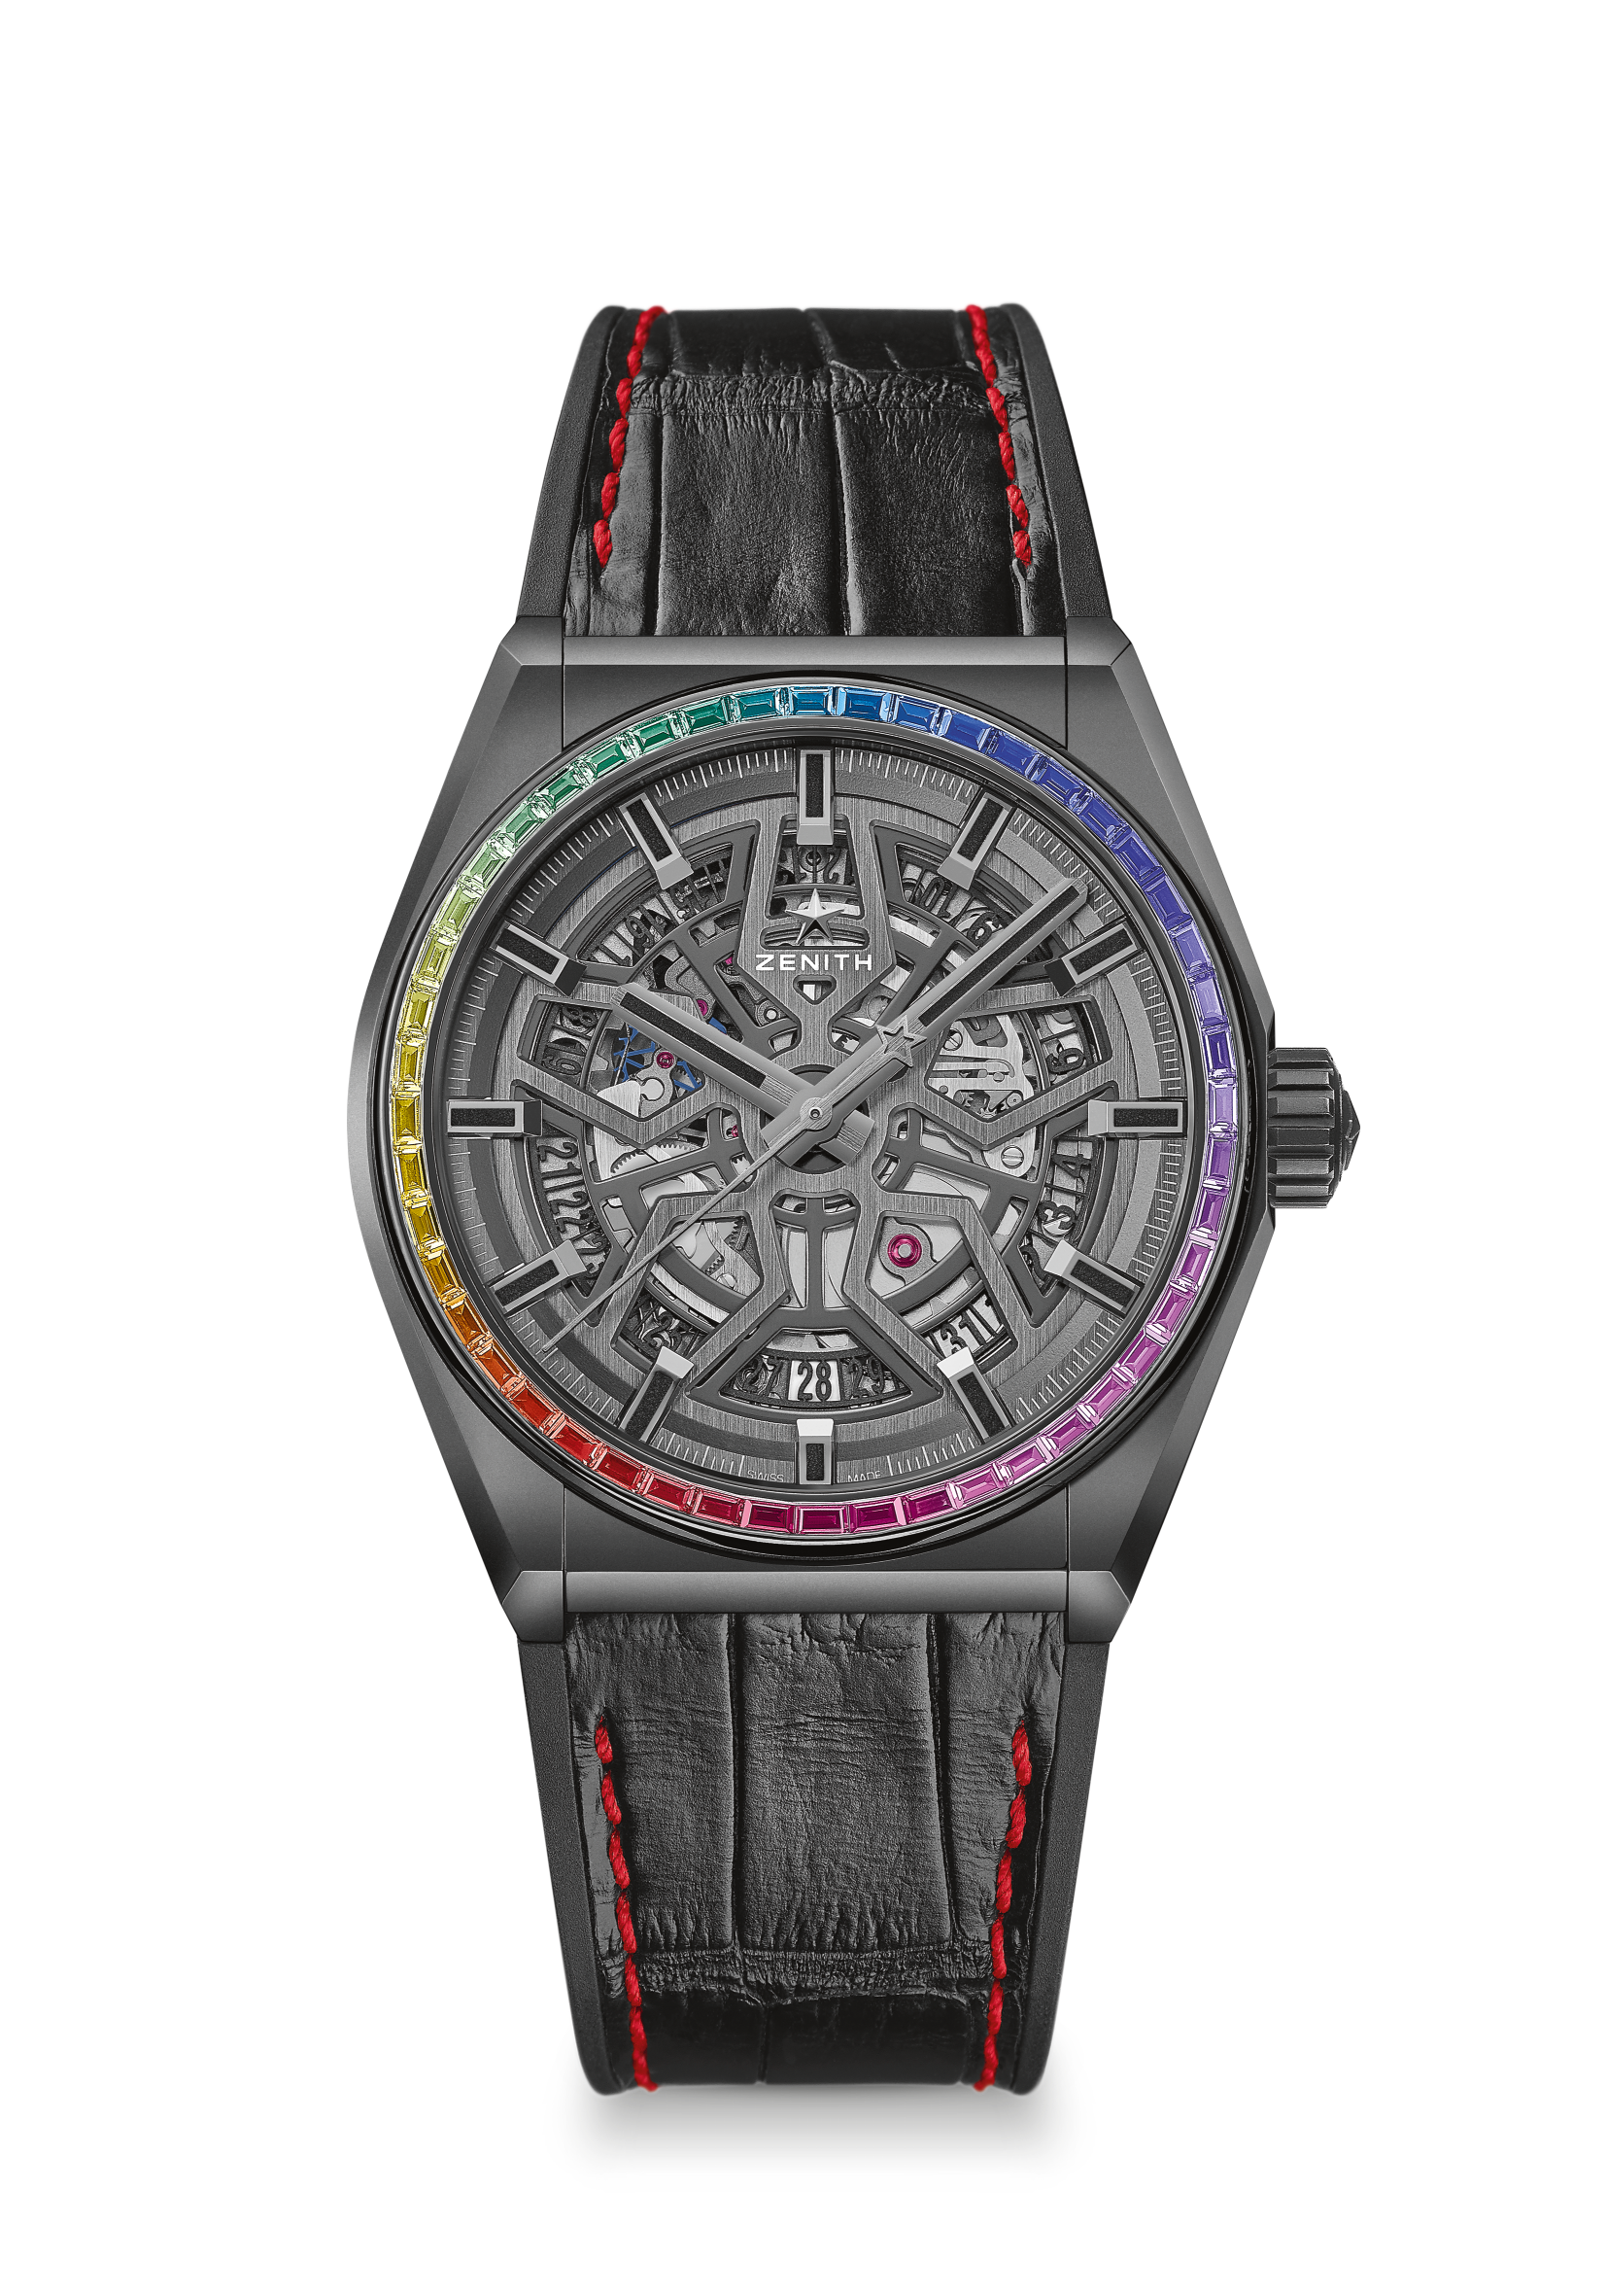
DEFY CLASSIC RAINBOW
LIMITED EDITION 150 PIECES
Reference: 33.9002.670/96.R587

KEY POINTS
41-MM Black Ceramic case with Rainbow sapphires bezel
Elite automatic skeletonised movement
Silicon escape-wheel and lever

MOVEMENT
Elite 670 SK, Automatic
Calibre: 11 ½``` (Diameter: 25.60mm)
Movement thickness: 3.88mm
Components: 187
Jewels: 27
Frequency: 28,800 VpH (4 Hz)
Power-reserve: min. 50 hours
Finishing: Special oscillating weight with satin-brushed finish

FUNCTIONS
Hours and minutes in the centre
Central seconds hand
Date indication at 6 o’clock

GEMSETTING
Carats: 1.78 cts
Bezel: 48 WS baguette-cut sapphires

CASE, DIAL & HANDS
Diameter: 41mm
Diameter opening: 32.5mm
Thickness: 10.75mm
Crystal: Domed sapphire crystal with anti-reflective treatment on both sides
Case-back: Transparent sapphire crystal
Material: Black ceramic
Water-resistance: 3 ATM
Dial: Openworked
Hour-markers: Ruthenium-plated, faceted and coated with black Super-LumiNova®
Hands: Ruthenium-plated, faceted and coated with black Super-LumiNova®

STRAP & BUCKLE
Strap: black rubber with black alligator coating & red stitching
Buckle: Titanium double folding clasp with black DLC coating
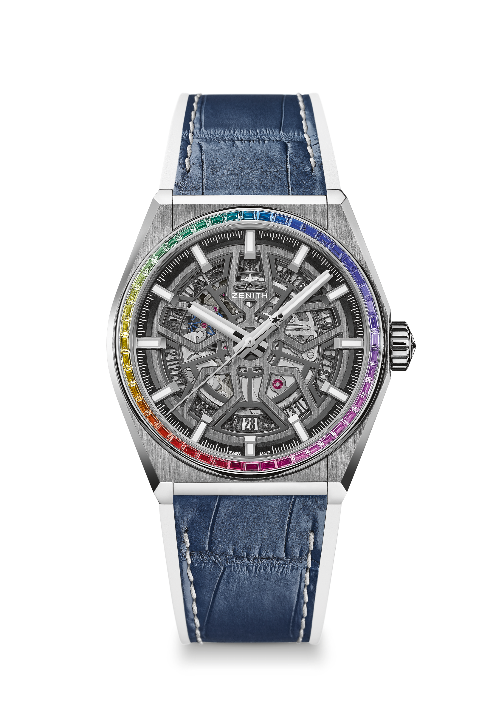
DEFY CLASSIC RAINBOW
LIMITED EDITION 150 PIECES
Reference: 32.9003.670/86.R588

KEY POINTS
41-MM Brushed Titanium case with Rainbow sapphires bezel
Elite automatic skeletonised movement
Silicon escape-wheel and lever

MOVEMENT
Elite 670 SK, Automatic
Calibre: 11 ½``` (Diameter: 25.60mm)
Movement thickness: 3.88mm
Components: 187
Jewels: 27
Frequency: 28,800 VpH (4 Hz)
Power-reserve: min. 50 hours
Finishing: Special oscillating weight with satin-brushed finish

FUNCTIONS
Hours and minutes in the centre
Central seconds hand
Date indication at 6 o’clock

GEMSETTING
Carats: 1.78 cts
Bezel: 48 WS baguette-cut sapphires

CASE, DIAL & HANDS
Diameter: 41mm
Diameter opening: 32.5mm
Thickness: 10.75mm
Crystal: Domed sapphire crystal with anti-reflective treatment on both sides
Case-back: Transparent sapphire crystal
Material: Brushed Titanium
Water-resistance: 3 ATM
Dial: Openworked
Hour-markers: Rhodium-plated, faceted and coated with Super-LumiNova® SLN C1
Hands: Rhodium-plated, faceted and coated with Super-LumiNova® SLN C1

STRAP & BUCKLE
Strap: White rubber with blue alligator coating & white stitching
Buckle: Titanium double folding clasp

