|  |  |
| --- | --- |
| **PRESS RELEASE**  **Phillips in Association with Bacs & Russo Presents**  **TWO EXCLUSIVE ZENITH EL PRIMERO LIMITED EDITION CHRONOGRAPHS DESIGNED BY PHILLIPS, including:**  **A Yellow Gold Ref. A386 Limited to 20 Pieces &**  **A Stainless Steel Ref. A386 Limited to 49 Pieces**  **A Total of 69 Timepieces will be offered to commemorate the 50th Anniversary**  **Of the Revolutionary Zenith El Primero Calibre**    On the left the yellow gold Ref. A386 limited to 20 pieces on right the stainless Steel Ref. A386 limited to 49 pieces  GENEVA – 8 November 2019 – Earlier this Fall, Phillips in Association with Bacs & Russo announced the presentation of a unique Zenith El Primero Ref. 386 in platinum. The first of three models created in collaboration with Zenith, this *pièce unique* will be sold this weekend by Phillips during **The Geneva Watch Auction X on November 9,** with proceeds from the sale donated to the ZOE4LIFE foundation. Known as the “One-Off”, the watch will be the only Ref. A386 that Zenith will ever make in PT 950 platinum, and is the first of its kind to feature a breathtaking Lapis Lazuli dial.  Following the presentation of the “One-Off”, Zenith and Phillips decided to pursue their collaboration by sitting down again to create two more El Primero Ref. A386 chronographs, limited to 69 pieces in total, in honor of the birth year of the El Primero caliber. It was an honor for Phillips to be put into the designer’s seat, and work with a watchmaker that has on more than one occasion revolutionized the way watches are made.  Since they felt it was impossible to create watches that would fully encapsulate the El Primero’s rich and beautiful history, Aurel Bacs, Senior Consultant at Bacs & Russo and Alex Ghotbi, Head of Watches Continental Europe & Middle East for Phillips, decided instead to turn back the clock and imagine themselves in Le Locle, in 1969, in the shoes of the manufacturer’s designers.  The world’s first automatic column-wheel high-frequency chronograph has just been developed and is about to be unveiled to the world. What would the design be? The result is an extraordinary yellow gold El Primero Ref. A386 with a stunning black dial with gold sub-registers and gold printing - a contrast that is beloved in the watch collecting community, and unlike anything previously made by Zenith.  For the stainless steel version, Phillips’ team was inspired by color schemes characteristic of fashionable textiles and popular interior design during the 60s. The iconic overlapping registers of the first ever Zenith El Primero Ref. A386 remain, but brown terracotta tones replace the grey, dark grey and blue of the original dial.  The launch, in Geneva, of the two limited edition Zenith El Primero Ref. A386 for Phillips in Association with Bacs & Russo, marks the final stop of **the El Primero 50th Anniversary World Tour** celebrating the watchmaker’s revolutionary chronograph across five continents.  The watches will be offered individually to clients, the steel model will be offered on a leather strap and a ladder bracelet reminiscent of the bracelets made by Gay-Frères for Zenith back in the day. However, the winning bidder of the “One-Off” Zenith El Primero A386 in platinum will be given right of first refusal to the yellow gold and stainless steel limited editions, in order to have the opportunity to acquire all three models made for Phillips in Association with Bacs & Russo, and completing a unique trilogy in three different case metals.  **Aurel Bacs, Senior Consultant Bacs & Russo and Alex Ghotbi, Head of Watches Continental Europe & Middle East**, enthusiastically declared: “*It was fascinating to sit on a time-machine, go back to 1969 and put ourselves in the shoes of Zenith designers and management, designing the dials of what would become one the most iconic movements ever created. We did not want to create an homage-piece but a watch whose design would have been in the Zenith archives since 1969. It was a true pleasure and honor to work with Zenith’s management and designers to create what for us is: a truly unique experience.*”  **Zenith CEO Julien Tornare** said: “*Watching how the teams at Zenith and Phillips clicked the way they did on the 50thAnniversary El Primero project was amazing. With all this creativity and passion bouncing back and forth between the two, we had to find a way to prolong the collaboration. The result is the Zenith x Phillips collection, developed and designed with and for Phillips. It consists of two editions, one in gold (20 watches) and the other in steel (49 watches). We couldn’t resist: adding up the production runs gives you the year the El Primero was born; and both in their own way draw on the El Primero’s rich heritage while creating modern classics in their own right*.”  [Click here to download images](https://protect-us.mimecast.com/s/vKlzCn5GqXu7V90Oc9AW_e)  *Permission for the use of any image is granted by the holder of the intellectual property rights for timely reporting and auction review purposes only. The underlying intellectual property rights in any property depicted remain the property of the rights holder. Phillips does not make any representations with respect to or accept any responsibility for any third party uses.*  *Courtesy of Phillips.*  ###  ABOUT PHILLIPS IN ASSOCIATION WITH BACS & RUSSO The team of specialists at Phillips Watches is dedicated to an uncompromised approach to quality, transparency, and client service, achieving a sale total of $ 108 million in 2018 – its third consecutive year as the worldwide market leader in watch auctions.  A selection of our recent record-breaking prices:  1.       Paul Newman’s Rolex “Paul Newman” Daytona reference 6239 (CHF 17,709,894/US$17,752,500) – New York Auction: Winning Icons – 26 October 2017 – ­­­Highest result ever achieved for any wristwatch at auction.    2.      Patek Philippe reference 1518 in stainless steel (CHF 11,020,000 /US$11,112,020) – Geneva Watch Auction: FOUR – 12 November 2016 – Highest result ever achieved for a Patek Philippe wristwatch at auction.  ABOUT PHILLIPS  Phillips is a leading global platform for buying and selling 20th and 21st century art and design. With dedicated expertise in the areas of 20th Century and Contemporary Art, Design, Photographs, Editions, Watches, and Jewelry, Phillips offers professional services and advice on all aspects of collecting. Auctions and exhibitions are held at salerooms in New York, London, Geneva, and Hong Kong, while clients are further served through representative offices based throughout Europe, the United States and Asia. Phillips also offers an online auction platform accessible anywhere in the world. In addition to providing selling and buying opportunities through auction, Phillips brokers private sales and offers assistance with appraisals, valuations, and other financial services.  Visit [www.phillips.com](http://www.phillips.com) for further information.  *\*Estimates do not include buyer’s premium; prices achieved include the hammer price plus buyer’s premium.*  PRESS CONTACTS:  GENEVA - Asta Ponzo, *PR Consultant*                                                  [aponzo@phillips.com](mailto:aponzo@phillips.com)                 +41 79 961 85 66  LONDON - Katie Carder, *Head of Press, Europe* [kcarder@phillips.com](mailto:kcarder@phillips.com) +44 20 7901 7938  NEW YORK - Jaime Israni, *Senior Public Relations Specialist* [jisrani@phillips.com](mailto:jisrani@phillips.com) +1 212 940 1398 | |
| PHILLIPS NEW YORK - 450 Park Avenue, New York, NY 10022  PHILLIPS LONDON - 30 Berkeley Square, London, W1J 6EX  PHILLIPS HONG KONG - 14/F St. George’s Building, 2 Ice House Street, Central Hong Kong  PHILLIPS GENEVA - Hôtel La Réserve, 301 Route de Lausanne, Geneva  VISIT US AT: [www.phillips.com](http://www.phillips.com)  FOLLOW US ON: [Twitter](https://twitter.com/phillipsauction) | [Instagram](https://instagram.com/phillipsauction/) | [Vimeo](https://vimeo.com/phillipsauction) | [Facebook](https://www.facebook.com/phillipsauction) | [Pinterest](https://www.pinterest.com/phillipsauction/) | [LinkedIn](https://www.linkedin.com/company/phillips) | WeChat (use QR Code to right) |  |





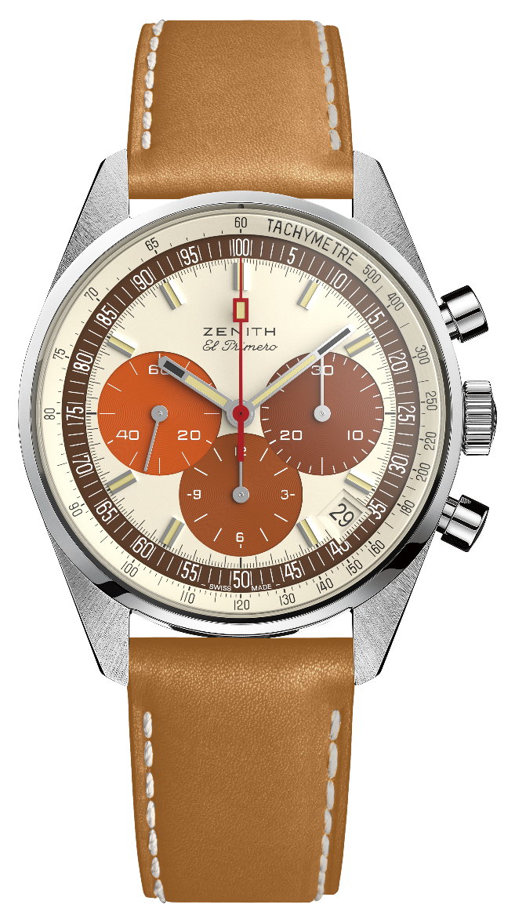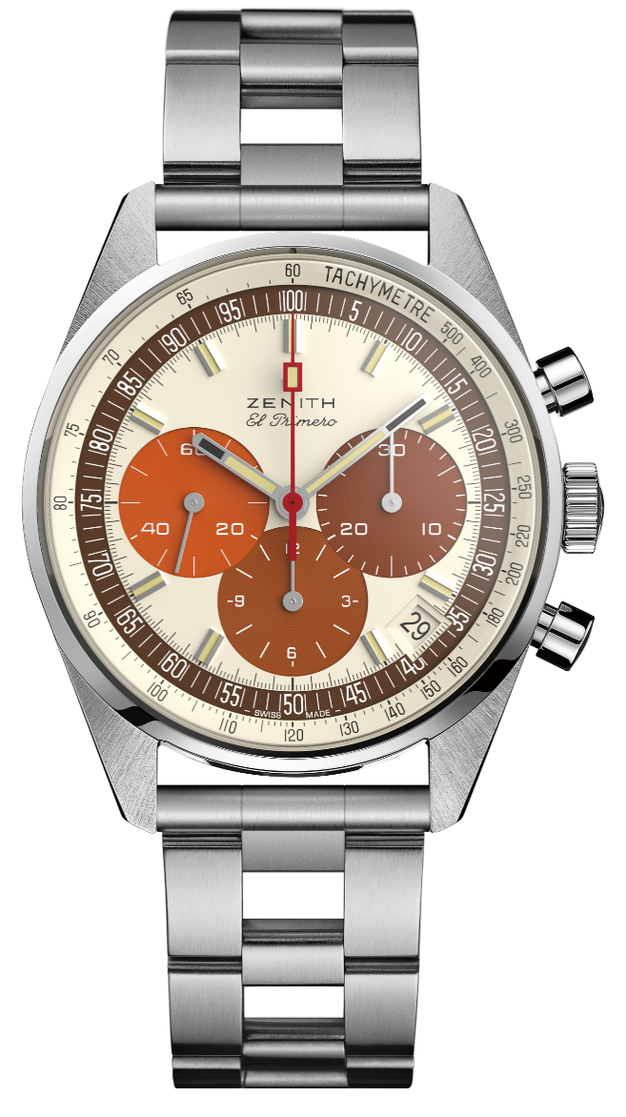**EL PRIMERO A386 REVIVAL - STEEL**

Reference: 03.P386.400/07.C840

**KEY POINTS**

Tribute to the 50th Anniversary of the Legendary El Primero

Original revival of the 1969 38-mm case

Automatic El Primero column-wheel chronograph

Available on straight end links ladder bracelet

Limited Edition of 49 units

**MOVEMENT**

El Primero 400, Automatic

Calibre: 13 ¼ ``` (Diameter: 30 mm)

Movement thickness: 6.6.mm

Components: 278

Frequency: 36,000 VpH (5 Hz)

Power-reserve: min. 50 hours

Finishes: Oscillating weight with “Côtes de Genève” motif

**FUNCTIONS**

Hours and minutes in the centre. Small seconds at 9 o'clock

Chronograph:

- Central chronograph hand

- 12-hour counter at 6 o'clock

- 30-minute counter at 3 o'clock

Tachymetric scale

Date indication at 4:30

**CASE, DIAL & HANDS**

Diameter: 38 mm

Diameter opening: 33.05 mm

Thickness: 12.60 mm

Crystal: Domed sapphire crystal with anti-reflective treatment on both sides

Case-back: Transparent sapphire crystal with PHILLIPS logo

Material: steel

Water-resistance: 5 ATM

Dial: Eggshell dial with 3 shades of brown colored counters. “Tropical” dial.

Hour-markers: Rhodium-plated, faceted and coated with beige Super-LumiNova SLN

Hands: Rhodium-plated, faceted and coated with beige Super-LumiNova SLN

**STRAP & BUCKLE**

Honey Calfskin leather strap with protective rubber lining.

Metal bracelet included (Revival of the original “Gay Frères” ladder bracelet). Steel pin buckle.





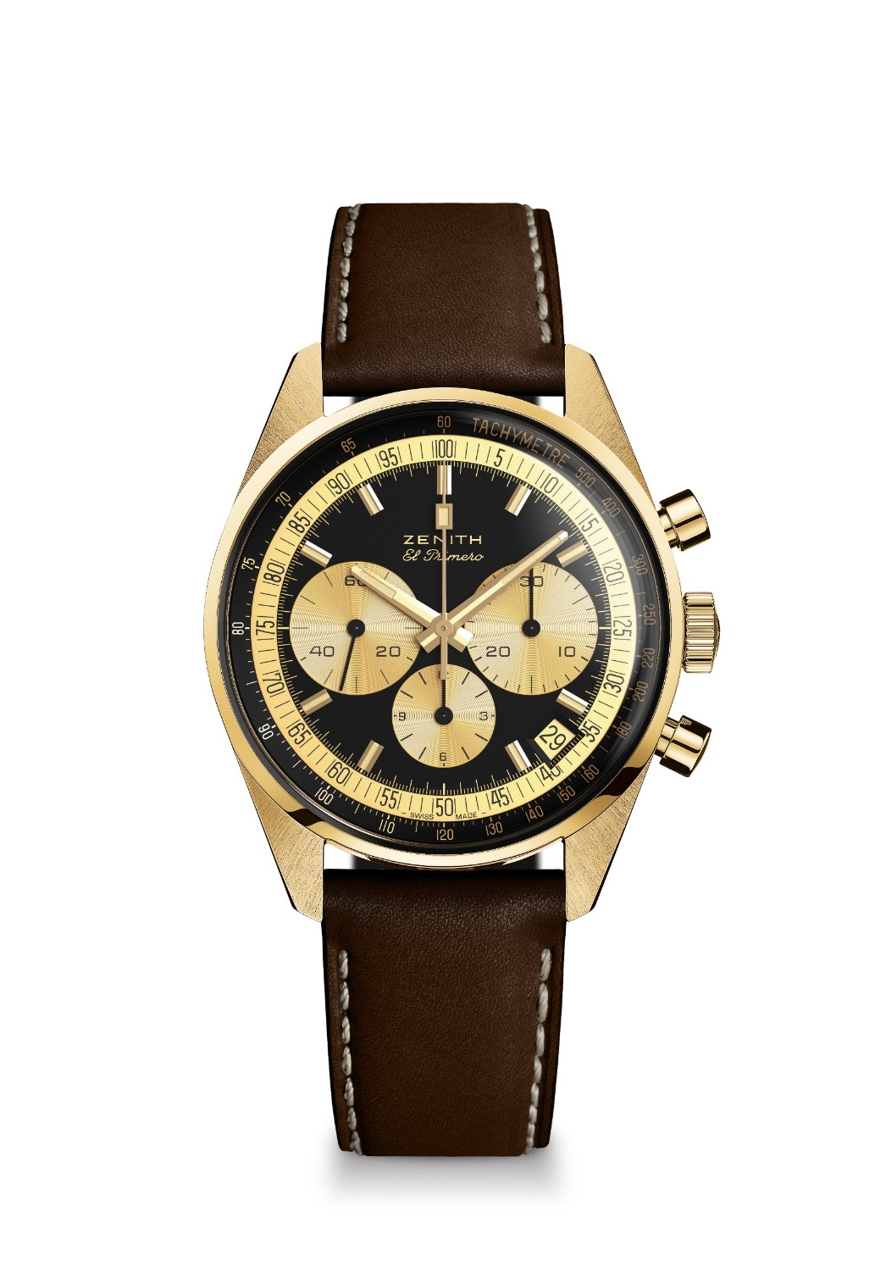**EL PRIMERO A386 REVIVAL – YELLOW GOLD**

Reference: 30.P386.400/27.C841

**KEY POINTS**

Tribute to the 50th Anniversary of the Legendary El Primero

Original revival of the 1969 38-mm case

Automatic El Primero column-wheel chronograph

Limited Edition of 20 units

**MOVEMENT**

El Primero 400, Automatic

Calibre: 13 ¼ ``` (Diameter: 30 mm)

Movement thickness: 6.6.mm

Components: 278

Frequency: 36,000 VpH (5 Hz)

Power-reserve: min. 50 hours

Finishes: Oscillating weight with “Côtes de Genève”. motif

**FUNCTIONS**

Hours and minutes in the centre

Small seconds at 9 o'clock

Chronograph:

- Central chronograph hand

- 12-hour counter at 6 o'clock

- 30-minute counter at 3 o'clock

Tachymetric scale

Date indication at 4:30

**CASE, DIAL & HANDS**

Diameter: 38 mm

Diameter opening: 33.05 mm

Thickness: 12.60 mm

Crystal: Box sapphire crystal with anti-reflective treatment on both sides

Case-back: Transparent sapphire crystal with PHILLIPS logo

Material: Yellow gold

Water-resistance: 5 ATM

Dial: Black dial with gold colored counters

Hour-markers: Gold-plated, faceted and coated with beige Super-LumiNova SLN

Hands: Gold-plated, faceted and coated with beige Super-LumiNova SLN

**STRAP & BUCKLE**

Brown calfskin leather strap with protective rubber lining. Yellow gold pin buckle.