Zenith presents its first watch based on a Japanese manga,
the “A384 Revival Lupin The Third Edition”.
With the release of the A384 Revival this year to mark the 50th anniversary of the El Primero calibre, the opportunity to finally create the watch depicted in the Japanese manga and anime series Lupin the Third presented itself to Zenith. Limited to 50 pieces, the A384 Lupin The Third Edition is Japan-exclusive. This collaboration marks the first time that a Zenith watch has been made based on a manga and anime series.
The year of 1969 saw the launch of the El Primero calibre and the first watch to be equipped with it, the A384. Two years later, the first anime series of the popular manga Lupin the Third begin airing, and was an instant hit domestically in Japan, and later across the world. One of the main characters in the story, Mr. Daisuke Jigen, a debonair partner of the main protagonist Lupin, is depicted wearing a Zenith watch on two occasions of first episode of the first anime TV series. Inspired by the A384, the watch shown in the animated series didn’t actually exist – until now.
Using the blue prints and production plans of the original A384, Zenith was able to recreate the uniquely shaped 37mm stainless steel case through a reverse engineering process. The end result is virtually identical to the original from 1969 – right down to the pump-style pushers and crown. The steel case back with a sapphire crystal features a printed silhouette of Mr Jigen in his typical hat tipping, effortlessly cool stance, that fans of the series would instantly recognize.

With only a brief illustration of Jigen’s watch from the animated series of Lupin the Third, the teams at Zenith worked on bringing the fictional dial to life. The matte black dial features contrasting grey chronograph counters and tachymeter scale, with golden hands and applied markers completing the look. Creamy beige SuperLuminova fills the hands and applied markers in a way that blends with the golden tones while giving a slightly aged appearance.
The A384 Revival Lupin The Third Edition comes in a special presentation box, where the outer box features a mosaic of images from the anime series, while the inner box is emblazoned with a silhouette of Jigen and a stylized logo of Lupin the Third designed by Zenith.

ZENITH: the future of Swiss watchmaking
With innovation as its guiding star, Zenith features exceptional in-house developed and manufactured movements in all its watches, such as the architectural DEFY Inventor watch with its unique, ultra-thin monolithic oscillator that replaces the 30+ components of a standard regulating organ, and the DEFY El Primero 21 with its high-frequency 1/100th of a second chronograph. Since its establishment in 1865, Zenith has consistently redefined the notions of precision and innovation, including the first serially produced automatic chronograph calibre “El Primero”, beating at the high rate of 36,000 VpH. Always one step ahead, Zenith is writing a new chapter in its unique legacy by setting new standards of performance and inspired design. Zenith is here to shape the future of Swiss watchmaking, accompanying those who dare to challenge time itself and reach for the stars.

EL PRIMERO REVIVAL A384 – LUPIN THE THIRD EDITION
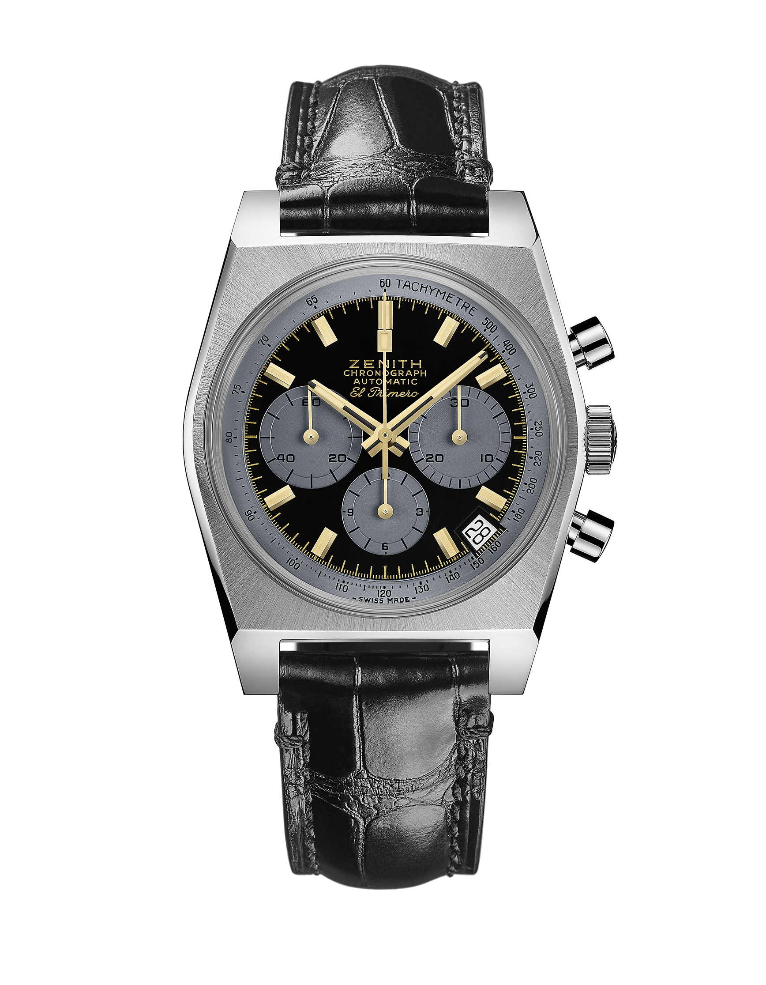
Reference: 03.L384.400/27.C815

UNIQUE SELLING POINTS
Original Revival of the 1969 Reference A384
Original 1969 case with 37 mm diameter
Automatic El Primero column-wheel chronograph
1st Ever creation of a real watch based on a Japanese Manga created in 1969
Exclusive Japanese Edition limited to 50 units

MOVEMENT
Movement: El Primero 400 Automatic
Calibre: 13¼``` (Diameter: 30 mm)
Movement thickness: 6.6 mm
Components: 278
Jewels: 31
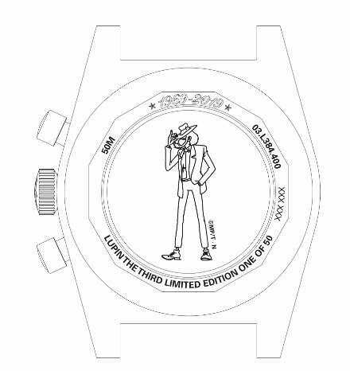
Frequency: 36,000 VpH (5 Hz)
Power-reserve.: min. 50 hours
Finishes: Oscillating weight with “Côtes de Genève” motif

FUNCTIONS
Hours and minutes in the centre
Small seconds at 9 o'clock
Chronograph:
- Central chronograph hand
- 12-hour counter at 6 o'clock
- 30-minute counter at 3 o'clock
Tachymetric scale
Date indication at 4:30
©MP/T・N
CASE, DIAL & HANDS

Diameter: 37 mm
Diameter opening: 32.3 mm
Thickness: 12.60 mm
Crystal: Domed sapphire crystal with anti-reflective treatment on both sides
Case-back: Special case-back with transparent sapphire crystal and printed with Mr. Jigen silhouette silhouette
Material: Stainless steel
Water-resistance: 5 ATM
Dial: Special black matte-lacquered dial with grey-coloured counters
Hour-markers: Gold-plated, faceted and coated with Beige Super-LumiNova®SLN
Hands: Gold-plated, faceted and coated with Beige Super-LumiNova®SLN

STRAPS & BUCKLES
Strap: Comes in a black alligator strap
Buckle: Stainless steel pin buckle

