Zenith and Revolution bring back the “Cover Girl” in the A3818 Revival

Miami, 25th of February 2020: During a cocktail party among press, clients and friends of the brand, Zenith and Revolution unveiled an exclusive Revival model based on an El Primero icon from the 1970s. Affectionately nicknamed the “Cover Girl” by vintage watch collectors and El Primero aficionados, following its appearance on the cover of a book about Zenith history, the A3818 was introduced in 1971 for a brief time and in limited quantities, making it one of the most elusive and sought-after vintage El Primero watches. Together with Revolution and its sister-media The Rake, Zenith is bringing back this sporty-chic chronograph icon in a limited-edition Revival series of 100 pieces.

“It’s an immense pleasure to bring back one of the most emblematic historical El Primero models with Revolution and The Rake, who have supported Zenith for the longest time. More than just leading media for watches and the finer things in life, Revolution and The Rake are also curators of exceptional objects and influential tastemakers with a story to tell”, said Julien Tornare, ZENITH CEO, of the collaboration. Wei Koh, the founder of Revolution and The Rake added “In the pantheon of watchmaking’s most iconic sports chronographs, there is only one timepiece bestowed with a sobriquet that enflames the desire of men to such an extreme. And that is of course Zenith’s legendary A3818 otherwise known as the Cover Girl thanks to its appearance on the front of Manfred Rossler’s halcyon tome Zenith: Swiss Watch Manufacture since 1865. In vintage collecting culture the Cover Girl is the single most sought-after and one of the rarest Zenith chronographs, with just 1000 pieces believed to have been made. It regularly achieves auction prices just below 20 thousand US dollars, making the watch a truly prized and elusive beast“.

One of the most distinguishing features of the original A3818, compared to other early El Primero watches, is its dial. Instead of the signature Zenith tri-colour chronograph sub-dials or high-contrast “panda” dials, the A3818 featured a textured blue dial – something of a rarity back in 1971. In the Revival series, the satin-brushed finish and petrol blue tone of the dial have been preserved, as have the “pyramid” seconds track and alternating grey and black colours on the sub-dial rings. Giving a uniquely modern twist on this historical reference and turning up its legibility in the dark, the pyramid track, tachymeter scale, logo and text are done in Super-LumiNova®. On the reverse side of the case is another welcome evolution from the original A3818, with a sapphire display back exposing the El Primero calibre.
Each part of the A3818’s 37mm faceted stainless steel case, including the pump-style pushers, is faithful to the original 1971 model. Completing the vintage look and feel of the watch, the A3818 Revival comes on a steel “ladder” bracelet, a modern remake of the Gay Frères bracelets that became emblematic of the early El Primero watches.
The El Primero A3818 Revival will be limited to 100 pieces, with 50 pieces allocated to Revolution and its sister publication The Rake’s online shops, and 50 pieces for Zenith boutiques around the world. The watch will come with a copy of Manfred Rössler’s 2009 book Zenith: Swiss Watch Manufacture Since 1865, one of the most insightful and comprehensive ever publications about the brand and its iconic watches.

ZENITH: TIME TO REACH YOUR STAR

With innovation as its guiding star, Zenith features exceptional in-house developed and manufactured movements in all its watches. From the first automatic chronograph, the El Primero, to the fastest chronograph with a 1/100th of a second precision, the El Primero 21, as well as the Inventor that reinvents the regulating organ by replacing the 30+ components with a single monolithic element, the manufacture is always pushing the boundaries of what's possible. Zenith has been shaping the future of Swiss watchmaking since 1865, accompanying those who dare to challenge themselves and reach for their star.

ZENITH PRESS ROOM

For additional pictures please access the below link
http://pressroom.zenith-watches.com/login/?redirect_to=%2F&reauth=1

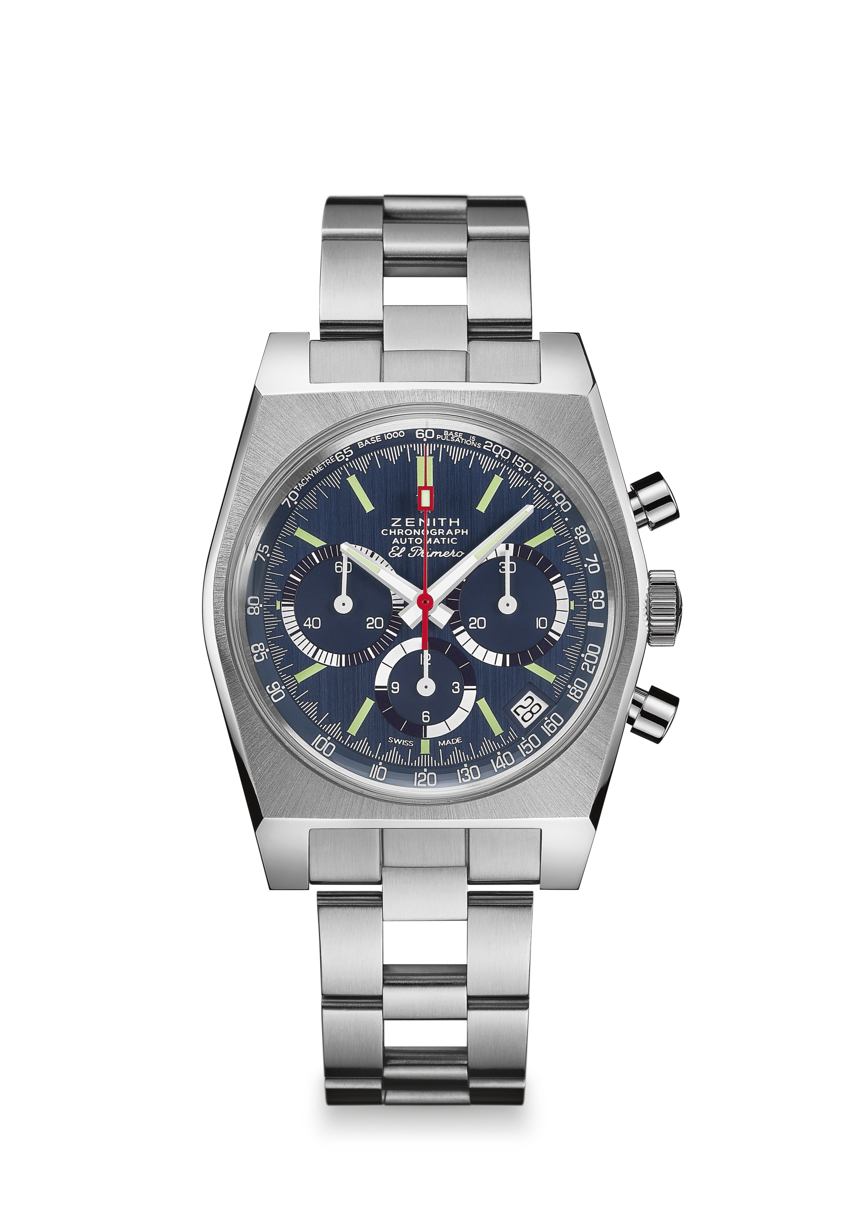
EL PRIMERO A3818 REVIVAL “The Cover Girl”
Reference: 03.A3818.400/51.M3818

UNIQUE SELLING POINTS
Revival of the 1971 Reference A3818
Original 1969 case with 37 mm diameter
Automatic El Primero column-wheel chronograph
Full Super-LumiNova® dial
Limited edition of 100 pieces:
50 pieces for Zenith Boutiques and at www.zenith-watches.com in the US
50 pieces for The Rake/Revolution
Complimentary copy of the Zenith book by Manfred Rossler

MOVEMENT
Movement: El Primero 400 Automatic
Calibre: 13¼``` (Diameter: 30 mm)
Movement thickness: 6.6 mm
Components: 278
Jewels: 31
Frequency: 36,000 VpH (5 Hz)
Power-reserve.: min. 50 hours
Finishes: Oscillating weight with “Côtes de Genève” motif

FUNCTIONS
Hours and minutes in the centre
Small seconds at 9 o'clock
Chronograph:
- Central chronograph hand
- 12-hour counter at 6 o'clock
- 30-minute counter at 3 o'clock
Tachymetric scale
Date indication at 4:30
PRICE 7900 CHF

CASE, DIAL & HANDS
Diameter: 37 mm
Diameter opening: 32.3 mm
Thickness: 12.60 mm
Crystal: Domed sapphire crystal with anti-reflective treatment on both sides
Case-back: Special transparent sapphire crystal caseback
Material: Stainless steel
Water-resistance: 5 ATM
Dial: Blue satin-brushed dial
Hour-markers: Rhodium-plated, faceted and coated with Super-LumiNova® SLN C3
Hands: Rhodium-plated, faceted and coated with Super-LumiNova® SLN C3

STRAP & BUCKLE
“Ladder” bracelet with double folding clasp

