A Zenith Mystery Comes full circle in the Chronomaster Revival “Shadow”, a timepiece inspired by an obscure prototype from 1970.

A timepiece shrouded in mystery. Its existence has eluded collectors and Zenith collaborators alike for decades. As the legend goes, in 1970, not long after Zenith debuted the groundbreaking El Primero calibre, the manufacture had produced a prototype of a manual-winding chronograph, housed in a blackened steel case – a rarity for the time. Only a handful of this spectral prototype was made, but the model was never officially produced or commercialized. Many watchmakers and longtime employees of Zenith had heard of and even seen one of the rare prototypes, even though official records about this piece are extremely scarce.

Fast-forward to 2019. As Zenith began celebrating the 50th anniversary of the seminal El Primero chronograph calibre, the team at the manufacture began to go through the secret walled-off attic where Charles Vermot had once hidden all the plans and parts necessary to produce the El Primero movement. There among the countless artifacts was a box and in it, the original prototype of the black chronograph that hadn’t been seen by anyone since the early 1970’s. For the team, surely this couldn’t be a coincidence, but fate calling. It was enthusiastically agreed that the timing was perfect to complete the black chronograph project that had begun almost 50 years ago.

The Chronomaster Revival “Shadow” reimagines what could have been, rather than directly reproducing a historical Zenith timepiece. Inspired heavily by the obscure black chronograph prototype from 1970, the Shadow is housed in a 37mm case, a faithful reproduction of the very first watch fitted with the El Primero, the A384. But instead of the traditional choice of stainless steel with a superficial layer of black coating, Zenith has opted for microblasted Titanium, bringing out the dark grey nuances of the lightweight yet highly durable metal with its completely matte finish. And unlike the prototype from 1970, which feature a manual-winding chronograph movement, the Chronomaster Revival Shadow features the most prolific automatic chronograph ever made, the El Primero, visible through the display back.

In spite of its dark demeanor, the Shadow remains a highly legible chronograph, with grey counters and tachymeter scale subtly contrasting against the deep, matte black dial. The hands and applied markers are filled with white SuperLuminova that emits a bright green glow in the dark. The black rubber strap with a cordura-effect features a touch of white on the stitching, fixed to a microblasted titanium pin buckle that matches the stealthy finish of the case.

ZENITH: TIME TO REACH YOUR STAR.
Zenith exists to inspire individuals to pursue their dreams and make them come true – against all odds. Since its establishment in 1865, Zenith became the first watch manufacture in the modern sense of the term, and its watches have accompanied extraordinary figures that dreamt big and strived to achieve the impossible – from Louis Blériot’s history-making flight across the English Channel to Felix Baumgartner’s record-setting stratospheric free-fall jump.

With innovation as its guiding star, Zenith features exceptional in-house developed and manufactured movements in all its watches. From the first automatic chronograph, the El Primero, to the fastest chronograph with a 1/100th of a second precision, the El Primero 21, as well as the Inventor that reinvents the regulating organ by replacing the 30+ components with a single monolithic element, the manufacture is always pushing the boundaries of what's possible. Zenith has been shaping the future of Swiss watchmaking since 1865, accompanying those who dare to challenge themselves and break barriers. The time to reach your star is now.

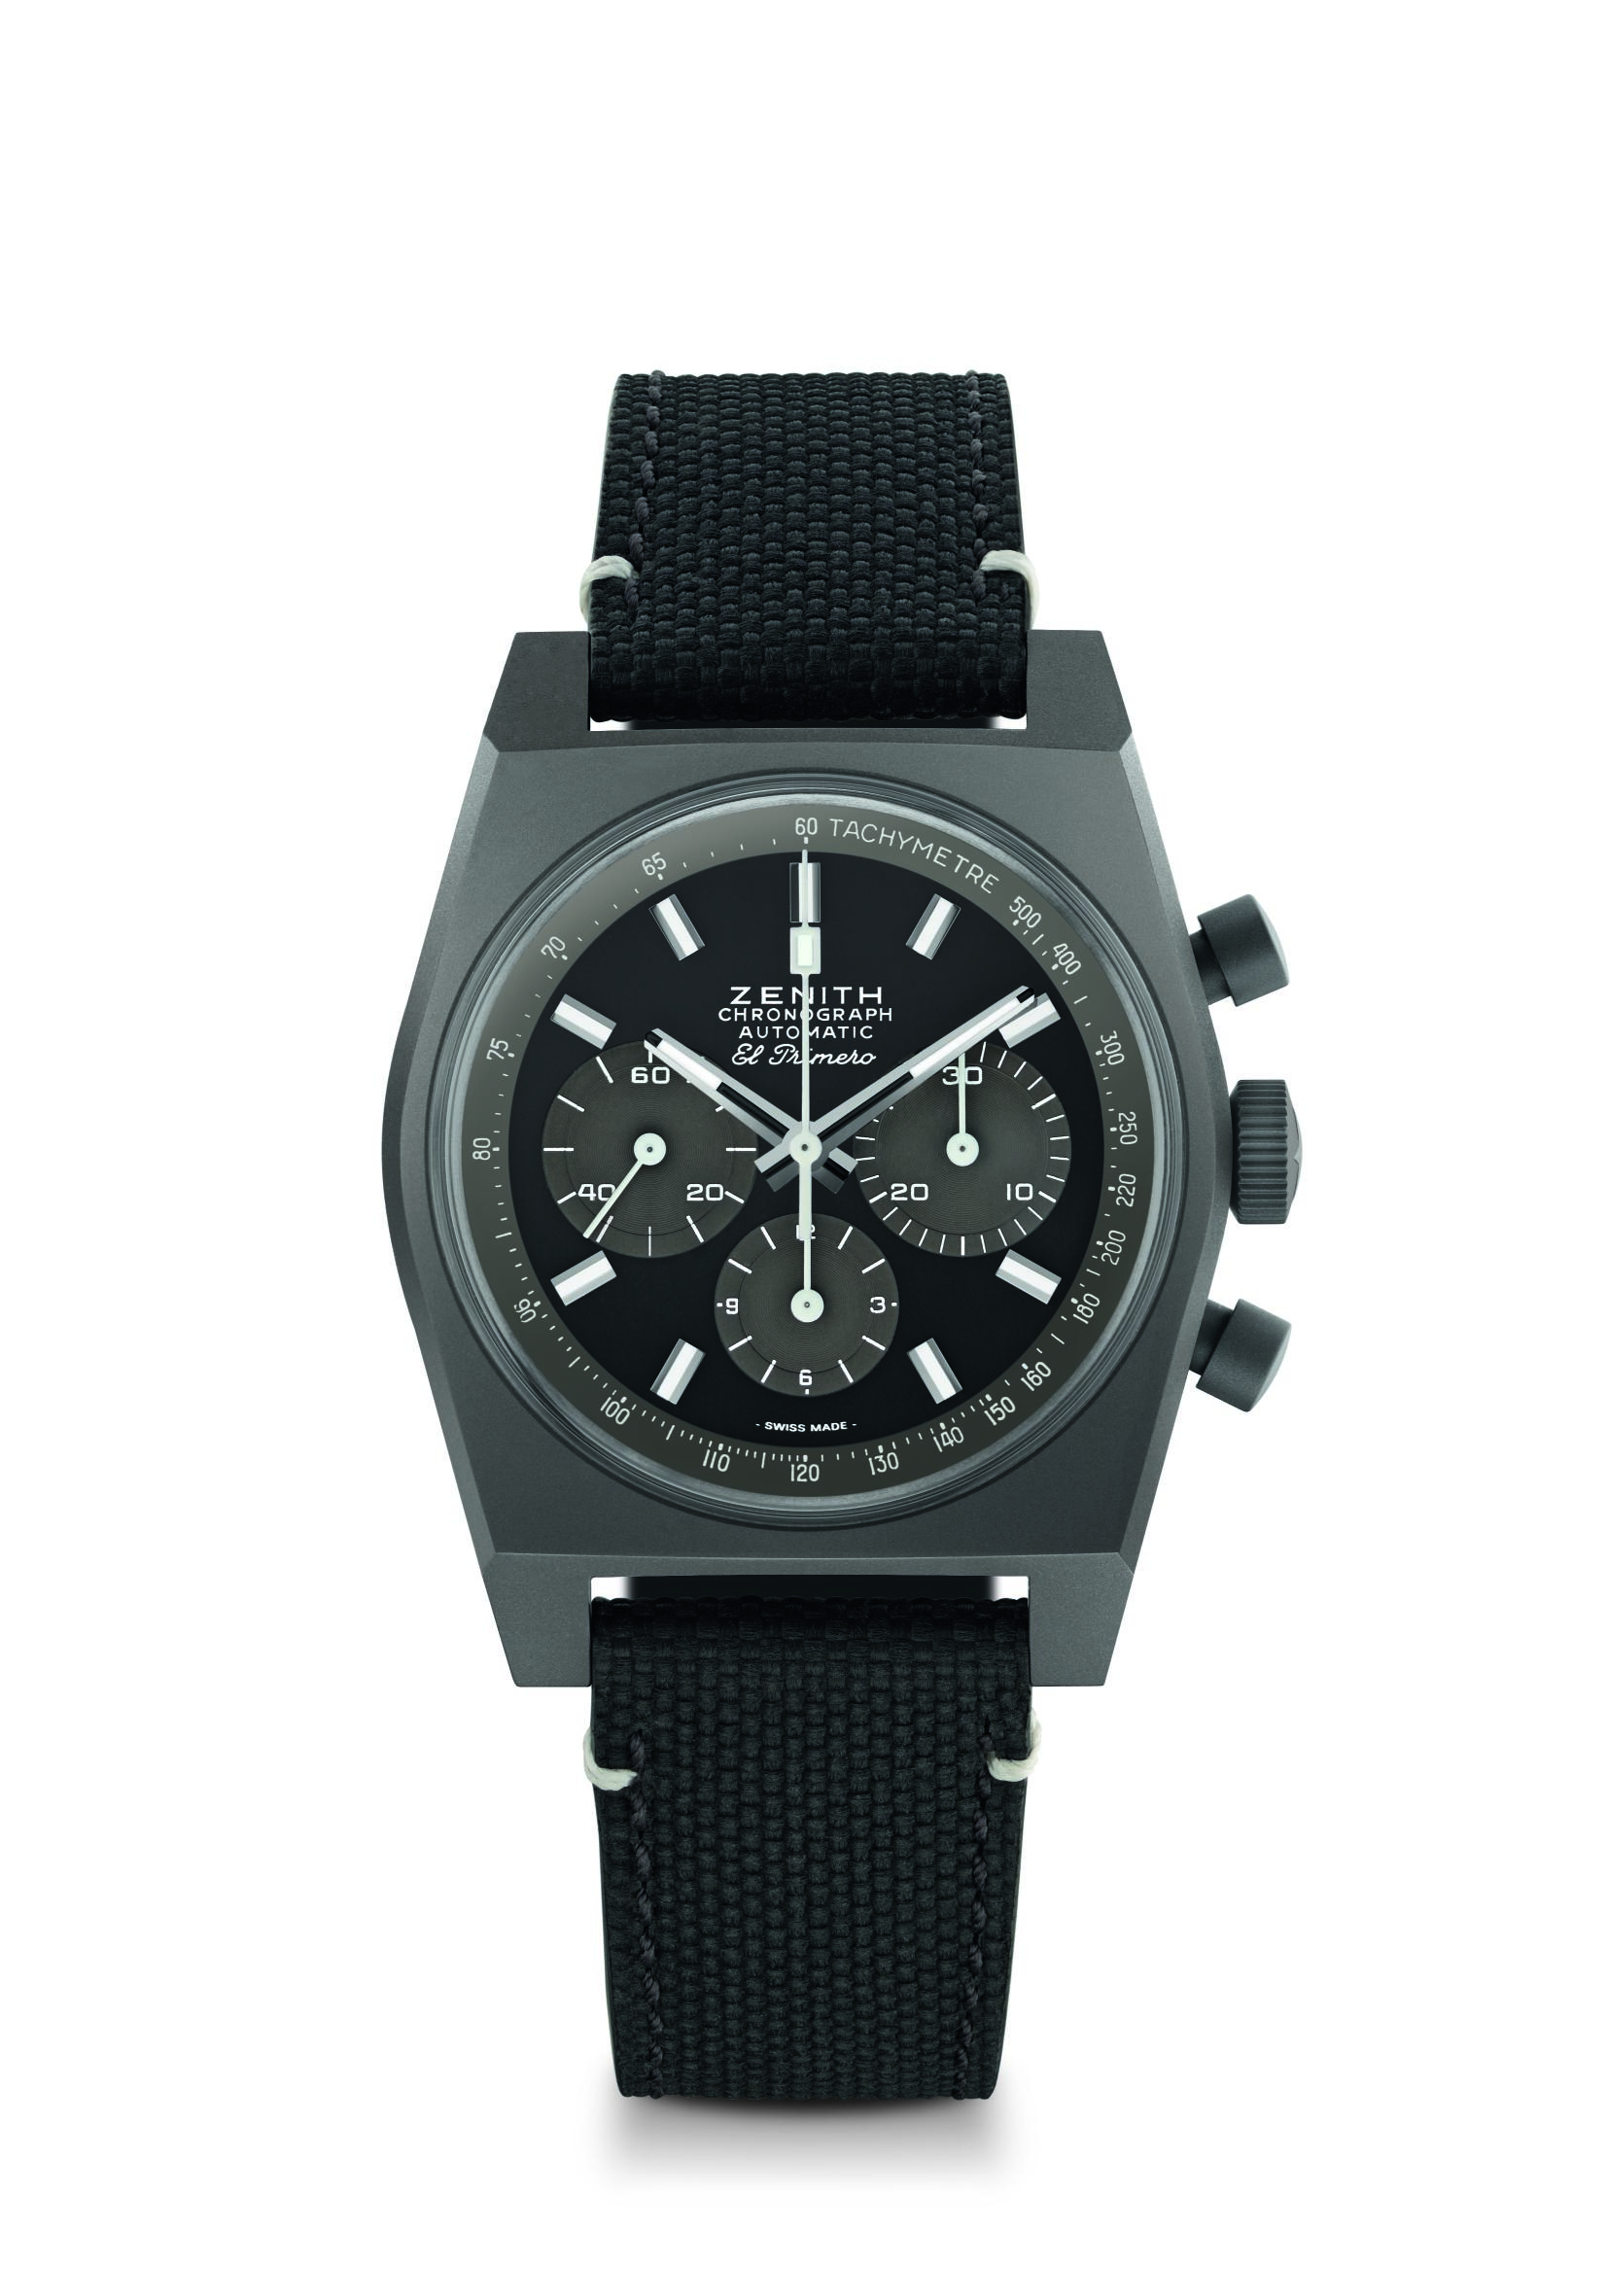
Chronomaster Revival ‘Shadow”
Reference: 97.T384.4061/21.C822

Key points: Original 1969 case with 37mm diameter, Automatic El Primero column-wheel chronograph
Movement: El Primero 4061 Automatic
Frequency: 36,000 VpH (5 Hz)
Power reserve: min. 50 hours
Functions: Hours and minutes in the centre. Small seconds at nine o’clock. Chronograph: central chronograph hand, 12-hour counter at six o’clock, 30-minute counter at three o’clock. Tachymetric scale.
Case: 37-mm
Material: microblasted titanium
Dial: Black dial with grey counters and tachymeter scale
Water-resistance: 5 ATM
Price: 8400 CHF
Hour-markers: Rhodium-plated, faceted and coated with Super-LumiNova®SLN C1
Hands: Rhodium-plated, faceted and coated with Super-LumiNova®SLN C1
Bracelet & Buckle: Black “cordura effect” strap and white stitching. Microblasted titanium pin buckle.

